PRACTICAL-3

Aim: To perform various operations using linux terminal commands.

1. **List files in your home directory by the last time they were modified**

**COMMAND:** ls -ltr

**OUTPUT:**

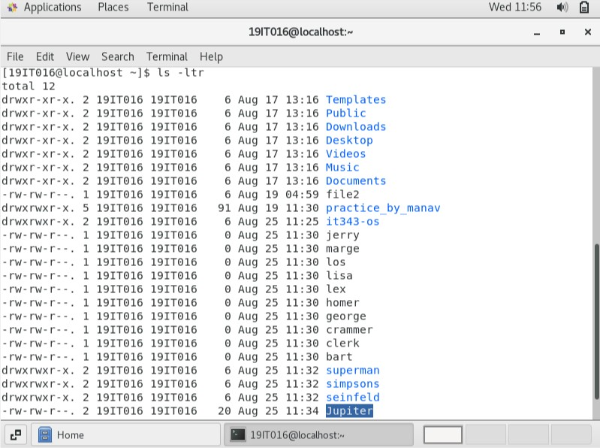

1. **Move jerry, george, kramer and puddy files into seinfeld directory**

**COMMAND:** mv george jerry kramer seinfield

Output:

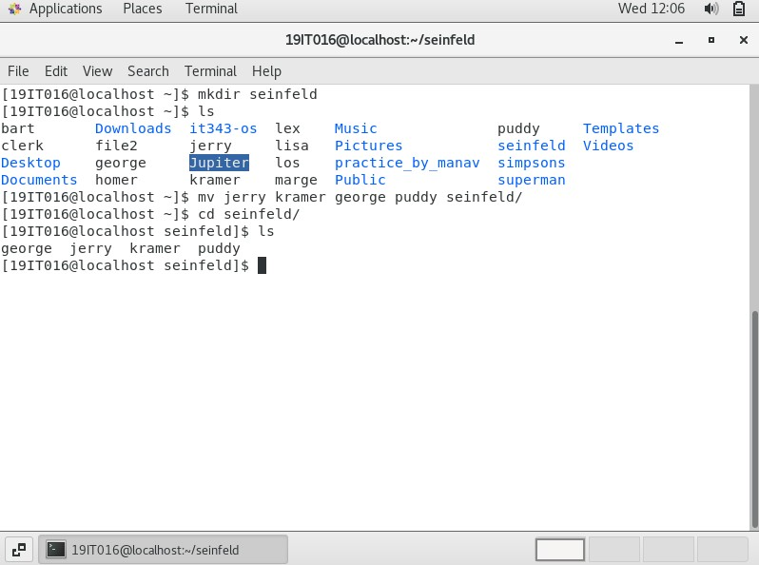

1. **Move homer, bart, marge, lisa files in simpsons directory**

**COMMAND:** mv bart marge lisa simpsons

**OUTPUT:**

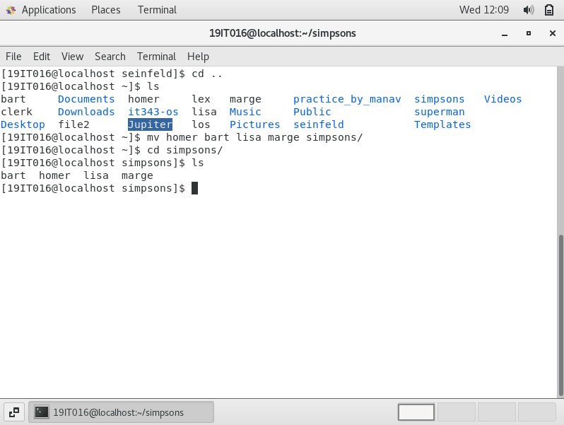

1. **Move clark, luther and lois files in superman directory**

**COMMAND:** mv clark luther lois superman

**OUTPUT:**

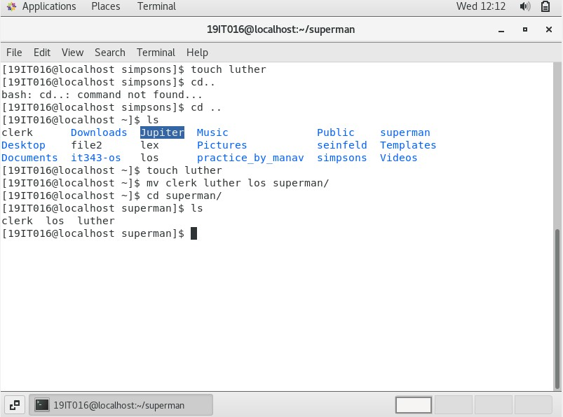

1. **List the content of seinfeld directory by the last time they were modified**

**COMMAND:** ls –ltr seinfield

**OUTPUT:**

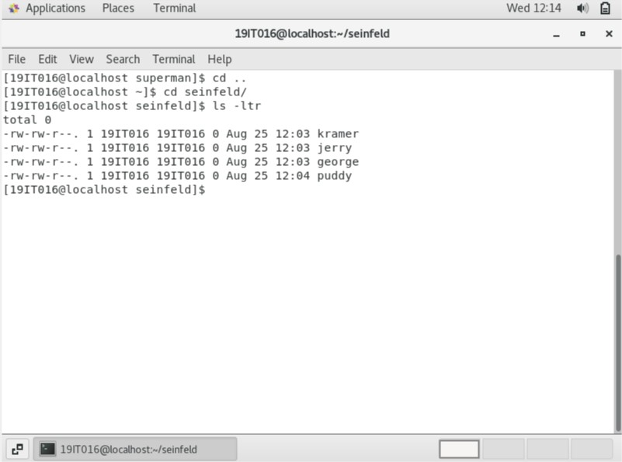

1. **Create 2 new files in seinfeld directory, elaine and newman**

**COMMAND:** cd seinfield

touch elaine newman

**OUTPUT:**

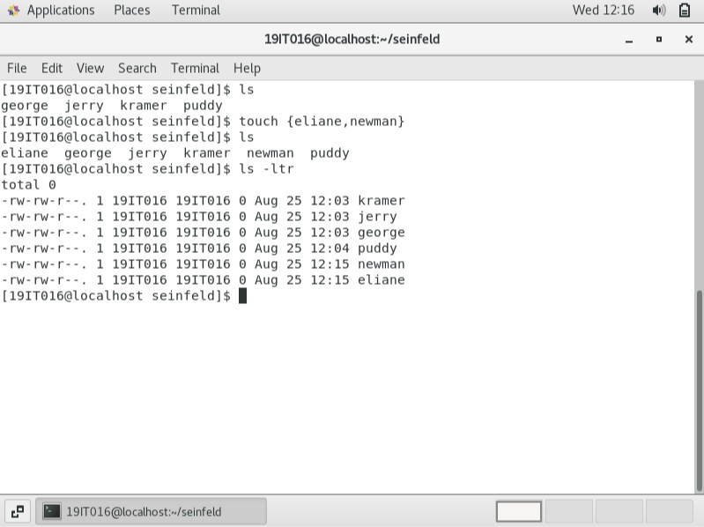

1. **Change file permission of eliane to remove read access from everyone**

**COMMAND:** chmod ugo-r elaine

**OUTPUT:**

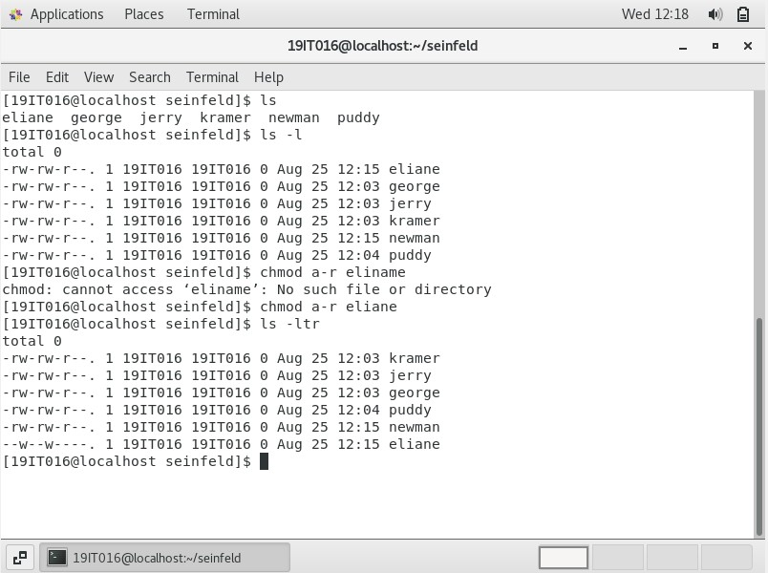

1. **Change file permission of newman to add write permissions to only group**

**COMMAND:** chmod g+w newman

**OUTPUT:**

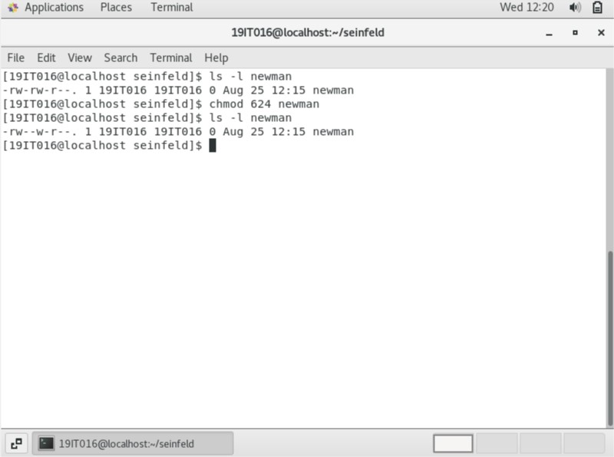

1. **Become root and cd into your home directory (e.g., /home/admin). Then Create 2 new files superman and zod in superman directory**

**COMMAND:** su –

cd /home/19IT016 cd superman

touch superman zod

**OUTPUT:**

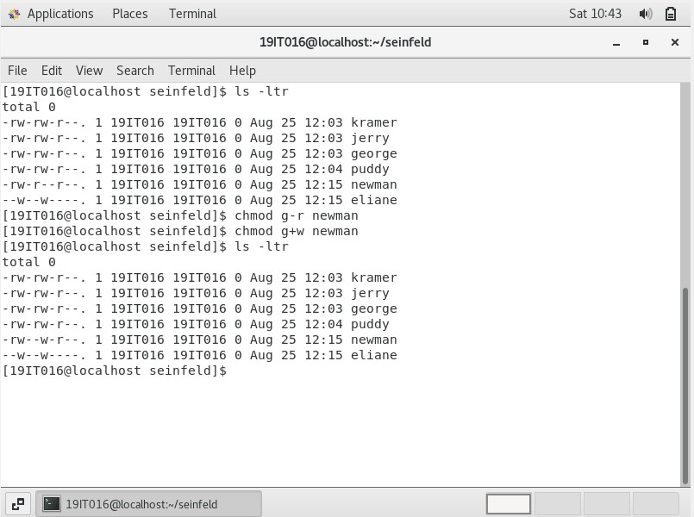

1. **Change ownership of zod file from root to your username**

**COMMAND:** chown 19IT016 zod

**OUTPUT:**

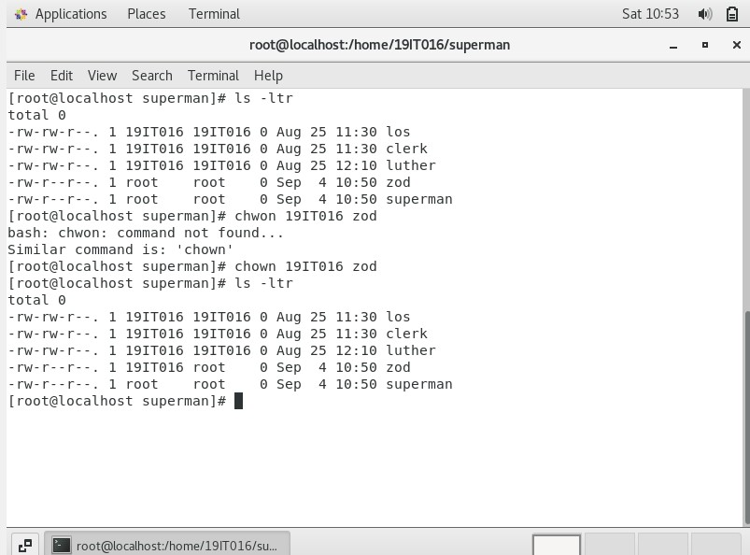

1. **Change group ownership of zod from root to your username**

**COMMAND:** chgrp 19IT016 zod

**OUTPUT:**

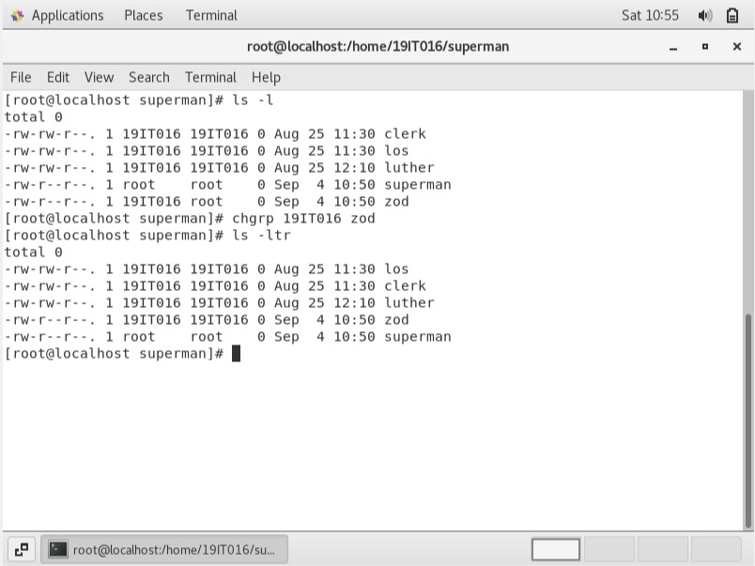

1. **Then move superman file to /tmp directory**

**COMMAND:** mv superman /tmp

**OUTPUT:**

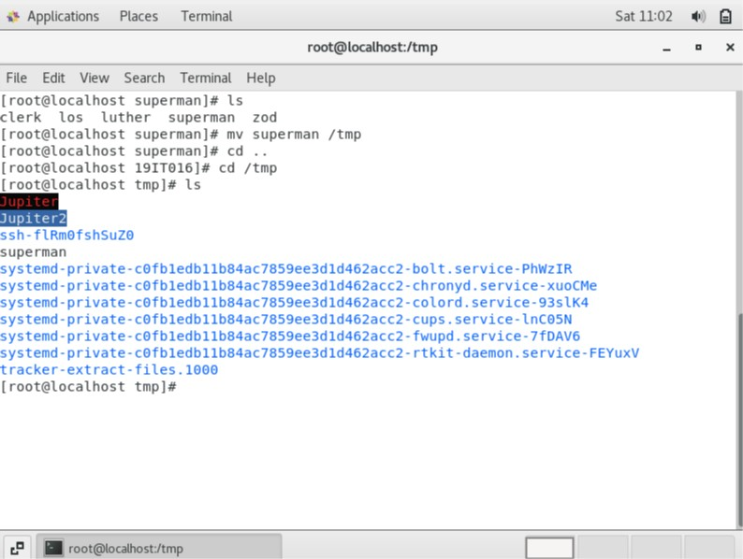

1. **Remove superman file from /tmp directory**

**COMMAND:** rm superman

**OUTPUT:**

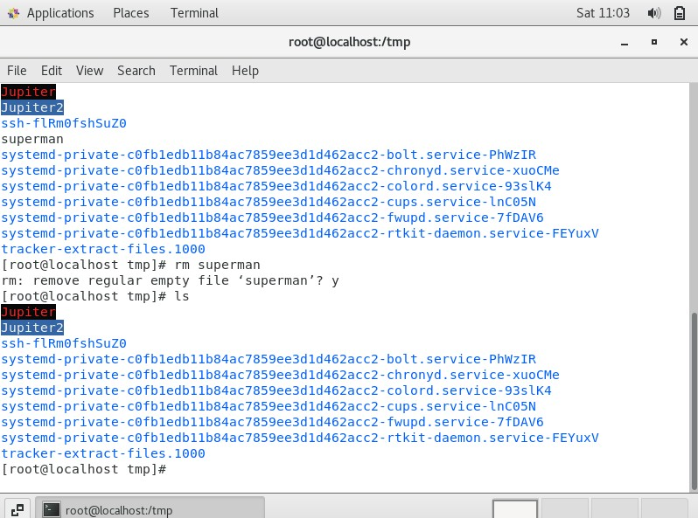

1. **Exit out of root account**

**COMMAND:** exit

**OUTPUT:**

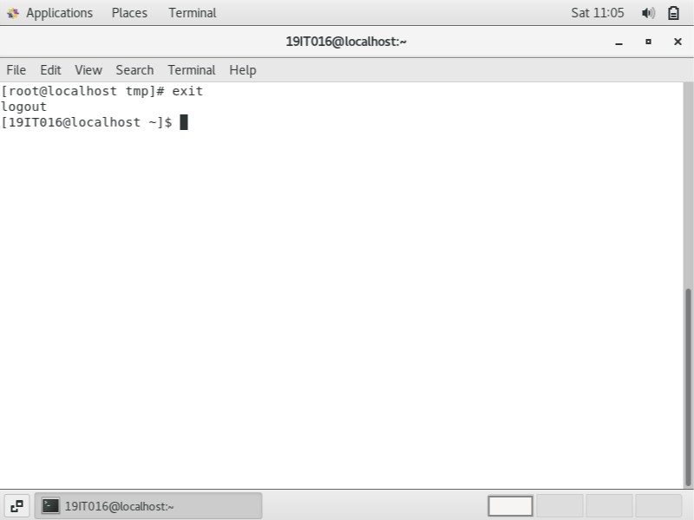

1. **Go back to superman directory in your home directory and add this line to zod "zod is a bad character in superman movie"**

**COMMAND:** echo “zod is bad character in superman movie” > zod

**OUTPUT:**

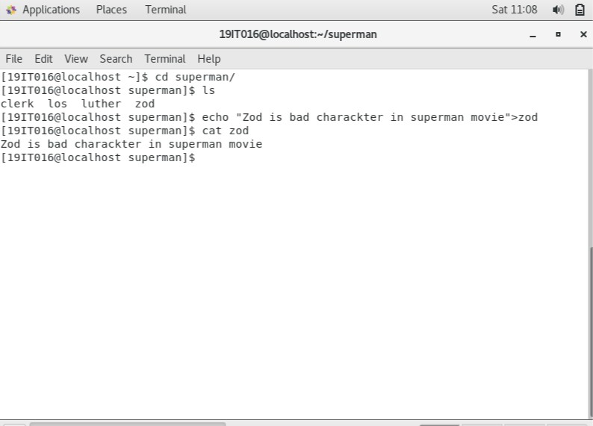

1. **Then go to the seinfeld directory and create a new file seinfeld.**

**COMMAND:** touch seinfield

**OUTPUT:**

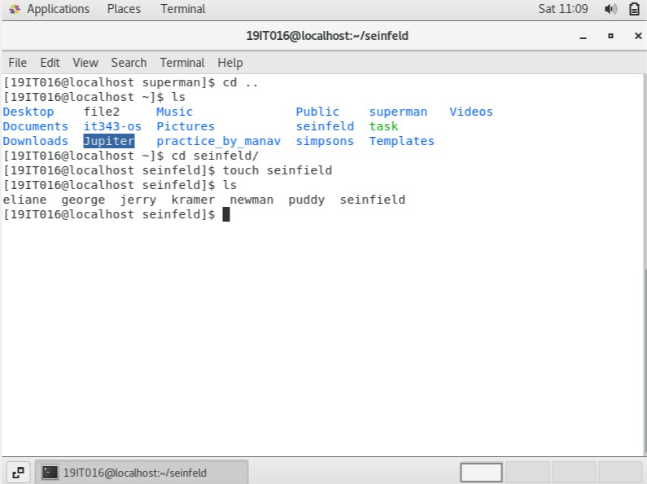

1. **Add 5 seinfeld character’s names in the seinfeld file. Jerry Seinfeld, George Costanza, Eliane Benis, Cosmo Kramer, and David Puddy**

**COMMAND:** echo “Jerry Seinfeld, George Costanza, Eliane Benis, Cosmo Kramer, David Puddy” > seinfield

**OUTPUT:**

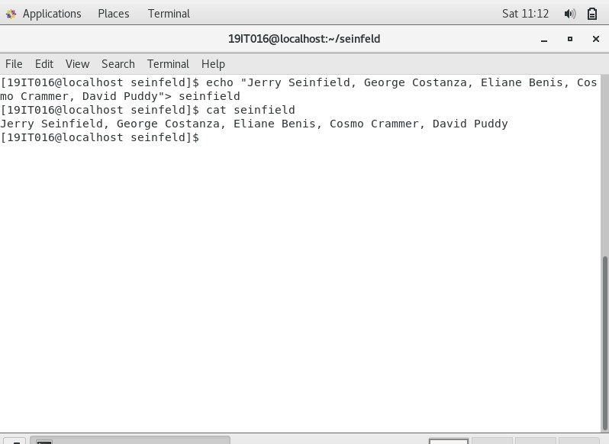

1. **Become root user again**

**COMMAND:** su -

**OUTPUT:**

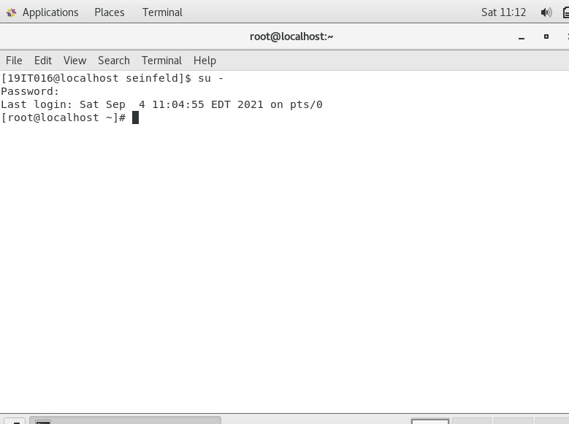

1. **Do cat /var/log/messages and output to a file called mesg-new in your home directory (e.g., /home/Admin)**

**COMMAND:** cat /var/log/meassages > /home/19IT016/mesg-new

**OUTPUT:**

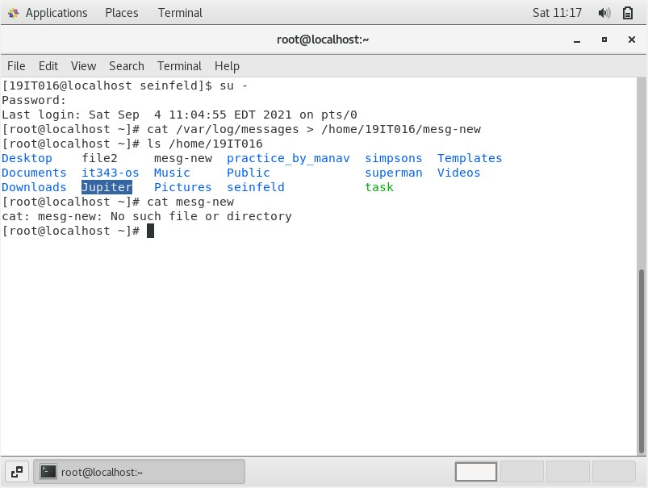

1. **Read the mesg-new file with cat, more and less commands and practice**

**COMMAND:** cat mesg-new

**OUTPUT:**

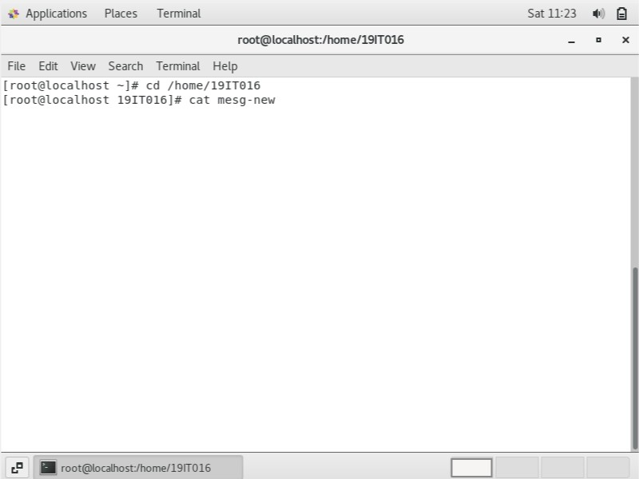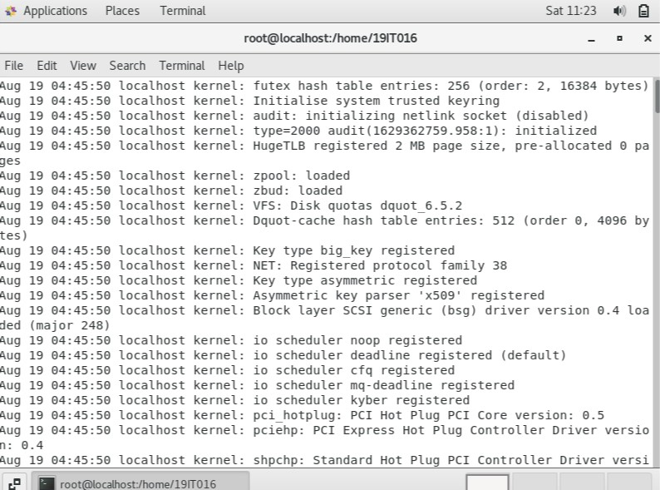

1. **View the first 10 lines of mesg-new file and output to a file name mesg-h10**

**COMMAND:** head -10 mesg-new > mesg-h10 Cat mesg-h10

**OUTPUT:**

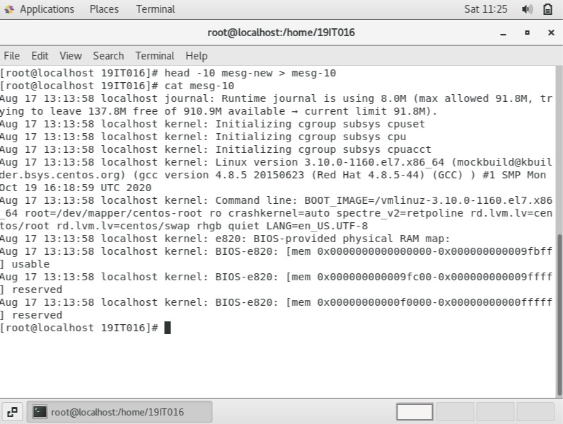

1. **View the last 20 lines of mesg-new file and output to a file name mesg-t20**

**COMMAND:** tail -20 mesg-new > mesg-t20

Cat mesg-t20

**OUTPUT:**

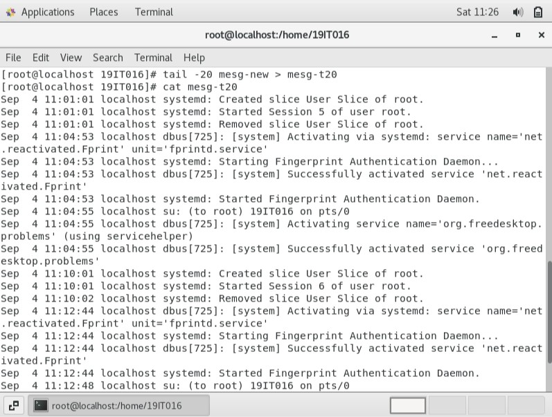

1. **Exit out of root user COMMAND:** su- **OUTPUT:**

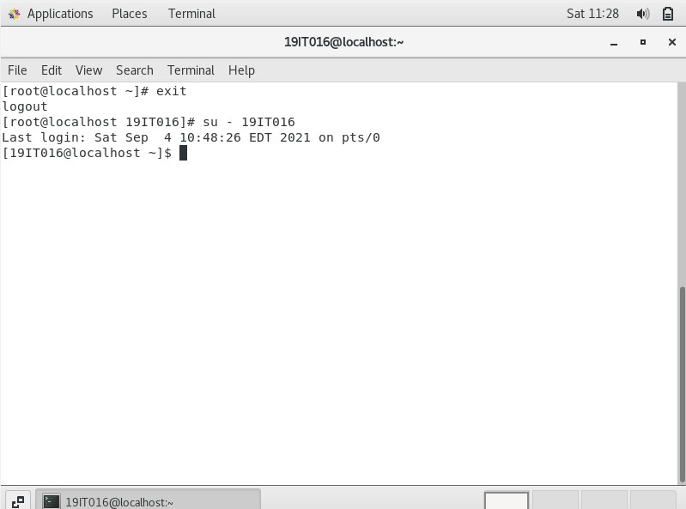

1. **Go to seinfeld directory in your home directory and create a new file “seinfeld-character”**

**COMMAND:** touch seinfield-character

**OUTPUT:**

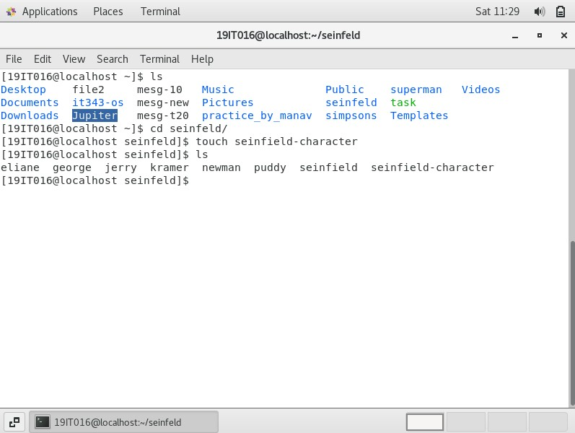

1. **Add text to the seinfeld-character file using echo command. Each character should be in one line, "Jerry Seinfeld, Cosmo Kramer, Eliane Benes, George Costanza, Newman Mailman, Frank Costanza, Estelle Costanza, Morty Seinfeld, Helen Seinfeld, Babes Kramer, Alton Benes, J Peterman, George Steinbrenner, Uncle Leo, David Puddy, Justin Pit and Kenny Bania" OUTPUT:**

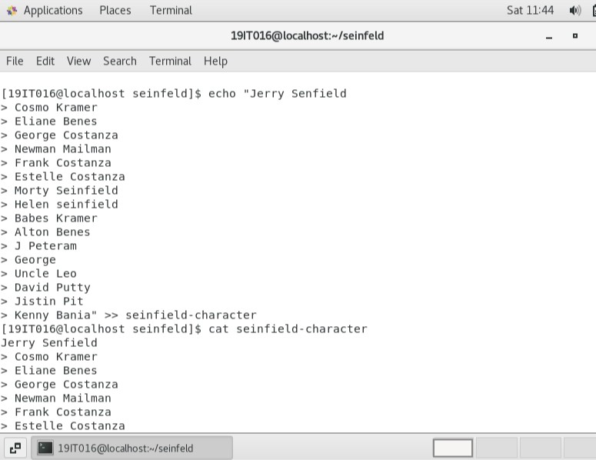

1. **Use cut command to cut the first 4 letters of each line from seinfeld- characters file and output to a different file name (name = filters-files) COMMAND:** cut –c 1-4 seinfield-character > filter-files

**OUTPUT:**

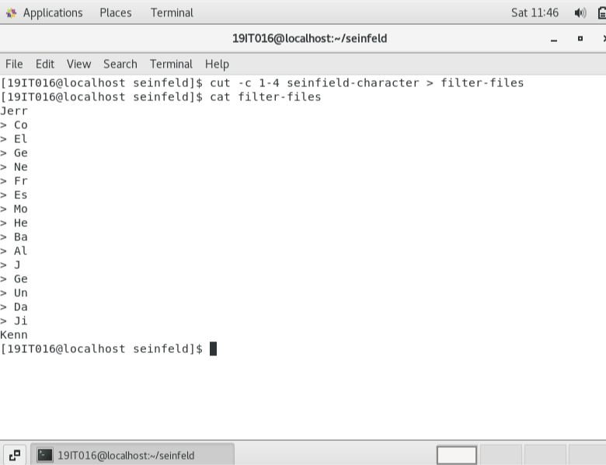

1. **Use awk command to get only the 2nd column of seinfeld-characters and Output to the filters-files without removing any other text from it COMMAND:** awk {‘print $2’} seinfield-character >> filter-files

**OUTPUT:**

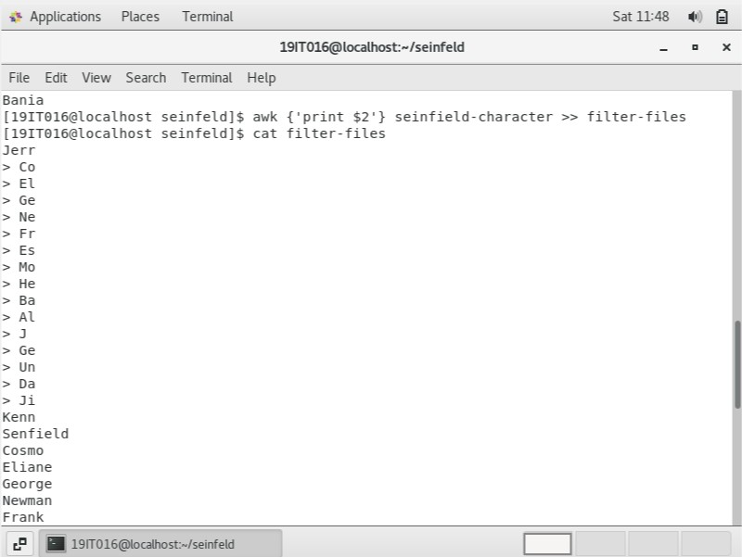

1. **Use grep command to only grep seinfeld and output to a new file call it seinfeld-family**

**COMMAND:** grep –I “seinfield” seinfield-character > seinfield-family

**OUTPUT:**

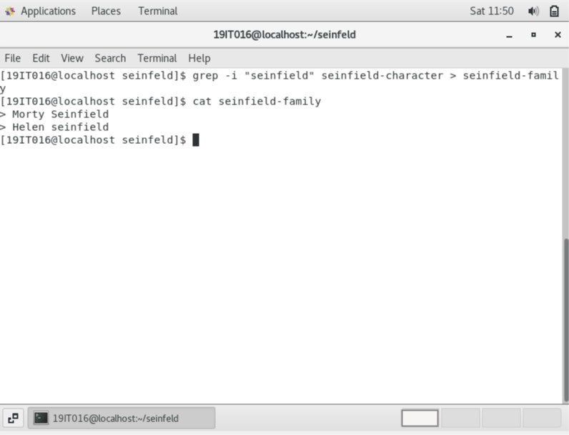

1. **Use sort command, uniq and wc command to practice whichever way you like by creating new files or working with existing files**

**COMMAND:** sort seinfield-character

Sort hello | uniq –iu

wc –w seinfield-character

**OUTPUT:**

