PRACTICAL-4

Aim: To perform various operations using Linux terminal commands.

1. **Go to your home directory and then go to superman directory**

**OUTPUT:**

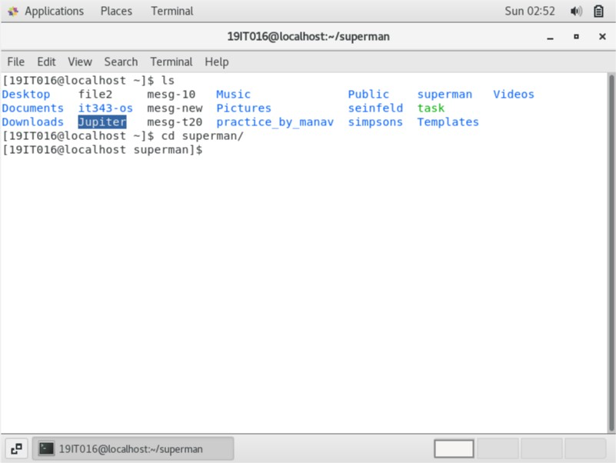

1. **Create a new file called "first4movies" using vi command**

**OUTPUT:**

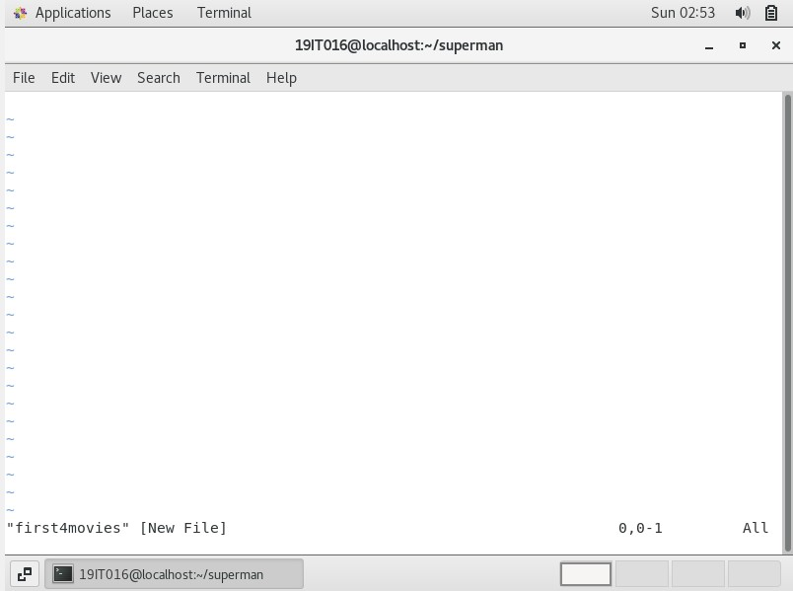

1. **Write anything you know about all first 4 movies of superman. If you never watched superman then you can enter at least 20 names of your family members. This file should have 20 lines and each line should have 5-6 words**

**OUTPUT:**

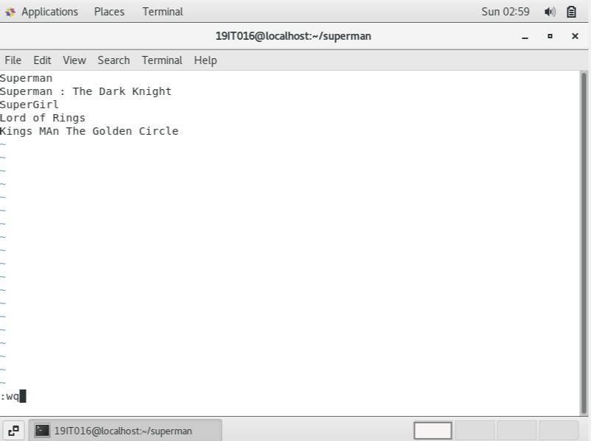

1. **Practice vi command by navigating the file content and remove some lines, edit or undo**

**OUTPUT:**

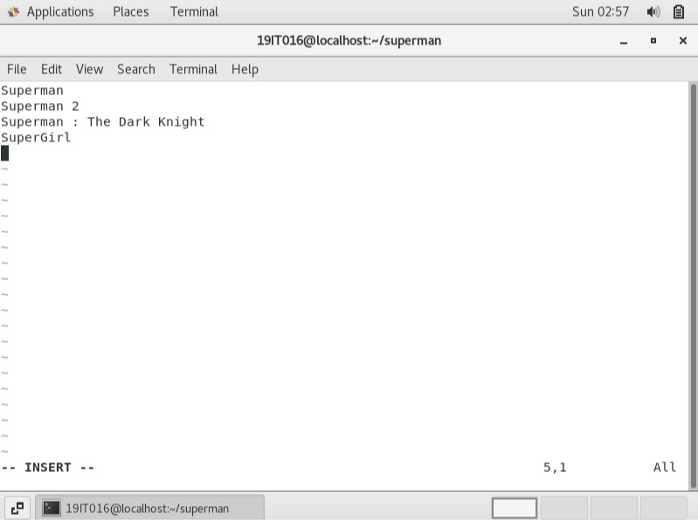

1. **Create a new group superheros (if you don't already have one)**

**OUTPUT:**

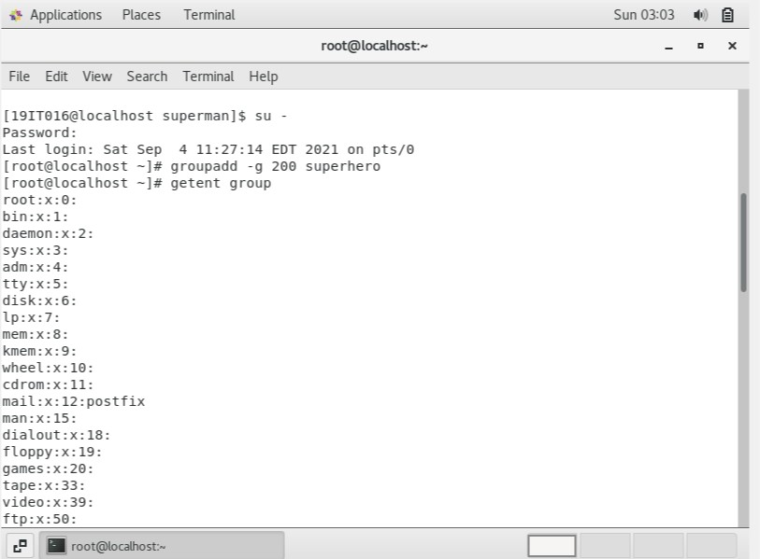

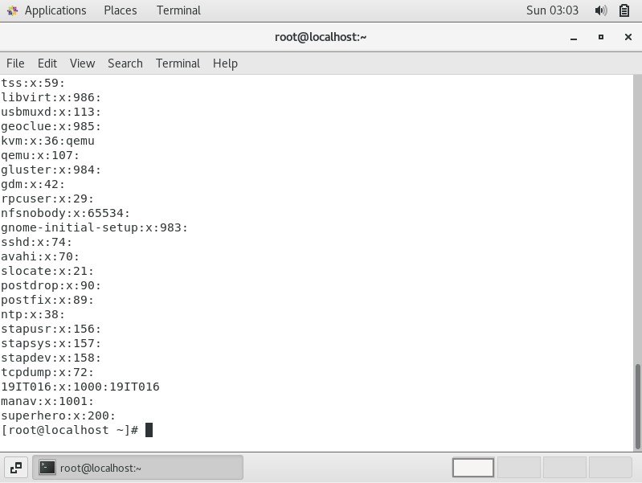

1. **Create a new user hulk and make sure its group should be superheros and its user id should be 2000**

**OUTPUT:**

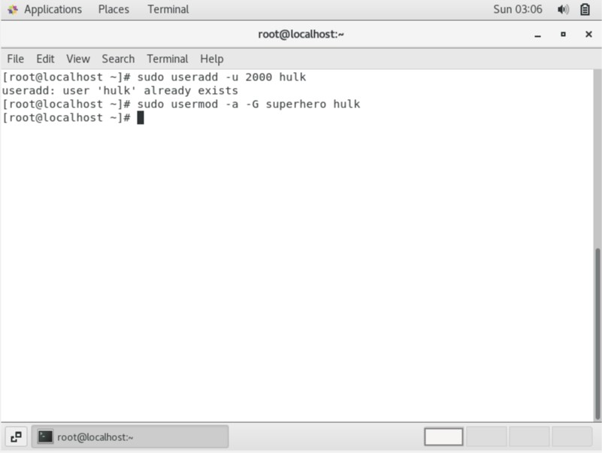

1. **Once the user hulk is created then change the password for hulk and then login as hulk**

**OUTPUT:**

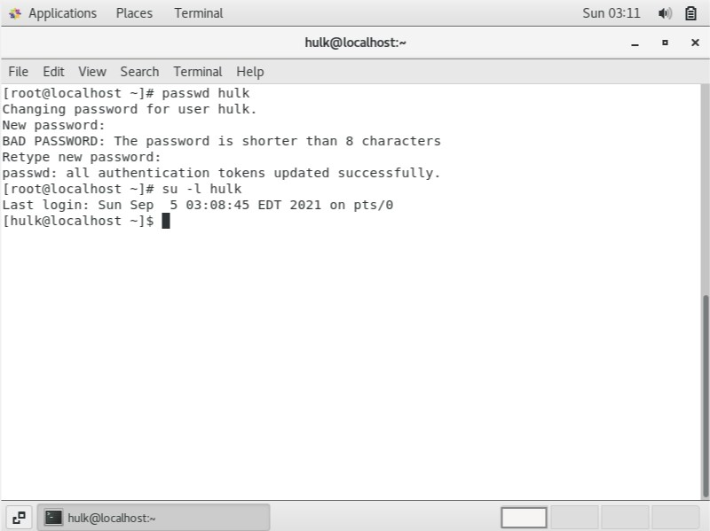

1. **Under hulk home directory create a file Skaar**

**OUTPUT:**

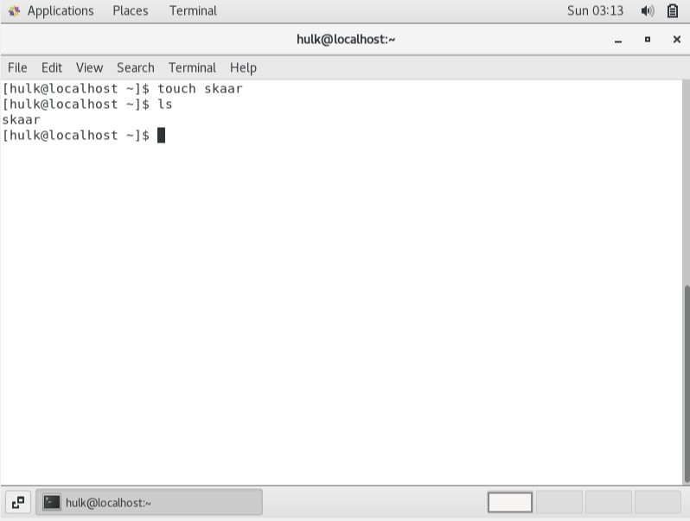

1. **Change group ownership of Skaar from superheroes to root**

**OUTPUT:**

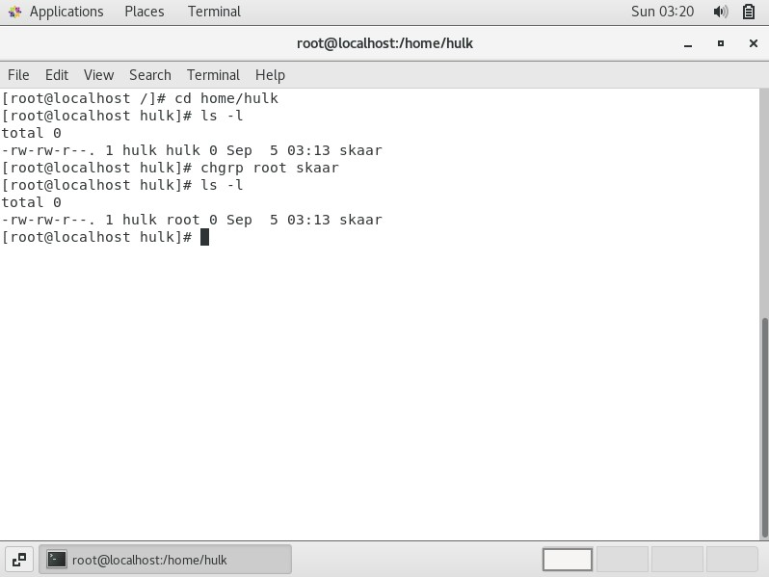

1. **Then create a new group continents**

**OUTPUT:**

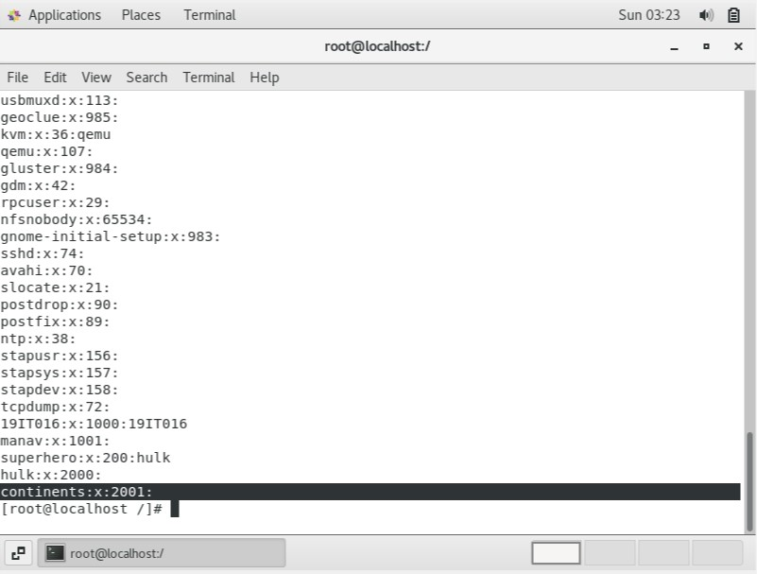

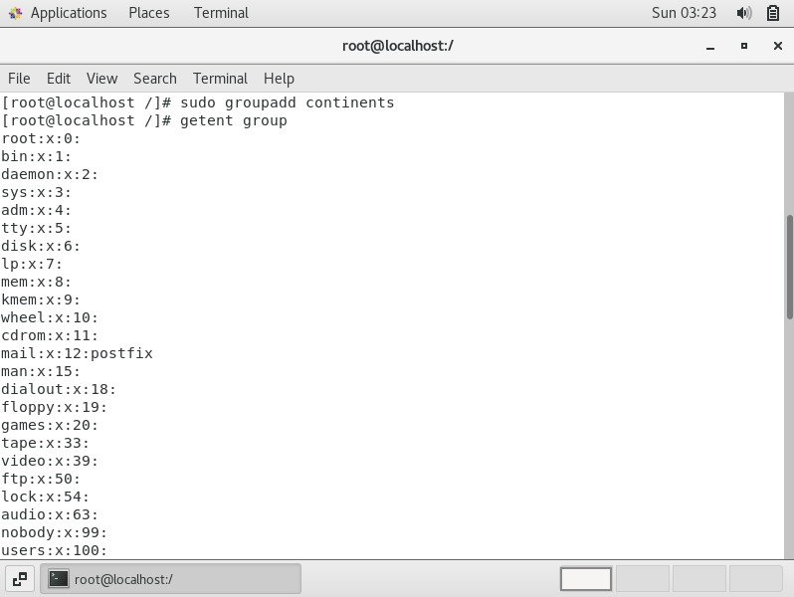

1. **Create a new users namerica, samerica, asia, europe, australia, africa and antartica**

**OUTPUT:**

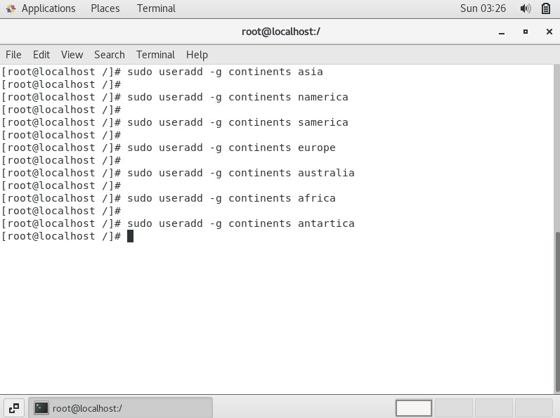

1. **Make sure all these user’s groups are continents**

**OUTPUT:**

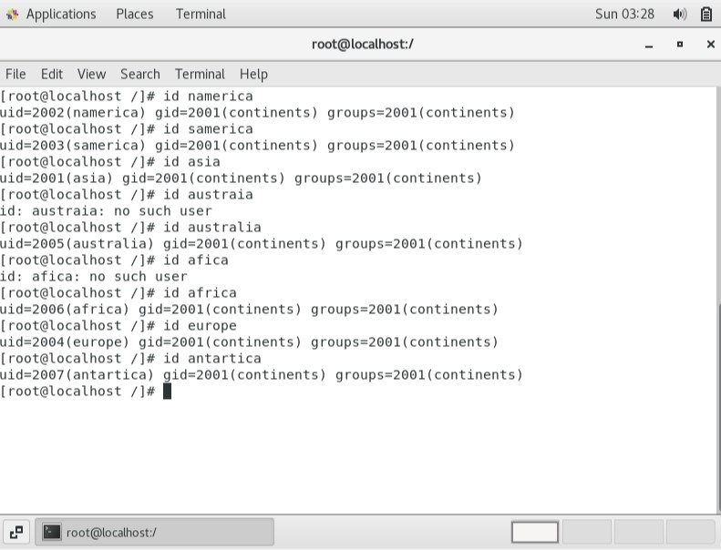

1. **Change password for every user, then switch into each user one by one using su - username command and create one file in each user account (e.g., england file in europe, usa in namerica, japan in asia and so on) OUTPUT:**

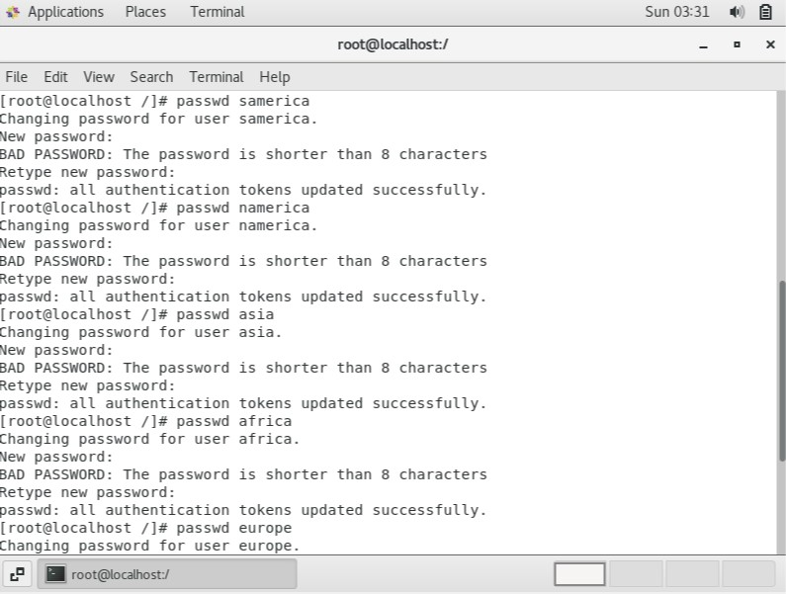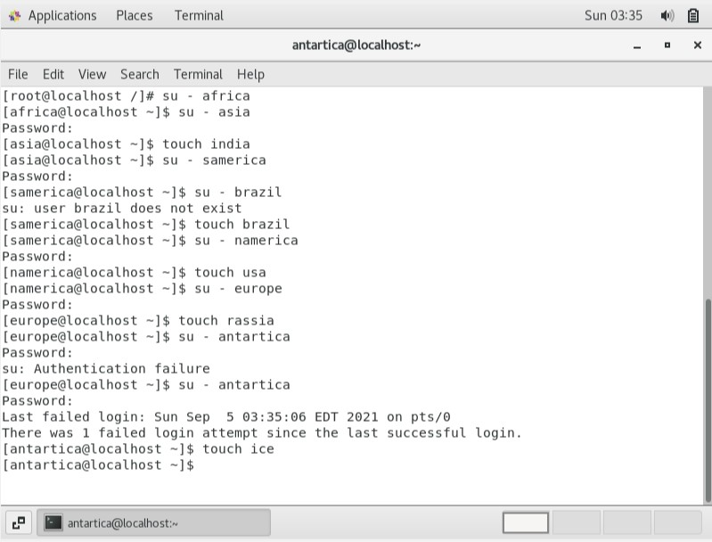

1. **Also add user namerica to wheel group to allow it to run root commands as root and then test it**

**OUTPUT:**

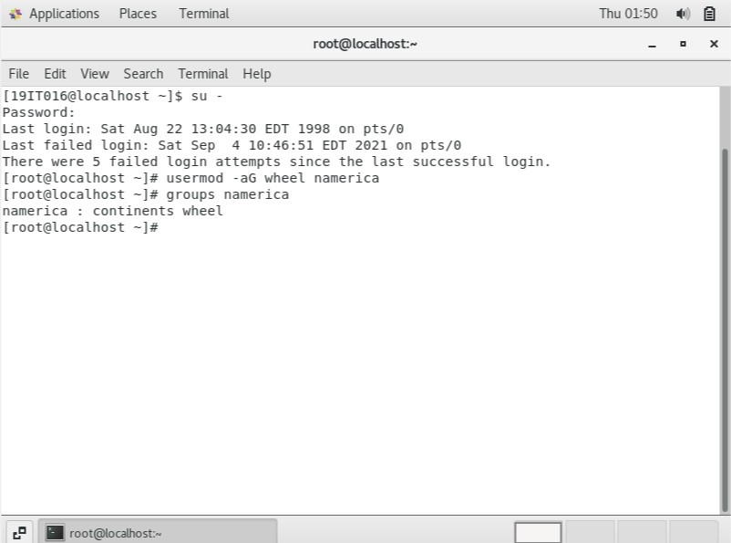

1. **Run id command on africa and australia users to verify their user id**

**OUTPUT:**

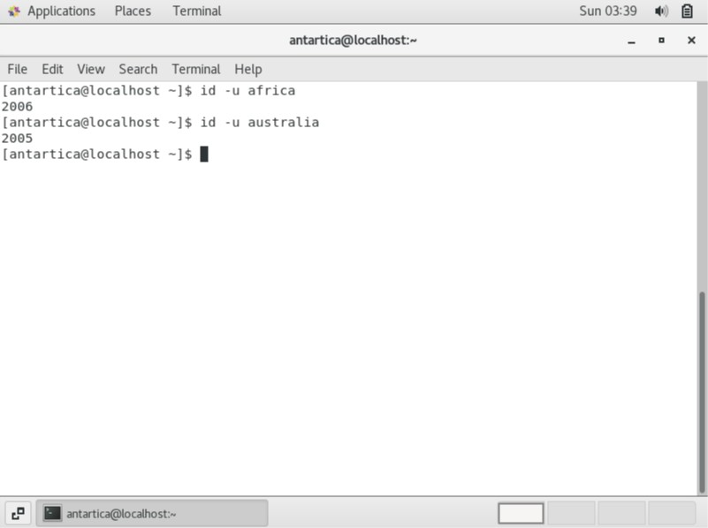

1. **Run the last command and find out the number of users logged in. (Do not count duplicate users)**

**OUTPUT:**

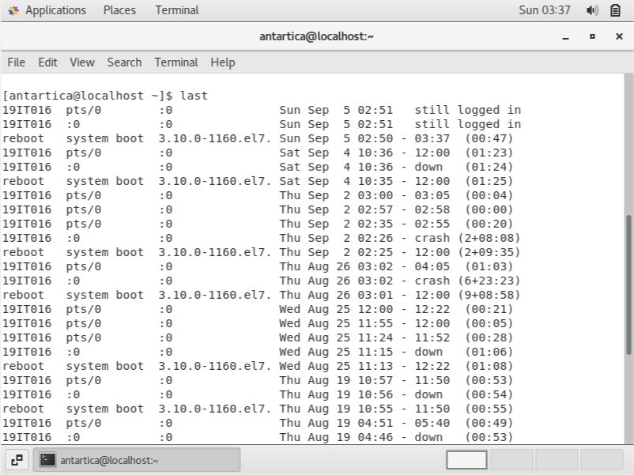

1. **Change the date of your system to Aug 22 1998 at 1pm and verify**

**OUTPUT:**

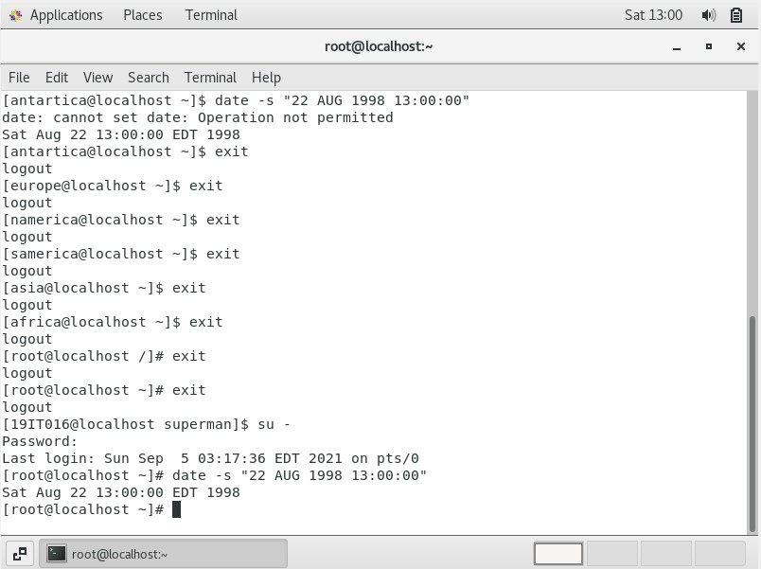

1. **Check system uptime**

**OUTPUT:**

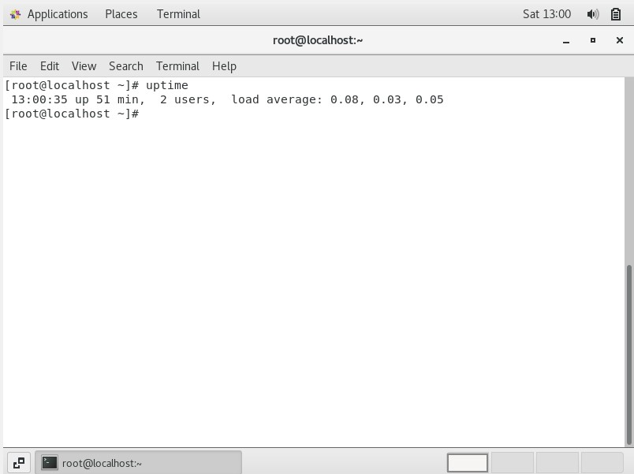

1. **List 1999 calendar**

**OUTPUT:**

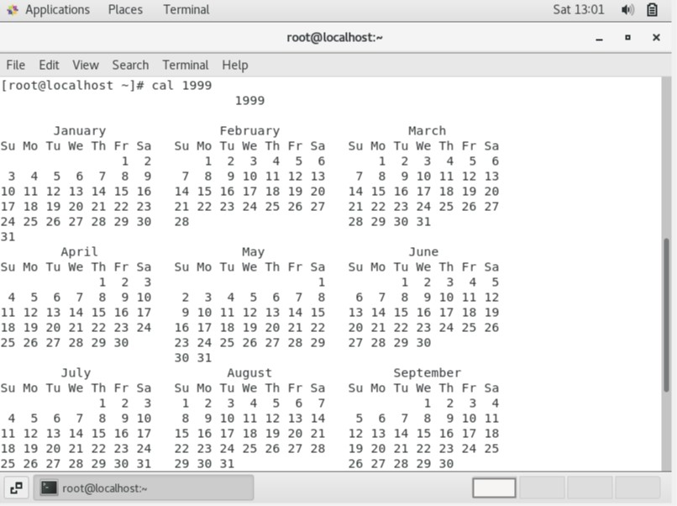

1. **Become yourself "your username" and run df -h command. Output the df -h command to another filename it systemdiskinfo**

**OUTPUT:**

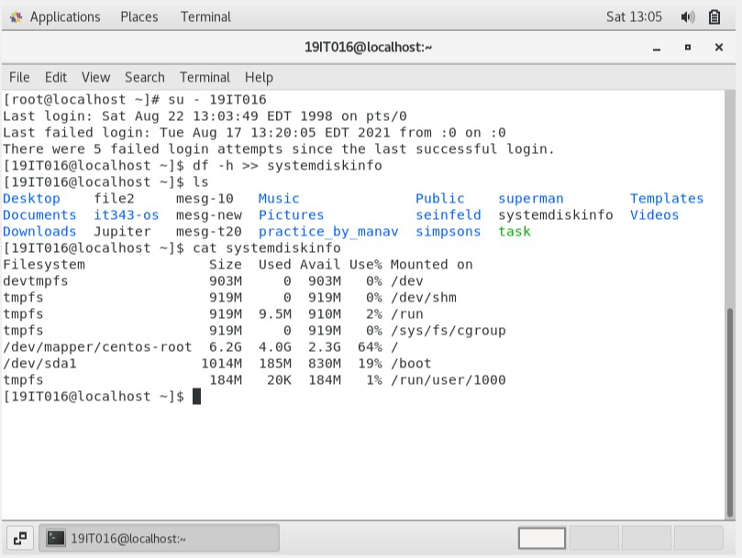

1. **List everything with uname command and find out where the system architecture information is located**

**OUTPUT:**

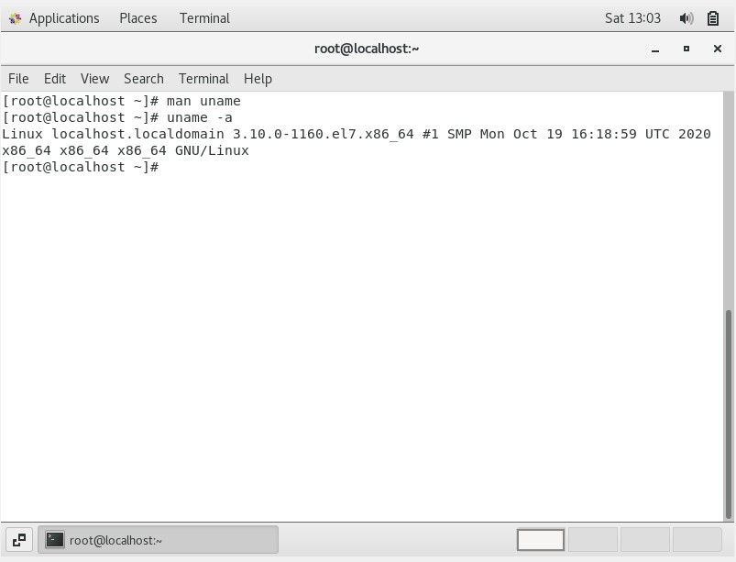

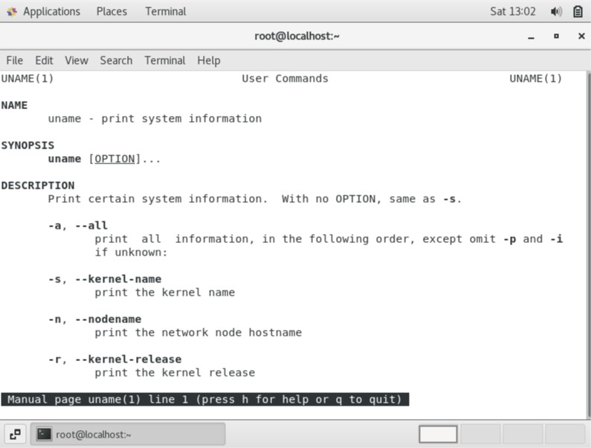

1. **vi systemdiskinfo file and remove the first and second line and save the file**

**OUTPUT:**

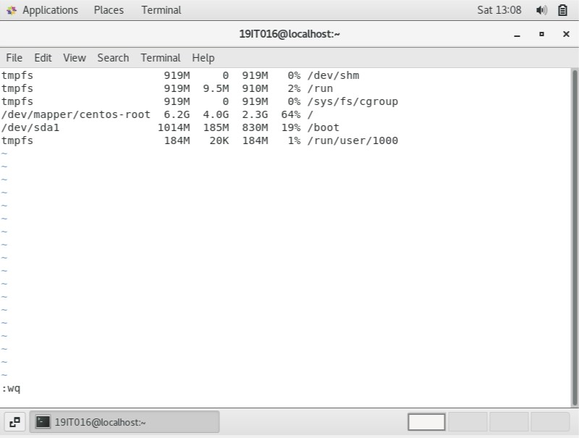

1. **Run dmesg command and output to dm-file**

**OUTPUT:**

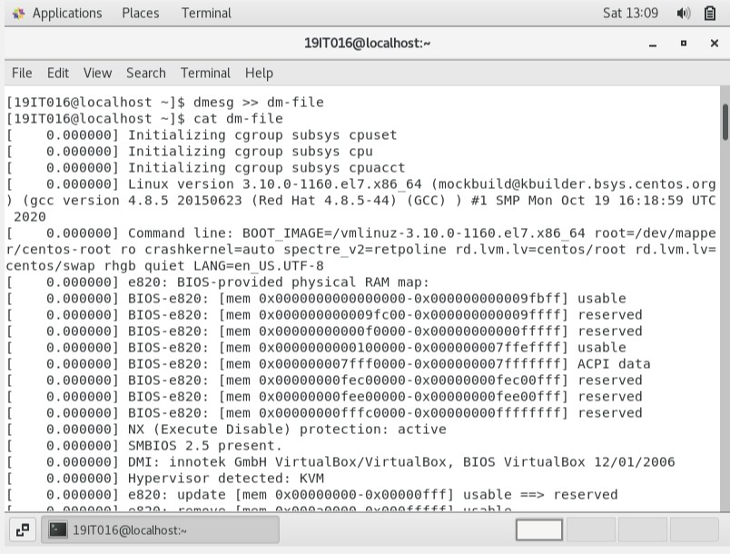

1. **vi dm-file and remove the last 5-7 lines**

**OUTPUT:**

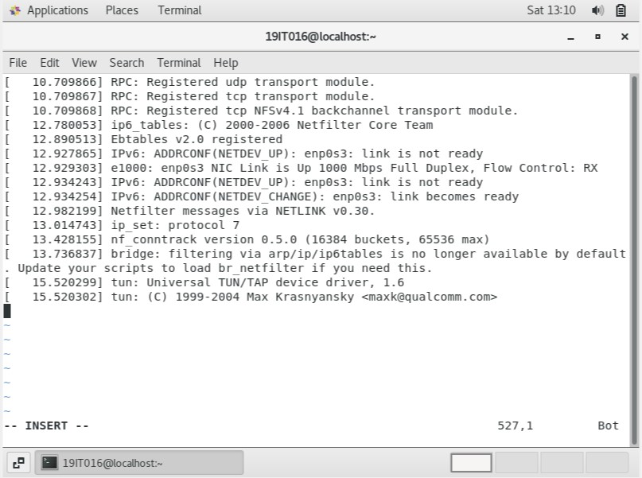

1. **Add text in the end of file dm-file using vi. Text = This is the end of the file. Then save the file**

**OUTPUT:**

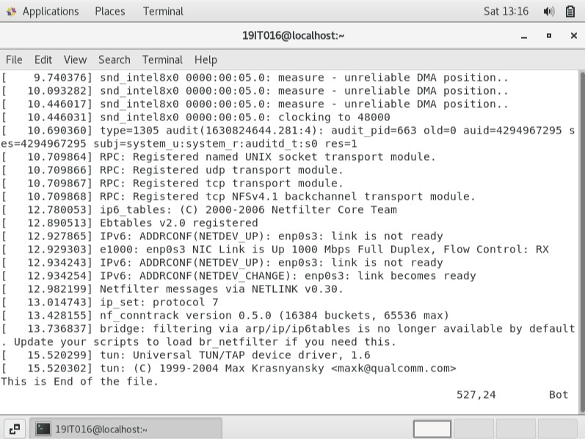

1. **Reboot the system using init command**

**OUTPUT:**

