**PRACTICAL-5**

**Aim: To perform various shell programming tasks.**

1. **Write a script called hello which outputs the following:**
   1. **your username**
   2. **the time and date**
   3. **who is logged on?**
   4. **Also, output a line of asterisks (*********) after each section.**

**CODE:**

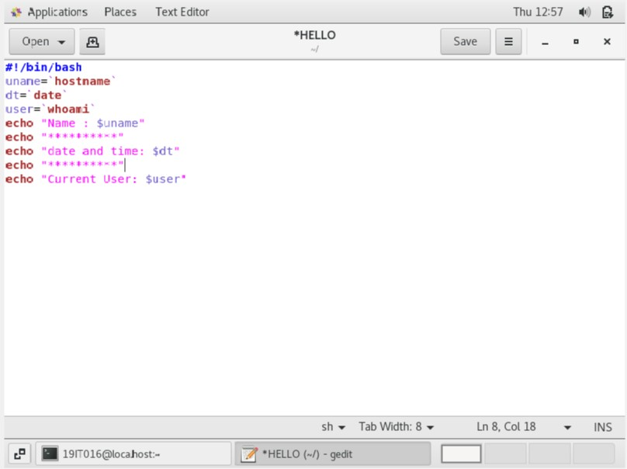

**OUTPUT:**

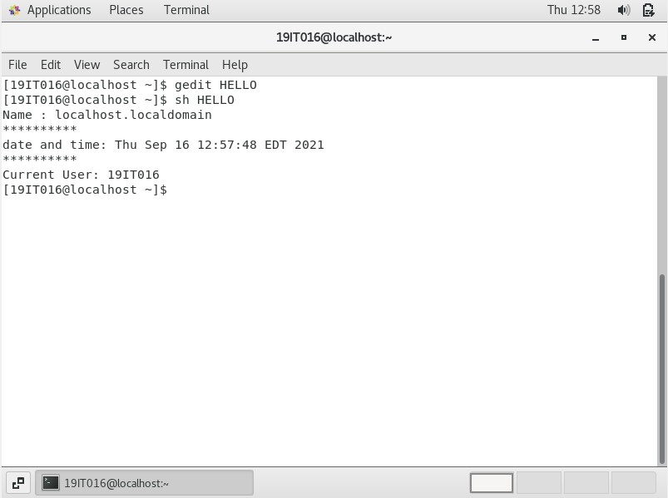

1. **Write a shell program to find the largest integer among the three integers given as arguments.**

**CODE:**

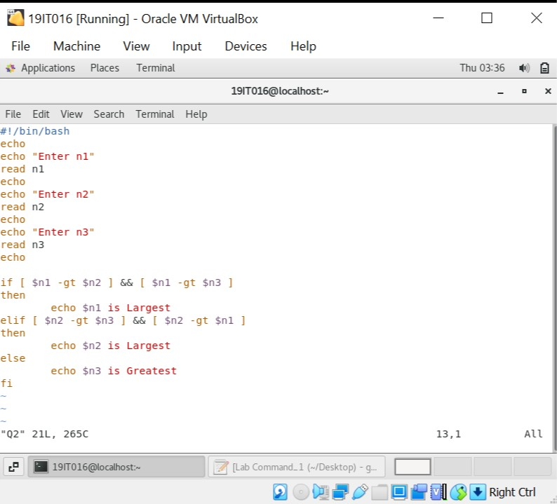

**OUTPUT:**

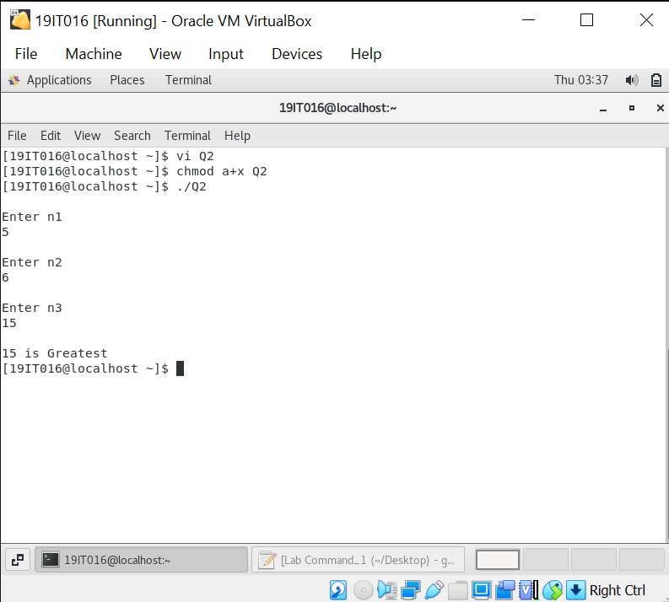

1. **Write a shell script to simulate a simple calculator.**

**CODE:**

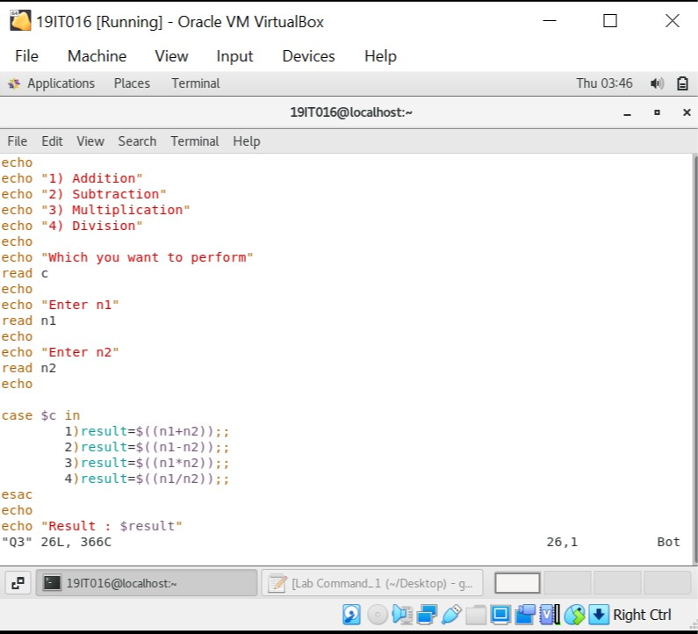

**OUTPUT:**

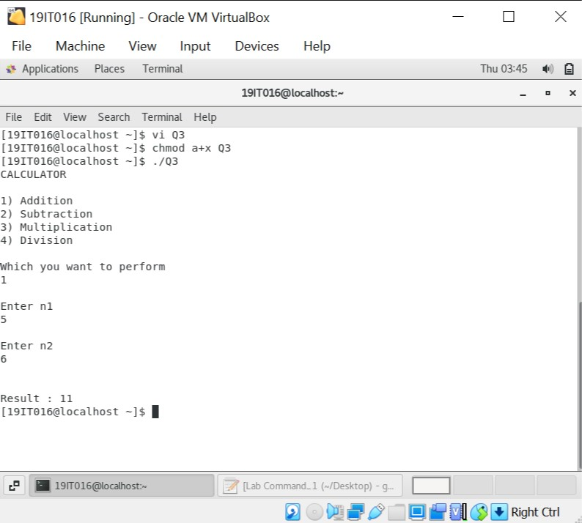

1. **Write a shell script to sort the number in ascending order and also calculate the shell script run time. (Using array).**

**CODE:**

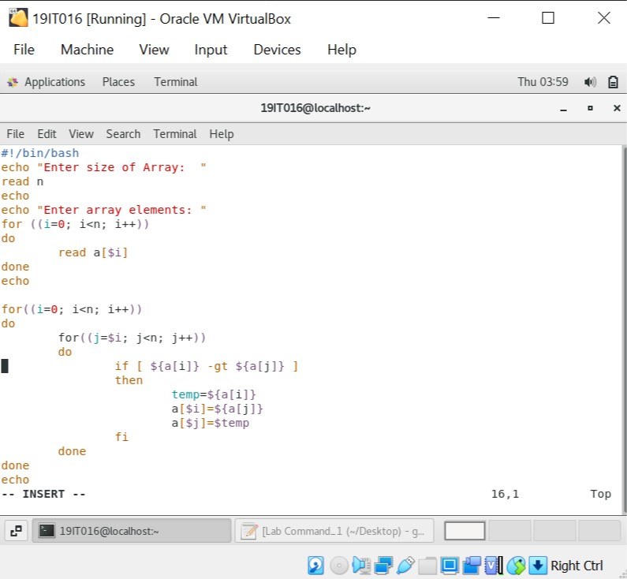

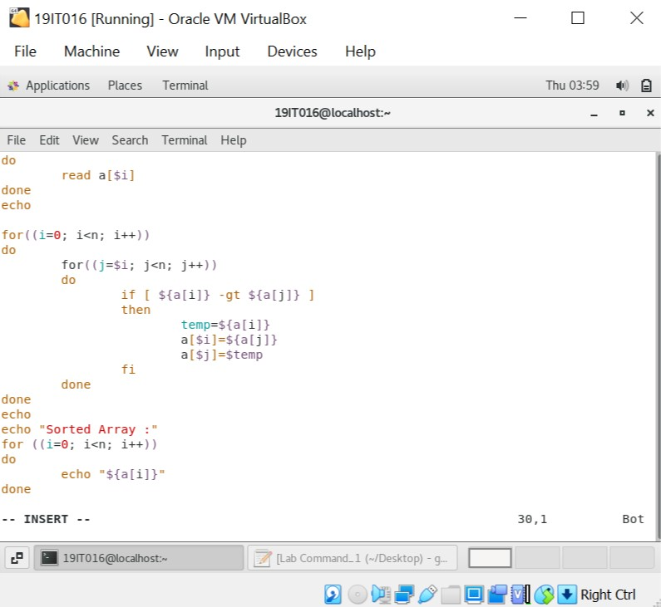

**OUTPUT:**

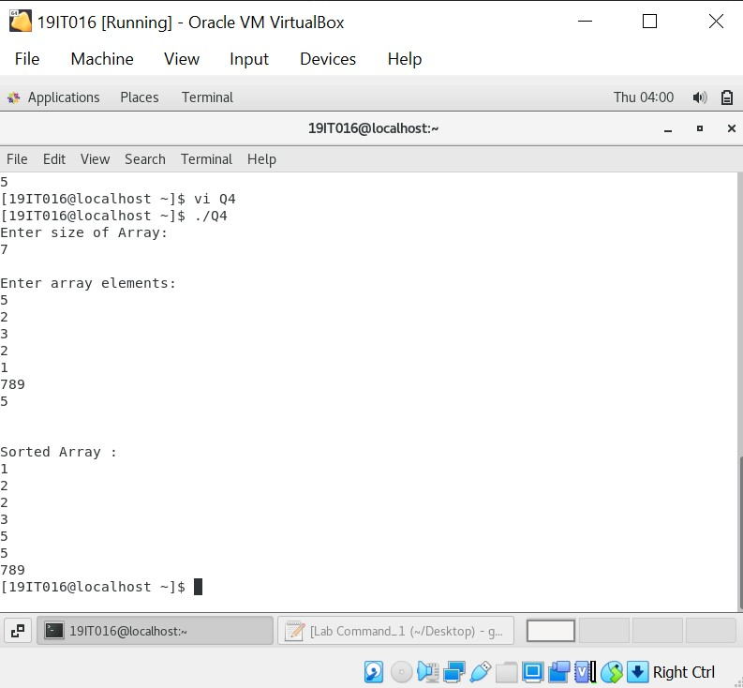

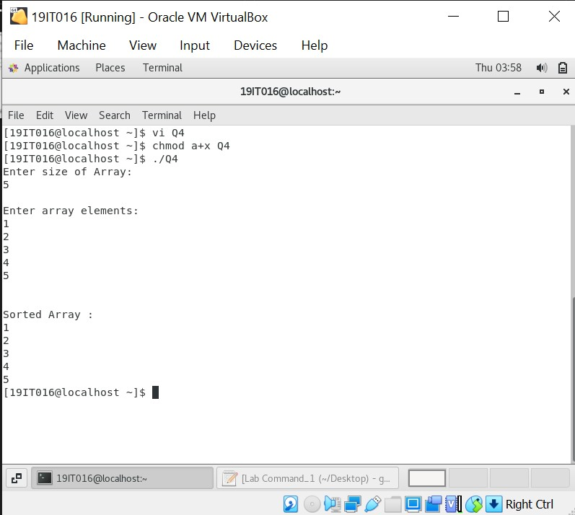

1. **Write a shell program to count the following in a text file:**
   1. **The number of vowels in a given text file.**
   2. **The number of blank spaces.**
   3. **The number of characters.**
   4. **The number of symbols.**
   5. **The number of lines.**

**CODE:**

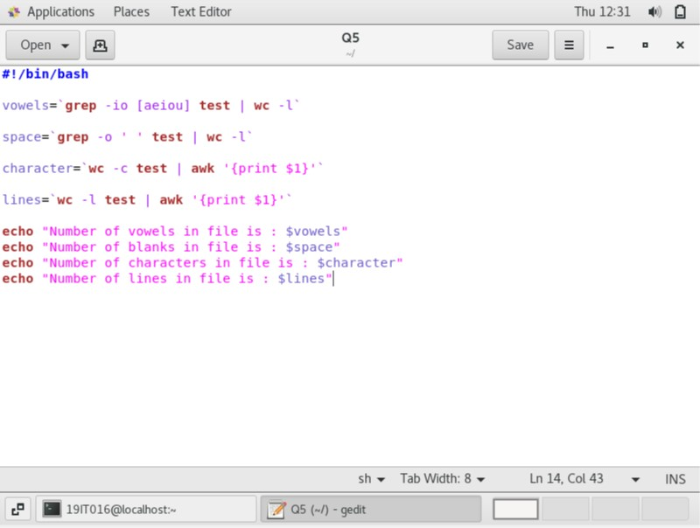

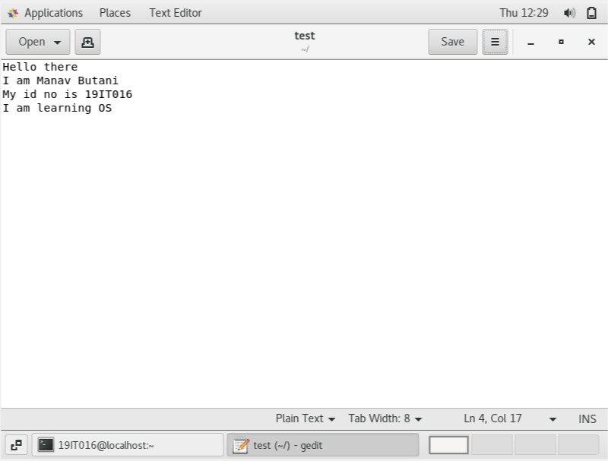

**OUTPUT:**

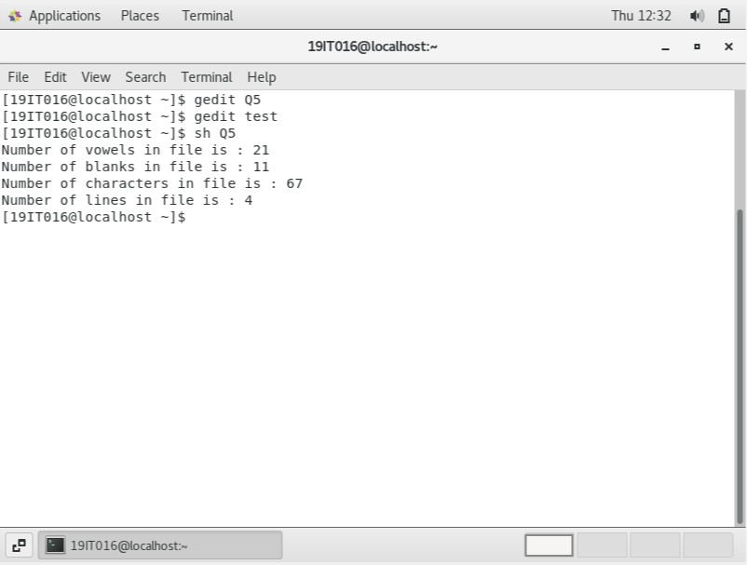

1. **Write a shell script that will take a file name from the user and finds that whether the file is there or not in a current working directory and displays the appropriate message.**

**CODE:**

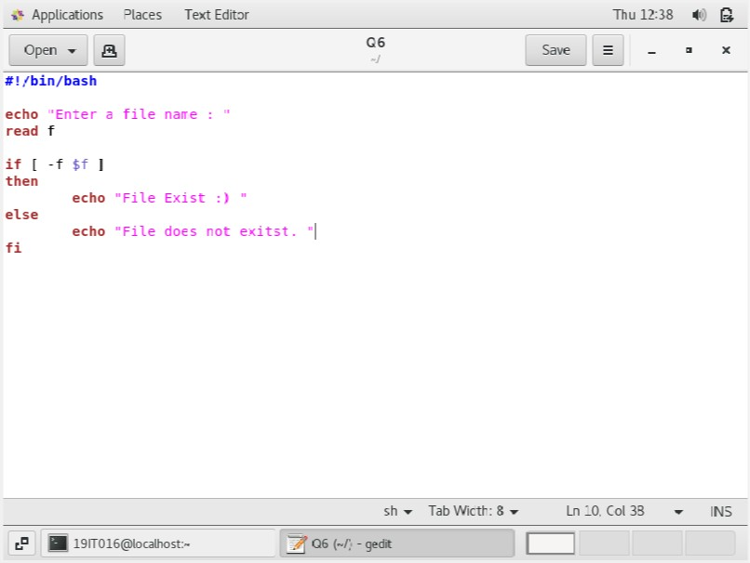

**OUTPUT:**

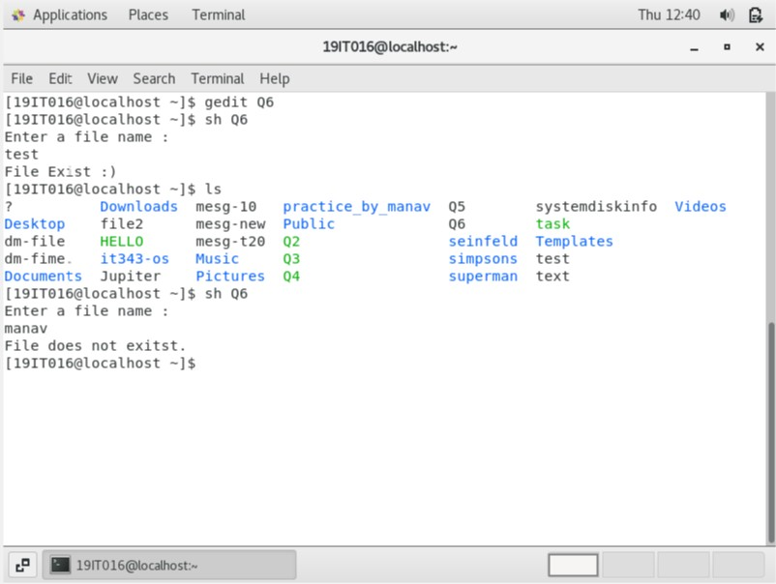

1. **Write a shell script that compares two files given by the user and if both files are the same then delete the second one, if not then merge the two files in a new file.**

**CODE:**

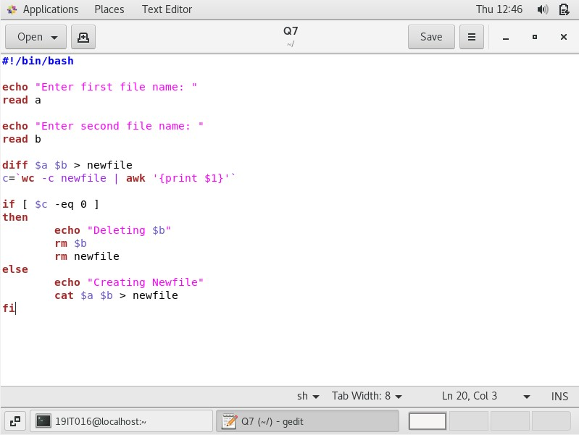

**OUTPUT:**

