Practical 6

1. **Write a shell script, which finds the prime factors of a given number.**

Program:

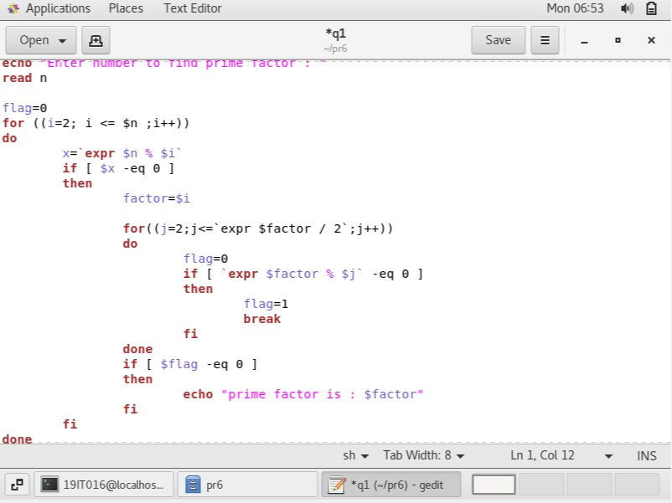

Output:

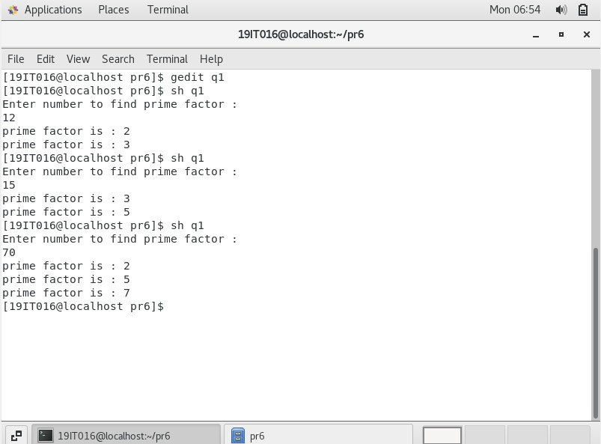

1. **Write a shell script that accepts a positive integer value from the user, say 34, and prints out all the divisors of 34 as a list:Enter a positive integer:34The divisors of 34 are: 1, 2, 17, and 34.**

Program:

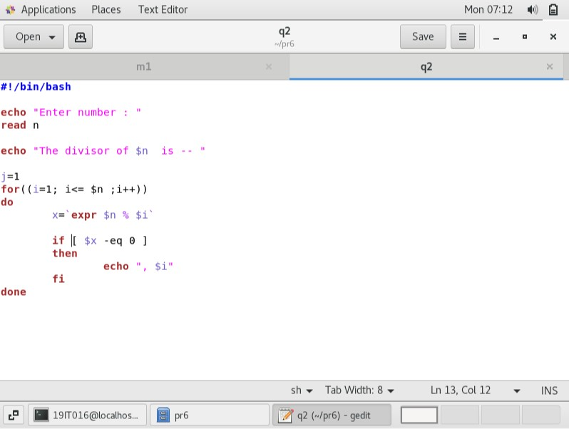

Output:

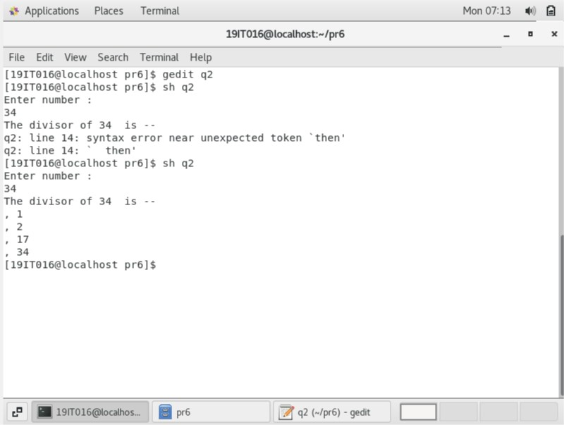

1. **Check whether a given file is readable or not. If it is readable, then display the file contents.**

Program:

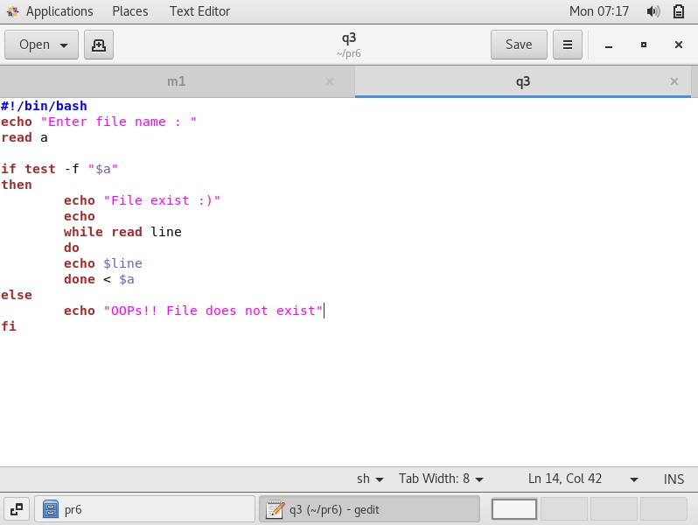

Output:

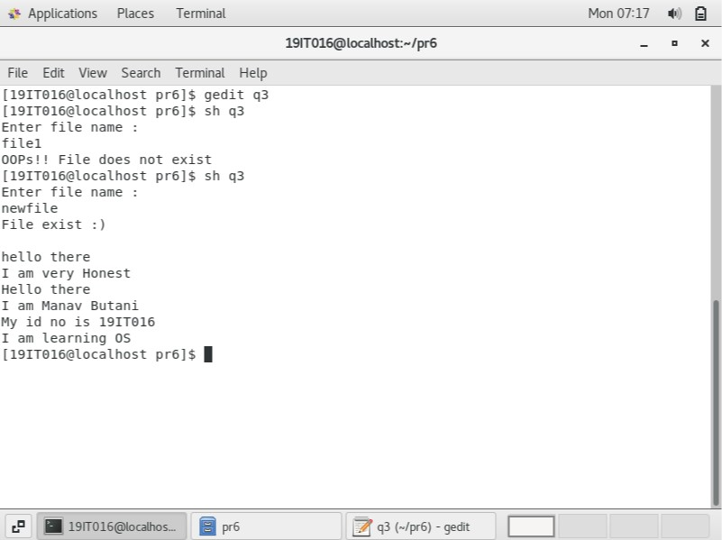

1. **Display a message “Good Morning” or “Good Afternoon” according to the user login time.**

Program:

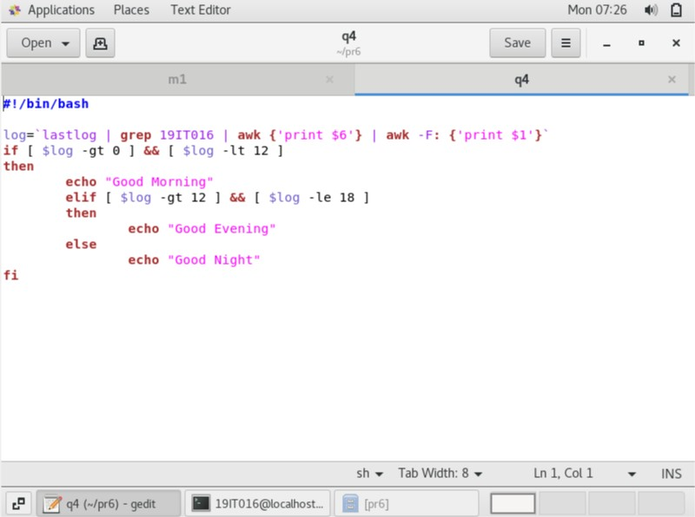

Output:

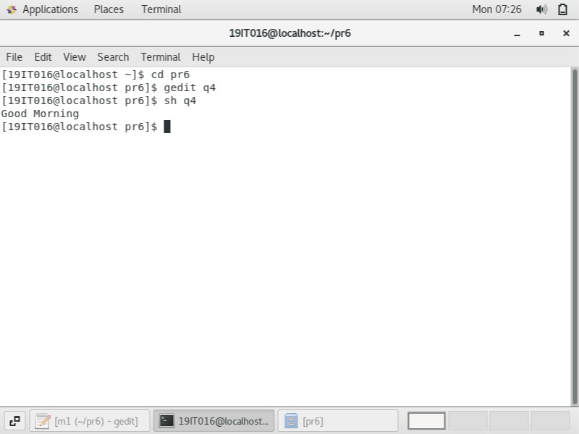

1. **A shell script, which takes as command line input a number n, and a word. It then prints the word n times, once on each line.**

Program:

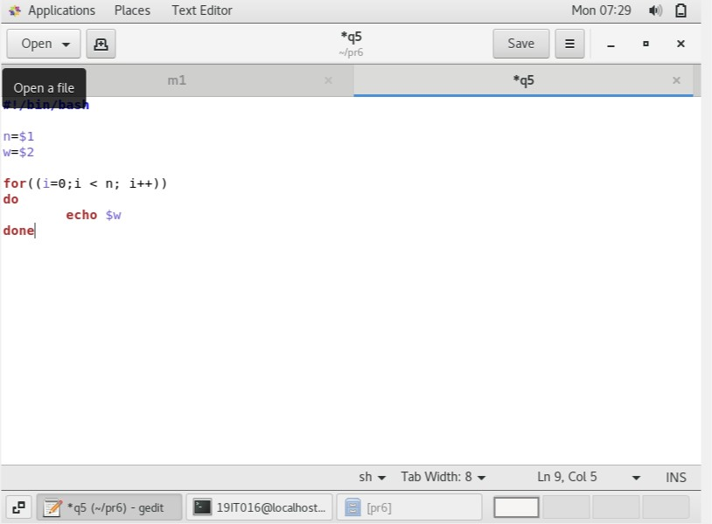

Output:

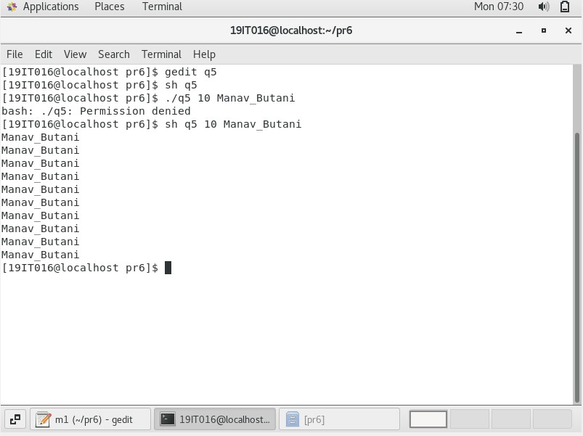

1. **A shell script, which reports the names and sizes of all the files in a directory whose size exceeds 100 bytes, in descending order of their sizes and the total number of such files.**

Program:

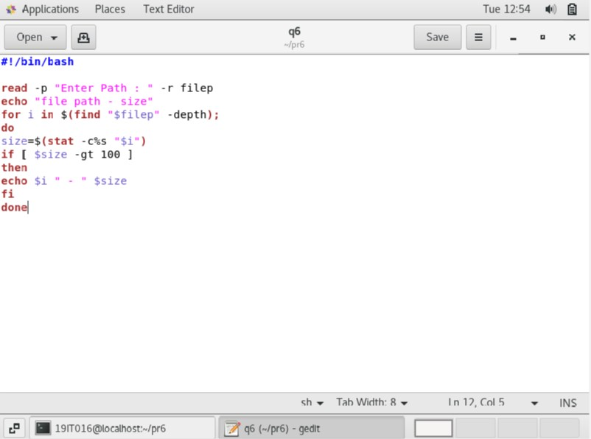

Output:

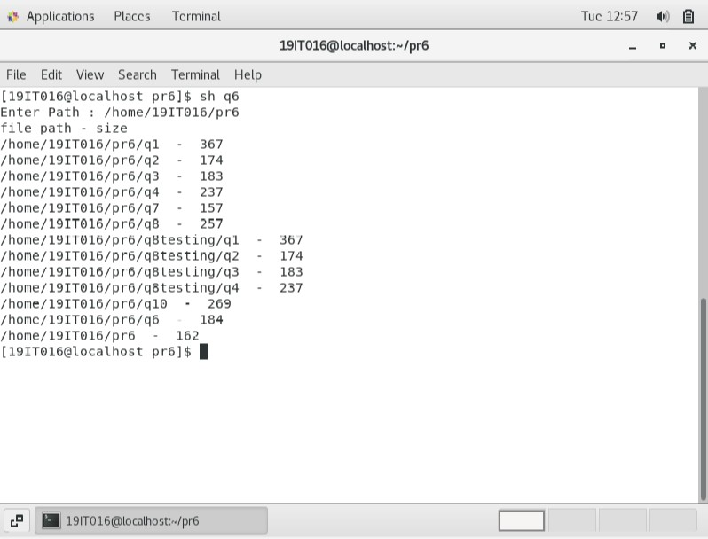

1. **Write a script that will search for a specific word in all the files in the current directory and then prompt with the file name in which word is found.**

Program:

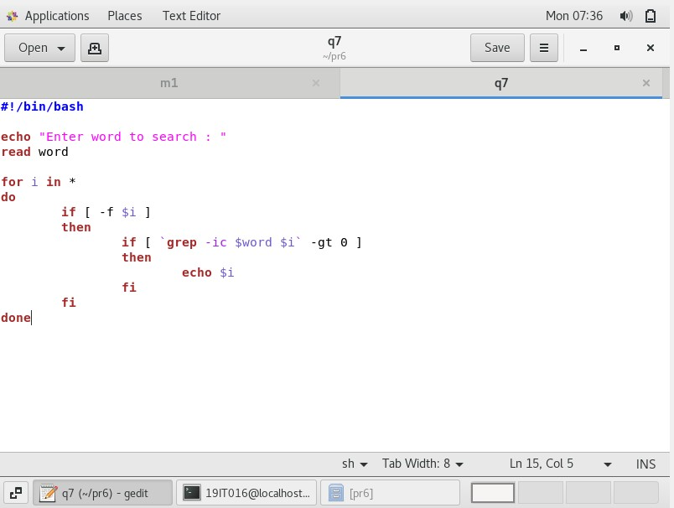

Output:

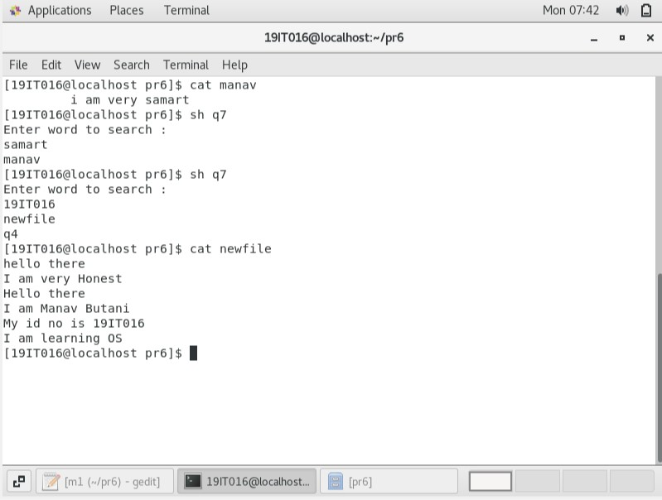

1. **Write a script to print only the number of executable files in each sub- dir of the argument directory specified.**

Program:

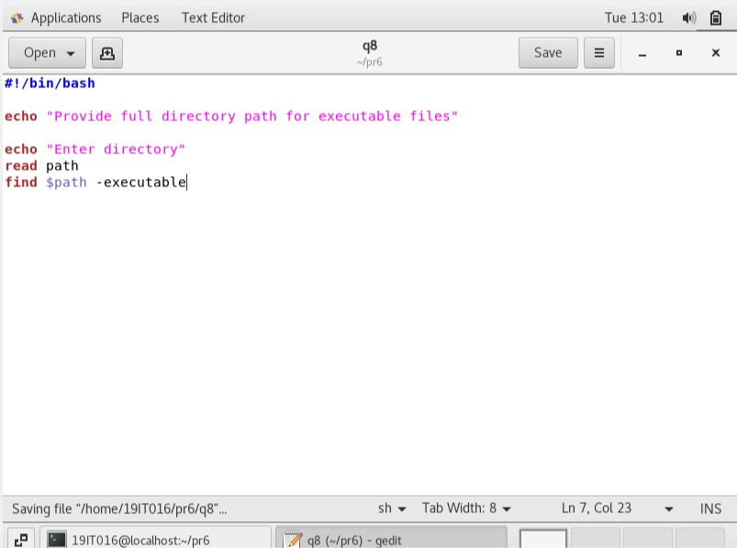

Output:

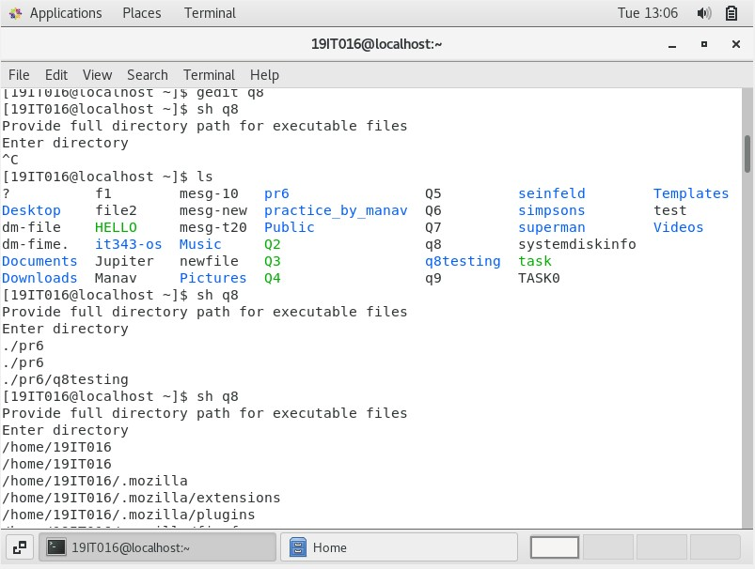

1. **Write a shell script file named exercise6.sh that makes a list of files in your home directory that were changed less than 24 hours ago, but leave out directories.**

Program:

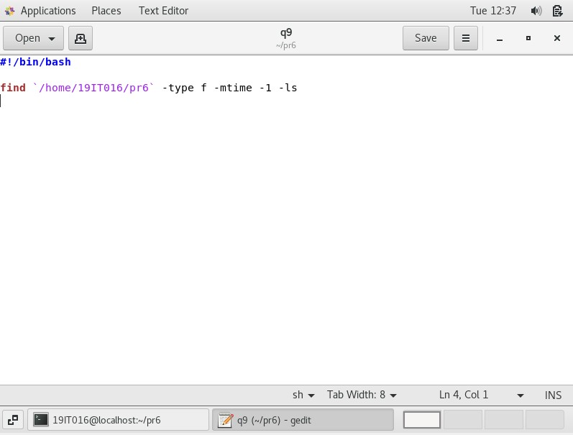

Output:

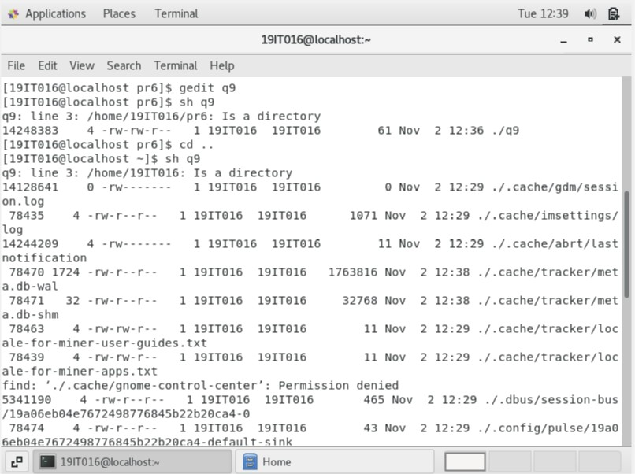

1. **Write a shell script which will take file name as argument and check whether the file name is a dir or not and then proceed further only if it is a dir, else give usage message. The script should then print in the tabular format, name of each sub-dir (within the argument dir) and a count of the number of top-level files in that sub-dir.**

Program:

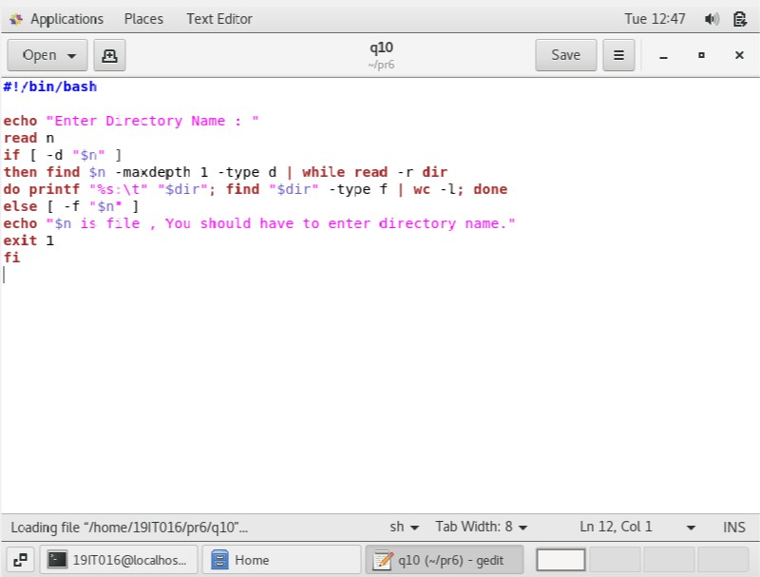

Output:

