SYMBIOSIS INSTITUTE OF TECHNOLOGY, PUNE
Department of Artificial Intelligence and Machine Learning
Assignment Practical No. 6
Adventure Works Sales & Profitability Dashboard


Name | Manavjeet Singh
PRN | 24070126106
Assignment | Assignment Practical No. 6
Course | Data Visualization Lab (TE7663)
Semester / Year | Sem V, Academic Year 2026-2027
PUBLISH LINK

1. Objective
The aim of this practical is to design analytical KPIs and custom DAX calculations in Power BI Desktop, validate them with DAX Studio, and present the results in an interactive dashboard. The question I set out to answer: which products, categories and regions drive Adventure Works’ sales and profit between January 2020 and June 2022, and how is performance changing over time?
The work covers the six required tasks:
- Create the 10 required KPI measures.
- Create at least 20 custom DAX measures (25 in total).
- Perform time-based analysis: monthly sales, previous-period sales, sales variance and growth percentage.
- Run and validate DAX queries in DAX Studio and capture screenshots.
- Build an interactive dashboard with KPI cards, at least four visuals, and slicers for year, category and region.
- Analyze the results and state the key insights and conclusion.

2. Dataset and Data Preparation
I used the Adventure Works dataset and loaded only the tables needed for the analysis. The data runs from 1 January 2020 to 30 June 2022, so 2022 covers half a year only.
Table | Rows | What it holds
Sales (2020–2022 combined) | 56,046 | Every order line: date, order number, product, customer, territory, quantity
Products | 293 | Product names, costs and prices
Subcategories | 37 | Connects products to categories
Categories | 4 | Bikes, Components, Clothing, Accessories
Territories | 10 | Region, country and continent
Customers | 18,148 | Customer details (after cleaning)
Dates | 912 | Calendar from 1 Jan 2020 to 30 Jun 2022

Cleaning. The three yearly sales files were combined into a single Sales table with the Folder connector. In the Customers file I removed six non-customer rows (three rows with a key like “30---”, one blank row and two export-note lines) and set CustomerKey to Whole Number. This fixed the duplicate-Null error and let the Sales–Customers relationship work.
Calculated columns. The sales files hold quantities only, so I derived sales and cost from each product’s price and cost:
Sales Amount = Sales[OrderQuantity] * RELATED(Products[ProductPrice])
Cost Amount = Sales[OrderQuantity] * RELATED(Products[ProductCost])

Model. All relationships are many-to-one with a single filter direction: Sales to Products, Customers, Territories and Dates, and Products to Subcategories to Categories. The Dates table has Year, Month Number, Month Name and YearMonth columns and is marked as the date table so time-intelligence functions work correctly.

3. DAX Measures and KPI Calculations
I created 25 measures in a dedicated Measures table: the 10 required KPIs, 11 additional measures that use CALCULATE, FILTER and RANKX, and 4 time-based measures.
Measure | DAX | What it gives
A. Required KPI measures (10)
Total Sales | SUM(Sales[Sales Amount]) | Total sales amount
Total Cost | SUM(Sales[Cost Amount]) | Total product cost
Total Profit | [Total Sales] - [Total Cost] | Sales minus cost
Total Quantity | SUM(Sales[OrderQuantity]) | Units sold
Total Orders | DISTINCTCOUNT(Sales[OrderNumber]) | Number of orders
Total Customers | DISTINCTCOUNT(Sales[CustomerKey]) | Unique customers
Average Sales | AVERAGE(Sales[Sales Amount]) | Average per order line
Average Order Value | DIVIDE([Total Sales], [Total Orders]) | Sales per order
Average Product Price | AVERAGE(Products[ProductPrice]) | Average list price
Profit Margin % | DIVIDE([Total Profit], [Total Sales]) * 100 | Profit as % of sales
B. Additional measures (11)
Order Line Items | COUNT(Sales[OrderLineItem]) | Number of order lines
Sales per Customer | DIVIDE([Total Sales], [Total Customers]) | Revenue per customer
Profit per Order | DIVIDE([Total Profit], [Total Orders]) | Profit per order
Avg Quantity per Order | DIVIDE([Total Quantity], [Total Orders]) | Units per order
Unique Products Sold | DISTINCTCOUNT(Sales[ProductKey]) | How many products sold
Bikes Sales | CALCULATE([Total Sales], Categories[CategoryName] = "Bikes") | Sales from Bikes only
High Value Sales | CALCULATE([Total Sales], FILTER(Sales, Sales[Sales Amount] > 1000)) | Sales from lines over 1,000
Sales % of Total | DIVIDE([Total Sales], CALCULATE([Total Sales], ALLSELECTED())) * 100 | Share of selected total
Product Rank | RANKX(ALL(Products[ProductName]), [Total Sales], , DESC, DENSE) | Product ranking
Region Rank | RANKX(ALL(Territories[Region]), [Total Sales], , DESC, DENSE) | Region ranking
Category Rank | RANKX(ALL(Categories[CategoryName]), [Total Sales], , DESC, DENSE) | Category ranking
C. Time-based measures (4)
Monthly Sales | CALCULATE([Total Sales], DATESMTD(Dates[Date])) | Sales for the month
Previous Month Sales | CALCULATE([Total Sales], DATEADD(Dates[Date], -1, MONTH)) | Last month’s sales
Sales Variance | [Total Sales] - [Previous Month Sales] | Change from last month
Sales Growth % | DIVIDE([Sales Variance], [Previous Month Sales]) * 100 | Month-on-month growth

Example screenshots of DAX measure creation
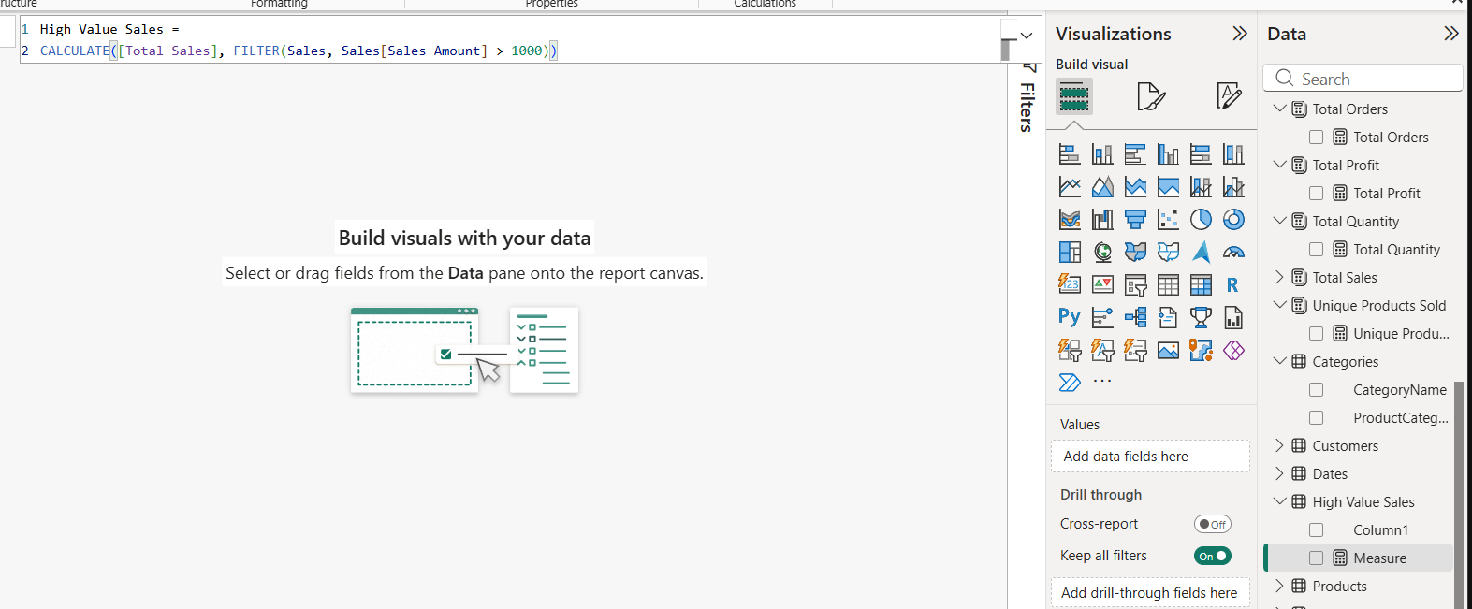

4. Validation in DAX Studio
The External Tools tab did not appear in my Power BI ribbon, so I opened DAX Studio on its own, chose PBI / SSDT Model and connected to my open file. I could then run queries against the model straight away.
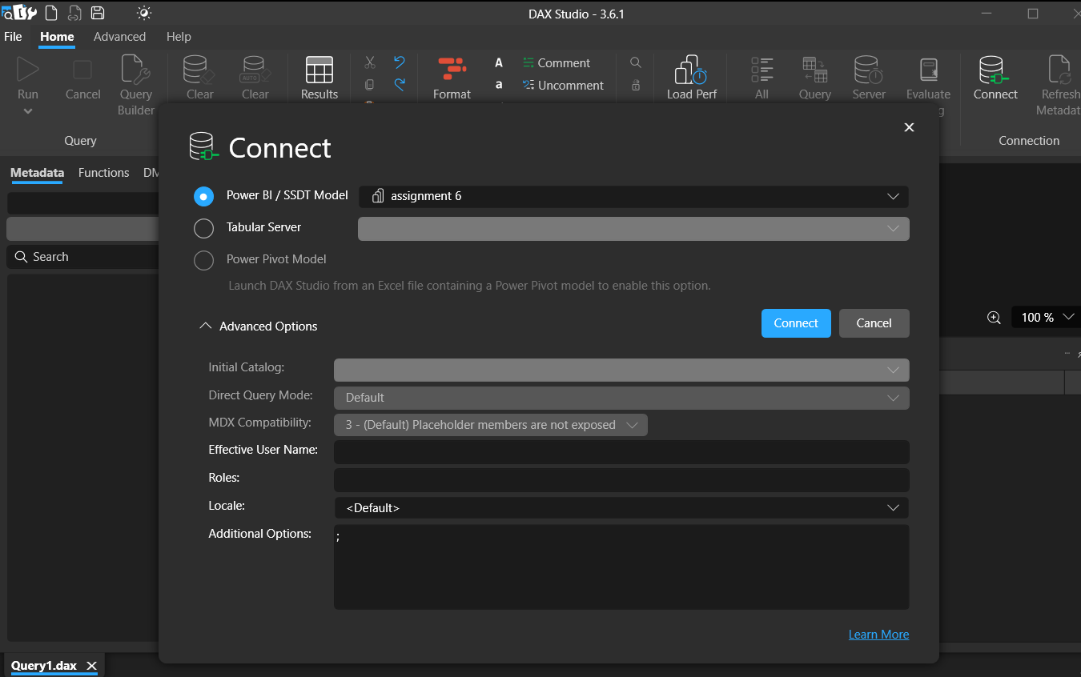

Query 1: KPI sanity check
This query pulls every required KPI into a single row so it can be compared with the dashboard cards.
EVALUATE
ROW(
"Total Sales", [Total Sales],
"Total Cost", [Total Cost],
"Total Profit", [Total Profit],
"Total Quantity", [Total Quantity],
"Total Orders", [Total Orders],
"Total Customers", [Total Customers],
"Average Sales", [Average Sales],
"AOV", [Average Order Value],
"Avg Product Price", [Average Product Price],
"Profit Margin %", [Profit Margin %]
)
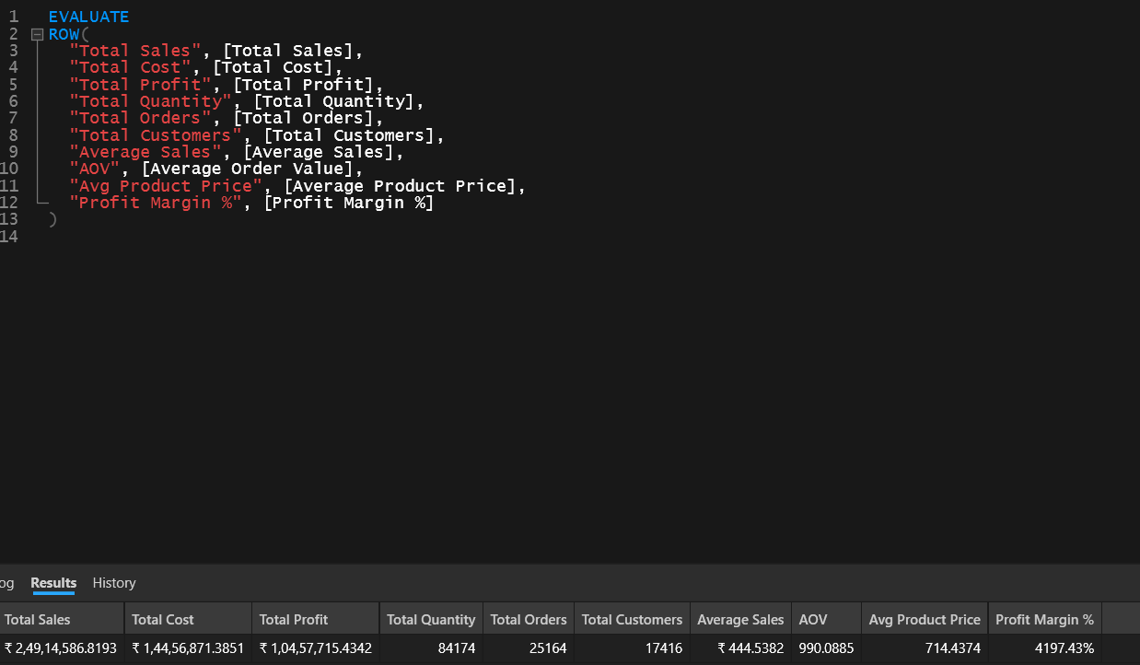
I also calculated the same totals directly from the raw CSV files, outside Power BI. Everything agreed:
Measure | Value | Matches the raw data?
Total Sales | 24,914,586.82 | Yes
Total Cost | 14,456,871.39 | Yes
Total Profit | 10,457,715.43 | Yes
Total Quantity | 84,174 | Yes
Total Orders | 25,164 | Yes
Total Customers | 17,416 | Yes
Average Sales (per line) | 444.54 | Yes
Average Order Value | 990.09 | Yes
Average Product Price | 714.44 | Yes
Profit Margin % | 41.97 | Yes

Query 2: top 10 products
EVALUATE
TOPN(10, SUMMARIZECOLUMNS(Products[ProductName], "Sales", [Total Sales], "Profit", [Total Profit]),
[Sales], DESC)
ORDER BY [Sales] DESC
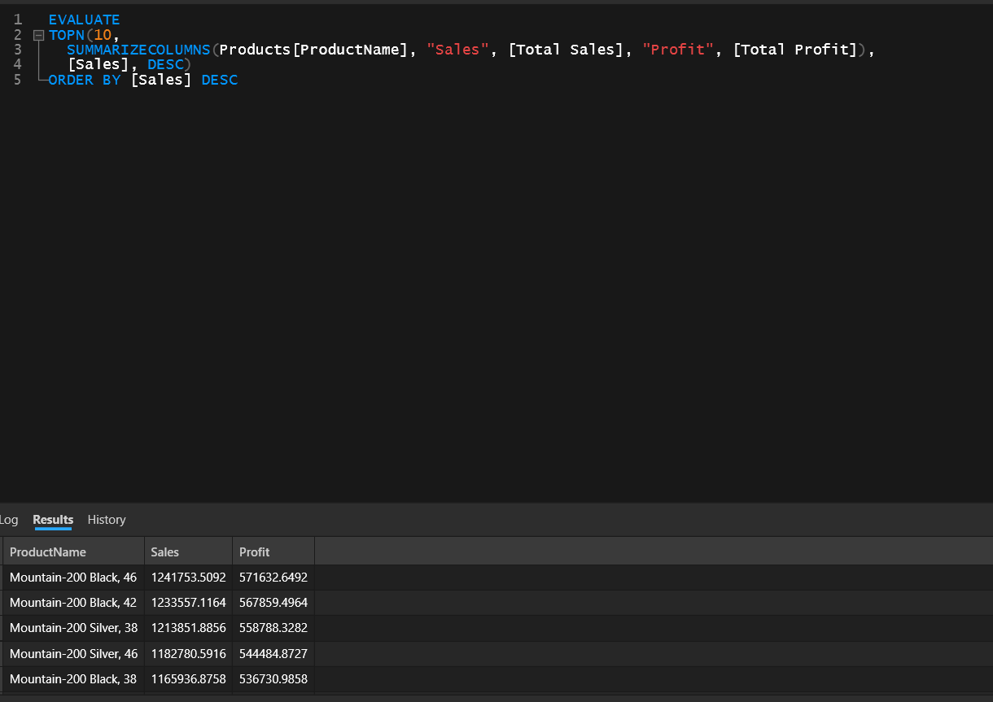

Query 3: sales and margin by category and region
EVALUATE
SUMMARIZECOLUMNS(Categories[CategoryName], Territories[Region],
"Sales", [Total Sales], "Margin %", [Profit Margin %])
ORDER BY [Sales] DESC
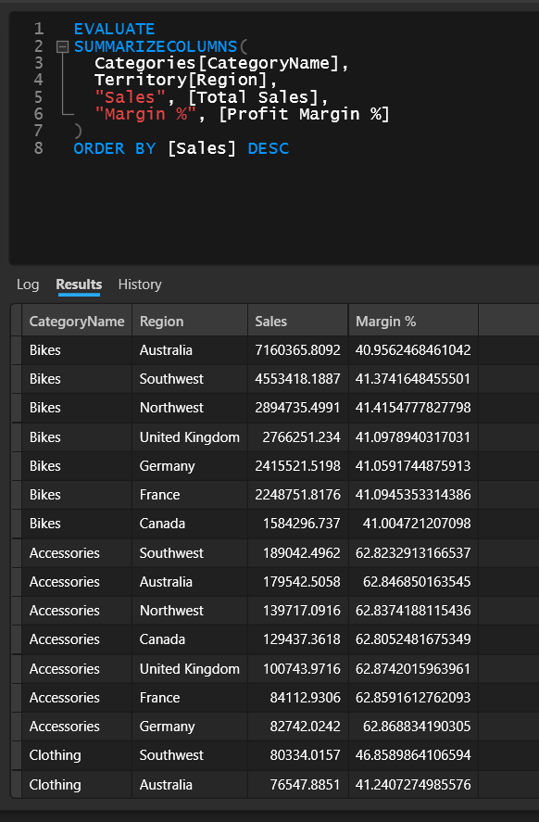

5. Interactive Dashboard
The dashboard has four KPI cards (Total Sales, Total Profit, Total Orders, Total Customers), slicers for Year, Region and CategoryName, four visuals and a key-insights panel. Selecting a slicer value updates every card and chart on the page.
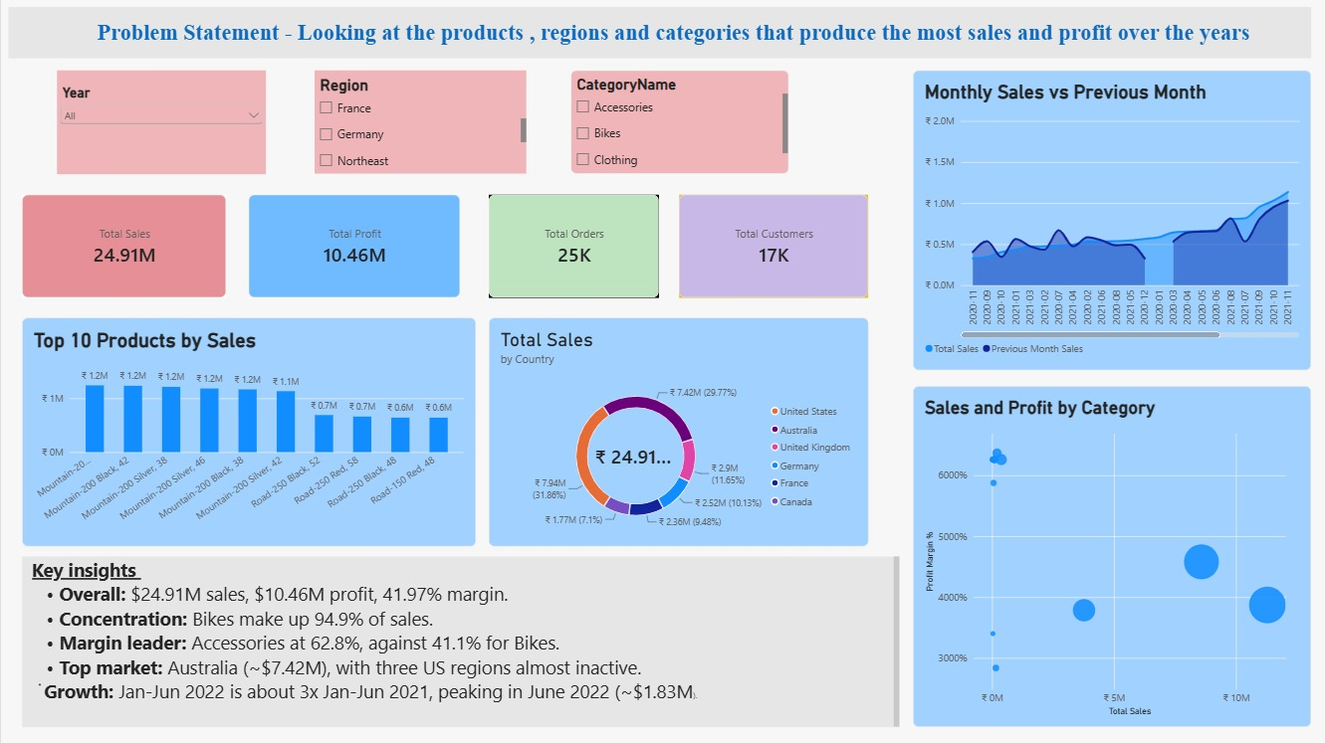
Visual | Fields | Why I added it
Area / line chart | X: Year-Month; Y: Total Sales, Previous Month Sales | To see the monthly trend against the previous month
Column chart | X: ProductName (Top 10); Y: Total Sales | To spot the best sellers
Donut chart | Legend: Country; Values: Total Sales | To see which countries contribute most to sales
Scatter chart | X: Total Sales; Y: Profit Margin % | To compare sales volume with profitability by category

6. Analytical Findings
- The big picture: about $24.91M in sales and $10.46M in profit, a 41.97% margin, from 25,164 orders placed by 17,416 customers. The average order is worth roughly $990.
- Top-selling products: the top of the list is all Mountain-200 bikes. Mountain-200 Black 46 leads with about $1.24M, followed by Black 42 (about $1.23M) and Silver 38 (about $1.21M).
- Categories: Bikes bring in about $23.64M, which is 94.9% of all sales. Accessories add roughly $0.91M and Clothing $0.37M. Components has no sales in this data.
- Profitability: Bikes sell the most but have the lowest margin (41.1%). Accessories earn the most per dollar sold (62.8%), and Clothing sits in the middle (44.3%). High revenue does not automatically mean the best margin.
Category | Sales ($) | Profit margin | Share of sales
Bikes | 23.64M | 41.1% | 94.9%
Accessories | 0.91M | 62.8% | 3.6%
Clothing | 0.37M | 44.3% | 1.5%
Components | No sales | - | -

- Regions: Australia leads with about $7.42M, close to 30% of all sales. Southwest (about $4.82M), Northwest (about $3.10M) and the United Kingdom (about $2.90M) follow. Three US regions, Central, Northeast and Southeast, barely register, with under $12K each.
- Sales trend: sales grew from $6.40M in 2020 to $9.32M in 2021. The 2022 data covers January to June only, and it had already reached $9.19M, about three times the same six months of 2021. The monthly line keeps climbing, and June 2022 was the best month so far at about $1.83M, up around 3.3% on May.

7. Conclusion
Adventure Works’ sales and profit come overwhelmingly from Bikes, led by the Mountain-200 range, and from a handful of markets, with Australia first. Accessories are the most profitable category per dollar (62.8% margin) but contribute only 3.6% of sales, so growing them is the clearest way to lift overall margin. Sales are rising steadily month on month, with the first half of 2022 already close to the full-year 2021 total. Three US regions are almost inactive, which points to untapped potential, and Components shows no sales at all, which is worth checking in the source data.
The 25 DAX measures match the raw data, and the dashboard lets these patterns be explored by year, region and category.

