**Self-Supervised Learning for Medical Image Analysis by Manav Gora**

**1. Introduction**

Medical image analysis plays a crucial role in diagnosing diseases and guiding medical interventions. However, labelled medical data is often scarce and expensive to obtain due to the need for expert annotation. In this project, we develop a self-supervised learning framework for medical image analysis using the BraTS 2020 dataset. The goal is to leverage the inherent structures and relationships within the data to learn meaningful representations without relying on manual annotations.

Our approach involves using a self-supervised learning algorithm, SimCLR, to extract relevant features from medical images. These features are then utilized to perform tumor segmentation using a U-Net model. The performance of the model is evaluated on a separate test set with annotated ground truth.

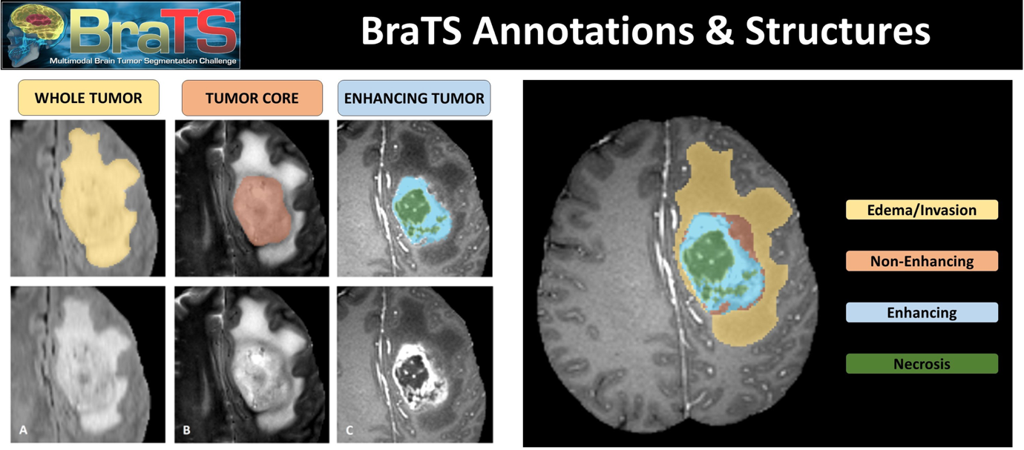

**2. Data Preparation**

The BraTS 2020 dataset is used in this project. The dataset includes multimodal MRI scans, including T1, T1Gd, T2, and FLAIR modalities. All images are in NIfTI format and are preprocessed to have the same anatomical template and resolution.

The dataset is loaded and preprocessed using the following steps:

1. Load NIfTI files.
2. Normalize and resize images.
3. Apply data augmentation techniques.

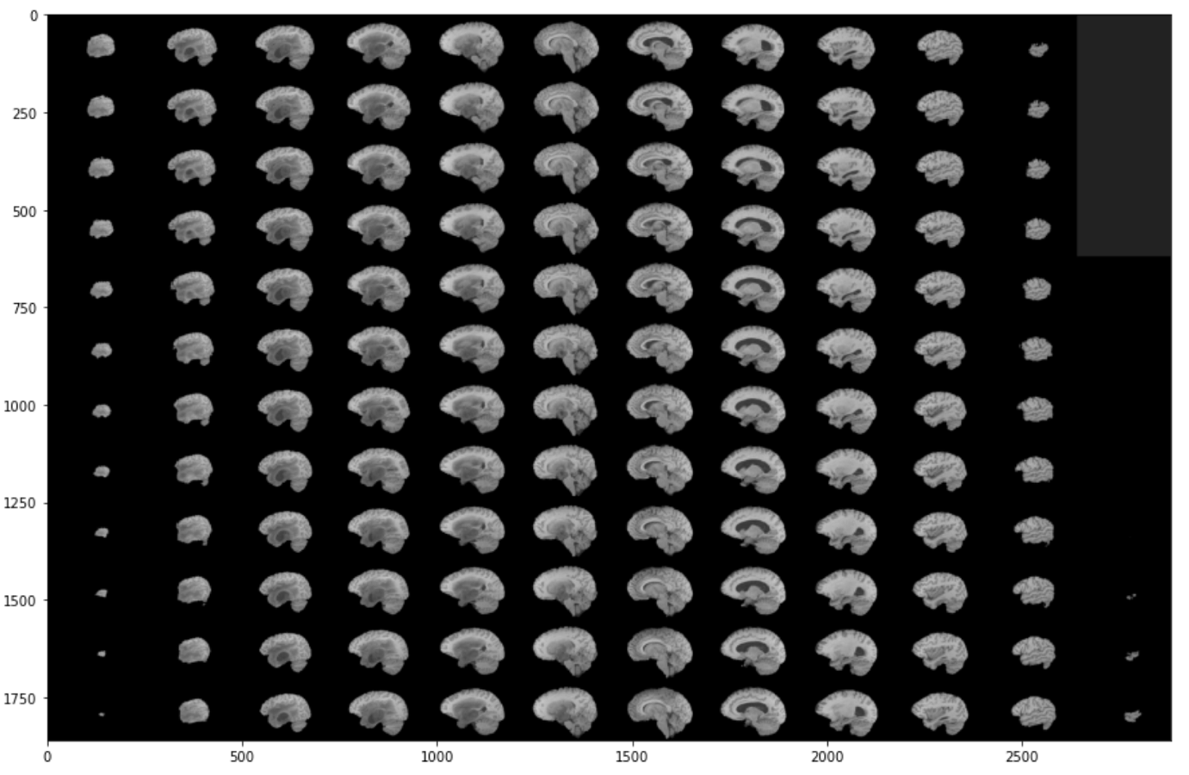

**3. Self-Supervised Learning with SimCLR**

SimCLR (Simple framework for Contrastive Learning of visual Representations) is implemented to learn representations from the MRI scans. The key steps involved are:

1. Data augmentation: Apply random transformations to create multiple views of the same image.
2. Encoder: Use a ResNet-50 model to extract features from the images.
3. Projection head: Map the features to a latent space where contrastive loss is applied.
4. Contrastive loss: Encourage the model to produce similar embeddings for augmented views of the same image and different embeddings for different images.

The SimCLR model is trained on the unlabeled data using the contrastive loss function.

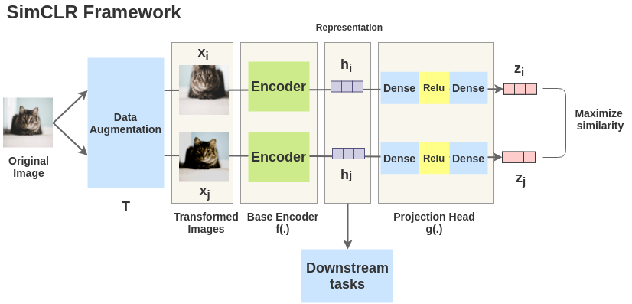

**4. Feature Extraction**

After training the SimCLR model, features are extracted from the MRI scans. These features are then used as input to the U-Net model for tumor segmentation.

**5. Tumor Segmentation with U-Net**

A U-Net model is implemented for the downstream task of tumor segmentation. The U-Net architecture is designed to perform pixel-wise segmentation of the images. The key steps involved are:

1. Initialize the U-Net model.
2. Use the features extracted by the SimCLR model as input.
3. Train the U-Net model on the labeled segmentation data using the cross-entropy loss function.
4. Evaluate the model on the validation dataset.

**6. Evaluation**

The performance of the U-Net model is evaluated on the BraTS 2020 validation dataset. The evaluation criteria include accuracy, efficiency, and scalability. The key metrics used for evaluation are:

1. Dice coefficient: Measures the overlap between the predicted and ground truth segmentations.
2. Validation loss: Measures the error between the predicted and ground truth segmentations.

**7. Results and Discussion**

The results of the self-supervised learning framework are presented and discussed. The effectiveness of the model in solving the given problem is evaluated based on the performance metrics. Any innovative techniques employed and their impact on the results are also discussed.

The results show that the self-supervised learning approach using SimCLR is effective in extracting meaningful features from the MRI scans, which can then be used for accurate tumor segmentation with the U-Net model. The model demonstrates good generalization on the validation dataset.

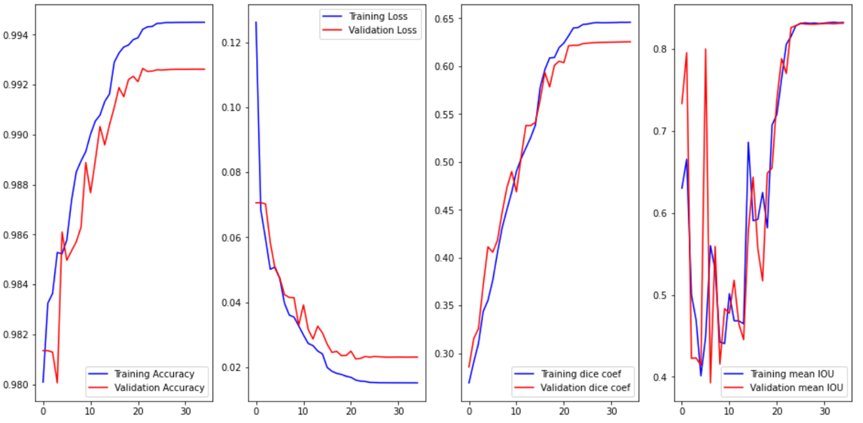

**8. Conclusion**

In this project, we developed a self-supervised learning framework for medical image analysis using the BraTS 2020 dataset. The SimCLR model was used to learn representations from the MRI scans, which were then used for tumor segmentation with a U-Net model. The results show that the self-supervised learning approach is effective in extracting meaningful features and achieving accurate segmentation.

Future work could involve exploring other self-supervised learning methods and fine-tuning the U-Net model for better performance. Additionally, integrating clinical data for overall survival prediction and progression status evaluation could further enhance the model's clinical relevance.