**Evaluation of Machine Learning techniques for PCOS prediction**

Manvendra Gosain, Bhooshan Jayendra Birje

Department of MCA, School of Information Technology and Engineering

Vellore Institute of Technology, Vellore – 632014, Tamil Nadu, India.

Anbarasa Kumar A.

School of Information Technology and Engineering

Vellore Institute of Technology, Vellore – 632014, Tamil Nadu, India

E-mail: <manvendra.gosain2022@vitstudent.ac.in>, <bhooshan.jayendra2022@vitstudent.ac.in>, anbarasakumar.a@vit.ac.in

**Abstract**

Polycystic Ovary Syndrome (PCOS) is a hormonal imbalance brought on by the ovaries producing too many male hormones, which affects a woman's reproductive system during her childbearing age. PCOS has been identified as of the major factors of infertility in women. It also raises the likelihood of developing other illnesses including diabetes, high blood pressure, sleep difficulties, depression, and anxiety, among others. The goal of this research was to address this issue by implementing machine learning approaches for early PCOS identification based on several medical markers. The model used a dataset of 541 women from 10 hospitals in Kerala. This paper examined trends and correlation within the medical parameters and determined the attributes which are most important in the diagnosis of PCOS. 14 important features were found most relevant to the target using correlation matrix. Further Chi-square test and independent samples t-test were used to verify the association of these features with the target for categorical and numerical features respectively. We experimented with various Classification models and compared them using accuracy and sensitivity. Hyperparameter tuning was performed to model to improve their performances. Out of all models, SVM gave the best results with 91% accuracy and 81% sensitivity. Furthermore, Number of follicles in the ovaries, skin darkening and age came out to be the most influential features for the prediction of PCOS.

**Keywords:** PCOS, dataset, feature selection, machine learning, classification models, hyperparameter tuning, feature importance

**Introduction**

Polycystic Ovary Syndrome (PCOS) is one of the most prevalent endocrine diseases in women of child-bearing age. PCOS causes the ovaries to develop small collection of fluids called follicles which make them unable to release eggs, which in turn make a woman hard to conceive. Along with this, PCOS comes with many symptoms including irregular menstrual cycles, skin infections, weight gains, high blood pressure, diabetes. This further causes women to have anxiety and some fall into depression. Thus, early detection of PCOS is necessary so that further complications can be reduced. 12% to 21% of the women worldwide are affected by PCOS but most of them are undiagnosed due to lack of awareness. Also, diagnosing PCOS is difficult due to vagueness of the symptoms. Sometimes, a PCOS patient may not show any symptoms. Due to this, it is necessary to take advice of different physicians. But here the problem lies in lack of coordination between the doctors, which may take longer to deduce the results. Also, the medical tests needed for diagnosis are expensive and are not available everywhere. This is where Machine Learning comes to the rescue. Machine Learning is playing a key role in the health sector. ML can be used to process huge amount of patient data and produce clinical insights which can help in diagnosis of diseases. Therefore, this project aims to develop a machine learning diagnostic model that can predict the probability of PCOS of a patient, taking into account their medical parameters. It also reduces the possibility of human error and helps in early diagnosis. In addition, it makes diagnosis timely, cost-effective and easily available at home.

**Materials and methods**

**Dataset**

The "Polycystic Ovary Syndrome" dataset, which is accessible on the internet website Kaggle, was gathered from 10 hospitals in the state Kerala, India. It contains information on 541 women, 177 of whom have been diagnosed with PCOS and 364 of whom are healthy. The information is broken down into a variety of hormonal, biochemical, clinical, and physical factors, including weight, blood type, age, blood pressure, height, endometrial thickness, levels of the hormone follicle-stimulating hormone (FSH), and cycle duration, among others. The dataset contains two biochemical parameters, nine metabolic parameters, sixteen physical parameters, three ultrasound imaging parameters, and nine hormonal parameters. This dataset is beneficial for machine learning professionals since it offers a variety of pertinent data on the subject of PCOS.

**Experimental Procedure**

We followed a series of steps for our research work (see Figure 1) starting from data collection to finding the best model for our system to predict likelihood of PCOS.

**Figure 1.** Flow of the research process

1. **Data Wrangling -** 
   1. Dropped a column ‘Unnamed:44’ which had empty cells
   2. Also dropped all the duplicate columns
   3. Removed descriptive columns which that were not needed for processing such as “Serial No.” and “Patient file no.”
   4. Some columns had values encoded as objects. Standardized all of them to numeric values
   5. Filled the cells with null values with the median of the column values
   6. Removed leading and trailing spaces in column names
2. **Variable Description-** This includes:
   1. The name of the variable and a brief description of what it represents
   2. The type of the variable (e.g., categorical, numerical, continuous, ordinal, etc.)
   3. The range of values that the variable can take on (e.g., for numerical variables, the minimum and maximum values; for categorical variables, the possible categories)
3. **Feature Selection**

Correlation Matrix is used for feature selection. After plotting correlation matrix (Figure 2), top 11 features with highest positive correlation and top 3 features with highest negative correlation are considered for further processing

Correlation matrix shows features (Table 1) that have correlation with the Target value.

|  |  |
| --- | --- |
| 1. Follicle No. (R) | 1. Follicle No. (L) |
| 1. Skin darkening (Y/N) | 1. hair growth(Y/N) |
| 1. Weight gain(Y/N) | 1. Cycle(R/I) |
| 1. Fast food (Y/N) | 1. Pimples(Y/N) |
| 1. AMH (ng/mL) | 1. Weight (Kg) |
| 1. BMI | 1. Cycle length(days) |
| 1. Age (years) | 1. Marriage Status (years) |

**Table 1.** List of Features selected for processing

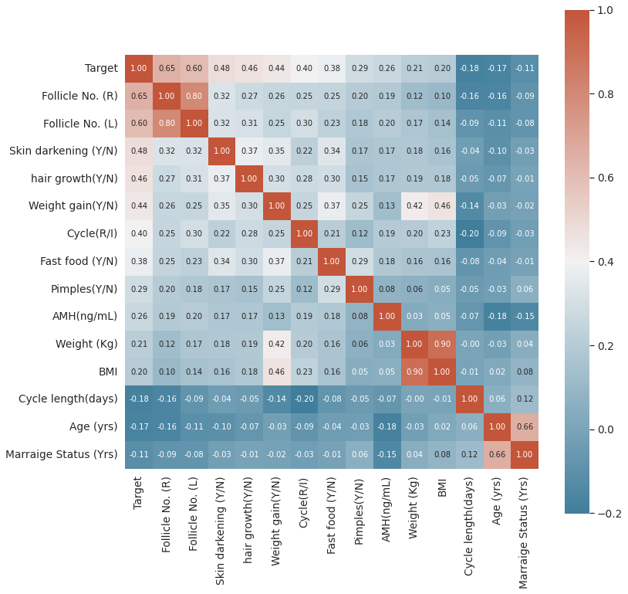

**Figure 2.** Correlation Matrix

Further, *Chi Square Test of Independence* *of attributes* was used to test if the categorical features considered have association with the target or not.

**Null Hypothesis**: Variables are independent of each other.

**Alternative Hypothesis**: Variables are not independent of each other.

All P values come out to be less than 0.05. Therefore, we reject the Null Hypothesis.

This confirms association of Target Variables with Selected Categorical Variables.

Similarly, *Independent Samples t-test* was employed to test the influence of numerical variables namely on the target. Here, numerical variables were divided into 2 groups, variables with positive patients and variables with negative patients. Then, t-test was used to check if mean of both the groups are equal or not. If both the means(averages) are equal that means numerical variables do not affect the target variables.

P values come out to be less than 0.05. Therefore, we reject the Null Hypothesis. **Null Hypothesis**: Means of both groups are not significantly different

**Alternative Hypothesis**: Means of both groups are significantly different.

All P values come out to be less than 0.05. Therefore, we reject the Null Hypothesis.

This confirms effect of numerical variables on Target Variable.

1. **Exploratory Data Analysis-** Here, we explored all the features selected using various graphical components. Association of variables with the target and also with each other.

**Inferences:**

* + 1. Menstrual Cycle length seemed to be shorter and also the length increased as the patient age was greater. While the negative target patients had same cycle length throughout the age groups.
    2. BMI of the positive patients increased drastically as the age increased while the negative patients had stable BMI.
    3. Also, patients with PCOS had higher irregularity in the menstruation as compared to negative patients.
    4. Number of follicles in both left and right ovaries of the PCOS patients were significantly higher than that of negative ones.
    5. Surprisingly, a greater number of younger patients had PCOS than the elder ones. But this could be because of the unawareness and readiness to treat the disorder.
    6. Weight of patients with PCOS was significantly higher than that of the non-PCOS patients.
    7. PCOS patients had slightly lower Hb levels.

1. **Data Modelling-** 
   1. **Splitting Data-** Data was split into 2 groups for training and testing the models. 70% of the data was considered for training while remaining 30% for testing. Assigning 14 independent variables to X and target variable to Y.

*Training – 378 samples*

*Testing – 163 samples*

* 1. **Data Standardization-** Standardization is a way to transform data so that it has a mean of 0 and a standard deviation of 1. This can be useful for some machine learning algorithms that assume that the input variables are centered around 0 and have a standard deviation of 1. Standardization is done using Standard Scaler function.

1. **Model Building-** 
   1. **List of Models employed in this system**:
2. XGBRF
3. Logistic Regression
4. K-Nearest Neighbors
5. SVM
6. Decision Tree
7. Random Forest
8. Cat Boost Classifier

We built above models using ‘sklearn’ library in python. Metrics were calculated for all the models for further evaluation. Models used default hyperparameters for building.

* 1. **Hyperparameter tuning-** We have used Grid Search CV in our system. Range of values for each parameter were given. Scoring parameter for the CV was set to ‘accuracy’. Grid Search returned with the best parameter for all the models which helps the model achieve highest accuracy.

After finding best parameters. Again, models were trained and tested but with their best hyperparameters

**Results and Discussions**

We compared accuracies between Untuned and Tuned models (see Table 2)

|  |  |  |  |  |  |  |
| --- | --- | --- | --- | --- | --- | --- |
| **Models** | **Accuracy** | **Precision** | **Sensitivity** | **Specificity** | **F1-Score** | **AUC** |
| SVM | 0.91 | 0.81 | 0.81 | 0.96 | 0.86 | 0.89 |
| Cat Boost | 0.91 | 0.78 | 0.78 | 0.97 | 0.85 | 0.88 |
| Logistic | 0.90 | 0.80 | 0.80 | 0.95 | 0.84 | 0.88 |
| XGBRF | 0.89 | 0.76 | 0.76 | 0.95 | 0.82 | 0.86 |
| Random Forest | 0.88 | 0.70 | 0.70 | 0.97 | 0.80 | 0.84 |
| KNN | 0.86 | 0.65 | 0.65 | 0.96 | 0.75 | 0.81 |
| Decision Tree | 0.83 | 0.69 | 0.69 | 0.91 | 0.73 | 0.80 |

**Table 2.** Table of models and their metric values sorted by first highest **Accuracy** and **Sensitivity**

**SVM performs better than all the other models for our system with an accuracy of 91% and a sensitivity of 81%**

Accuracy and Sensitivity are used as important metrics for this study. This is because, we hope to achieve highest possible accuracy for our prediction model. Higher the accuracy, greater the chances of accurate predictions. Moreover, in medical inspections, it is intended to miss as few positive cases as possible and higher the sensitivity values, lower the chances of positive cases missed.

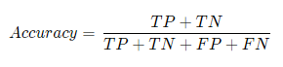 

Where, TP, TN, FP, FN stand for True Positive, True Negative, False Positive, and False Negative respectively.

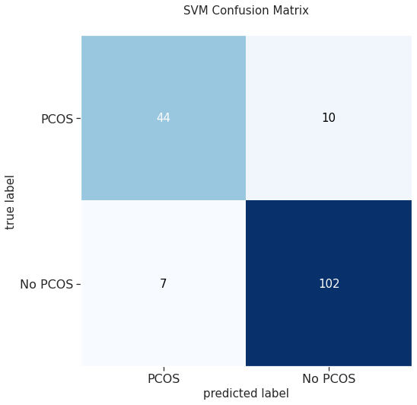 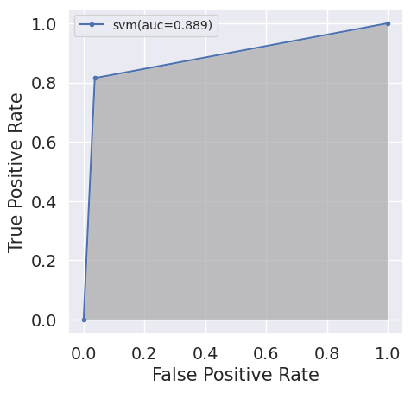

**Figure 3.** Confusion Matrix **Figure 4.** ROC-AUC Curve

**The Area Under the Curve (Figure 4) for SVM is 0.889 which is greatest amongst all the models.**

**Confusion matrix (Figure 3) gives the following inferences:**

1. **True Positive:** SVM predicted *44* PCOS patients who actually had it.
2. **False Positive:** SVM predicted *10* patients to have PCOS, but they did not.
3. **False Negative:** *7* patients were predicted not to have PCOS by SVM, but they actually had it.
4. **True Negative:** SVM predicted *102* patients to be unaffected by PCOS who were in fact unaffected.

**Feature Importance-** For a given model, feature importance refers to the method of calculating a score that represents the importance of each input feature. If a feature has a high score, it has a greater impact on the model that is being used to predict a certain variable.

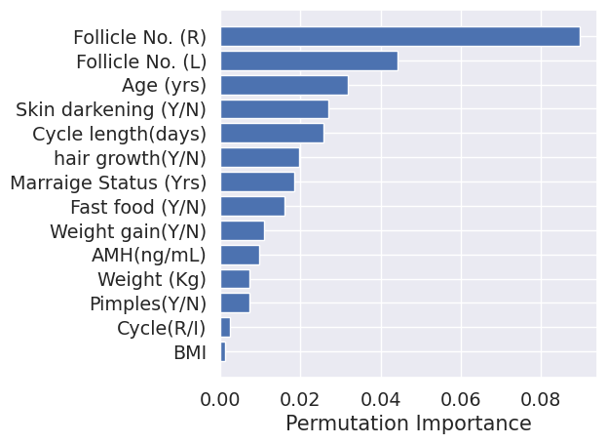

**Figure 5.** Importance of features in the model

Plotting Permutation importance graph (Figure 5), we get the top 4 features which SVM found most influential in prediction of PCOS are

1. Follicle No. (R)
2. Follicle No. (L)
3. Age (yrs.)
4. Skin darkening (Y/N)

From the tuned SVM we can still get false results in that case to avoid misleading results, we can take the help of feature importance from which we will see the 4 most important features and compare them with the ideal parameters and if they are violating it, we can tell the patient that he/she is at the risk of having PCOS.

**Conclusion**

Today, millions of patients are affected by PCOS but the tragedy is that most of them are unaware of it. Patients suffer significant health consequences as a result. Our main goal was to develop a system that would allow a patient to determine their risk of PCOS by entering a few basic health information. In this study, we explored various medical parameters, how they are related to each other and how they vary for a person with PCOS. Then we explored various machine learning models. Tuned their hyperparameters to get accurate results. Out of all, SVM performed better than others with an accuracy of 0.91 and Sensitivity of 0.81. Further, Number of follicles in the ovaries, Age and darkening of skin came out to be the most important features. The dataset used for investigation had a smaller number of samples and it was concentrated on a single geographical location. For improving the diagnosis model large number of datasets have to be collected and awareness about PCOS should be increased.

**Acknowledgments:**

Without the outstanding assistance and direction of our supervisor, Dr. Anbarasa Kumar A, neither this work nor the study supporting it would have been feasible. His zeal, expertise, and meticulous attention to detail served as an inspiration and guided us as we worked, through the very first step of topic selection to the final composition of my dissertation. Dr. Anbarasa has also reviewed the development of our project and patiently responded to our many inquiries concerning the languages and technology utilized in this project.

**Conflict of Interest Statement:**

**We declare that we have no conflict of interest to disclose in regard to this research work.**

**Data Availability Statement:**

**The dataset used in this study is available at Kaggle by Prasoon Kottarathil, https://www.kaggle.com/datasets/prasoonkottarathil/polycystic-ovary-syndrome-pcos**

**References**

**https://www.kaggle.com/datasets/prasoonkottarathil/polycystic-ovary-syndrome-pcos**

https://atomurl.net/math/

A. S. Prapty and T. T. Shitu, “An Efficient Decision Tree establishment and performance analysis on Polycystic Ovary Syndrome”

S. Bharati, P. Poddar and M. R. Hossain Mondal, “Diagnosis of Polycystic Ovary Syndrome using Machine Learning Algorithms”

Y. A. Abu Adla, D. G. Raydan, M. Z J. Charaf, R. A. Saad, J. masreddine and M. O. Diab, “Automated Detection of Polycystic Ovary Syndrome using Machine Learning”

P. Chauhan, P. Patil, N. Rane, P. Raundale and H. Kanakia, “Comparative Analysis of machine learning Algorithms for Prediction of PCOS”

M. S. Khan Inan, R. E. Ulfath, F. I. Alam, F. K. Bappe and R. hasan, “Improved Sampling and Feature Selection to Support Extreme Gradient Boosting For PCOS Diagnosis”

N. Nabi, S. Islam, S. A. Khushbu and A. K. M. Masum, “Machine Learning Approach: Detecting Polycystic Ovary Syndrome & its impact on Bangladesh Women”