TASK: -1

Extracting tweets based on #elearning

And performing Cleaning & Sentiment Analysis using NLP

Importing Libraries: -

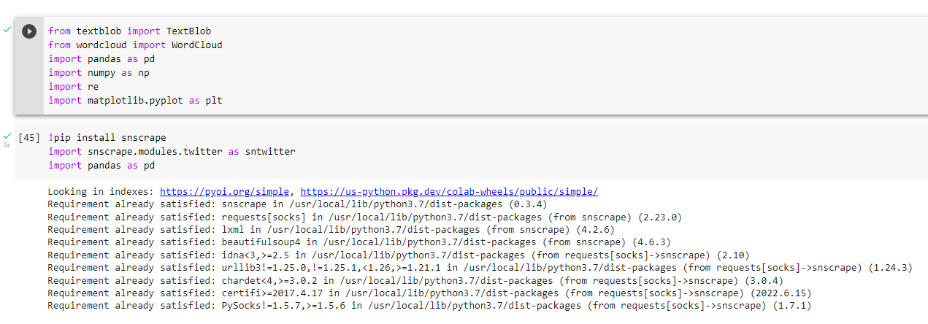

Extracting Tweets: -

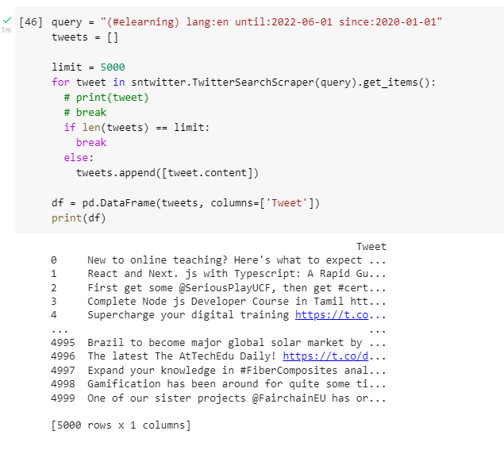

Cleaning text: -

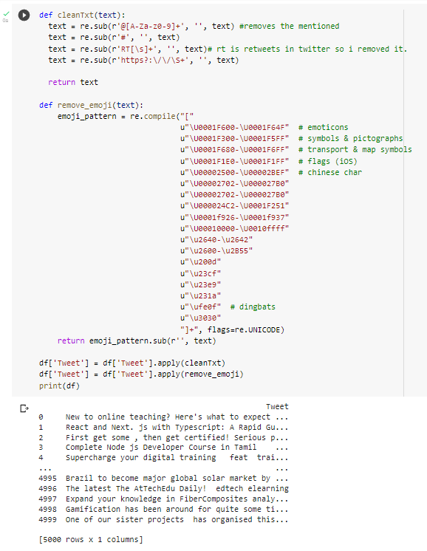

Calculating Subjectivity and Polarity and adding their columns respectively: -

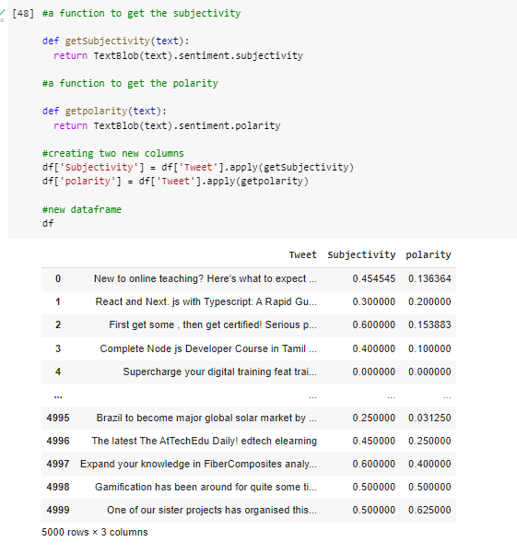

**Polarity is float which lies in the range of [-1,1] where 1 means positive statement and -1 means a negative statement**. Subjective sentences generally refer to personal opinion, emotion or judgment whereas objective refers to factual information.

Generating a Word Count Analysis plot: -

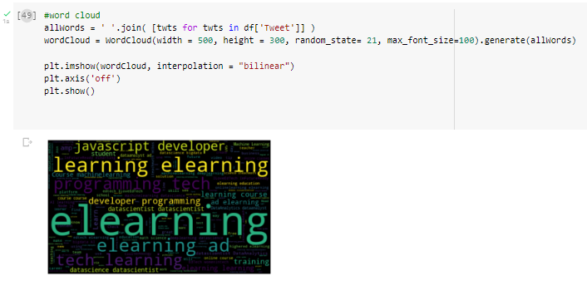

The size of the words depends upon the number of times the word has appeared in the tweets. The Highest appearing word will be the largest.

Here, it seems “elearning” has appeared the highest.

Classifying the sentiments as “Positive”, “Neutral” and “Negative” and adding a “Analysis” column: -

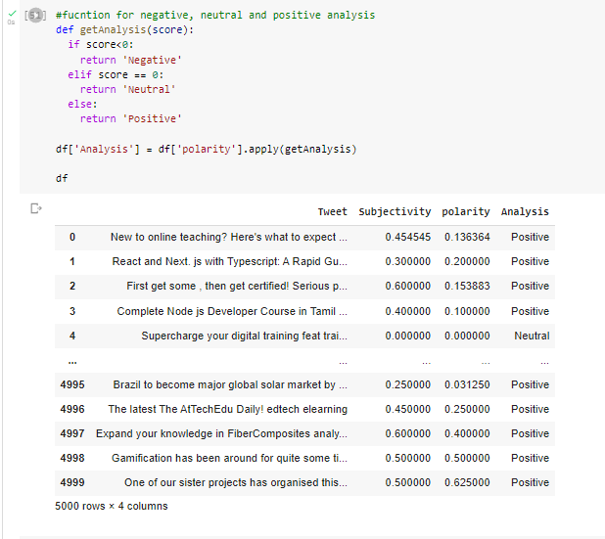

Printing Positive and Negative Tweets:-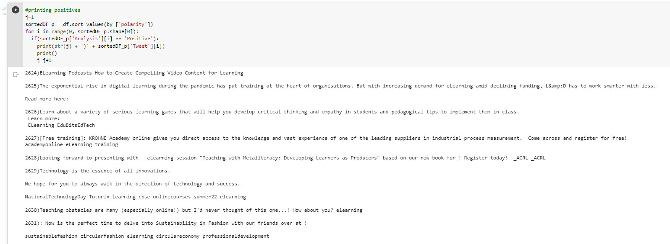

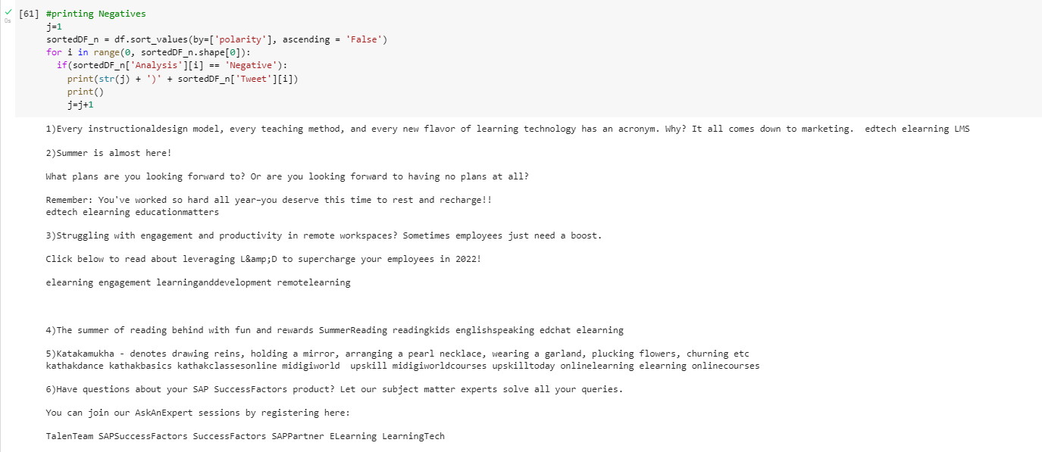

Plotting a Scatterplot based in Subjectivity and polarity: -

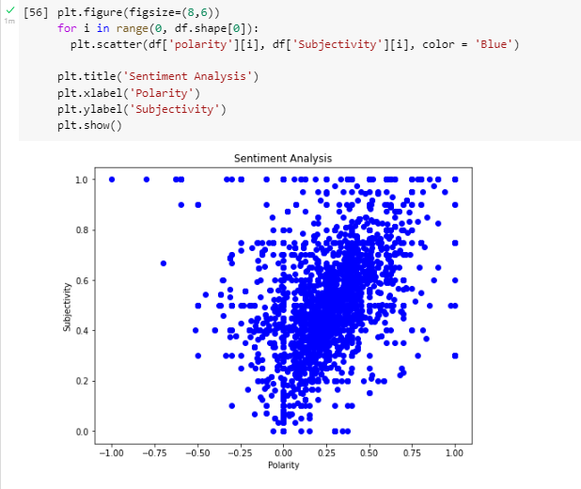

We can see here that most of the tweets are either positive or neutral, which is good.

Calculating the percentage of positive neutral and negative tweets: -

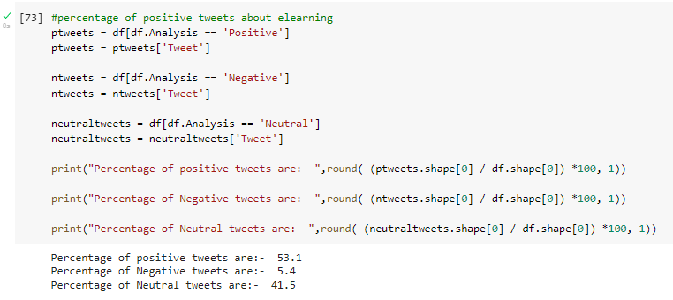

This confirms our scatterplot.

Generating a value count – BAR graph: -

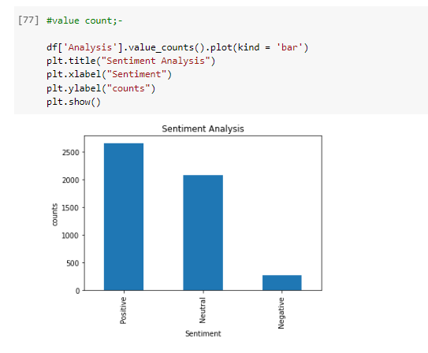

This task is performed by Manav Khambhayata to get selected for the Internship in Artificial Neural Network.

Email: - [king.manav.nk@outlook.com](mailto:king.manav.nk@outlook.com)

LinkedIn: - https://www.linkedin.com/in/manav-khambhayata-3a12461b2