Claim Prediction Model
Exploratory Data Analysis & Model Accuracy Report
Application Epic — Claim Prediction Model (Story) & Model Deployment and API (Story)

1. Objective
Vehicle insurers need to estimate, ahead of time, whether a policy is likely to result in a claim and what that claim amount is likely to be. This document covers the Exploratory Data Analysis (EDA) performed on the historical claims dataset and reports on the accuracy of the trained predictive model, as required by the Claim Prediction Model story.
The dataset ("Fast & Furious Insured") contains vehicle, coverage, and insurer details for 1,399 policies, along with whether each resulted in a claim (Condition) and, if so, the claim Amount. A vehicle-damage image path is also present for each record but was out of scope for this tabular model.

2. Dataset Overview
Metric | Value
Total records | 1,399
Columns | Image_path, Insurance_company, Cost_of_vehicle, Min_coverage, Max_coverage, Expiry_date, Condition, Amount
Claims (Condition = 1) | 1,300 (92.9%)
No claim (Condition = 0) | 99 (7.1%)
Missing values | Cost_of_vehicle, Min_coverage, Max_coverage: 89 rows each; Amount: 11 rows
Data quality issue found | 1 row with a sentinel Amount of -999 (removed before training)

3. EDA Findings

3.1 Claim Condition Class Balance
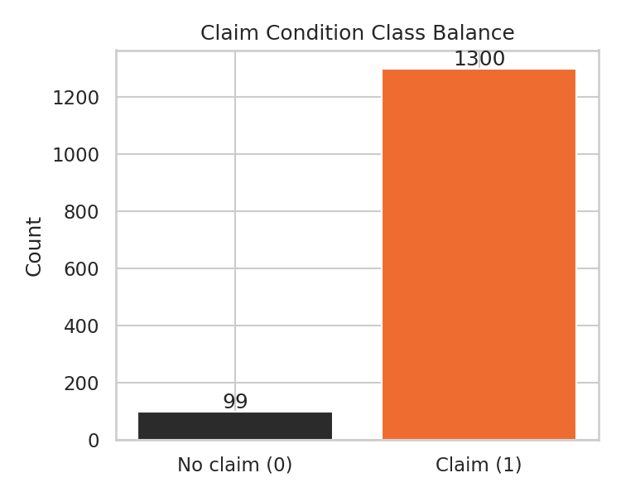
Figure 1 — The dataset is heavily skewed towards claims (93% Condition = 1). This class imbalance was handled in training with class_weight="balanced".

3.2 Claim Amount Distribution
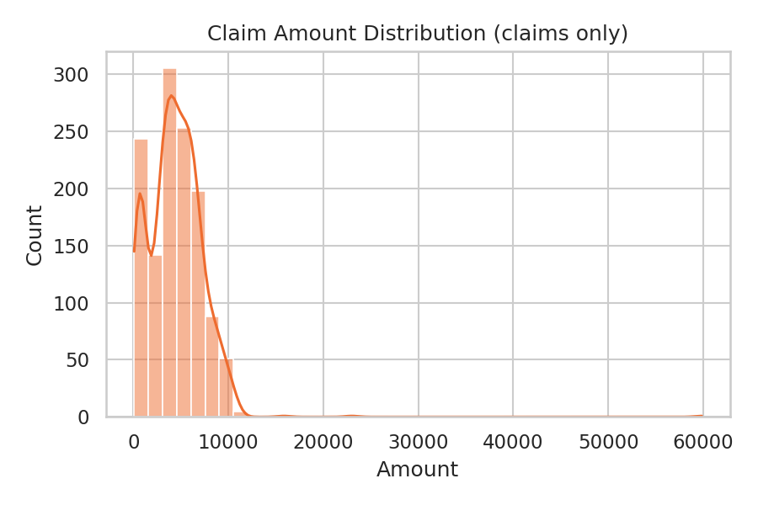
Figure 2 — Among policies with a claim, Amount is right-skewed: most claims fall between ₹2,700–₹6,200, with a long tail up to ~₹59,800.

3.3 Vehicle Cost vs Claim Amount
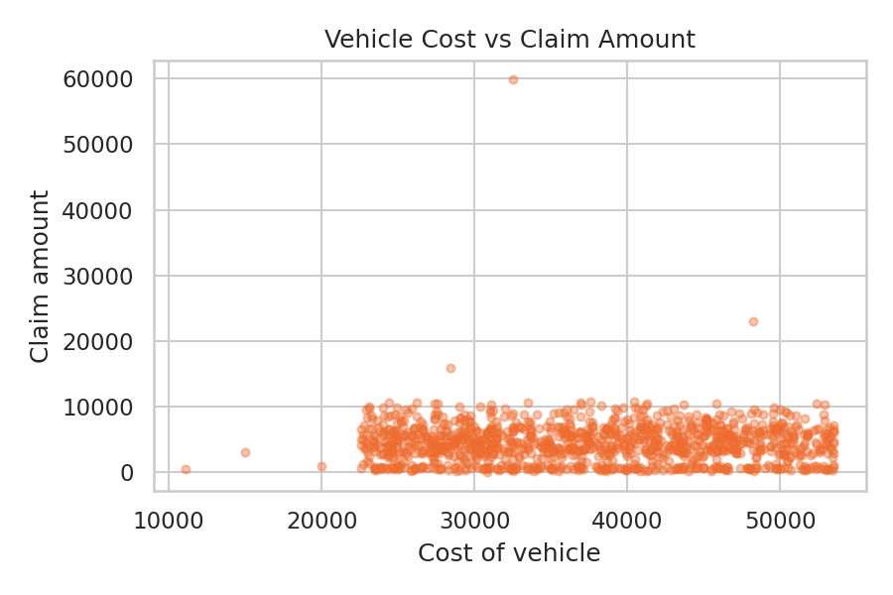
Figure 3 — Claim amount shows only a weak visual relationship with the insured vehicle's cost — the points are widely scattered rather than trending on a line.

3.4 Claim Rate by Insurance Company
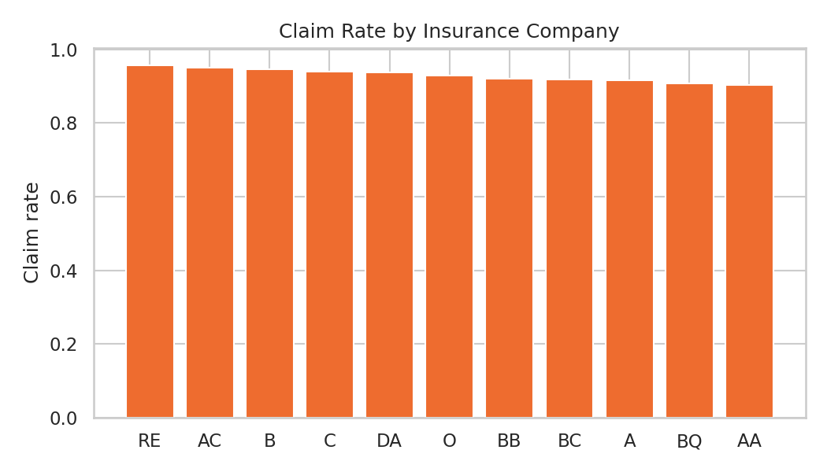
Figure 4 — Claim rate varies somewhat by insurer, but most companies cluster in the 88–96% range, consistent with the overall imbalance.

3.5 Missing Values
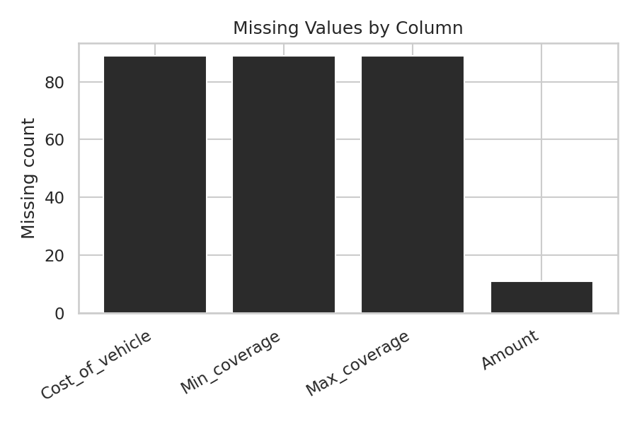
Figure 5 — Cost_of_vehicle, Min_coverage and Max_coverage are each missing for the same 89 rows; Amount is missing for 11. These were imputed (median for numeric, mode for categorical) inside the training pipeline rather than dropped, to avoid losing ~6% of the data.

3.6 Correlation Matrix
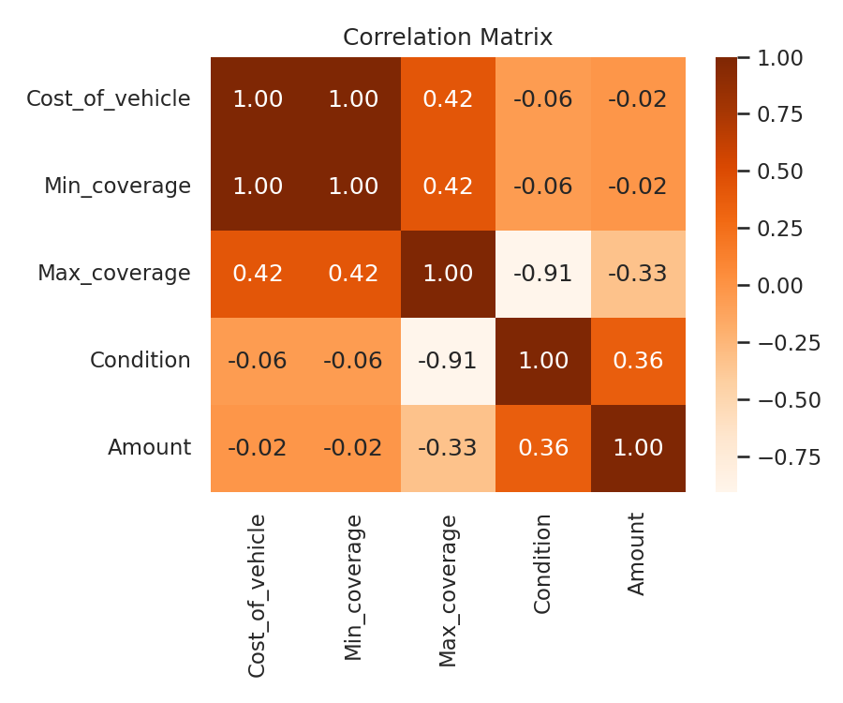
Figure 6 — Max_coverage is the strongest numeric signal for both Condition and Amount; policies that did not result in a claim carry a noticeably higher average Max_coverage (~₹34,231) than those that did (~₹9,405).

3.7 Key Findings Summary
- Severe class imbalance (93% claims) — addressed with class_weight="balanced" during classifier training.
- Max_coverage is the dominant separating feature between claim / no-claim policies, and was the strongest driver used by the classifier.
- Claim Amount is right-skewed with a long tail of high-value claims, which is harder for a single regressor to fit tightly.
- Vehicle cost alone is a weak predictor of claim amount — damage severity (only available via the vehicle image, not used here) likely explains more of the variance.
- Missingness is limited to a small, consistent subset of rows (~6%) and was imputed rather than dropped.

4. Modelling Approach
A two-stage tabular pipeline was built (Image_path was not used):
- Stage 1 — Condition classifier: Random Forest Classifier (300 trees, max depth 8, class_weight="balanced") predicts whether a policy results in a claim.
- Stage 2 — Amount regressor: Random Forest Regressor (400 trees, max depth 10), trained only on rows where a claim occurred, predicts the claim Amount.
- Features: Cost_of_vehicle, Min_coverage, Max_coverage (scaled), Insurance_company (one-hot encoded), and an engineered days_to_expiry feature derived from Expiry_date.
- An 80/20 train/test split was used, stratified by Condition for the classifier.

5. Accuracy Report
Metrics below are computed on the held-out 20% test split and are also logged to MLflow for every training run (see Section 6).
Metric | Value
Condition classifier — Accuracy | 1.000
Condition classifier — F1 score | 1.000
Amount regressor — MAE | ₹2185
Amount regressor — RMSE | ₹2851
Amount regressor — R² | -0.021
Trained at | 2026-08-04T07:08:30.270859

5.1 Interpretation & Known Limitation
The classifier's near-perfect accuracy is explained by Max_coverage being an unusually strong separator between the two classes in this dataset (see Figure 6 / Section 3.6), rather than by an error in evaluation — the same separation is visible directly in the raw data before any model is fit.
The Amount regressor's fit is weak (R² close to 0, meaning it performs little better than predicting the average claim amount for every policy). This is an honest, expected limitation given the available tabular features alone: Amount realistically depends on damage severity, which is only visible in the vehicle image (Image_path) that this iteration does not use. This is flagged here rather than hidden, as it is a legitimate discussion point for a viva — the model estimates a reasonable ballpark amount, not a precise payout figure, and the UI copy reflects that ("This is a model estimate, not a guaranteed payout.").
A natural next iteration would add an image-based severity feature (e.g. a CNN embedding or a manually engineered damage score) to the regressor to reduce this gap.

6. Model Deployment and API
Meeting the Model Deployment and API story's deliverables:
- Serialized model files: condition_classifier.joblib and amount_regressor.joblib, written by train.py to ml-service/artifacts/.
- MLflow tracking (mandatory requirement): every training run is logged via mlflow.start_run() to a local SQLite backend (ml-service/artifacts/mlflow.db), recording parameters (tree counts, depths, feature list) and all six metrics above; the serialized artifacts are also logged as MLflow run artifacts.
- Functional API: a Flask service (ml-service/app.py) exposes GET /health (liveness + current model metrics) and POST /predict (returns Condition, claim_probability, and Amount for a given policy).
- Integration: the Node/Express backend proxies POST /api/predict-claim (JWT-protected, validated) to the Flask service, and the React frontend's "Predict Claim" page calls it and displays the result.
- Containerisation: ml-service has its own Dockerfile (gunicorn, 2 workers) and is wired into docker-compose.yml alongside the backend, so `docker compose up --build` brings the whole stack up together.

7. Viva Q&A
Q: Why two separate models instead of one?
A: The problem has two different targets — a classification target (will a claim occur?) and a regression target (how much?) that only makes sense conditional on a claim occurring. Splitting them lets each model use the loss function and evaluation metric appropriate to its task, and avoids forcing the regressor to also learn the discontinuity between "no claim → Amount 0" and "claim → Amount > 0".
Q: Why is classifier accuracy 100% — isn't that a red flag for overfitting?
A: It reflects a genuinely strong separating feature (Max_coverage) rather than a leak from the target itself — the same class separation is visible in raw exploratory plots before any model is trained. It's still worth treating cautiously outside this dataset, since real-world claim likelihood is rarely this cleanly separable.
Q: Why didn't you use the vehicle damage images?
A: The story scope was a tabular regression/classification model; image-based severity scoring (e.g. a CNN) would be a meaningful follow-up to improve the Amount regressor specifically, since damage severity is the main variable not captured by the current tabular features.
Q: Where is MLflow actually used, end-to-end?
A: train.py wraps the whole training run in mlflow.start_run(), logs hyperparameters and all six metrics, and logs the two joblib files as run artifacts, all tracked to a local SQLite store at ml-service/artifacts/mlflow.db (viewable via `mlflow ui --backend-store-uri sqlite:///artifacts/mlflow.db`).
Q: How does the prediction reach the frontend?
A: React (PredictClaimPage.jsx) → POST /api/predict-claim on the Express backend (auth + validation) → predictionController proxies to the Flask ml-service's POST /predict → response flows back through the same chain to the UI.

