Contents

Loop 2

For- loop 2

While-loop 2

Dowhile-loop 2

Suvs 3

Crossover 3

Maruti 3

3-Row-SUV 3

planets 4

Mars 4

Moon 4

Earth 4

sports 5

Ninga-xr 5

Royal-infiled 5

hero 5

Java

# Loop

For- loop: for loop is use if total number of Ietration is given.it is uses for n number of itreatoins.

While-loop: While loop it is use for when n number of iteration is not define.

Dowhile-loop: Dowhile loop is use for when first itreation is must perform without cheaking condition.

Car

# Suvs

Crossover:The smallest SUVs in the market are car-based ones,sometimes called crossover cars.

Maruti:Maruti Brezza price for the base model starts at Rs.8.69 Lakh and the top model proce goes upto Rs.14.14 lakh

3-Row-SUV:The smallest SUVs in the market are car-based ones,sometimes called 3-row car –cars.

Solar System

# planets

Mars:it is known as red planet is the fourth planet from the sun and is characterized by its dusty.

Moon:The moon is earth’s only natural satellite.

Earth:earth is the thired planet from the sun.

Bike

# sports

Ninga-xr:The smallest SUVs in the market are car-based ones,sometimes called crossover cars.

Royal-infiled:Maruti Brezza price for the base model starts at Rs.8.69 Lakh and the top model proce goes upto Rs.14.14 lakh

hero:The smallest SUVs in the market are car-based ones,sometimes called 3-row car –cars.

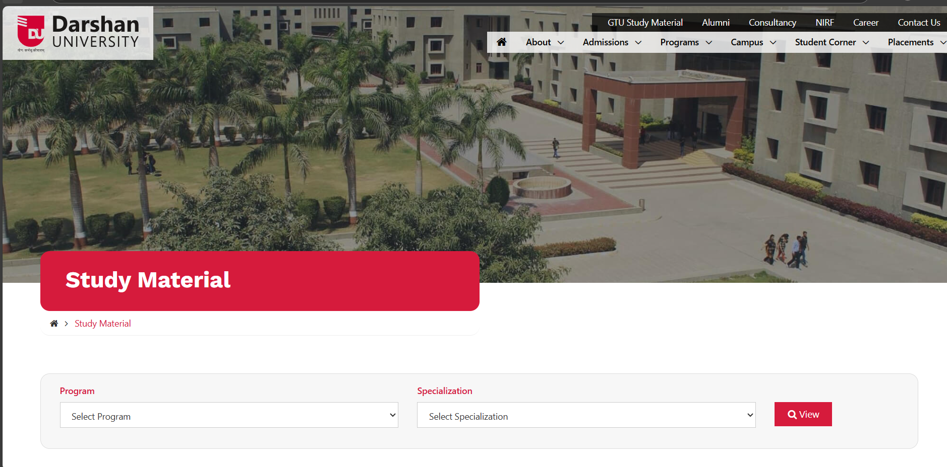

Video provides a powerful way to help you prove your point. When you click Online Video, you can paste in the embed code for the video you want to add.

* You can also type a keyword to search online for the video that best fits your document. To make your document look professionally produced, Word provides header, footer, cover page, and text box designs that complement each other.

1. For example, you can add a matching cover page, header, and sidebar. Click Insert and then choose the elements you want from the different galleries.

Themes and styles also help keep your document coordinated. When you click Design and choose a new Theme, the pictures, charts, and SmartArt graphics change to match your new theme.

When you apply styles, your headings change to match the new theme. Save time in Word with new buttons that show up where you need them.

1. Video provides a powerful way to help you prove your point. When you click Online Video, you can paste in the embed code for the video you want to add. You can also type a keyword to search online for the **video that best** fits your document.

**To make your document look professionally produced, Word provides header, footer, cover page, and text box designs that complement each other. For example, you can add a matching cover page, header, and sidebar. Click Insert and then choose the elements you want from the different galleries.**

**Themes and styles also help keep your document coordinated. When you click Design and choose a new Theme, the pictures, charts, and SmartArt graphics change to match your new theme. When you apply styles, your headings change to match the new theme.**

*Save time in Word with new buttons that show up where you need them. To change the way a picture fits in your document, click it and a button for layout options appears next to it. When you work on a table, click where you want to add a row or a column, and then click the plus sign.*

Reading is easier, too, in the new Reading view. You can collapse parts of the document and focus on the text you want. If you need to stop reading before you reach the end, Word remembers where you left off - even on another device.

*Manav_Delvadiya_108_CSE_3A*