Designs-

The designs of my game have changed over time. My first design was that the user will always travel between rooms this means that the user will only have 3 main inputs and what are 1,2,3 this means that the user selects what room he or she wants travel into or out of the room. In some of the rooms there will be a hidden a chest and in some of the rooms an enemy or a trap can be waiting for them. The user can leave the room and choose another option, but the rooms can be randomly generated so I won’t know what could be in the rooms. Another idea for my game was to have a shop where the user could buy and spend weapons or money the adventurer can collect on there journey. This version of the game doesn’t really share a story some people may like this since they can repeat the game over and over again but most people like a story where they can fully imagine them self’s in the environment the game is set in. The game was first planned to have a hit by hit, so the player gets to hit the monster first then the monsters turn etc this attack scene would be a long fight and a waste of time.

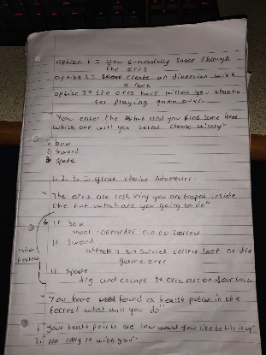My final version of the game includes a attack system but instead of having hit by hit the user will choose our of the options and if it is attack the game will automatically decide the users outcome its like a dice roll if its 5 and above the user will kill the demon if the roll is below you either take damage or you will die. The player will not know what number he got all he will know is that the character lost health or he killed the demon. The game now also has a unique story that isn’t based of any other game as well as the gameplay is smooth, and it will take the player into a different universe. The code used does not repeat its self over and over again meaning it doesn’t take up a lot of space on someone’s computer and it will load up fast for the user to play. The game takes the player to new areas, so it isn’t repetitive and the only way for the user to win the game is by defeating the boss at the end of the game.

This the main script I used to create my game the idea of the whole thing was made from this brief idea I wrote down. It was a brainstorm of a story that can be interesting for the user to play.

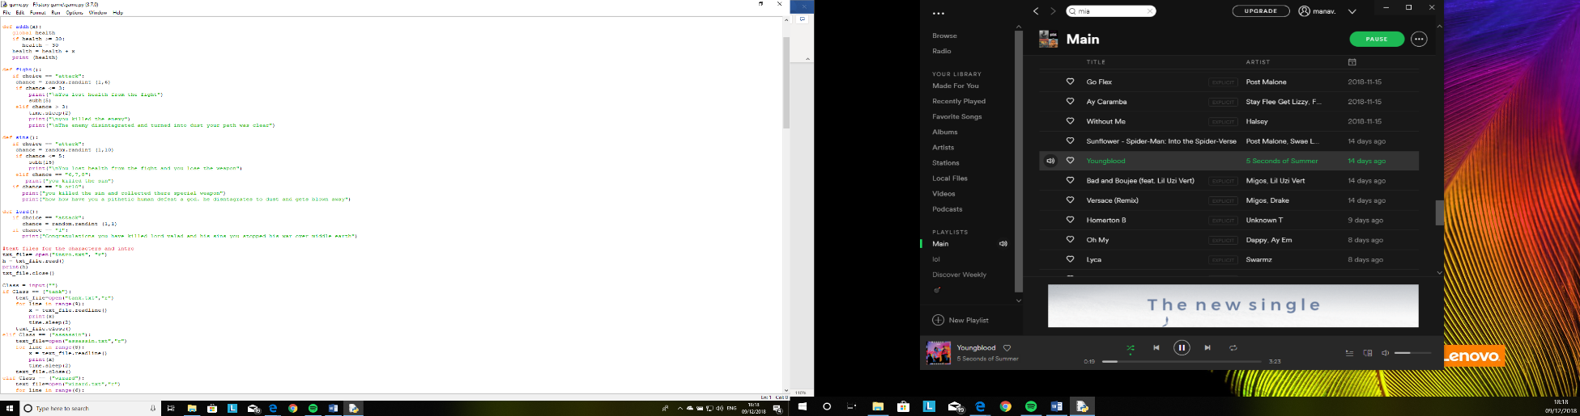

This is my fight scene code against the sins and the normal demons that the user will encounter through the game.

Analysis of requirements of the program

My first requirement was to create a story that can keep the user involved and interested through to the end. My story has many fight scenes that will keep the user interested to the very end, as well as a unique story that has a genre of a mythical tale what has a big community. Another requirement for my game is that it shouldn’t be too long, so the player will get bored after a while and the game shouldn’t be too small that it would be a waste of time to play. The game should not be buggy or glitchy what could ruin the experience of the game. Another requirement for my game is that the code shouldn’t be repeated meaning that all the code that are the same has been put inside a function, so the total storage and file size won’t be too big that It will take time to load up. The file organisation such as creating a note pad document with all the text inside this means instead of typing all the back story for each character as well as the tutorial and the welcome section of the game. This makes the game easier to look at and the code looks more presentable to the user’s eyes if they would like to look at the code. The overall code will be smaller since it won’t have loads of sections with massive chunks of text.

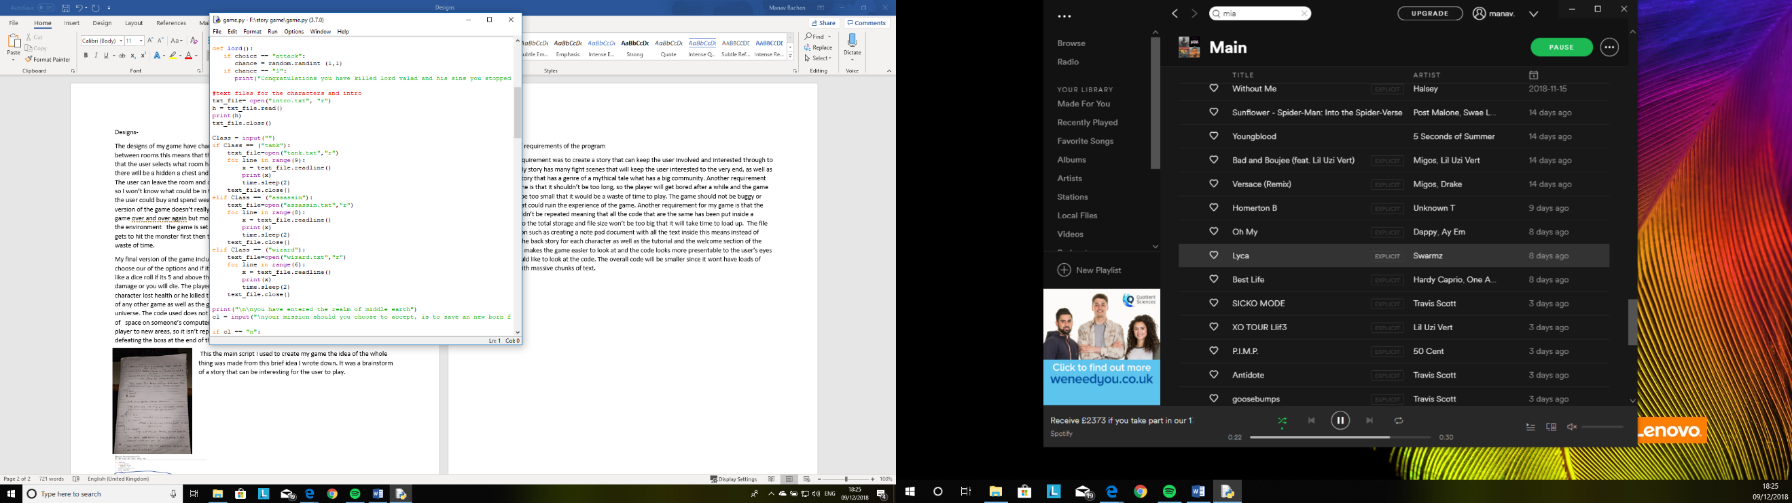this is the code used for the game it has all the notepad file linked to it so when the user types in the right command it will open the file, so the user can read the text. In this case the text is the back stories for each character so when the user types in the characters name it will load the back story for the character. I did this, so the user knows exactly why their character is fighting in this war.

Another requirement for the game that when the user dies it should not save the progress this means that the user will have to restart the game from the beginning. This will bring out the competitive side of people because they will want to keep on playing until they complete the game this will keep the player more interested in the game of time.

Testing

|  |  |  |
| --- | --- | --- |
| Test | Did it work | Improvement |
| Fighting scene | The fighting scenes do work but sometimes the scenes don’t work and skips the fight. | Instead of using a function I could write the code for every fight, but this method isn’t a great way, but it will work, |
| Time.sleep code | Yes this does work for most of the game besides of the first lines of code if the user doesn’t want to play the line after time.sleep still shows up what shouldn’t appear. | Remove the line after time.sleep and added it onto the if statement of yes. |
| Health code | the health part my game works perfectly fine but when the user dies it kind of glitches out and still show the next line of the story. | Make it so after the user runs out of health next line must be you have lost game over press enter to leave before the next line loads up. |
| Txt files | The note pad files did work well it was easy to write up all the back stories for each character instead of adding a lot of print statements in the code. | n/a |
| Functions | The functions did work well it saved a lot of time and it didn’t take too long to set up. | n/a |
| The loading of the note pad documents | The code used for the txt files worked quite well but it left weird gaps after each line, but the files did load up correctly without issues. | I’m not sure how to fix this issue. |
| Traveling | Travelling to different places does work quite well as soon as the user types in there input the next action or the next part of the story loads up so it doesn’t keep the user waiting. | n/a |

Critique

The things that went well with my work is the story line the story liner is really interesting another goo thing is the responses the user has all the responses can either make the player lose health or they get followed by demons what can put them in trouble later in the game. Another good feature in my game is the back story it shows the user what each character experienced before the war and why they are fighting in this war. The health system allows the player to play an mmorpg game instead of a game where you can’t die and your invincible like most of the tell-tale games. Another advantage to my game is that it is quite long but the story doesn’t drag it gets straight to the point what makes the game more interesting.

The things that didn’t really work was the different ending theory I tried implementing it, but it was really confusing the code will mainly be if statements within if statements what is annoying, and it could make the game have more errors or bugs what will be harder to fix. The health bar was another issue that I came across when the user dies the game doesn’t end the next line of text just load up.