Influence of Indian Information Technology Company Stocks on Sensex

Context: Trying to establish the relationship between Sensex(Indian Stock Exchange Index) and share prices of top two Information Technology companies of India namely Tata Consultancy Services and Infosys Limited from last ten years and detailed out for this year.

Sensex -Sensex is the stock market index of the Bombay Stock Exchange or BSE – it is also called BSE Sensex.

Sensex Meaning

It is the market weighted stock index of 30 companies that are selected on the basis of financial soundness and performance. Usually, large and well-established companies that are are representatives of the various industrial sectors are chosen.

The Sensex values collected over ten year period from 2007 to 2017 were divided by 10 to bring the data close to other stock prices range.

The purpose of this exercise was to visually show the pattern of variation rather than actual values which is well depicted by below graphs which were plotted in R language using ggplot function.

The data for all the Sensex, TCS Stock Price and Infosys Stock price was gathered from public websites yahoo finance and respective websites <https://www.tcs.com> and <https://www.infosys.com>

There was some stock data missing for some of the dates for Infosys and it was put based on average of preceeding and succeeding day.

|  |  |
| --- | --- |
| Infosys | Stock Price |
| 9-Nov-07 | Missing |
| 1-Jan-09 | Missing |
| 5-Nov-10 | Missing |
| 26-Oct-11 | Missing |
| 28-Apr-12 | Missing |
| 26-Oct-12 | Missing |
| 11-May-13 | Missing |
| 3-Nov-13 | Missing |
| 11-Nov-15 | Missing |
| 30-Oct-16 | Missing |

The data from 01-Jan-2007 till 23-Jun-2017 was collected and saved as CSV file in “Sensex.csv” attached here. The half yearly values are also plotted in figure 2 which gives more smooth pattern w.r.t. figure 1.



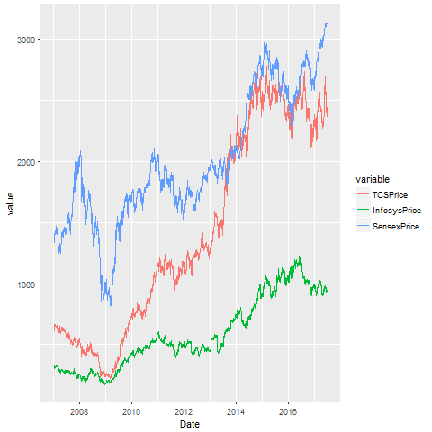

Fig 1: Plot of all the daily values from 01-Jan-2007 till 23-Jun-2017

Since the data was quite cluttered in above graph the half yearly values were taken to have more meaningful trend of variation.(This proves quality of data is more important than quantity of data)

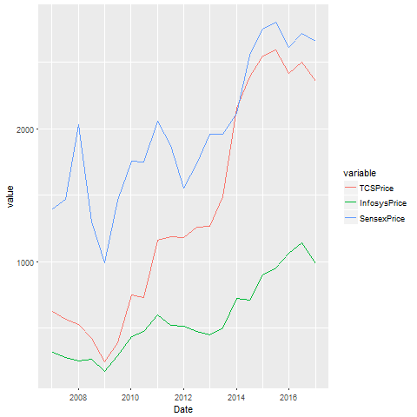

Fig 2: Plot of half yearly values from 01-Jan-2007 to 23-Jun-2017

Analysis

-----------

The visual observation was that Infosys(green) and Sensex variations(blue) were quite similar in pattern till end of 2016. TCS stock(red) was outlier as compared to Sensex and Infosys stock till end of 2016.

Now I expanded the 2017 analysis to be monthly plot of data starting from 01-Dec-2016 till 01-Jun-2017. Here the story has changed where TCS and Infosys stock are more in line in the pattern and Sensex is outlier.

The reason for this stablizing of Information Technology stock is the change in policies of USA regarding work visa which is the biggest geography for Indian IT outsourcing companies.

On the other hand the Sensex is climbing steadily in 2017 because of stable government in India and Indian national party BJP has won most of the state assembly elections in late 2016 and early 2017. Indian government’s policies in controlling corruption and streamlining tax structures are showing positive effect in country’s economy. The data for below graph is attached here.



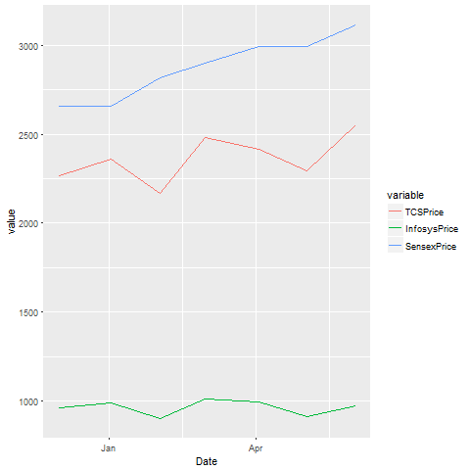

Fig 3 Trend for stocks in 2017

Conclusion- the influence of India IT companies stock in overall Sensex is getting lower in 2017 as compared to previous years as developed economies are facing less growth putting severe pressure on rate and margin of IT companies and IT in general is becoming more commoditized.

All the above graphs were plotted using R language on Windows 8.1 64 bit machine using 3.4.0 version of R. Following steps were taken to plot the above graphs.

1. The data was loaded into R language from .csv file using read.csv(“Sensex.csv”) function where Sensex.csv is input file present in the default folder(C:\Users\Corei3\Documents) of R language.
2. The package ggplot2 was installed using following command. Once it is downloaded on the local PC then these packages are available for R language.

install.packages("ggplot2")

The downloaded binary packages are in

C:\Users\Corei3\AppData\Local\Temp\RtmpmgXzVK\downloaded_packages

1. The library has to be called every time the workspace is opened. Following two libraries were called.

> library(ggplot2) for ggplot function

> library(reshape2) for melt function for collecting the data in an object to be plotted

4) Following commands were used plot the graph for multiple lines on y axis versus date at x axis.

> mdf<-melt(df, id.vars="Date") #melt function for storing the data in long format for plotting based on timeline (date)

> mdf$Date<-as.Date(df$Date,"%m/%d/%Y") # for converting to date format for sorting date wise

> myplot<-ggplot(data=mdf,aes(x=Date, y=value, group=variable, colour=variable))+geom_line()

> png("myplot.png") # Graph output to .png file

> print(myplot)

> dev.off()

References:

1. <https://stackoverflow.com/questions/17150183/plot-multiple-lines-in-one-graph> for plotting multiple lines in a graph
2. <http://www.statmethods.net/input/dates.html> for converting to date format
3. <http://www.sthda.com/english/wiki/ggsave-save-a-ggplot-r-software-and-data-visualization>

for saving the plot in a file