**ECONOMICS PROJECT**

**Foreign Direct Investment**

**Submitted To: Prof. Parul**

**Submitted By:**

**Arpit 17108017**

**Tanmay**

**Ashish**

**Bodhit**

**Executive Summary**

Foreign direct investment (FDI) is considered to be one of the primary factors which lead the path to the upstanding of the Indian economy. India being a developing country has been majorly affected in a positive outlook through the concept of FDI. With the diversifying economists all across the nations, FDI has proved out to be that one concept that lead the economists to a better understanding of the Indian business mind.

FDI inflows to the developing countries have increased with a greater pace in the 90’s era and accounting for about 36.6 per cent of global FDI inflows in the year 2008. Similar trends been visualized in India where FDI concept has elevated rapidly following the economic reforms .The reforms were directed towards increased liberalization, privatization and deregulation of the industrial sector, integrating the economy with that of world economy by reducing trade barriers and adapting favorable policy framework toward expansion of foreign investment in the country. This has made Indian economy as a favorable destination for foreign investors.

**INDEX**

|  |  |  |
| --- | --- | --- |
| S.NO | TITLE | PAGE NO. |
| 1 | **Introduction** | **2** |
| 1.1 | FDI inflow routes |  |
| 1.2 | Why investors are attracted to invest through FDI in India |  |
| 1.3 | FDI non-permitted sectors |  |
| 2 | **Review of Literature** | **4** |
| 2.1 | Horizontal/Vertical FDI |  |
| 2.2 | Corporate hijack of Retail |  |
| 2.3 | Doing business in India |  |
| 2.4 | Case study of Coca Cola |  |
| 2.5 | FDI in the retail sector |  |
| 3 | **Objectives of study** | **7** |
| 4 | **Methodology** | **8** |
| 5 | **Analysis** | **9** |
| 5.1 | FDI policy making in India |  |
| 5.2 | Need for FDI in India |  |
| 5.3 | Arguments in favour of Foreign capital inflow |  |
| 5.4 | Impact on Indian Economy |  |
| 5.5 | Sectoral composition of FDI |  |
| 6 | **Findings** | **16** |
| 6.1 | Status of FDI till 2015 |  |
| 6.2 | Issues implying less FDI inflow in India |  |
| 6.3 | Positive implications |  |
| 6.4 | Negative implications |  |
| 7 | **Suggestions** | **22** |
| 7.1 | Suggestions for increased inflow of FDI inflow |  |
| 8 | **Conclusion** | **25** |
| 9 | **Bibliography** | **27** |

**INTRODUCTION**

* Foreign Direct Investment (FDI) is a type of investment to an enterprise in a country by another enterprise located in another country by buying a company in the target country or by expanding its reach through an existing business in that country.
* FDI provides a number of treats like preludes of new technology, innovative products, and new markets extension, employment opportunities and introduction of new skills etc., which reflect in the growth of income of any nation.
* Many countries provide many incentives for attracting the foreign direct investment (FDI). The investment and saving rate in any country decides the need of FDI. It is acting as a bridge to fulfil the gap between investment and saving.
* Foreign direct investment is one of the measures of growing economic globalization. The objective behind allowing FDI is to complement and supplement domestic investment, for achieving a higher opportunity for technological up gradation and higher level of economic development, as well as access to Global managerial skills and practices.

**FDI inflow routes**

Foreign Direct Investment may be received by an Indian company under the two routes as given under:

1. Automatic Route: In automatic route FDI in sectors does not require any prior approval by either from the Government or the Reserve Bank of India.

2. Government Route: Those FDI activities which are not covered under the automatic route requires prior approval of the Government which is then considered by the Foreign Investment Promotion Board (FIPB), Department of Economic Affairs, and Ministry of Finance.

**WHY ARE INVESTORS ATTRACTED TO INVEST IN INDIA THROUGH FDI?**

* STABLE POLICIES: India stable economic and socio policies have attracted

investors across border. Investors prefer countries which stable economic policies. The changes in policies made by government will have effect on the business and the

business too requires a lot of funds which need to be deployed and any such change in policy against the investor will bring a negative effect.

* ECONOMIC FACTORS: Different economic factors encourage inward FDI. These

include interest loans, grants, subsidies, tax breaks and removing restrictions and

limitations. To attract the foreign investors government of India has provided many subsidies and tax exemption that would help in developing the economy.

* CHEAP AND SKILLED LABOR: There is abundant labor available in India in

terms of skilled and unskilled human resources. Foreign investors will try to take

benefit of the difference i.e. In the cost of labour as we both skilled and cheap labours.

Example: India is providing the skilled labor to foreign firms which have invested in BPO’s.

* BASIC INFRASTRUCTURE: India though is a developing country, one of the basic requirement is to create special economic zone where there is availability of normally required infrastructure such as roads, effective transportation and worldwide carrier departure, Modern era technology and network systems, electricity supply, financial

Institutions, and legal system and other basic requirements which are must for the success

of the business. A fair legal system and up to the mark infrastructure supporting a

smooth distribution of goods and services in the host country.

* UNEXPLORED MARKETS: India has a large section of markets which are yet to be explored and still unutilized and proves to be a great scope for the investors. In India the target group for new markets is large middle class income group which proves to be a potential customer market for foreign firms. Example: BPO was one of the sector where the investors had large scope in exploring the markets where the service was provided with just a call, with utmost customer satisfaction.
* AVAILABILITY OF NATURAL RESOURCES: As we know that India has large

amount of natural resources like coal, petroleum, Natural gas, ores etc. The foreign investors will use these natural resources for extraction and various kinds of production processes.

**FDI is not permitted in the following industrial sectors:**

∙ Arms and ammunition

∙ Atomic Energy

∙ Railway Transport.

∙ Lignite and coal

∙ Mining of manganese, iron, chrome, gypsum, sulphur, gold, diamonds, copper, zinc.

∙ Lottery Business

∙ Betting and Gambling

∙ Chit Fund business

∙ Agricultural (excluding Horticulture, Floriculture Development of seeds, Animal Husbandry, Pisciculture and cultivation of vegetables, mushrooms, etc. under strict conditions and services related to agro and allied sectors) and activities related to plantation (other than Tea Plantations) .

∙ Real Estate and Housing business.

∙ Trading in Transferable Development Rights (TDRs).

∙ In manufacturing of cheroots, cigars, cigarillos and cigarettes, of tobacco or of tobacco substitutes.

**REVIEW OF LITERATURE**

1. HORIZONTAL / VERTICAL FDI :

FDI can be defined as a package of capital, technology, management, and entrepreneurship, which allows a firm to operate and provide goods and services in a foreign market. From a theoretical viewpoint, FDI can be bifurcated into two categories: Horizontal and Vertical. Horizontal FDI (HFDI) is a type of investment which is in the same industry operating abroad as a company operate, or offers the same services as it does at home, and tends to produce for local or original markets only without exporting much output to host country.It seeks to take advantages of a new large market, which is considered as traditional motive for FDI. It is believed that this model will help to reduce the risk and enable them to share experience, resources, and acknowledgment that already have developed at home country.

The revenues which are collected through taxation assist in increasing the income in FDI. It also plays a vital role in the rise of the productivity of the host countries. This process proves to be beneficial for those countries that make foreign direct investment in other countries. This helps the companies to get an opportunity to search newer markets and thereby generate more income and profits.

(2) A Report by Research Foundation for Science, Technology and Ecology, New Delhi

CORPORATE HIJACK OF RETAIL

Retail Dictatorship vs Retail Democracy

This report talks about superpowers like Walmart and Reliance taking over the retail sector of India.The entry of this supermarket in the food sector will have direct impact on India‘s 650 million farmers and 40 million people employed in small retail businesses. There wee around 6600 stores planned to be built by 2011. After this scenario, there now exists a cut throught competition in the food market arena. Henceforth, the arrival of Walmart in India resulted in vital losses of the small business holders in the food range.

(3) DOING BUSINESS IN INDIA

A publication of the World Bank and the International Finance Corporation

Foreign direct investment gives a helping hand in the growth of the income that is generated through incoming revenues through the taxes applied within our Indian policy. FDI plays a vital role in increasing the productivity of the host country as they get a medium to ventilate business processes within the country,hence which keeps the cash flowing. In case of countries that make foreign direct investment in other countries this process has positive impact as well.

On the other hand for the countries investing in the host countries, it not only increases the the exposure content of the country’s economical and financial community but also gives them a turn to increase their business hands in other boundaries.

(4) Case Study of COCA COLA -

During the early 1970s Coca Cola was the first soft drink company to enter in the 900 crore market in India. Before this Indian market was mainly ruled by the domestic products in which Limca was the largest selling brand. Cola was sharing a maximum market share of 40%, Lemon drink 31%, and orange drink 19% only. Coca was leading the Indian market till 1977 but then due to the norms set by Foreign Exchange Regulation Act (FERA), Coca Cola had to face a big setback and left Indian market and didn't returned till 1993.

As per RBI's move on Foreign Equity Regulation, in 1974 it asked all the multinationals operating in low priority areas like consumer goods has to step down their equity to 40%.

As per the rules of RBI under FERA( Foreign Equity Regulation Act ) Indian government asked Coca Cola if they can comply property with new norms, later on Cole do decide to wind up in India, but quit making allegations over Indian government that they forced Coca Cola to tell there's secret formula.

After this allegation over Indian government, blame game between the two parties started and in the counter to Coca Cola, Indian government slapped them with the charges and accused the parent of bleeding profits and repatriating large sums of funds aroad as administrative charges.

During the period of 1977 Coke left Indian market and didn't returned for nearly two decades. By that time a lot of transformation has occurred and among this the most important change was made by a diluting the particular provision in FERA.

As Coke had a comeback in 1997, it voluntarily offered to divest 49% in favor of the public of India through an IPO at the end of three years. Coke divested 49% despite the fact that as per FDI norms for soft drinks sector they are not supposed to do some sort of mandatory divestment of stock.

After the re-entry of Coca Cola it made significant investment to build and continually consolidate it's business in the country, it includes new production facilities, waste water management treatment plants, distribution systems and marketing channels. Coca Cola is among the top international investor's of the country, having invested more than 1 USD billion in India during the first decade, and further pledged another USD 100 million in 2013 for it's operation only.

The huge success of Coca Cola is the reason why other investor's are coming here to invest in India thus this also resulted in competition in Indian soft drink market.

(5) FDI IN THE RETAIL SECTOR :

An article by Koshy Joseph Joseph and Joseph Law

Allowance of the FDI in the retail sector has been a debate in India since ages.FDI has been allowed by the government to be prevailed in the government sectors whereas the permission of FDI in the retail sectors has been an issue specially for the small business set ups. Since the governments decision to allow the FDI to prevail in the retail sectors has faced a lot of hardship from the opposition along with the small business owners who have less funds for the inventory.The gates have now opened for multinationals looking forward to building strong relationships in the retail business of India.

**OBJECTIVES OF STUDY:**

Research Objectives :

* To discuss the FDI policy framework in India.
* To identify the various determinants of FDI.
* To understand the need for FDI in India.
* To analysis sector wise inflow of FDI in India.
* To identify the problems relating to low inflow of FDI and to make suitable suggestions for attracting more FDI inflow to India.

**METHODOLOGY**

**Type of research:**

* Quantitative & Analytical Research.
* Data Collection Method: - Secondary data from different web sites & reports of RBI, CEDAR-USIBC report on FDI, reports of Asian Development Bank.

This study is based on published sources of data collected from various sources. The data was extracted from the following sources:

* Economic Survey, Government of India
* Handbook of Statistics on the Indian economy, RBI.
* Case Studies: Appropriate case studies have been provided for enhancing the knowledge related to impact of economic changes on foreign companies investing in India
* Analysis: Appropriate Statistical tools have been used to analyse the growth patterns of foreign investment in India during the post liberalisation period. The percentage analysis used to measure the share of each investing countries and the share

**ANALYSIS**

**FDI POLICY MAKING IN INDIA**

* Policy regime is one of the key factors driving investment flows to a country. Apart from underlying overall fundamentals, ability of a nation to attract foreign investment essentially depends upon its policy regime - whether it promotes or restrains the foreign investment flows.
* There has been a sea change in India’s approach to foreign investment from the early 1990s when it began structural economic reforms about almost all the sectors of the economy.

1. **Pre-Liberalisation Period:**

* India had followed a selective and an extremely risk free approach while formulating and studying and formulating the FDI policy in view of the governance of import-substitution strategy‟ of industrialisation.
* The regulatory framework was consolidated through the enactment of Foreign Exchange Regulation Act (FERA), 1973 wherein foreign equity holding in a joint venture was allowed only up to 40 per cent.
* Drawing from successes of other country experiences in Asia, Government not only established special economic zones(SEZs) but also designed liberal policy and provided incentives for promoting FDI in these zones with a view to promote exports.
* The policy was characterised by de-licensing of some of the industrial rules and promotion of Indian manufacturing exports as well as emphasising on modernisation of industries through liberalised imports of capital goods and technology
* This was supported by trade liberalisation measures in the form of tariff reduction and shifting of large number of items

1. **Post-Liberalisation Period:**

* Industrial policy reforms slowly but surely removed restrictions on investment projects and business expansion on the one hand and allowed increased access to foreign technology and funding on the other
* Measures directed towards liberalizing foreign investment included:

1. Introduction of dual route of approval of Government’s approval (SIA/FIPB) route and FDI-RBI’s automatic route.
2. Need of automatic permission for technology agreements in high priority industries and clearing the restriction over FDI in low technology areas as well as liberalisation of technology imports.
3. Permission to invest up to 100 per cent in high priorities sectors to Overseas Corporate Bodies (OCBs) and Non-resident Indians (NRIs)
4. Liberalisation of the use of foreign “brands name” and sudden hike in the foreign equity participation limits to 51 per cent for existing companies.
5. Signing the Convention of Multilateral Investment Guarantee Agency (MIGA) for protection of foreign Investments.

* NEED FOR FDI IN INDIA

For economic development in India capital will be one of the scarce resources that will be required. As it is limited and there are many other issues such as poverty, health, employment, education, R & D, technology i.e. no longer in use, worldwide competition. A good FDI flow in India from across the world will bring the funds at cheaper cost, employment generation, better technology and upgraded technology transfer, scope for more trade, linkages and spillovers to domestic firms.

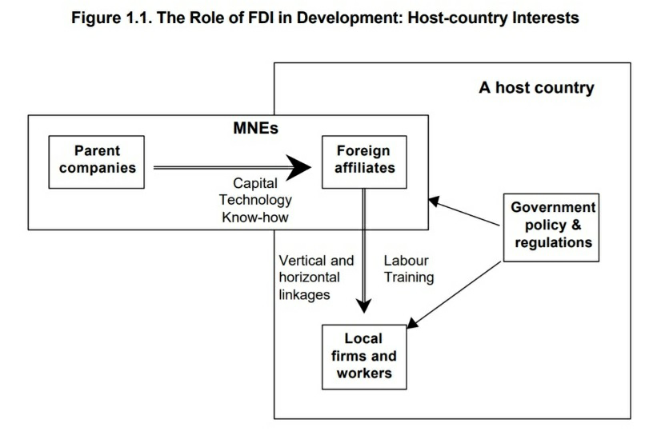

. **Arguments which are in favor of foreign capital inflow are as follows:-**

* SUSTAINING A HIGH LEVEL OF INVESTMENT: In this modern era of globalization all the developing and under developed countries want to extend their reach in terms of industrialization and further develop themselves, therefore for a fair and better industrialization it becomes necessary to raise the level to investment substantially. Savings are quite low because of low GDP and poverty. So there is a requirement to narrow the gap between savings and income through FDI’s.

TECHNOLOGICAL GAP: Generally we need technical expertise from foreign sources for provision of, training of Indian personnel and educational, research and training institutions, expert services.

* EXPLOITATION OF NATURAL RESOURCES: India has abundant amount of natural resources like coal, petroleum, natural gas, various kinds of ores, but to extract them we need foreign technology.
* UNDERSTANDING THE INITIAL RISK: There is risk of investments in new projects or ventures for industrialization are high because capital is a scare resource in developing countries. Therefore foreign capital reduces that high risk by investments.
* DEVELOPMENT OF BASIC ECONOMIC INFRASTRUCTURE: In the recent years

Governments of advanced countries and foreign financial institutions have made substantial capital available to the developing countries. FDI will help in establishing firm’s different parts in the country, thus developing the infrastructure. For improvising the industrial growth governments are developing special economic zones

* IMPROVEMENT IN THE BALANCE OF PAYMENTS POSITION: The inflow

FDI will lead to improve the balance of payment. Goods that can be produced at a low cost in India will be produced in the country itself and export the same, this will help in increasing the exports.

* INCREASE IN THE COMPETITION: Foreign companies proved to be better than domestic ones in terms of technology, innovations and process. This healthy competition causes better performance for the existing companies.

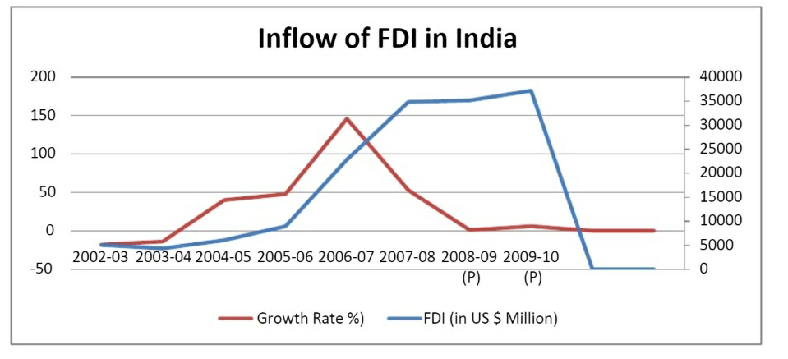

**Impact on Indian economy**

FDI’s helps in developing the economy by providing employment to the unemployed, , Financial stability to the government, Generating revenues in the form of tax and incomes, development of infrastructure, forward and backward linkages to the domestic firms for the requirements of raw materials, business infrastructure, tools and act as support for financial system. Foreign firms are supported through developing forward and back ward linkages with supply of raw and other requirements. It helps in reducing poverty and also helps in employment generation. The proposals that are approved by the foreign investment board from the time period of February 2003 to December.2009 were 3511 proposals and the proposed inflows of FDI is 194708.83 (Rs. in Crores). During 2009 alone FIPB approved 300 proposals with FDI inflow of Rs.404111 crores. Then in the thirteenth round second quarter of financial year 2011 of the professional forecaster’s survey conducted by the RBI, expects the real GDP growth to be marginally higher at 8.5 percent in financial year 2011 from the last survey.

**SECTORAL COMPOSITION OF FDI: -**

The Sectoral composition of FDI over the period of April 2000 to June 2015, from this we can find that the largest recipient of such huge investment is service sector (Financial and non-financial services). The share of this sector in cumulative FDI flows is 27 % of the inflow total FDI.

The foreign investors are attracted mainly by financial services due its profit generating advantage. This sector provides scope for the foreign investor to take back the profits to the home country. In service sector the services are consumed in the host country and there by generating outflow of funds from the host country.

The second recipient which shares 14% of total FDI is Construction Development sector Telecommunication, Computer software and hardware, , Automobile industry, Drugs and pharmaceuticals, Chemical (Other than Fertilizers), Power, Metallurgical industries, Hotel and tourism contribute 11%,11%,8%,8%,7%,6%,6%2% respectively.

The important points regarding global flows are – the increase in the relative share of developing countries as both destination and sources and flow to the sector gaining over manufacturing.

To limit the foreign direct investments RBI has designed Sectoral limits or caps 100% investment has been allowed to the following sectors-, NBFC’S, private sector banking, petroleum, housing and Real estate, Hotel and tourism, road and highways, ports and harbors, advertising, films, mass raped transportation, power, drug and pharmaceuticals, pollutions control and management and special economic zones. Other sectors such as airports are allowed with 74% caps and telecommunication with 49% and insurance with 26%.

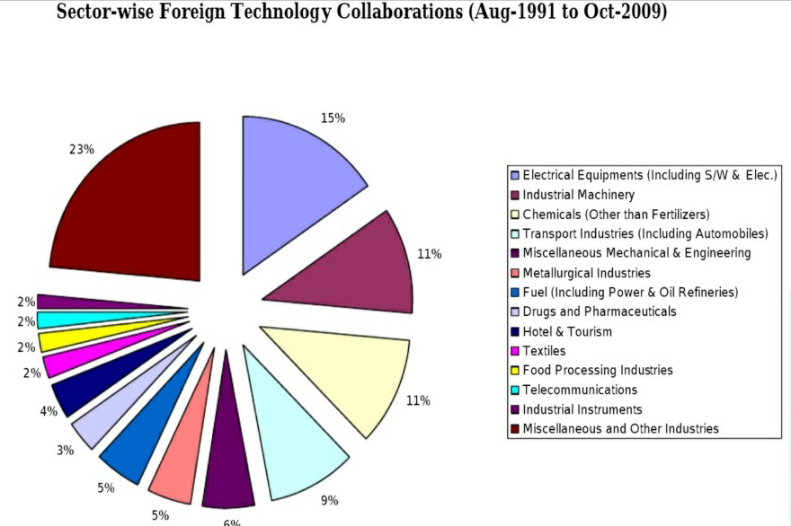

**FINDINGS**

**STATUS OF FDI IN INDIA (TILL 2015):**

As of June 2015, the Government of India allowed FDI in single and multi-brand retailing with the following conditions: -

1. Up to 100% FDI in single brand retail trading.

* By only one non-resident entity whether owner or the brand or otherwise.
* Rather than compulsory, 30% domestic sourcing requirement eased to preferable sourcing is provided.
* Product should be sold under the same brand internationally i.e. of a “single brand”
* “Single brand” product retailing would cover only products, which are branded during manufacturing.

1. Up to 51% FDI in multi brand retail trading.

* At least 100 million US$ must be invested into Indian company.
* Within 3 years at least 50% of the total FDI is to be invested in back end infrastructure
* At least 30% of the value of procurement of processed product shall be sourced from Indian small industry. Fresh agriculture produce is permitted to be sold unbranded.
* Indian states have been given the privilege to accept or refuse the implementation of FDI.
* Retail outlets can be set up in cities having population of at least 1 million.
* Application needs to be approved by two levels at Department of Industrial Policy and Promotion and Foreign Investment Promotion Board.

**PROBLEMS FOR LOW FDI FLOW TO INDIA: -**

India is the largest democratic country with the second largest population in the world, with rule of law and a highly educated English speaking work force, the country is considered as a safe haven for foreign investors.

But still, India is facing to from a host of self-imposed restrictions and problems regarding opening its markets completely too global investors by implementing full scale economic reforms. India’s poor performances in the area of FDI are due to the following reasons: political instability, poor infrastructure, confusing tax and tariff policies, Draconian labour laws, well entrenched corruption and governmental regulations.

* + Inadequate infrastructure:

It is one of the major reasons that cause low FDI inflows into India. This leads to discourage foreign investors in investing in India .Poor supply of electricity is also one of the hurdle and biggest infrastructure problem. Due to this many companies are forced to shut their businesses as of frequent power cuts.

* + Strict labour laws:

In India large firms are not allowed to reduce or cut off any workers, or close down the unit without the permission of the state government. Thus provide legitimate attempts to restructure business and protect the laws. To reduce unnecessary workers, firms need approval from both employees and state governments-approval that is barely given. Trade Unions also try to extort huge chunk of money from companies through over-generous voluntary retirement schemes.

* + Corruption:

We found Corruption in nearly every public service, from defence to education sector, from distribution of subsidized food to the poor people, to the generation and transmission of electric power. The combination of legal issues, lack of institutional reforms, decision-making by certain bureaucrats and the allegations of corruption at the higher level have turned foreign investors away from India

.

* + Poor decision-making of authorities with the state governments:

The State Governments are not given much power to reform process of liberalization of economy but the Centre government has the privilege to do so. Generally, the central government remains in control in most of the important infrastructure areas. Examples such as Brazil, Russia and China where regional governments take the charge in pushing reforms and prompting further actions by the central government.

Lack of export processing zones: Due to factors like relatively limited scale; the Government’s general uncertainty about attracting FDI; the unclear and changing incentive packages attached to the zones; and the control of the central government in the regulation of the zones, India is lacking in export processing zones. India has failed to develop the zones as one can compare to China which took initiative for establishment only in 1980 and on the other hand India established its first Export Processing Zone in 1965.

* + High corporate tax rates:

Foreign companies are paying a rate of 48 percent in India as compared to what they pay in East Asia as corporate tax which is in the range of 15 to 30 percent. This is the reason that India is lagging behind in foreign corporate investment and companies step back by looking at much higher corporate tax rates as compared to others.

* + Political instability and poor decision making by government:

The direct inflow of FDI in India is affected by many anomalies on the side of government during the last two decades such as mismanagement and suppression by the different company, which further affect the image of the country and also proves to be a decisive factor for the prospective investor, who is very much conscious about constant return and safety on their investment.

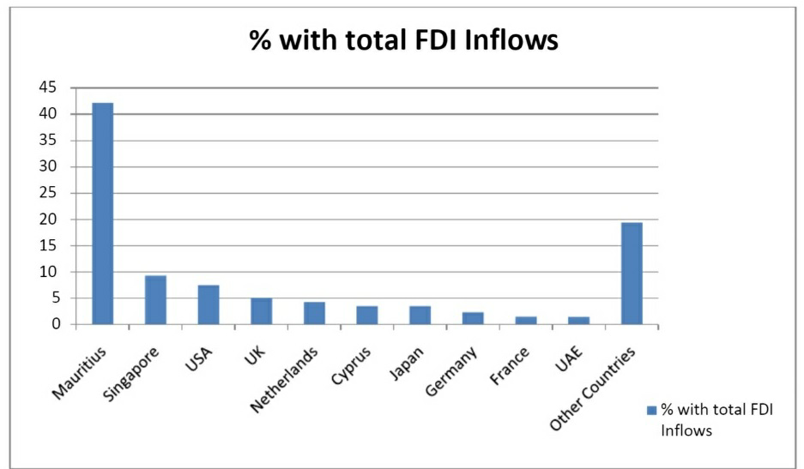

**There are two types of implications i.e. positive and negative as per following:**

**Positive Implications:**

a) FDI is a source of capital which is generally missing in the target country-Long term capital is suitable for economic development.

b) Foreign investors are able to finance their investments projects at cheaper and better rates.

(c) Creation of new workplaces by foreign corporations

d) FDI bring new technologies that are usually not available in the target country-There is empirical evidence that there are spill-over effects as the new technologies usually spread beyond the foreign corporations.

e) Foreign corporations provide better access to foreign markets-Ex. Foreign corporations can provide useful contacts even for their domestic subcontractors.

f) Foreign corporations bring new know-how and managerial skills into the target country- Again, there is a spill-over effect – as people leave the corporations they leave with the knowledge and know-how they accumulated.

g) Foreign corporations can help to change the economic structure of the target country- With a good economic strategy government can attract companies from promising and innovative sectors. h) “Crowding in” effect-The foreign corporations often bring additional investors into the target country (ex. their usual subcontractors).

i) Foreign corporations improve the business environment of the target country-Ethical business or rules of conduct.

j) Foreign corporations bring new “clean” technologies that help to improve the environmental conditions.

k) Foreign corporations usually help increase the level of wages in the target economy.

l) Foreign corporations usually have a positive effect on the trade balance.

**Negative Implications**:

a) Foreign corporations may buy a local company in order to shut it down (and gain monopoly for example).

b) “Crowding out” effect- We can see this effect if the foreign corporations target the domestic market and domestic corporations are not able to compete with these corporations.

c) Foreign corporations may cut working positions (privatization deals or M&A transactions).

d) Foreign corporations have a tendency to use their usual suppliers which can lead to increased imports (no problem if the production is export driven).

e) Repatriation of the profits can be stressful on the balance of payments.

f) The high growth of wages in foreign corporations can influence a similar growth in the domestic corporations which are not able to cover this growth with the growth of productivity- The result is the decreasing competitiveness of domestic companies.

g) Missing tax revenues- If the foreign corporations receive tax holidays or similar provisions.

**SUGGESTIONS**

**SUGGESTIONS FOR INCREASED FLOW OF FDI INTO THE COUNTRY:**

1. Flexible labour laws needed:

China gets maximum FDI in the manufacturing sector, which has helped the country become the manufacturing hub of the world. In India the manufacturing sector can grow if infrastructure facilities are improved and labour reforms take place. The country should take initiatives to adopt more flexible labour laws.

1. Re look at sectoral caps:

Though the Government has hiked the sectoral cap for FDI over the years, it is time to revisit issues pertaining to limits in such sectors as coal mining, insurance, real estate, and retail trade, apart from the small-scale sector. Government should allow more investment into the country under automatic route. International Journal of Scientific and Research Publications, Volume 5, Issue 10, October 2015 29 ISSN 2250-3153 www.ijsrp.org Reforms like bringing more sectors under the automatic route, increasing the FDI cap and simplifying the procedural delays has to be initiated. There is need to improve SEZs in terms of their size, road and port connectivity, assured power supply and decentralized decision-making.

1. Geographical disparities of fdi should be removed:

The issues of geographical disparities of FDI in India need to address on priority. Many states are making serious efforts to simplify regulations for setting up and operating the industrial units. However, efforts by many state governments are still not encouraging. Even the state like

West Bengal which was once called Manchester of India attracts only 1% of FDI inflow in the country. West Bengal, Bihar, Jharkhand, Chhattisgarh are endowed with rich minerals but due to lack of proper initiatives by governments of these states, they fail to attract FDI.

1. Promote Greenfield projects:

India’s volume of FDI has increased largely due to Merger and Acquisitions (M&As) rather than large Greenfields projects. M&A’s not necessarily imply infusion of new capital into a country if it is through reinvested earnings and intra company loans. Business friendly environment must be created on priority to attract large Greenfields projects. Regulations should be simplified so that realization ratio is improved (Percentage of FDI approvals to actual flows). To maximize the benefits of FDI persistently, India should also focus on developing human capital and technology.

1. Develop debt market:

India has a well developed equity market but does not have a well developed debt market. Steps should be taken to improve the depth and liquidity of debt market as many companies may prefer leveraged investment rather than investing their own cash. Therefore it is said that countries with well-developed financial markets tend to benefits significantly from FDI inflows.

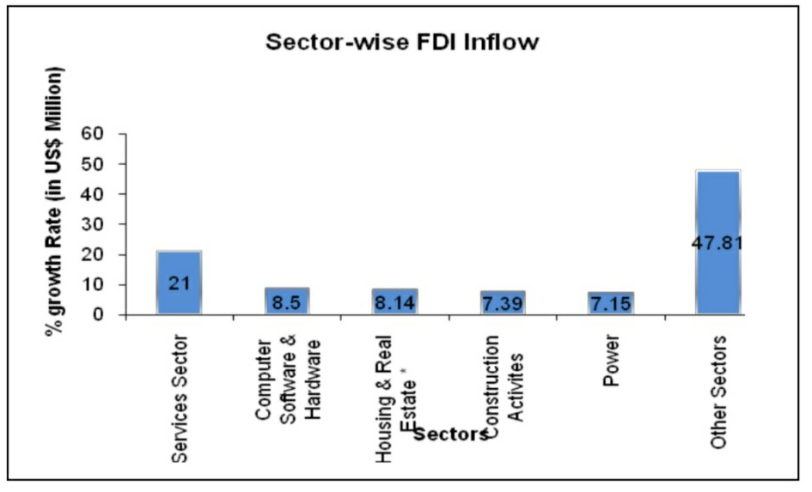

1. Education sector should be opened to FDI:

India has a huge pool of working population. However, due to poor quality primary education and higher education, there is still an acute shortage of talent. FDI in Education Sector is lesser than one percent. By giving the status of primary and higher education in the country, FDI in this sector must be encouraged. However, appropriate measure must be taken to ensure quality education. The issues of commercialization of education, regional gap and structural gap have to be addressed on priority.

1. Strengthen research and development in the country: India should consciously work towards attracting greater FDI into R&D as a means of strengthening the country’s technological prowess and competitiveness.

**Conclusion**

FDI has played a significant role in India for both it's economic growth as well as development. FDI can attain sustained economic growth and development in various sectors through creating more and more job opportunities and expanding the existing manufacturing industries. The inflow of FDI in various sectors like construction, development and service has attained substantial sustained economic and development of growth in India through the creation of jobs during the period of April,2000 to June, 2015.

There were few other sectors where FDI showed their interest and those are namely - Computer, Software and Hardware, Drugs and Pharmaceuticals.

FDI has played a major role in raising the Output, Productivity and Employability in many sectors and especially in Service sector.

On the other hand banking and insurance sector helps in developing the foreign exchange system in the country and helps in strengthening the Indian economic system.

So, we drive to the conclusion that FDI always support the industries running on Small Scale, and also helps in creating employability in the country, and also helps the country through liberalization and globalization to put an impression on the world wide level.

**Bibliography**

The sources and references for this secondary study has been done from the following:

1.https://www.hbs.edu/faculty/Publication%20Files/FDICapital_Formatted_20170922_Final_W_c7fcb82c-f318-4632-a589-20118eaeebf8.pdf

2.<http://zenithresearch.org.in/images/stories/pdf/2012/JUNE/ZIJMR/9_ZIJMR_VOL2_ISSUE6_JUNE2012.pdf>

3. <http://www.ijetsr.com/images/short_pdf/1498728725_752-765-ieteh252_ijetsr.pdf>

4. <https://www.pymnts.com/news/retail/2018/reliance-industries-walmart-amazon-india/>

5. <http://sezindia.nic.in/>

6. <https://www.bestcurrentaffairs.com/latest-measures-attract-fdi-india/>

7. <https://www.google.co.in/search?rlz=1C1JZAP_enIN767IN767&ei=-J7aW7PYF4299QPiqYSIBw&q=SEZ+IN+FDI&oq=SEZ+IN+FDI&gs_l=psy-ab.3...2980.4645.0.4944.7.7.0.0.0.0.0.0..0.0....0...1c.1.64.psy-ab..7.0.0....0.ESwU_hS4LRo>

8.<https://www.google.co.in/search?q=SUGGESTIONS+FOR+ATTRACTING+MORE+FDI+S+IN+INDIA&rlz=1C1JZAP_enIN767IN767&oq=SUGGESTIONS+FOR+ATTRACTING+MORE+FDI+S+IN+INDIA&aqs=chrome..69i57.10271j1j7&sourceid=chrome&ie=UTF-8>

9.<https://www.researchgate.net/publication/275543791_Foreign_Direct_Investment_and_Economic_Growth_Literature_Review_from_1994_to_2012>

10. <https://www.jica.go.jp/jica-ri/IFIC_and_JBICI-Studies/jica-ri/publication/archives/jbic/report/paper/pdf/rp15_e.pdf>

11. <http://www.grips.ac.jp/teacher/oono/hp/docu01/paper14.pdf>

12. <https://www.researchgate.net/publication/271729440_AN_OVERVIEW_OF_FOREIGN_DIRECT_INVESTMENT_IN_INDIA>

13. <https://www.researchgate.net/publication/314809571_A_Research_Paper_on_Role_of_Foreign_Direct_Investment_FDI_in_Economic_Development_of_India>

14. <https://www.scribd.com/doc/48883592/Foreign-Direct-Investment-in-India-case-studies>

15. <https://www.investopedia.com/terms/f/fdi.asp>

16. <https://en.wikipedia.org/wiki/Foreign_direct_investment>

17. <https://www.ibef.org/economy/foreign-direct-investment.aspx>

18. <https://study.com/academy/lesson/what-is-foreign-direct-investment-definition-advantages-disadvantages.html>

19. https://www.thehindu.com/business/Economy/are-foreign-direct-investments-at-an-ebb/article24671759.ece