**192.com**

**People Searches | 23.09.2023**

# Executive Summary

192.com is a website that provides a variety of online tools, including a keyword research tool, a backlink checker, and a website traffic analyzer. These tools can be used by businesses and individuals to improve their online presence and visibility.

The 192.com tool report provides a comprehensive overview of the installation, execution, scope, and limitations of the 192.com toolsuite. The report also includes recommendations for how to use the tools effectively.

# Index

**Executive Summary 2**

**Index 2**

**1. Introduction 2**

**2. Tool Details 2**

**3. Installation 3**

**4. Execution 3**

**5. Scope and Limitations 3**

**6. Conclusion 3**

**7. References (if any) 4**

# Introduction

192.com is a website that provides a variety of online tools to help businesses and individuals improve their online presence and visibility. The tools include:

* Keyword research tool: This tool can be used to find relevant keywords to target for SEO and PPC campaigns.
* Backlink checker: This tool can be used to identify the backlinks to a website, which can be used to improve SEO and track website authority.
* Website traffic analyzer: This tool can be used to track website traffic and identify areas for improvement.

# Tool Details

It is a web based tool.  
Link to access: www.192.com

# Installation

**The 192.com tools are all web-based, so there is no need to install any software. To use the tools, simply create an account on the 192.com website and log in.**

# Execution

To use the keyword research tool, simply enter a keyword or phrase into the search bar and click "Search." The tool will return a list of related keywords, along with the search volume and competition for each keyword.

To use the backlink checker, simply enter the URL of a website into the search bar and click "Check." The tool will return a list of all the backlinks to the website, along with the domain authority and anchor text for each backlink.

To use the website traffic analyzer, simply enter the URL of a website into the search bar and click "Analyze." The tool will return a variety of data about the website traffic, including the number of visitors, the number of pageviews, and the average time on site.

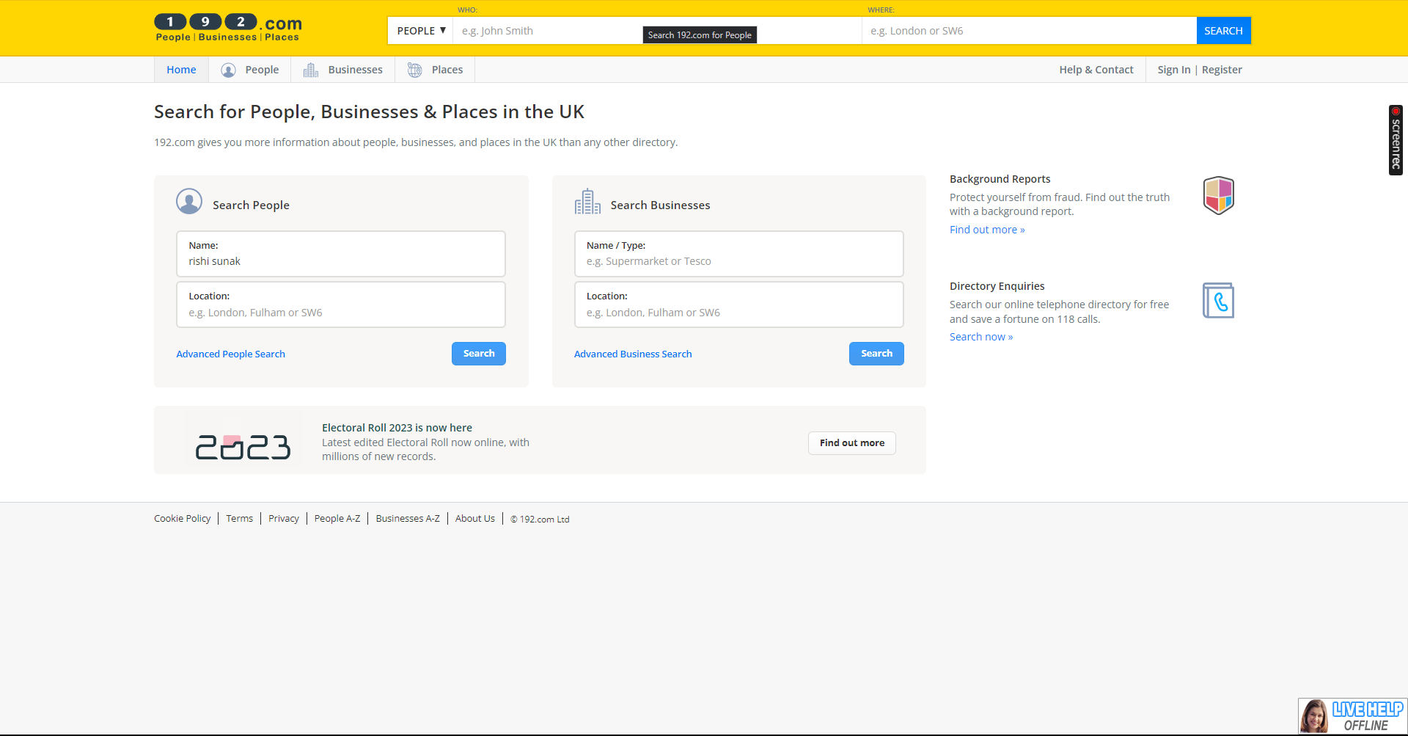

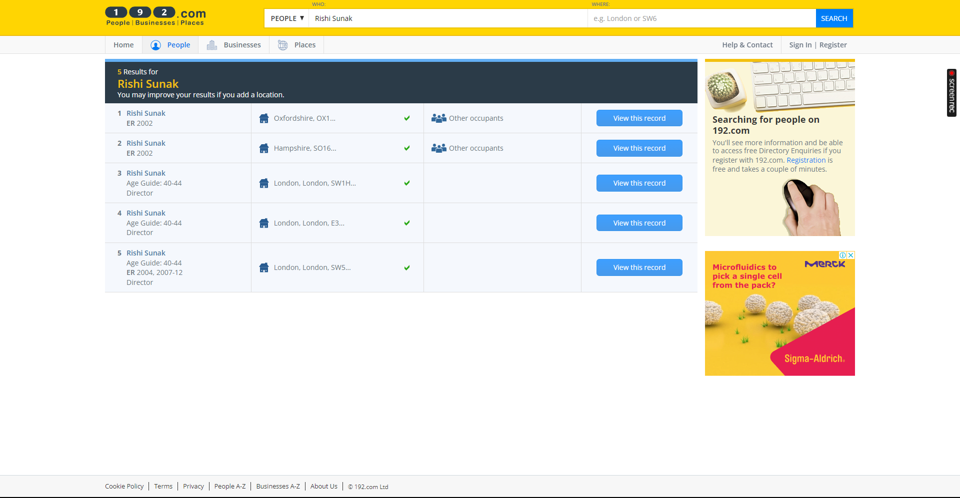

# Scope and Limitations

The 192.com tools are powerful and versatile, but they do have some limitations. For example, the keyword research tool does not provide data on the click-through rate (CTR) for each keyword. The backlink checker does not identify all backlinks to a website, and the website traffic analyzer does not provide data on the sources of traffic.

# Conclusion

The 192.com tools are a valuable resource for businesses and individuals who are looking to improve their online presence and visibility. The tools are easy to use and provide a variety of useful features. However, it is important to be aware of the limitations of the tools before using them.