**DEEPCYTES REPORT FORMAT**

**General rules: (to be followed on the backend)**

* Name the folder as ‘Report/ToolName_Vertical_YYYYMM_YourName’
* Folder should contain 3 files:
  + Documentation for the work done.
    - The documentation to be named as ‘Doc_ToolName_Vertical_YYYYMM_YourName’
  + .txt file of script for installation
    - The script file to be named as ‘Script_ToolName_Vertical_YYYYMM_YourName’
    - Should include a readme/comments section at the top of the script. (FORMAT TBD)
    - To update the index, click the ‘Update table of contents’ button. 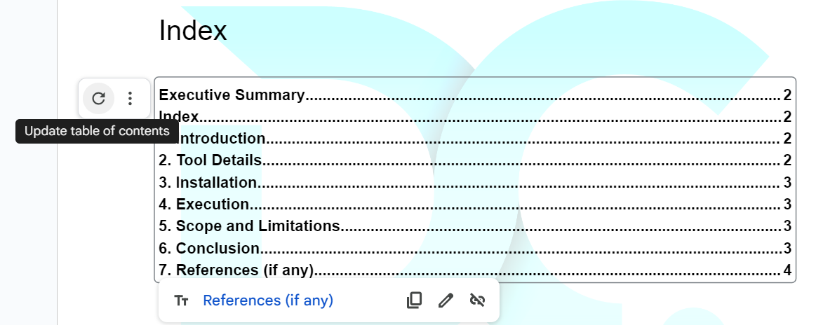
    - Format: Section Headers: Heading 1, Subheaders: Heading 2
  + Demo Video
    - The demo video to be named as ‘Demo_ToolName_Vertical_YYYYMM_YourName’
    - Video format: .mp4
    - Video should include all the use cases as stated in the use cases section in the document.
    - A VO explaining the working must be included.
* Access for this folder should be shared with your Team Manager, [info@deepcytes.io](mailto:info@deepcytes.io) , and any other IDs if mentioned.
* To start editing this document, make a copy and start Page 2 onwards.

**Biznar**

**Cyber Intel | Biznar | 23rd September 2023**

# Executive Summary

Biznar is a deep web search engine that returns high quality results by submitting your query to other search engines and collating, ranking and dropping duplicates in the results

# Index

Executive Summary 2

Index 2

1. Introduction 3

2. Tool Details 3

3. Installation 4

4. Execution 4

5. Scope and Limitations 7

6. Conclusion 8

7. References 8

# Introduction

Biznar is a deep web search engine developed by Deep Web Technologies. It uses a technique known as federated search to deliver results that other search engines, such as Google, Bing, and Yahoo, do not. Federated search works by submitting a query to multiple search engines and then combining and ranking the results. This allows Biznar to index and search a much wider range of content than other search engines, including content that is not publicly accessible on the surface web.

**Features:**

* **Access to the deep web:** Biznar can index and search content that is not publicly accessible on the surface web, such as content in databases, academic journals, and government websites.
* **Comprehensive search results:** Biznar combines the results from multiple search engines to deliver a more comprehensive set of results than other search engines alone.
* **Advanced search features:** Biznar offers a number of advanced search features, such as Boolean operators, field search, and proximity search.
* **Customizable dashboard:** Biznar users can customize their dashboard to save and track search results, create custom alerts, and export data to other applications

# Tool Details

Link to Tool: [biznar.com](http://biznar.com)

Dependency: None

Use Cases:

* Business Research
* Market Research
* Competitive Intelligence

Version worked on in the report: NA

Date of installation and run: 23rd September 2023

OS used: Windows and Kali Linux

GUI/CLI/Web: Web Based Tool

# Installation

**No Installation Required**

# Execution

**Use Case 1.** Company Research

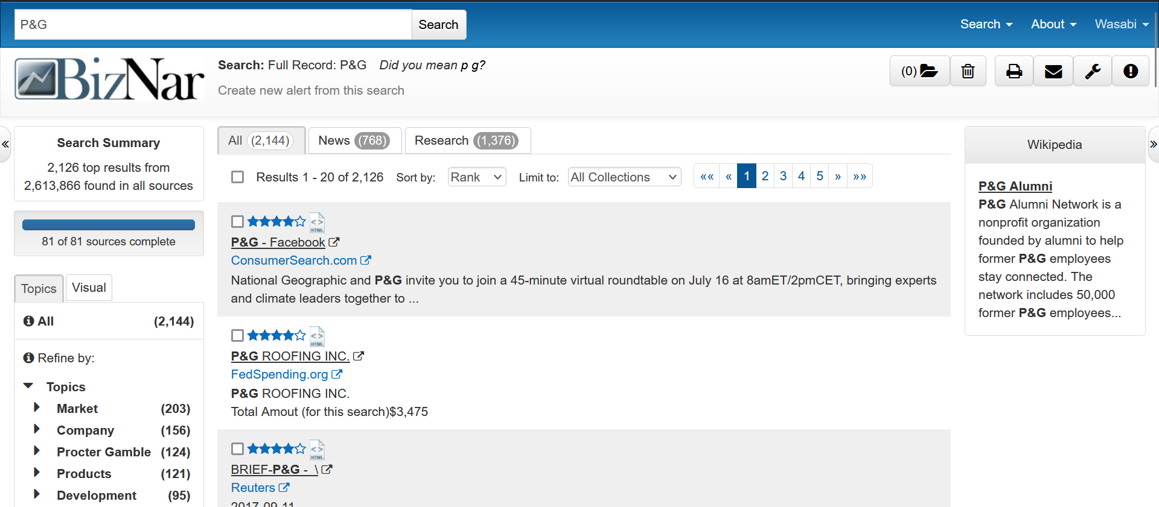

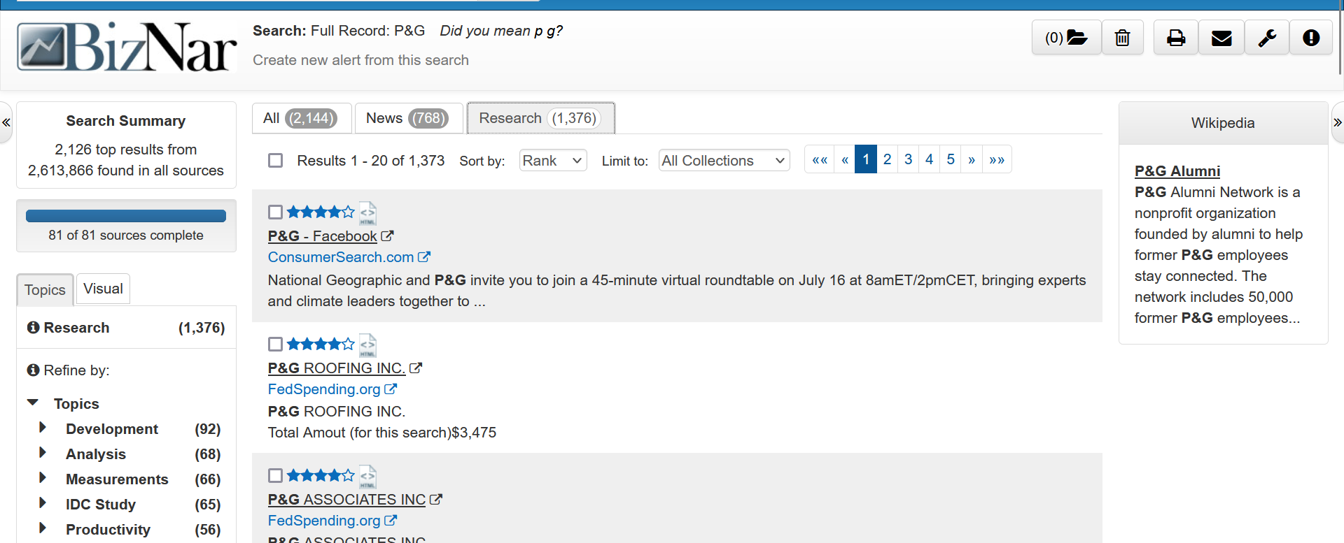

**Use Case 2.** Finding Research Papers

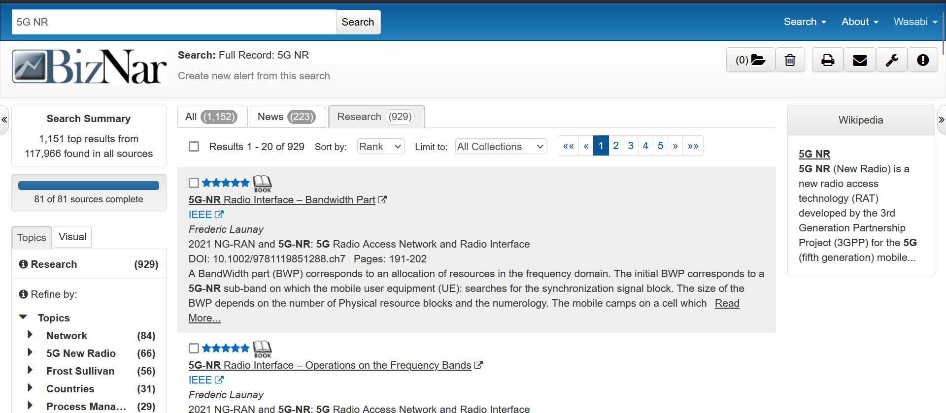

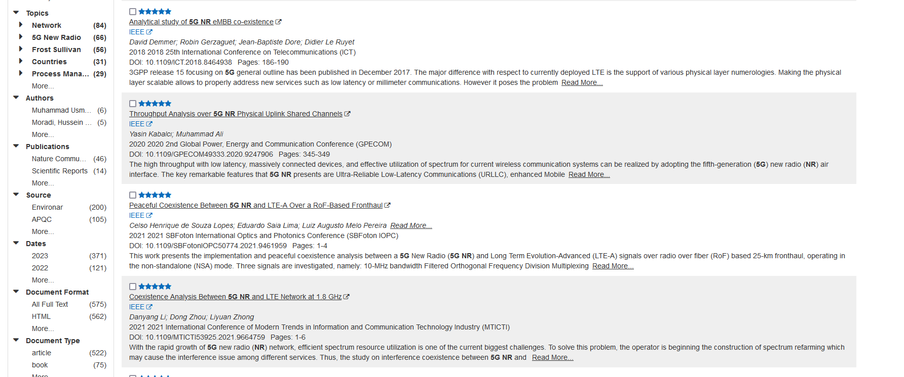

**Use Case 3.** Sensitive Content

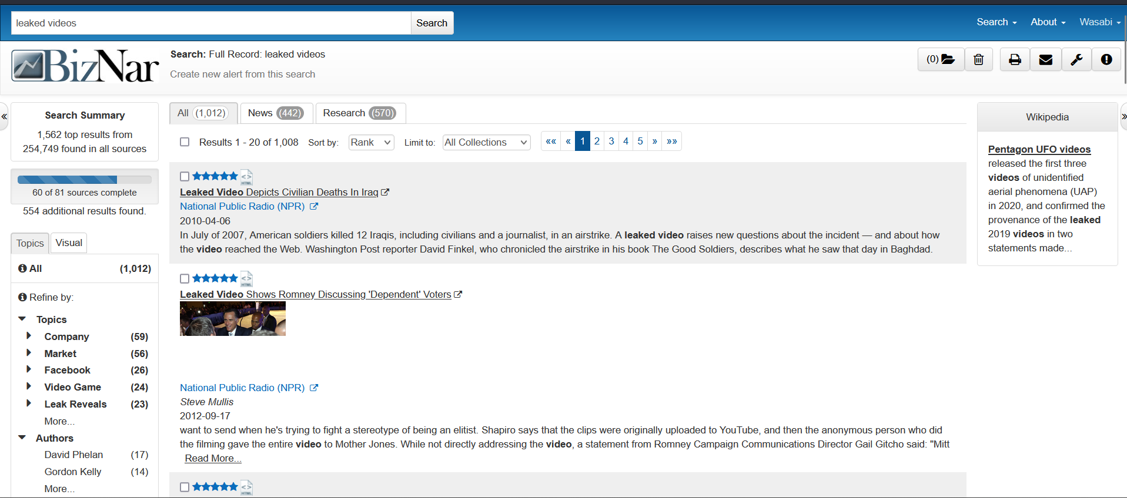

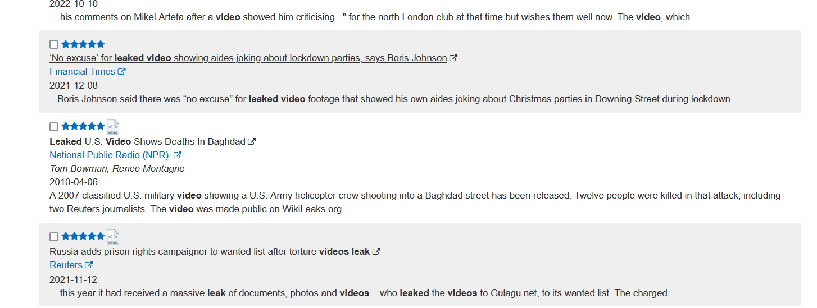

**Use Case 4.** Competitive Analysis

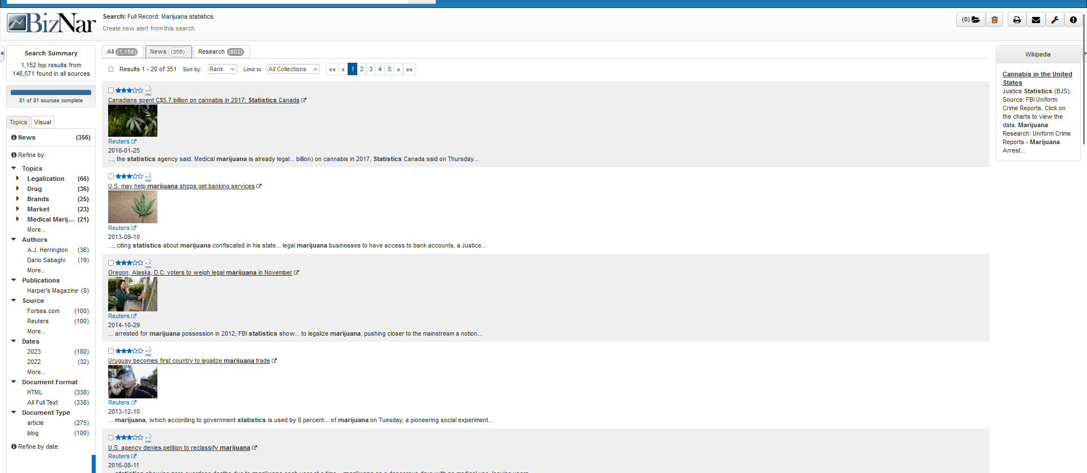

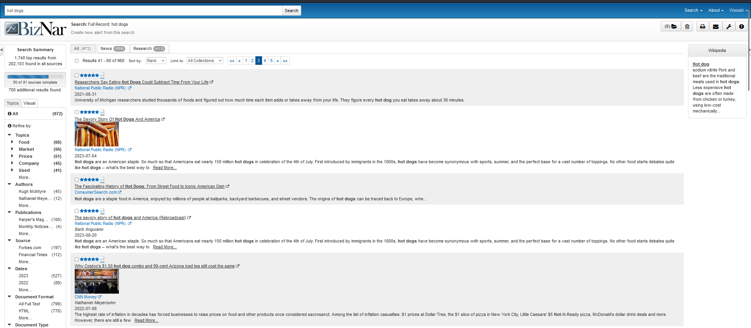

# Scope and Limitations

* **Limited coverage:** Biznar does not index and search all of the deep web. There are still many deep web databases and websites that are not accessible to Biznar.
* **Cost:** Biznar is a subscription-based service, which can be expensive for some users.
* **Relevance:** Biznar's search results may not always be relevant to the user's query. This is because Biznar combines the results from multiple search engines, which can include results that are not directly related to the user's query.

# Conclusion

Overall Biznar is a powerful search engine that can be used to find information on a wide range of topics, including business, market research, and competitive intelligence. It is a valuable tool for business users, researchers, and anyone else who needs to find comprehensive and accurate information.

# References

<https://mobilegroove.com/mobile-search-app-review-road-test-biznar/>