**DNS RECON TOOL**

**People Searches | 23.09.2023**

# Executive Summary

DNSDumpster is a free online tool that provides information about domain names and IP addresses. This information can include DNS records, subdomains, email addresses, and web servers. DNSDumpster can be used by businesses and individuals to gather information about their own domains and the domains of their competitors.

The DNSDumpster tool report provides a comprehensive overview of the installation, execution, scope, and limitations of the DNSDumpster tool. The report also includes recommendations for how to use the tool effectively.

# Index

**Executive Summary 2**

**Index 2**

**1. Introduction 2**

**2. Tool Details 2**

**3. Installation 3**

**4. Execution 3**

**5. Scope and Limitations 3**

**6. Conclusion 3**

**7. References (if any) 4**

# Introduction

DNSDumpster is a free online tool that provides information about domain names and IP addresses. This information can include DNS records, subdomains, email addresses, and web servers. DNSDumpster can be used by businesses and individuals to gather information about their own domains and the domains of their competitors.

DNSDumpster is a valuable tool for a variety of tasks, including:

* Identifying subdomains: DNSDumpster can be used to identify all of the subdomains associated with a domain name. This can be useful for businesses that want to identify all of their subdomains, or for individuals who want to identify all of the subdomains associated with a competitor's domain name.
* Finding email addresses: DNSDumpster can be used to find email addresses associated with a domain name. This can be useful for businesses that want to identify all of the email addresses associated with a competitor's domain name, or for individuals who want to identify all of the email addresses associated with a particular domain name.
* Identifying web servers: DNSDumpster can be used to identify the web servers that are hosting a domain name. This can be useful for businesses that want to identify the web servers that are hosting their competitors' domains, or for individuals who want to identify the web servers that are hosting a particular domain name.

# Tool Details

It is a web based tool.  
Link to access: <https://dnsdumpster.com/>

# Installation

**No installation needed.**

# Execution

To use the DNSDumpster tool, simply enter the domain name or IP address that you want to search into the search bar and click the "Search" button. DNSDumpster will then return a list of information about the domain name or IP address.

The type of information that is returned will depend on the type of search that you perform. For example, if you perform a DNS record lookup, DNSDumpster will return a list of DNS records for the domain name. If you perform a subdomain search, DNSDumpster will return a list of subdomains associated with the domain name.

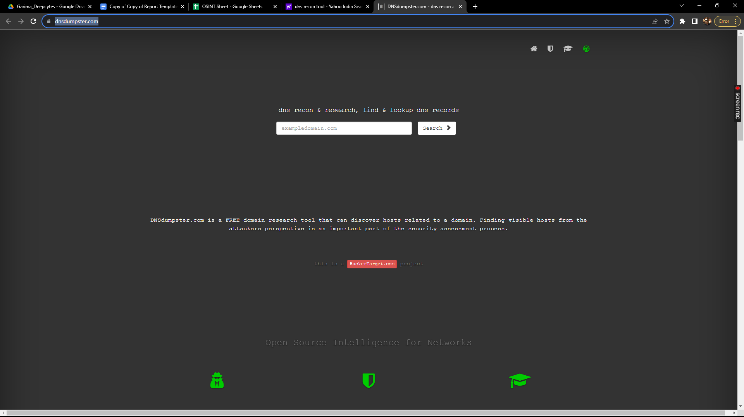

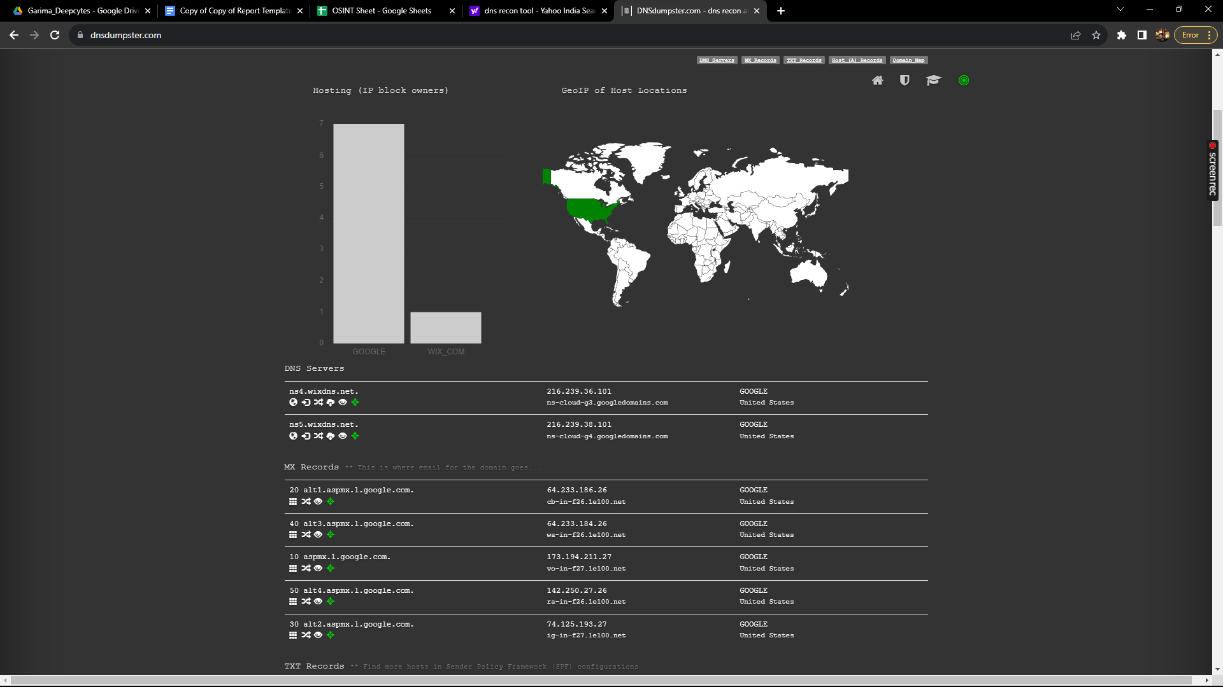

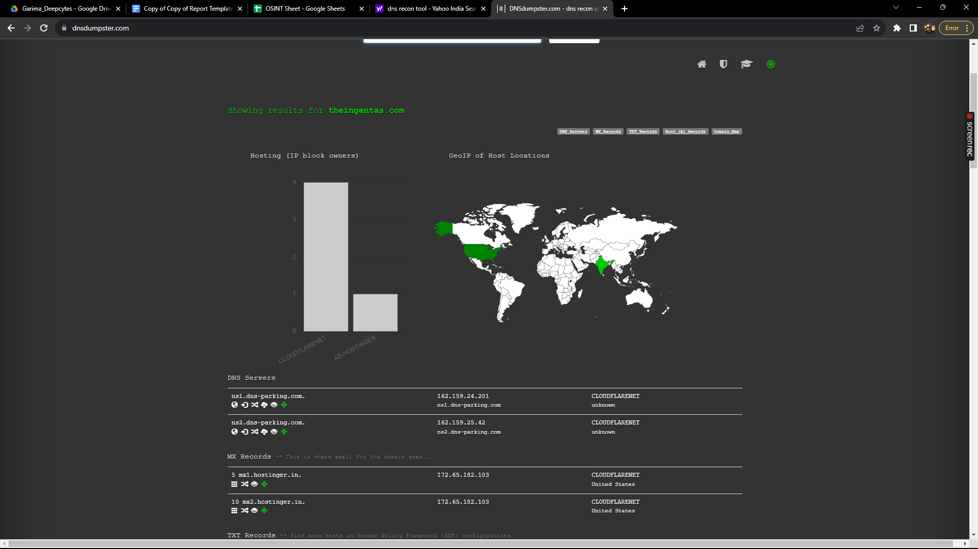

# Scope and Limitations

DNSDumpster is a powerful tool for gathering information about domain names and IP addresses. However, it is important to be aware of the limitations of the tool.

It can only return information about domain names and IP addresses that are publicly accessible. DNSDumpster cannot return information about domain names and IP addresses that are hidden or private.

Additionally, it cannot guarantee that the information that it returns is accurate or up-to-date. It is possible that the information that DNSDumpster returns may be incorrect or out of date.

# Conclusion

DNSDumpster is a valuable tool for businesses and individuals who want to gather information about domain names and IP addresses. The tool is easy to use and provides a variety of useful features. However, it is important to be aware of the limitations of the tool before using it.