**Have I Been Pwned**

**People Searches | 23.09.2023**

# Executive Summary

Have I Been Pwned (HIBP) is a free website that allows users to check if their email addresses or phone numbers have been compromised in a data breach. HIBP has a database of over 12 billion passwords and email addresses that have been leaked in publicly known breaches.

HIBP is a valuable tool for anyone who wants to protect their online security. By checking their email addresses and phone numbers on HIBP, users can learn if their information has been compromised and take steps to protect their accounts.

# Index

**Executive Summary 2**

**Index 2**

**1. Introduction 2**

**2. Tool Details 2**

**3. Installation 3**

**4. Execution 3**

**5. Scope and Limitations 3**

**6. Conclusion 3**

**7. References (if any) 4**

# Introduction

Data breaches are a serious and growing problem. In recent years, there have been numerous high-profile data breaches that have exposed millions of people's personal information. This information can be used by criminals to commit identity theft, fraud, and other crimes.

HIBP was created to help people protect themselves from the risks of data breaches. HIBP allows users to check if their email addresses or phone numbers have been compromised in a data breach. If a user's information has been compromised, HIBP will provide them with information about the breach and steps they can take to protect their accounts.

# Tool Details

* It is a Web-Based tool.
* Link to access:https://haveibeenpwned.com/

# Installation

**No Installation needed.**

# Execution

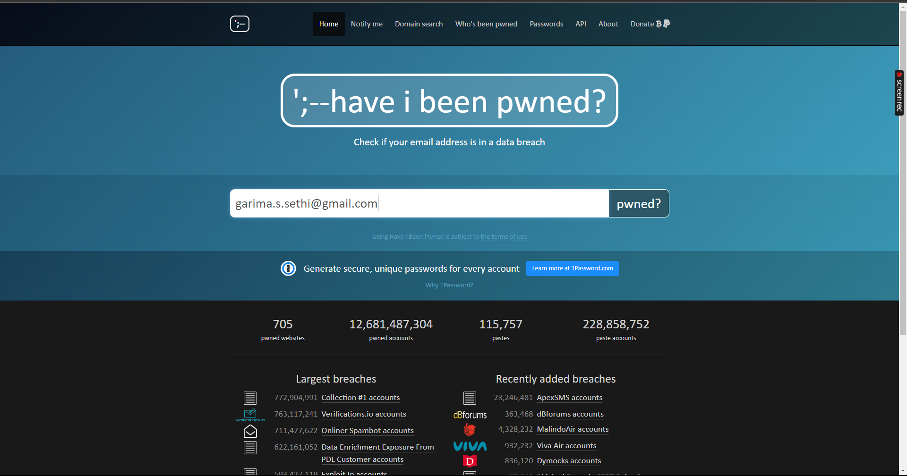

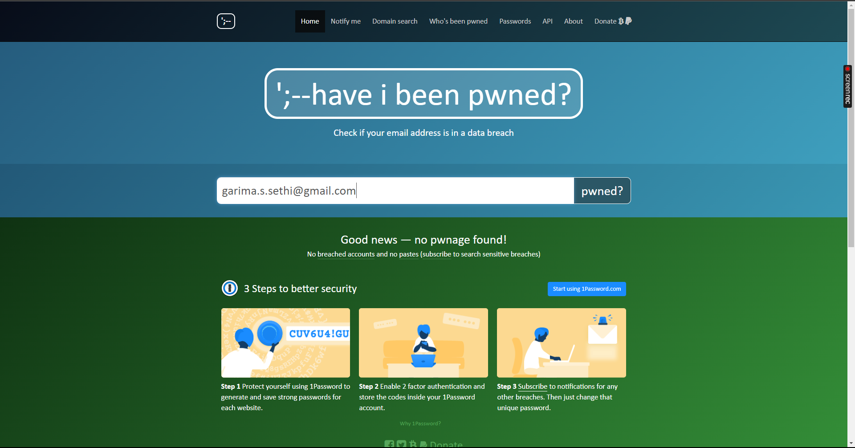

# Scope and Limitations

HIBP is a valuable tool for anyone who wants to protect their online security. However, it is important to be aware of the scope and limitations of the tool.

HIBP is limited to the information that has been publicly disclosed in data breaches. If a user's information has been compromised in a data breach that has not been publicly disclosed, HIBP will not be able to detect it.

Additionally, HIBP is only able to detect breaches of email addresses and phone numbers. HIBP cannot detect breaches of other types of personal information, such as Social Security numbers, credit card numbers, or medical records.

# Conclusion

HIBP is a valuable tool for anyone who wants to protect their online security. It is easy to use and provides users with important information about whether or not their email addresses or phone numbers have been compromised in a data breach.

While HIBP has some limitations, it is still a valuable tool for protecting yourself from the risks of data breaches. It is important to check your email addresses and phone numbers on HIBP regularly, especially if you have heard about a data breach that may have affected you.

Recommendations

Here are some recommendations for using HIBP effectively:

Check your email addresses and phone numbers on HIBP regularly.

If you are notified that your email address or phone number has been compromised in a data breach, take steps to protect your accounts, such as changing your passwords and enabling two-factor authentication.

Use strong and unique passwords for all of your online accounts.

Be careful about clicking on links in emails or opening attachments from unknown senders.

Keep your software up to date, including your operating system, browser, and security software.