**Knowem**

**People Searches | 23.09.2023**

# Executive Summary

Knowem is a web-based tool that provides a variety of services, including brand protection, domain monitoring, and social media monitoring. Knowem can be used by businesses and individuals to protect their brands online, monitor their competitors, and identify potential risks.

The Knowem tool report provides a comprehensive overview of the installation, execution, scope, and limitations of the Knowem toolsuite. The report also includes recommendations for how to use the tools effectively.

# Index

**Executive Summary 2**

**Index 2**

**1. Introduction 2**

**2. Tool Details 2**

**3. Installation 3**

**4. Execution 3**

**5. Scope and Limitations 3**

**6. Conclusion 3**

**7. References (if any) 4**

# Introduction

Knowem is a web-based tool that provides a variety of services, including brand protection, domain monitoring, and social media monitoring. Knowem can be used by businesses and individuals to protect their brands online, monitor their competitors, and identify potential risks.

Knowem's brand protection services include trademark monitoring, domain monitoring, and social media monitoring. Knowem's domain monitoring services include domain registration monitoring, domain transfer monitoring, and domain expiration monitoring. Knowem's social media monitoring services include social media account monitoring, social media post monitoring, and social media hashtag monitoring.

# Tool Details

It is a web based tool.  
Link to access: https://knowem.com/

# Installation

**No installation needed.**

# Execution

To use the Knowem brand protection tools, simply enter your brand name into the search bar and click the "Search" button. Knowem will then search for your brand name across a variety of online sources, including social media platforms, websites, and domain name registrars.

To use the Knowem domain monitoring tools, simply enter the domain name that you want to monitor into the search bar and click the "Add Domain" button. Knowem will then monitor the domain name for any changes, such as a change in ownership or a change in DNS records.

To use the Knowem social media monitoring tools, simply enter the social media account or hashtag that you want to monitor into the search bar and click the "Add Account" button. Knowem will then monitor the social media account or hashtag for any changes, such as a new post or a new comment.

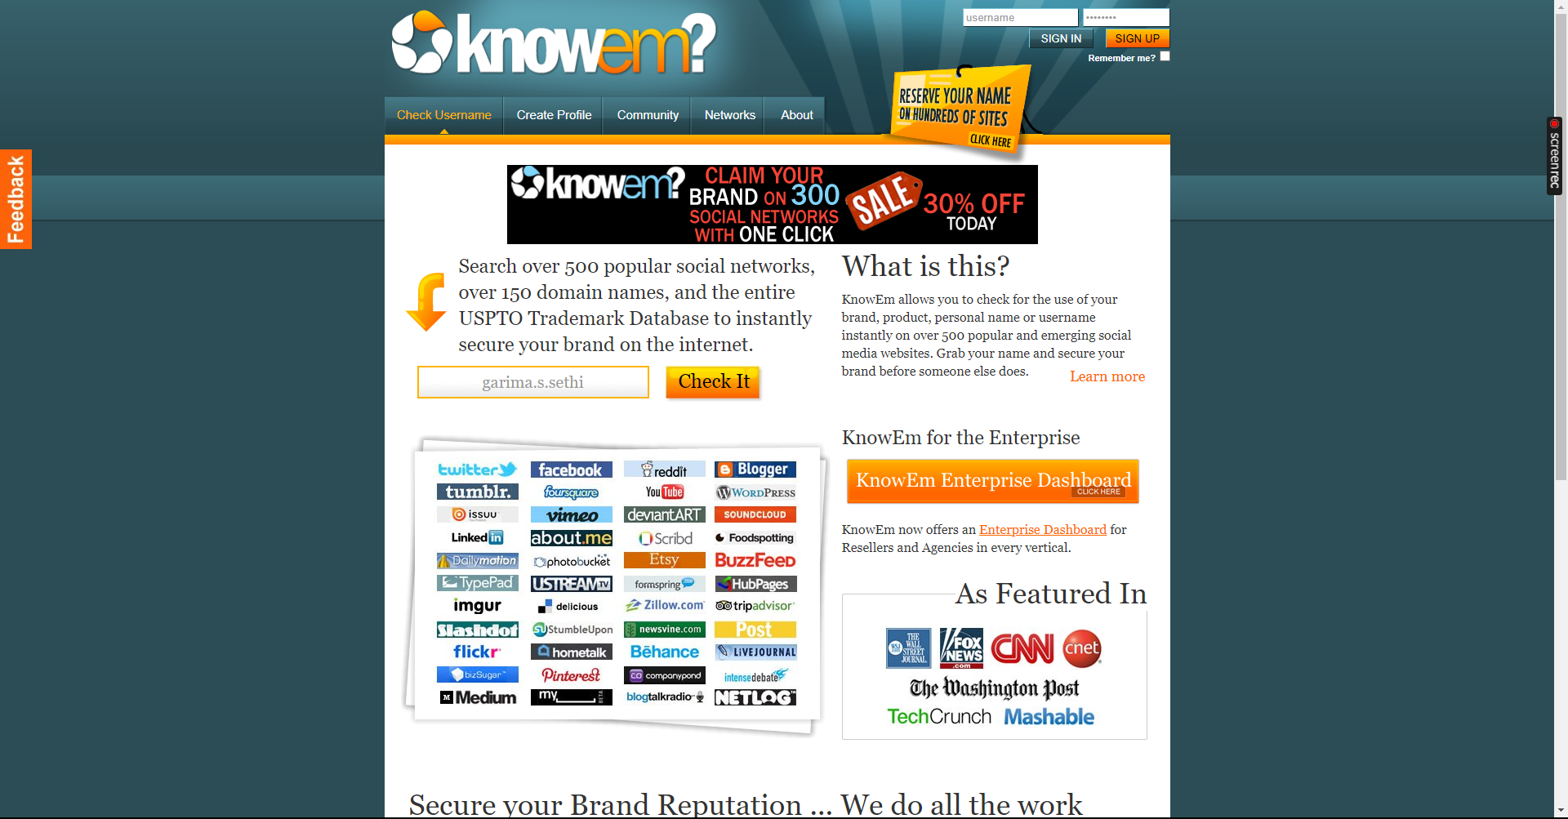

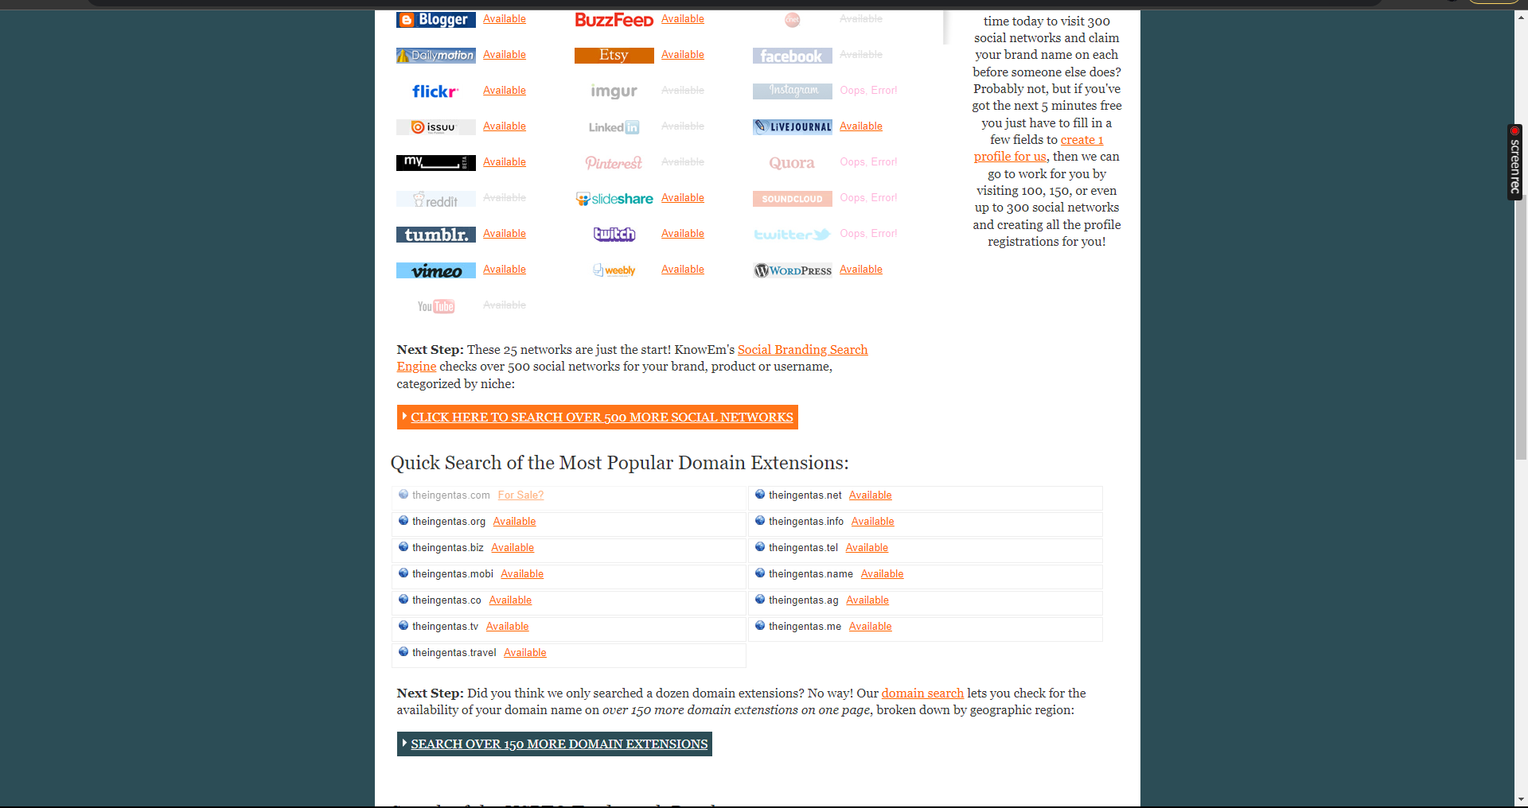

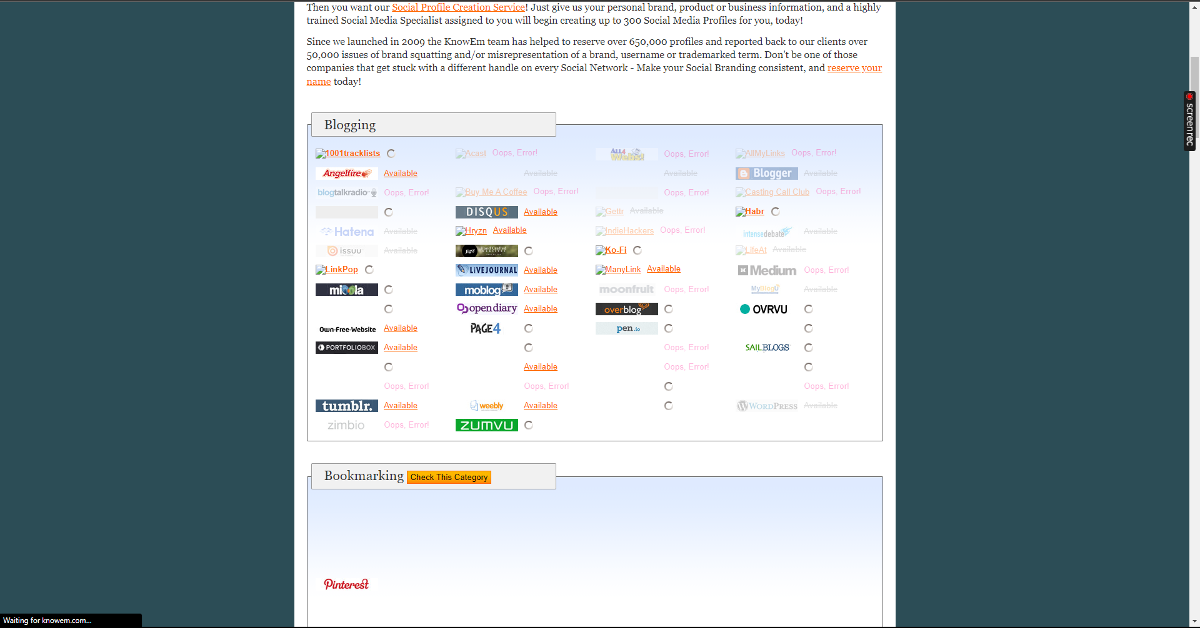

# Scope and Limitations

Knowem is a powerful tool for protecting brands online, monitoring competitors, and identifying potential risks. However, it is important to be aware of the limitations of the tool.

Knowem does not monitor all online sources. For example, Knowem does not monitor all social media platforms or all websites. Additionally, it does not monitor private social media networks.

Knowem also does not guarantee that it will identify all potential risks. It is possible that it could miss a potential risk if it is not monitored by Knowem.

# Conclusion

Knowem is a valuable tool for businesses and individuals who want to protect their brands online, monitor their competitors, and identify potential risks. The tool is easy to use and provides a variety of useful features. However, it is important to be aware of the limitations of the tool before using it.