**Namechk**

**People Searches | 23.09.2023**

# Executive Summary

Namechk is a free online tool that allows users to check the availability of a username or domain name across a variety of social media platforms and websites. This can be useful for businesses and individuals who want to create a consistent brand presence online.

The Namechk tool report provides a comprehensive overview of the installation, execution, scope, and limitations of the tool. The report also includes recommendations for how to use the tool effectively.

# Index

**Executive Summary 2**

**Index 2**

**1. Introduction 2**

**2. Tool Details 2**

**3. Installation 3**

**4. Execution 3**

**5. Scope and Limitations 3**

**6. Conclusion 3**

**7. References (if any) 4**

# Introduction

Namechk is a free online tool that allows users to check the availability of a username or domain name across a variety of social media platforms and websites. This can be useful for businesses and individuals who want to create a consistent brand presence online.

Namechk supports over 100 social media platforms and websites, including Twitter, Facebook, Instagram, YouTube, and LinkedIn. It also supports domain name registrars such as GoDaddy and Namecheap.

# Tool Details

It is a web-based tool.

Link to access: https://namechk.com/

# Installation

**No installation needed.**

# Execution

To use the Namechk tool, simply enter the username or domain name that you want to check into the search bar and click the "Check" button. Namechk will then check the availability of the username or domain name on the supported social media platforms and websites.

For each platform or website, Namechk will display a green checkmark if the username or domain name is available, and a red X if it is unavailable. Namechk will also display the domain authority of each website, which can be useful for assessing the quality of the website.

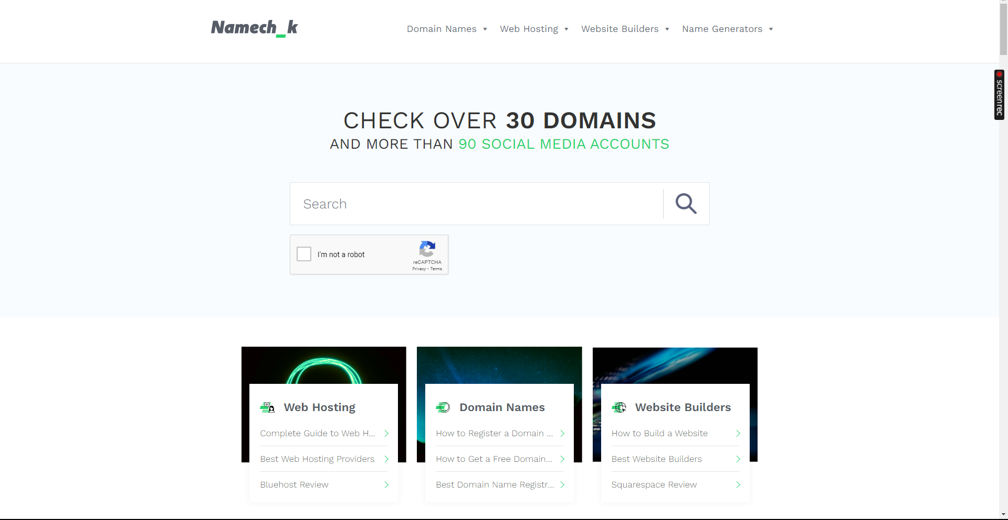

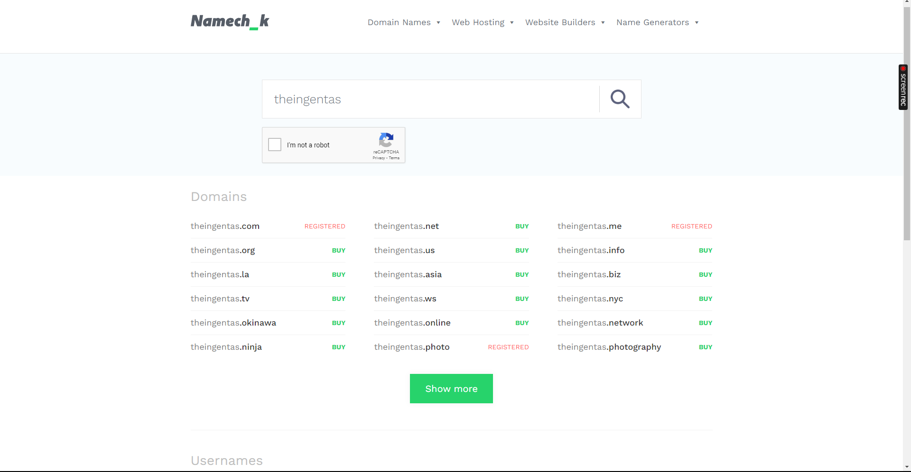

# Scope and Limitations

Namechk is a powerful tool for checking the availability of usernames and domain names across a variety of social media platforms and websites. However, it is important to be aware of the limitations of the tool.

It does not check the availability of usernames on all social media platforms and websites. For example, it does not support TikTok or Pinterest. Additionally, Namechk does not check the availability of usernames on private social media networks.

Namechk also does not guarantee that a username or domain name will remain available after it has been checked. It is possible that another user could register the username or domain name before you have a chance to do so.

# Conclusion

Namechk is a valuable tool for businesses and individuals who want to create a consistent brand presence online. The tool is easy to use and provides a variety of useful features. However, it is important to be aware of the limitations of the tool before using it.