**Nigeria Phonebook**

**People Searches | 23.09.2023**

# Executive Summary

Nigeria Phonebook Tool is a free online tool that allows users to search for phone numbers in Nigeria. The tool is easy to use and provides users with access to a comprehensive database of Nigerian phone numbers.

Nigeria Phonebook Tool can be used for a variety of purposes, including:

* Finding contact information for friends, family, and colleagues
* Verifying the phone numbers of businesses and organizations
* Conducting background checks on individuals
* Gathering information for investigative purposes

# Index

**Executive Summary 2**

**Index 2**

**1. Introduction 2**

**2. Tool Details 2**

**3. Installation 3**

**4. Execution 3**

**5. Scope and Limitations 3**

**6. Conclusion 3**

**7. References (if any) 4**

# Introduction

Nigeria Phonebook Tool is a valuable tool for anyone who needs to find phone numbers in Nigeria. The tool is easy to use and provides users with access to a comprehensive database of Nigerian phone numbers.

To use Nigeria Phonebook Tool, simply go to the website and enter the name or phone number of the person or organization you are looking for. The tool will then return a list of results that match your search criteria.

# Tool Details

Web based tool.

https://nigeriaphonebook.com/

# Installation

**Nigeria Phonebook Tool is a web-based tool, so there is no need to install any software. Simply go to the website and start searching for phone numbers.**

# Execution

To use Nigeria Phonebook Tool, simply enter the name or phone number of the person or organization you are looking for. The tool will then return a list of results that match your search criteria.

You can refine your search results by using the filters on the website. For example, you can filter your results by state, city, or phone carrier.

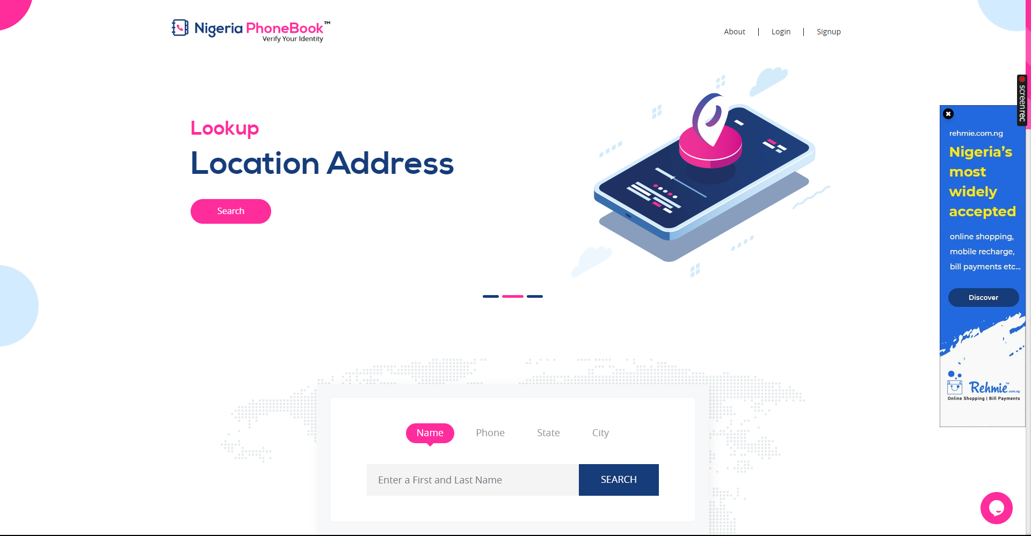

# Scope and Limitations

Nigeria Phonebook Tool is a valuable tool, but it has some limitations.

First, the tool is only able to search for phone numbers that are publicly available. If the phone number you are looking for is not publicly available, then Nigeria Phonebook Tool will not be able to find it.

Second, Nigeria Phonebook Tool may sometimes generate inaccurate or incomplete results. It is important to verify the results generated by Nigeria Phonebook Tool from other sources if necessary.

Finally, it is important to be aware of the legal implications of using Nigeria Phonebook Tool. In some cases, it may be illegal to use Nigeria Phonebook Tool to collect information about people or organizations.

# Conclusion

Nigeria Phonebook Tool is a valuable tool for anyone who needs to find phone numbers in Nigeria. The tool is easy to use and provides users with access to a comprehensive database of Nigerian phone numbers. However, it is important to be aware of the limitations of the tool and to use it responsibly.