**Person lookup Tools**

**People Searches | 23.09.2023**

# Executive Summary

Person lookup tools are software applications or websites that allow users to find information about people. This information can include personal contact information, such as name, address, phone number, and email address, as well as professional information, such as job title, employer, and education history.

Person lookup tools can be used for a variety of purposes, including:

* Finding long-lost friends or family members
* Conducting background checks on potential employees or business partners
* Locating people who may be missing or endangered
* Gathering information for investigative purposes
* Learning more about someone you met online
* There are a variety of different person lookup tools available, both free and paid.

Some popular person lookup tools include:

* Whitepages
* Spokeo
* PeopleFinders
* Truthfinder
* BeenVerified

It is important to note that person lookup tools can only access information that is publicly available. If the information you are looking for is not publicly available, then a person lookup tool will not be able to find it. Additionally, it is important to be careful when using person lookup tools, as some of them may sell your personal information to third parties.

# Index

**Executive Summary 2**

**Index 2**

**1. Introduction 2**

**2. Tool Details 2**

**3. Installation 3**

**4. Execution 3**

**5. Scope and Limitations 3**

**6. Conclusion 3**

**7. References (if any) 4**

# Introduction

Person lookup tools are a valuable tool for anyone who needs to find information about people. They can be used for a variety of purposes, both personal and professional.

There are a variety of different person lookup tools available, both free and paid. Some popular person lookup tools include Whitepages, Spokeo, PeopleFinders, Truthfinder, and BeenVerified.

# Tool Details

* Whitepages  
    
  <https://www.whitepages.com/>  
    
  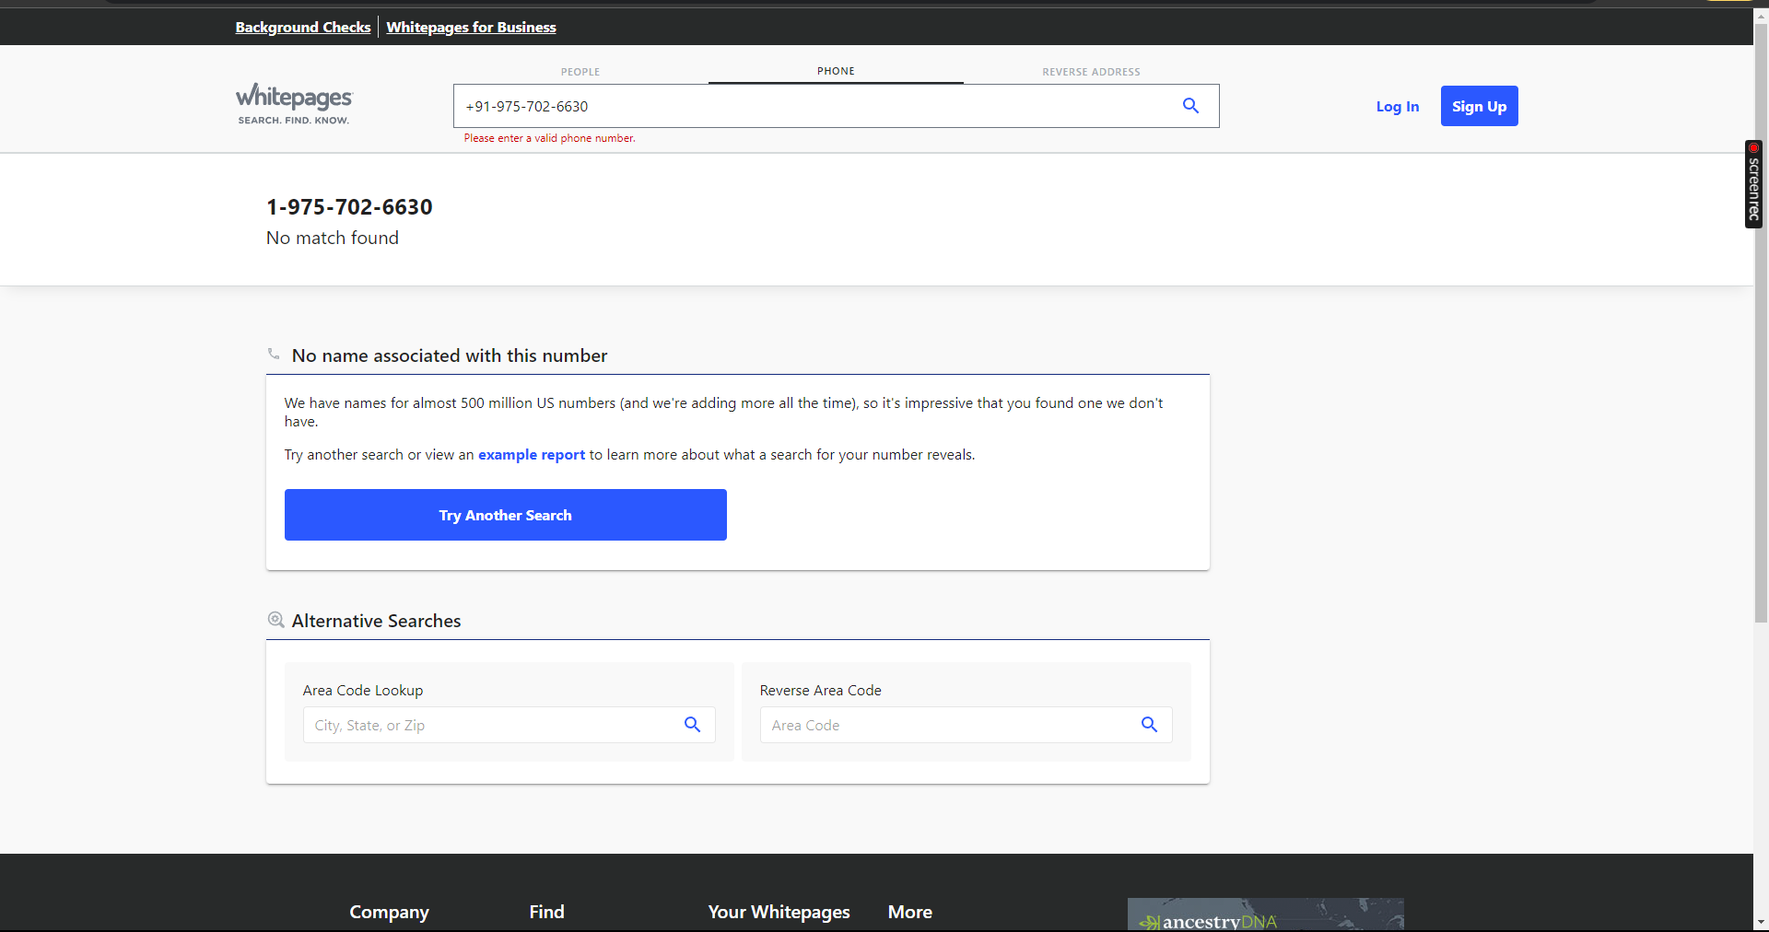
* Spokeo  
  <https://www.spokeo.com/>  
    
  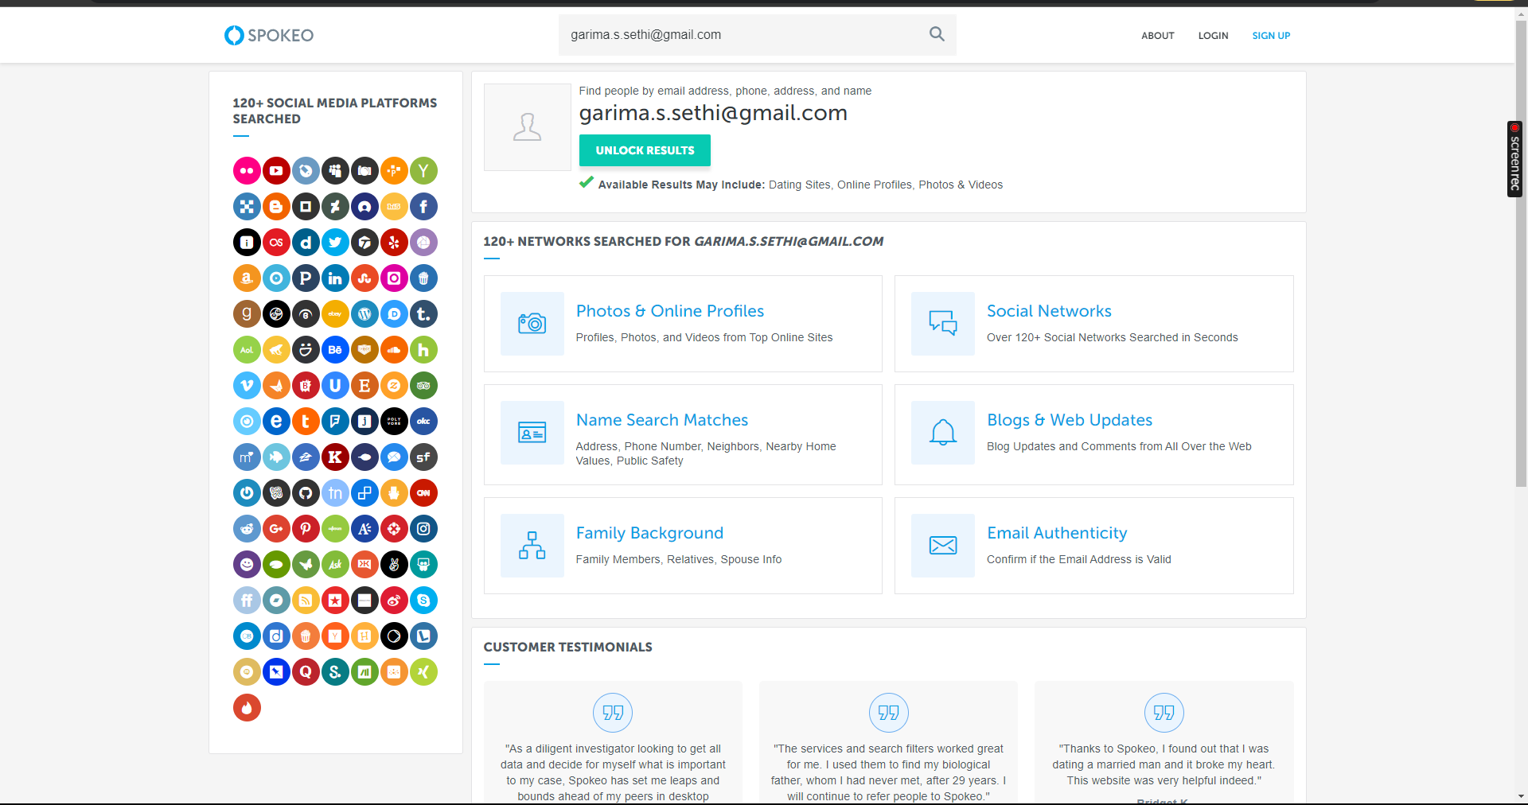
* People Finder  
    
  <https://www.peoplefinder.com/>  
    
  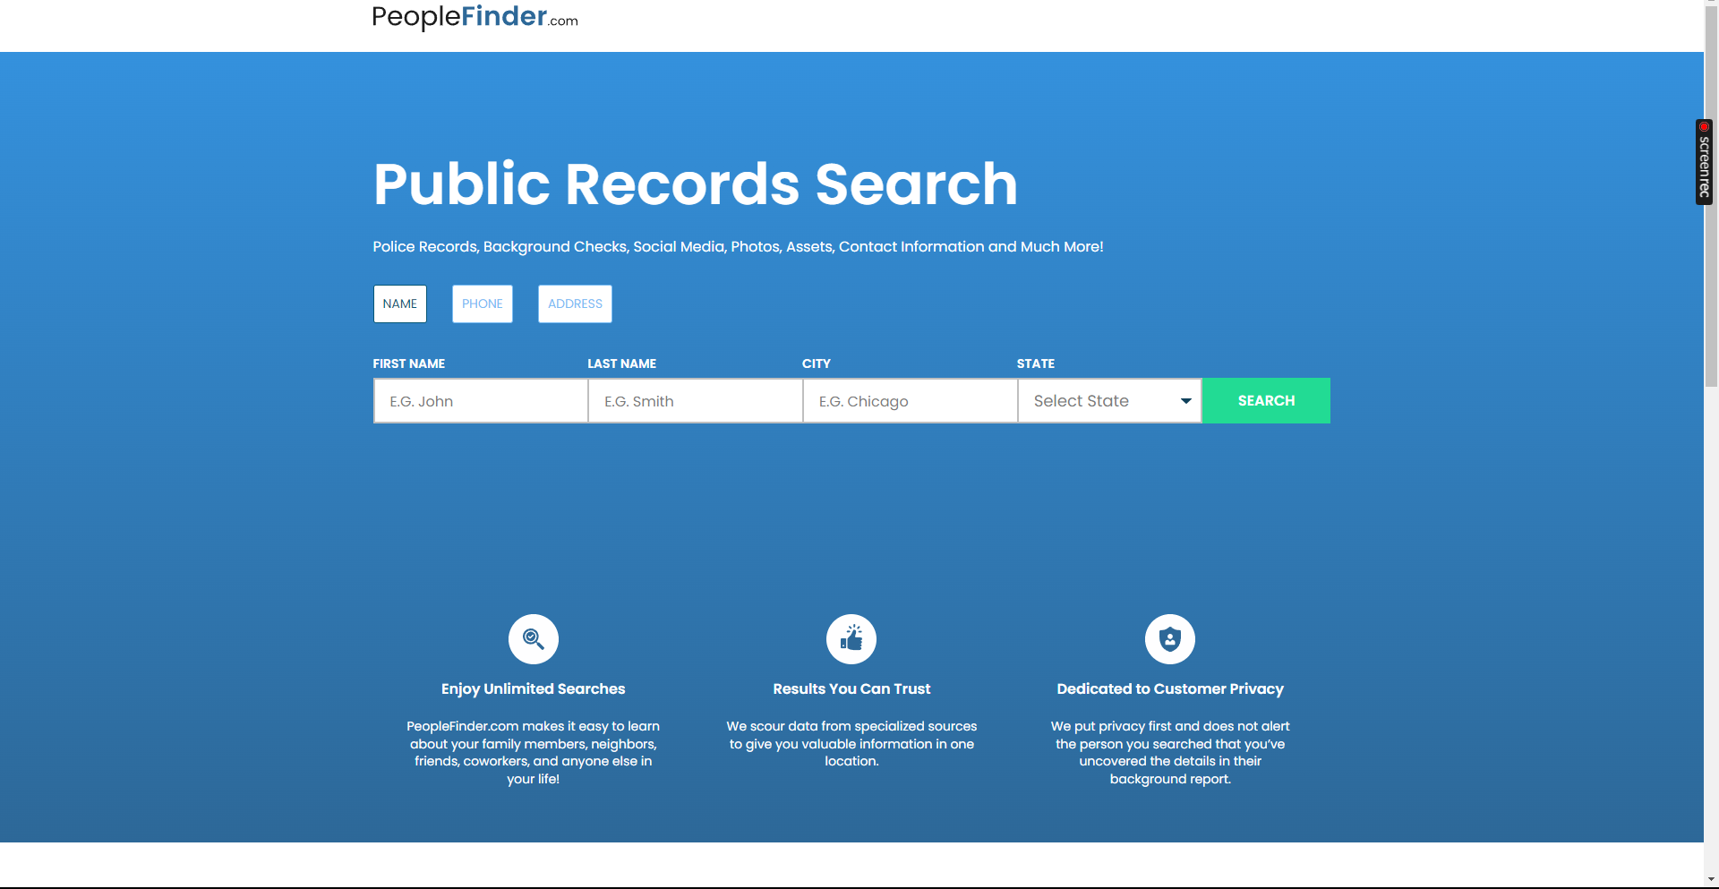
* TruthFinder  
    
  <https://www.truthfinder.com/>  
    
  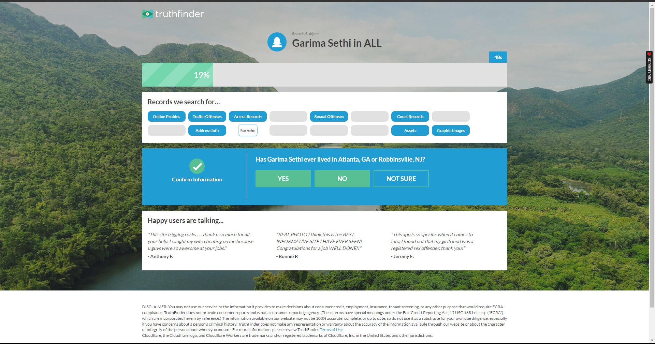  
    
  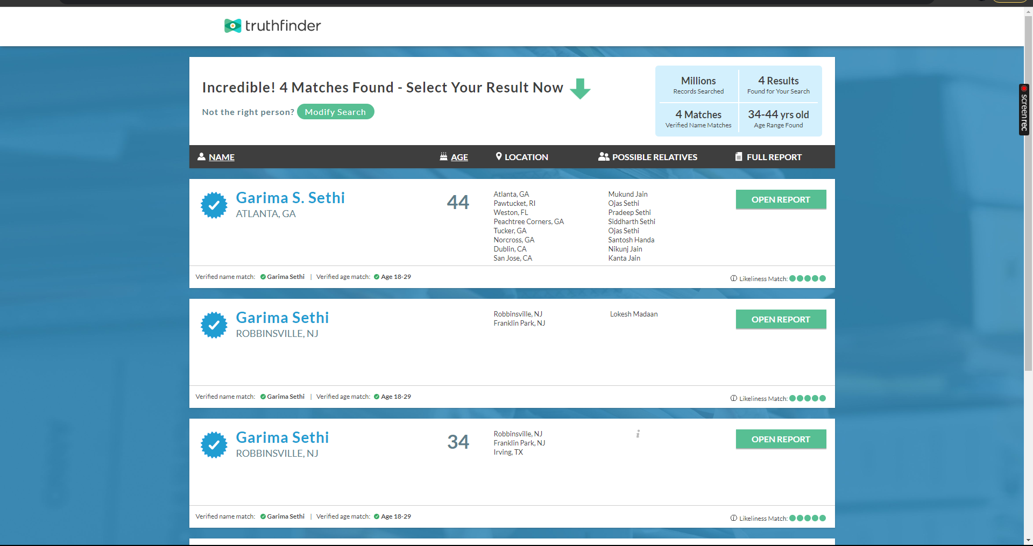

# Installation

**The tools are web-based tools.**

# Execution

To execute a person lookup tool, simply enter the name, address, phone number, or email address of the person you are looking for. The person lookup tool will then search its database of public information and return any results that it finds.

It is important to note that person lookup tools can only access information that is publicly available. If the information you are looking for is not publicly available, then a person lookup tool will not be able to find it.

# Scope and Limitations

Person lookup tools are a valuable tool for finding information about people, but they have some limitations.

First, person lookup tools can only access information that is publicly available. If the information you are looking for is not publicly available, then a person lookup tool will not be able to find it.

Second, person lookup tools are not perfect and may sometimes generate inaccurate or incomplete results. It is important to carefully review the results generated by a person lookup tool and to verify them from other sources if necessary.

Finally, it is important to be careful when using person lookup tools, as some of them may sell your personal information to third parties.

# Conclusion

Person lookup tools are a valuable tool for anyone who needs to find information about people. They can be used for a variety of purposes, both personal and professional.

It is important to be aware of the scope and limitations of person lookup tools. Person lookup tools can only access information that is publicly available, and they may sometimes generate inaccurate or incomplete results. Additionally, it is important to be careful when using person lookup tools, as some of them may sell your personal information to third parties.

Recommendations

Here are some tips for using tools effectively:

Be specific in your searches. The more specific you are, the more accurate and relevant your results will be.

Use a variety of sources. Don't rely on just one person lookup tool. Use multiple sources to get a more complete picture.

Be critical of the results. Person lookup tools are not perfect and may sometimes generate inaccurate or incomplete results. It is important to carefully review the results generated by a person lookup tool and to verify them from other sources if necessary.