**Swedish Name Register (Namnsok)**

**People Searches | 23.09.2023**

# Executive Summary

Namnsök is a free online tool provided by the Swedish Tax Agency (Skatteverket) that allows users to search for information about people in the Swedish Population Register. The tool is easy to use and can be accessed from any web browser.

Namnsök can be used for a variety of purposes, including:

* Finding long-lost friends or family members
* Conducting background checks on potential employees or business partners
* Locating people who may be missing or endangered
* Gathering information for investigative purposes
* Learning more about someone you met online

# Index

**Executive Summary 2**

**Index 2**

**1. Introduction 2**

**2. Tool Details 2**

**3. Installation 3**

**4. Execution 3**

**5. Scope and Limitations 3**

**6. Conclusion 3**

**7. References (if any) 4**

# Introduction

Namnsök is a valuable tool for anyone who needs to find information about people in Sweden. It is easy to use and provides users with access to a wide range of information, including names, dates of birth, and addresses.

To use Namnsök, simply go to the website and enter the name of the person you are looking for. The tool will then return a list of results that match the name you entered. You can refine your search results by entering additional information, such as the person's date of birth or address.

# Tool Details

* It is a web-based tool.
* Link to access; https://www.scb.se/hitta-statistik/sverige-i-siffror/namnsok/

# Installation

**No Installation needed.**

# Execution

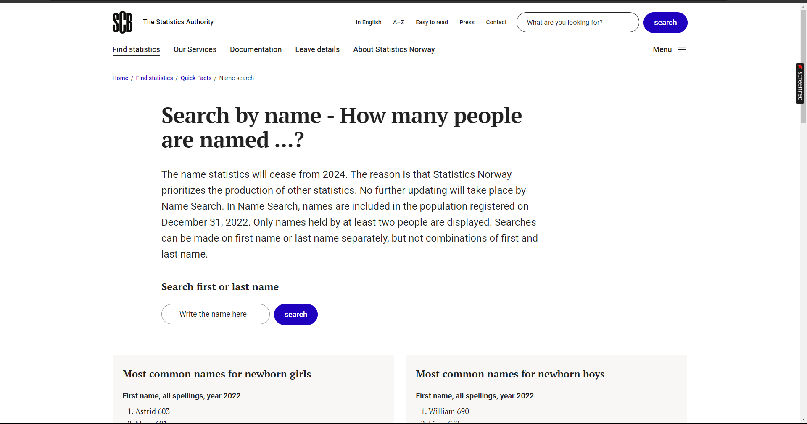

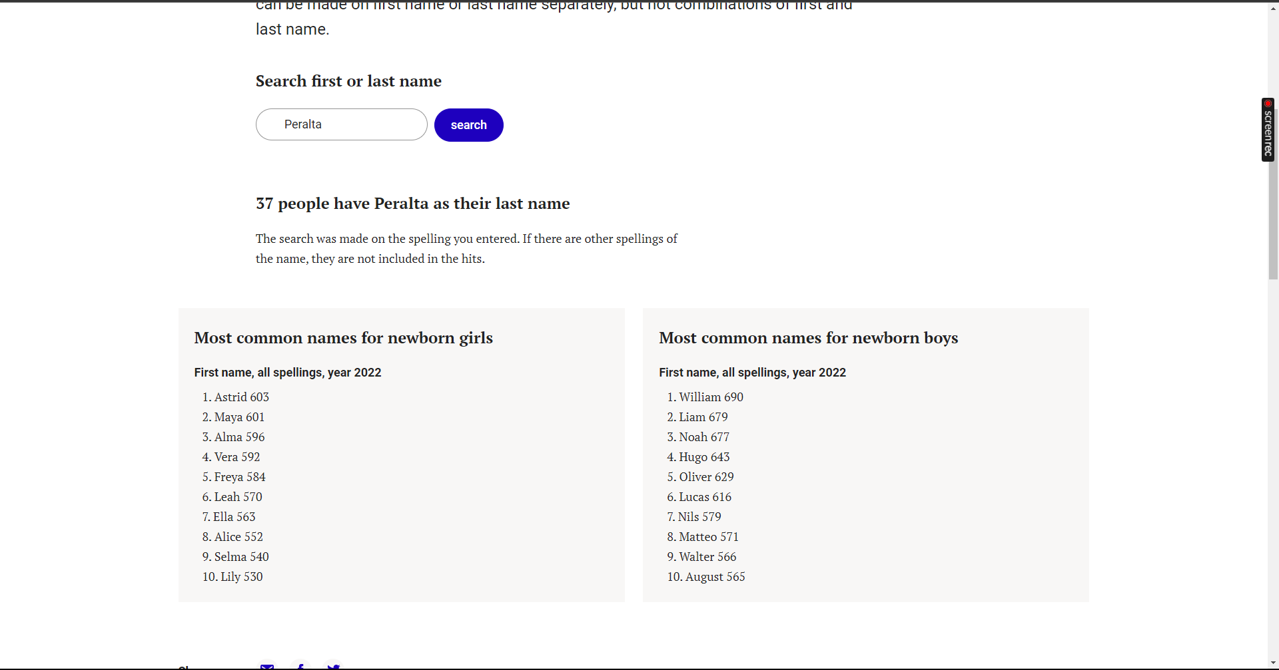

# Scope and Limitations

Namnsök is a valuable tool, but it has some limitations.

First, the tool is only able to search for people who are registered in the Swedish Population Register. If the person you are looking for is not registered in the Swedish Population Register, then Namnsök will not be able to find them.

Second, Namnsök may sometimes generate inaccurate or incomplete results. It is important to carefully review the results generated by Namnsök and to verify them from other sources if necessary.

Finally, it is important to be careful when using Namnsök, as the tool may contain personal information about other people.

# Conclusion

Namnsök is a valuable tool for anyone who needs to find information about people in Sweden. It is easy to use and provides users with access to a wide range of information. However, it is important to be aware of the limitations of Namnsök and to use it carefully.

.