**ThisNumber**

**People Searches | 23.09.2023**

# Executive Summary

Thisnumber is a free online tool that allows users to look up phone numbers. The tool provides information such as the phone number's carrier, location, and type. Thisnumber can also be used to report spam and scam calls.

It is a valuable tool for anyone who wants to protect themselves from spam and scam calls. It is also a useful tool for businesses that want to verify the identity of their customers.

# Index

**Executive Summary 2**

**Index 2**

**1. Introduction 2**

**2. Tool Details 2**

**3. Installation 3**

**4. Execution 3**

**5. Scope and Limitations 3**

**6. Conclusion 3**

**7. References (if any) 4**

# Introduction

Thisnumber is a free online tool that allows users to look up phone numbers. The tool provides information such as the phone number's carrier, location, and type. Thisnumber can also be used to report spam and scam calls.

To use Thisnumber, simply enter the phone number you want to look up into the search bar on the website. Thisnumber will then return a list of results that match the phone number you entered. The results will include information such as the phone number's carrier, location, and type.

Thisnumber can also be used to report spam and scam calls. To report a spam or scam call, simply click on the "Report Spam" button next to the phone number in the search results. Thisnumber will then ask you to provide some information about the call, such as the date and time of the call and the nature of the call.

# Tool Details

It is a web based tool.

Link to access: www.thisnumber.com

# Installation

**No installation needed.**

# Execution

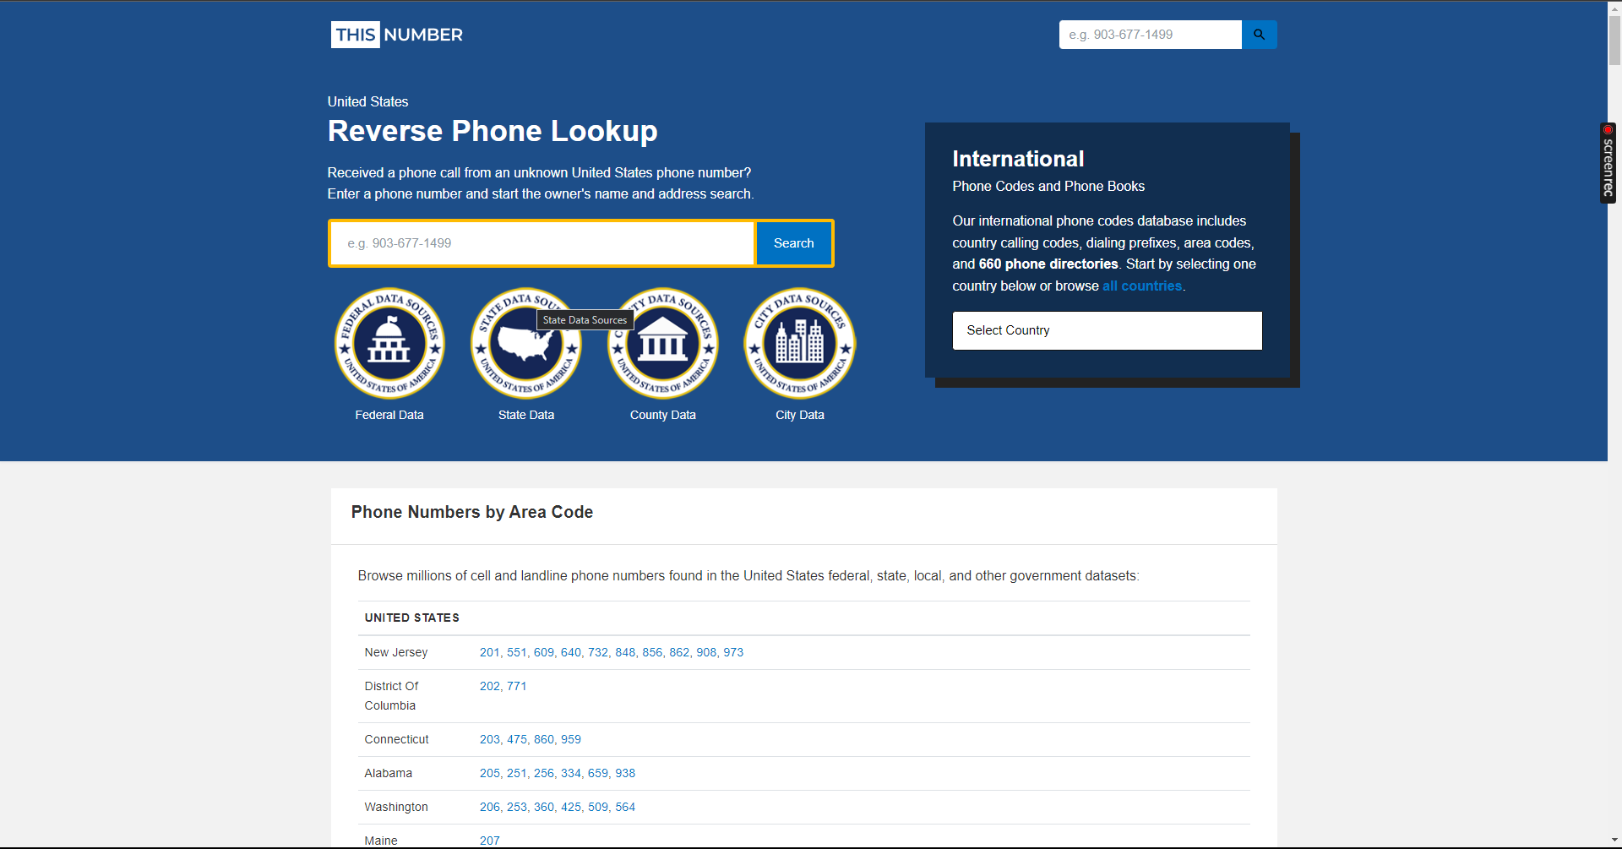

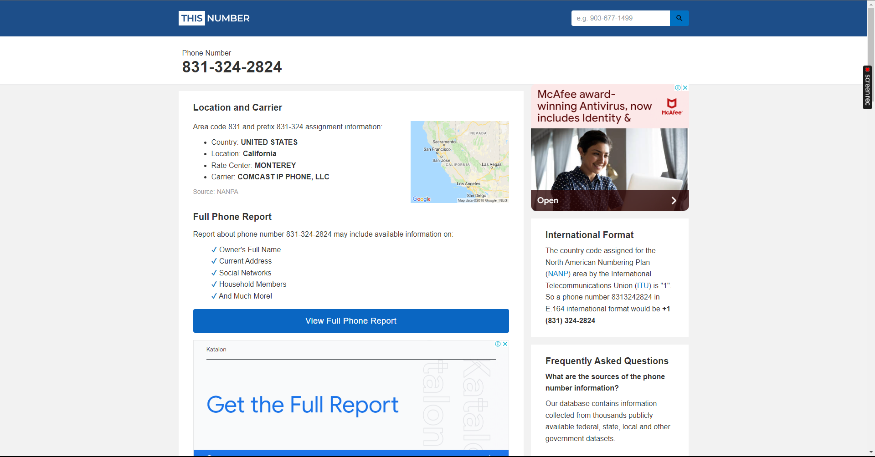

# Scope and Limitations

Thisnumber is a valuable tool, but it has some limitations.

First, Thisnumber is only able to look up phone numbers that are publicly available. If the phone number you are looking for is not publicly available, then Thisnumber will not be able to find it.

Second, itmay sometimes generate inaccurate or incomplete results. It is important to carefully review the results generated.

Finally, it cannot prevent you from receiving spam and scam calls. However, Thisnumber can help you to identify spam and scam calls so that you can take steps to protect yourself.

# Conclusion

Thisnumber is a valuable tool for anyone who wants to protect themselves from spam and scam calls. It is also a useful tool for businesses that want to verify the identity of their customers.

It is important to be aware of the limitations of Thisnumber. It is only able to look up phone numbers that are publicly available, and it may sometimes generate inaccurate or incomplete results. Additionally, Thisnumber cannot prevent you from receiving spam and scam calls.

However,is a valuable tool that can help you to identify spam and scam calls so that you can take steps to protect yourself.