**ViewDNS**

**People Searches | 23.09.2023**

# Executive Summary

ViewDNS is a web-based tool that provides a variety of information about domain names and IP addresses. This information can include DNS records, MX records, reverse DNS records, and traceroutes. ViewDNS can be used by businesses and individuals to troubleshoot DNS problems, monitor website performance, and identify potential security risks.

The ViewDNS tool report provides a comprehensive overview of the installation, execution, scope, and limitations of the ViewDNS tool. The report also includes recommendations for how to use the tool effectively.

# Index

**Executive Summary 2**

**Index 2**

**1. Introduction 2**

**2. Tool Details 2**

**3. Installation 3**

**4. Execution 3**

**5. Scope and Limitations 3**

**6. Conclusion 3**

**7. References (if any) 4**

# Introduction

ViewDNS is a web-based tool that provides a variety of information about domain names and IP addresses. This information can include DNS records, MX records, reverse DNS records, and traceroutes. ViewDNS can be used by businesses and individuals to troubleshoot DNS problems, monitor website performance, and identify potential security risks.

ViewDNS provides a variety of tools for troubleshooting DNS problems. For example, the ViewDNS DNS Record Lookup tool can be used to view the DNS records for a domain name, and the ViewDNS Reverse DNS Lookup tool can be used to view the reverse DNS records for an IP address.

ViewDNS also provides tools for monitoring website performance. For example, the ViewDNS Traceroute tool can be used to trace the route between your computer and a website server.

ViewDNS also provides tools for identifying potential security risks. For example, the ViewDNS DNSSEC Test tool can be used to test whether a domain name is using DNSSEC, and the ViewDNS Chinese Firewall Test tool can be used to test whether a website is accessible from China

# Tool Details

It is a web based tool.

Link to access: https://viewdns.info/

# Installation

**No installation needed.**

# Execution

To use the ViewDNS tool, simply enter the domain name or IP address that you want to search into the search bar and click the "Search" button. The ViewDNS tool will then return a list of information about the domain name or IP address.

The type of information that is returned will depend on the tool that you use. For example, if you use the ViewDNS DNS Record Lookup tool, the ViewDNS tool will return a list of DNS records for the domain name. If you use the ViewDNS Reverse DNS Lookup tool, the ViewDNS tool will return a list of reverse DNS records for the IP address.

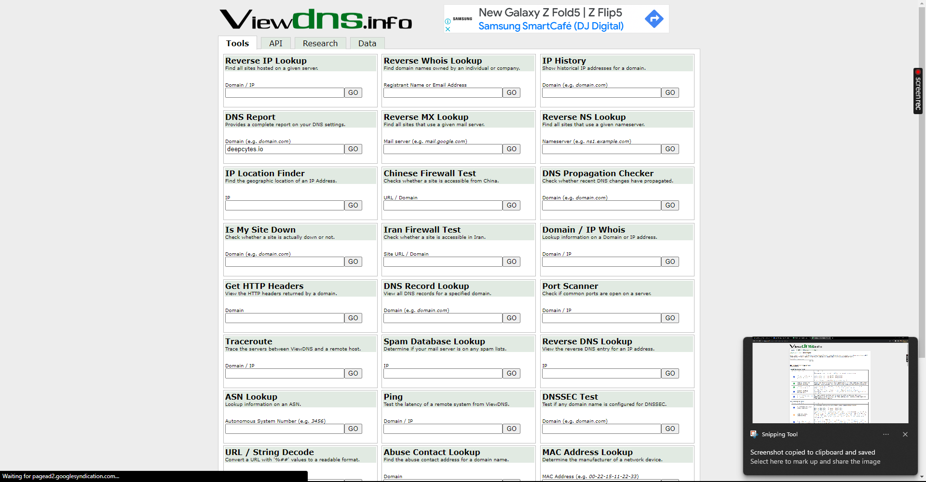

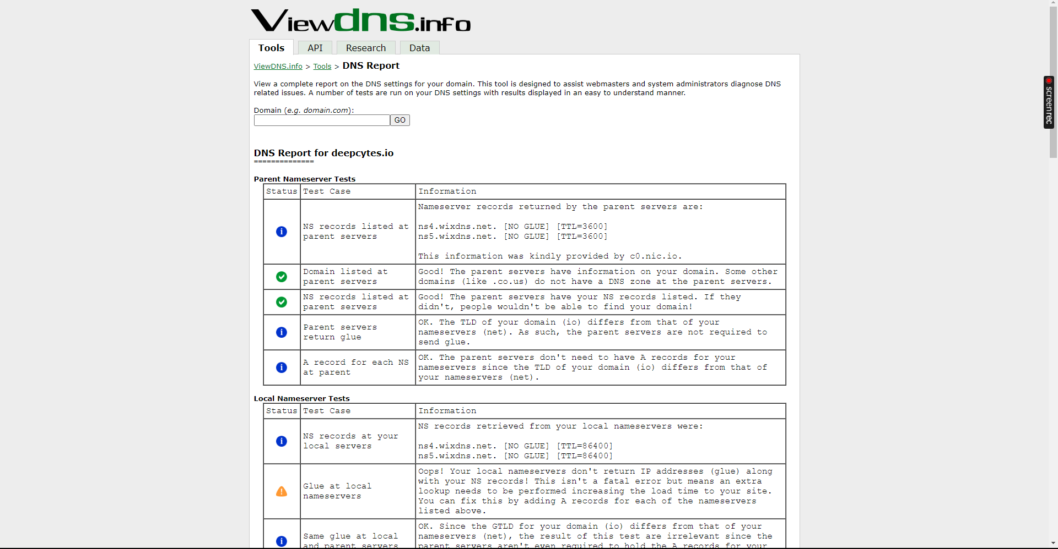

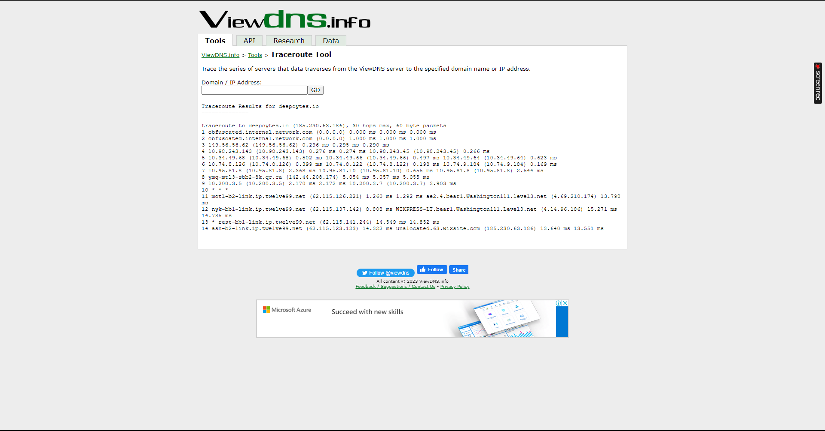

# Scope and Limitations

ViewDNS is a powerful tool for troubleshooting DNS problems, monitoring website performance, and identifying potential security risks. However, it is important to be aware of the limitations of the tool.

ViewDNS can only return information about domain names and IP addresses that are publicly accessible. ViewDNS cannot return information about domain names and IP addresses that are hidden or private.

Additionally, ViewDNS cannot guarantee that the information that it returns is accurate or up-to-date. It is possible that the information that ViewDNS returns may be incorrect or out of date.

# Conclusion

ViewDNS is a valuable tool for businesses and individuals who want to troubleshoot DNS problems, monitor website performance, and identify potential security risks. The tool is easy to use and provides a variety of useful features. However, it is important to be aware of the limitations of the tool before using it.