**WhatsMyName**

**People Searches | 23.09.2023**

# Executive Summary

Whatsmyname is an open-source intelligence (OSINT) tool that helps users find information about people from a variety of public sources, including social media, websites, and databases. It is a powerful tool for investigators, journalists, and anyone else who needs to gather information about people quickly and efficiently.

Whatsmyname is easy to use and does not require any prior experience with OSINT. It can be used to find a wide range of information about people, including personal information, professional information, and public records.

Whatsmyname is a valuable tool for anyone who needs to gather information about people quickly and efficiently. It is a powerful tool for investigators, journalists, and anyone else who needs to find reliable information about people from a variety of public sources.

# 

# 

# 

# 

# 

# Index

**Executive Summary 2**

**Index 2**

**1. Introduction 2**

**2. Tool Details 2**

**3. Installation 3**

**4. Execution 3**

**5. Scope and Limitations 3**

**6. Conclusion 3**

**7. References (if any) 4**

# Introduction

Whatsmyname is a powerful open-source intelligence (OSINT) tool that helps users find information about people from a variety of public sources, including social media, websites, and databases. It is a valuable tool for investigators, journalists, and anyone else who needs to gather information about people quickly and efficiently.

Whatsmyname is easy to use and does not require any prior experience with OSINT. To use Whatsmyname, simply enter the name of the person you are interested in and the tool will generate a list of relevant results. You can then filter the results by date, source, and other criteria.

Whatsmyname can be used to find a wide range of information about people, including:

* Personal information: Whatsmyname can be used to find people's social media accounts, email addresses, phone numbers, and other personal details.
* Professional information: Whatsmyname can be used to find people's employment history, education history, and other professional information.
* Public records: Whatsmyname can be used to find people's criminal records, property records, and other public records.

Whatsmyname is a valuable tool for anyone who needs to gather information about people quickly and efficiently. It is a powerful tool for investigators, journalists, and anyone else who needs to find reliable information about people from a variety of public sources.

Here are just a few examples of how Whatsmyname can be used:

* An investigator can use Whatsmyname to find information about a suspect's social media accounts, email addresses, and phone numbers.
* A journalist can use Whatsmyname to research a story about a person of interest, such as a politician, a celebrity, or a suspect in a crime.
* A business can use Whatsmyname to conduct competitive intelligence by researching their competitors' employees.
* An individual can use Whatsmyname to learn more about a potential employer, a new city they are considering moving to, or a person they met online.

Whatsmyname is a versatile tool that can be used for a variety of purposes. It is a valuable tool for anyone who needs to gather information about people quickly and efficiently.

# Tool Details

* It is a web based tool.
* Link to access: https://whatsmyname.app/

# Installation

**No Installation Needed.**

# Execution

To run the tool

1. Enter the username in the input box and hit the search button.

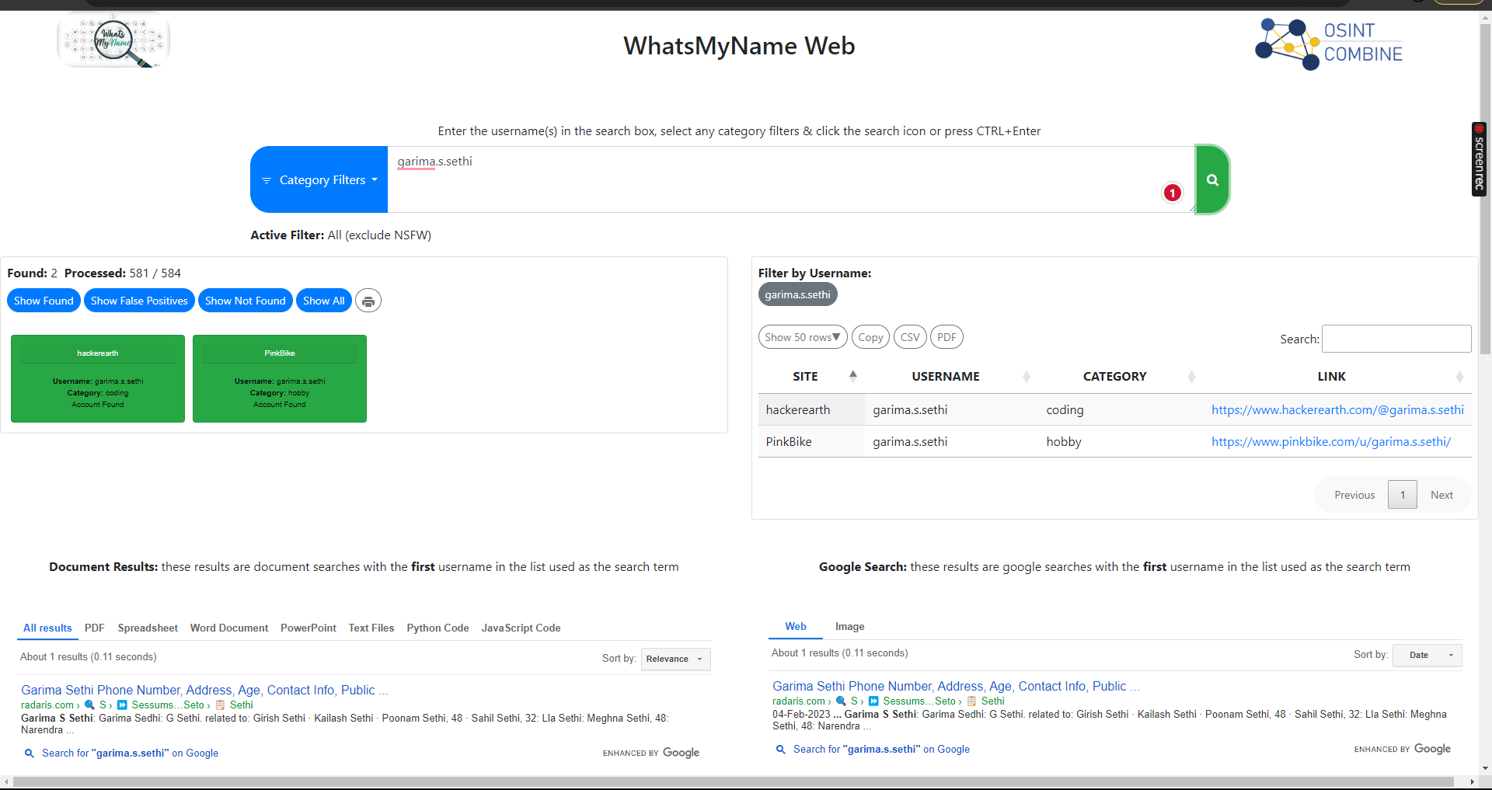

# Scope and Limitations

Scope

Whatsmyname can be used to find a wide range of information about people from a variety of public sources, including social media, websites, and databases. It can be used to find information about people's personal lives, professional lives, and public records.

Limitations

Whatsmyname is limited by the availability of public information. If the information you are looking for is not publicly available, then Whatsmyname will not be able to find it. Additionally, Whatsmyname is not a perfect tool and it may sometimes generate inaccurate or incomplete results. It is important to carefully review the results generated by Whatsmyname and to verify them from other sources if necessary.

Here are some specific examples of the limitations of Whatsmyname:

Whatsmyname cannot find information that is not publicly available. For example, It cannot find information about someone's bank account or their medical records.

Whatsmyname may generate inaccurate or incomplete results. For example, if someone has multiple social media accounts, it may not be able to find all of them.

It is not a substitute for human judgment. It is important to carefully review the results generated to verify them from other sources if necessary.

# Conclusion

Overall, Whatsmyname is a powerful OSINT tool that can be used for a variety of purposes. It is a valuable tool for investigators, journalists, and anyone else who needs to gather information about people quickly and efficiently. However, it is important to be aware of the scope and limitations of the tool. Whatsmyname is limited by the availability of public information and it is not a perfect tool. It is important to carefully review the results generated.

Here are some recommendations for using Whatsmyname effectively:

Be specific in your searches. The more specific you are, the more accurate and relevant your results will be.

Use a variety of sources. It can access a wide range of public sources, but it is important to use a variety of sources to verify your results.

Be critical of the results. It is not a perfect tool and it may sometimes generate inaccurate or incomplete results.