**Whois Lookup**

**People Searches | 23.09.2023**

# Executive Summary

Whois Lookup is a tool that allows users to search for information about a domain name or IP address. This information can include the domain name registrant, contact information, and registration and expiration dates. Whois Lookup can be used by businesses and individuals to protect their brands online, monitor their competitors, and identify potential risks.

The Whois Lookup tool report provides a comprehensive overview of the installation, execution, scope, and limitations of the Whois Lookup tool. The report also includes recommendations for how to use the tool effectively.

# Index

**Executive Summary 2**

**Index 2**

**1. Introduction 2**

**2. Tool Details 2**

**3. Installation 3**

**4. Execution 3**

**5. Scope and Limitations 3**

**6. Conclusion 3**

**7. References (if any) 4**

# Introduction

Whois Lookup is a tool that allows users to search for information about a domain name or IP address. This information can include the domain name registrant, contact information, and registration and expiration dates. Whois Lookup can be used by businesses and individuals to protect their brands online, monitor their competitors, and identify potential risks.

Whois Lookup is a public record, so anyone can use it to search for information about a domain name or IP address. This information can be used to identify the owner of a domain name, to contact the owner of a domain name, or to learn more about a domain name.

# Tool Details

It is a web-based tool.

Link to access: www.whois.domaintools.com

# Installation

**No installation needed.**

# Execution

To use the Whois Lookup tool, simply enter the domain name or IP address that you want to search into the search bar and click the "Search" button. The Whois Lookup tool will then return a list of information about the domain name or IP address, such as the domain name registrant, contact information, and registration and expiration dates.

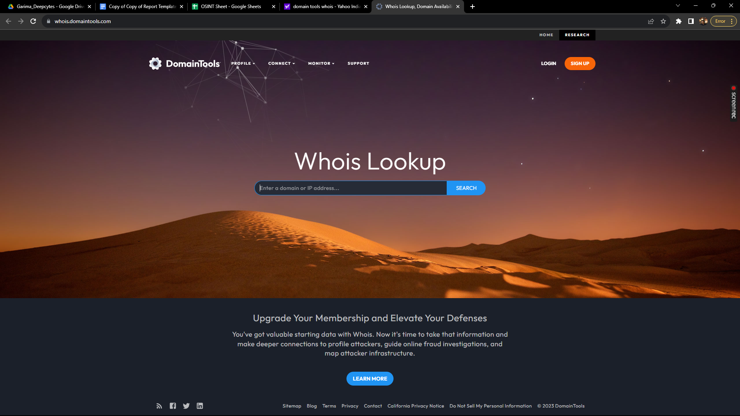

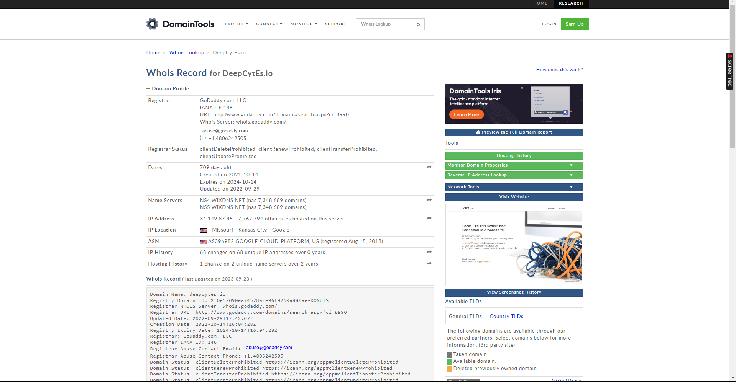

# Scope and Limitations

Whois Lookup is a powerful tool for searching for information about domain names and IP addresses. However, it is important to be aware of the limitations of the tool.

Whois Lookup does not always return accurate information. For example, the domain name registrant may have chosen to hide their contact information. Additionally, Whois Lookup does not always return up-to-date information. It is possible that the domain name registrant may have changed their contact information or that the domain name may have been transferred to a new owner.

# Conclusion

Whois Lookup is a valuable tool for businesses and individuals who want to protect their brands online, monitor their competitors, and identify potential risks. The tool is easy to use and provides a variety of useful features. However, it is important to be aware of the limitations of the tool before using it.