**Worldmap of OSINT Tools**

**People Searches | 23.09.2023**

# Executive Summary

The Worldmap of OSINT Tools is a free online tool that provides a comprehensive list of OSINT tools organized by category and region. The tool is easy to use and can be accessed from any web browser.

The Worldmap of OSINT Tools is a valuable resource for anyone who needs to find information about people, places, or events. The tool can be used for a variety of purposes, including:

* Conducting investigations
* Gathering intelligence
* Researching stories
* Learning more about the world around you

# Index

**Executive Summary 2**

**Index 2**

**1. Introduction 2**

**2. Tool Details 2**

**3. Installation 3**

**4. Execution 3**

**5. Scope and Limitations 3**

**6. Conclusion 3**

**7. References (if any) 4**

# Introduction

The Worldmap of OSINT Tools is a valuable resource for anyone who needs to find information about people, places, or events. The tool is easy to use and provides access to a wide range of OSINT tools, including search engines, social media platforms, and public records databases.

To use the Worldmap of OSINT Tools, simply go to the website and select the category and region that you are interested in. The tool will then return a list of OSINT tools that are relevant to your selection.

# Tool Details

* It is a web based interface.
* Link to access: cybdetective.com/osintmap

# Installation

**Most of the OSINT tools listed on the Worldmap of OSINT Tools are web-based, so there is no need to install any software. Simply click on the link to the tool that you want to use and the tool will open in your web browser.**

# Execution

Each OSINT tool has its own unique interface and features. However, most OSINT tools work in a similar way. To use an OSINT tool, simply enter the search term or criteria that you are interested in and the tool will return a list of results.

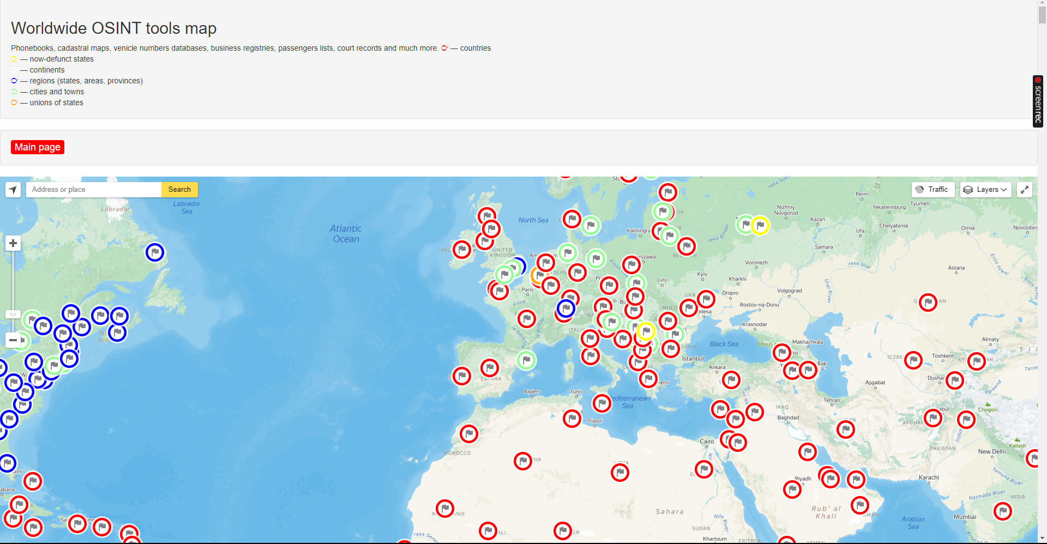

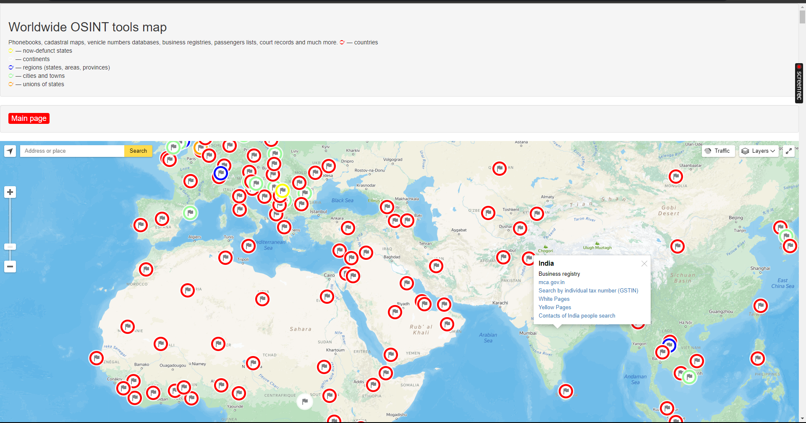

# Scope and Limitations

The Worldmap of OSINT Tools is a valuable resource, but it has some limitations.

First, the tool only lists OSINT tools that are publicly available. If the OSINT tool you are looking for is not publicly available, then it will not be listed on the Worldmap of OSINT Tools.

Second, the tool does not provide any information about the accuracy or reliability of the OSINT tools it lists. It is important to carefully evaluate the OSINT tools you use and to verify the results they generate from other sources if necessary.

Finally, it is important to be aware of the legal implications of using OSINT tools. In some cases, it may be illegal to use OSINT tools to collect information about people or organizations.

# Conclusion

The Worldmap of OSINT Tools is a valuable resource for anyone who needs to find information about people, places, or events. The tool is easy to use and provides access to a wide range of OSINT tools. However, it is important to be aware of the limitations of the tool and to use it responsibly.

Recommendations

Here are some recommendations for using the Worldmap of OSINT Tools effectively:

* Be specific in your searches. The more specific you are, the more accurate and relevant your results will be.
* Use a variety of tools. Don't rely on just one OSINT tool. Use multiple tools to get a more complete picture.
* Be critical of the results. OSINT tools are not perfect and may sometimes generate inaccurate or incomplete results. It is important to carefully evaluate the results you generate from OSINT tools and to verify them from other sources if necessary.
* Be aware of the legal implications. In some cases, it may be illegal to use OSINT tools to collect information about people or organizations.