**Data Wrapper**

**Data Visualisation | 23.09.2023**

# Executive Summary

DataWrapper is a web-based tool that allows users to create interactive charts and maps from data. The tool is easy to use and provides a variety of features, including:

* A wide range of chart and map types
* Customizable design options
* The ability to collaborate on projects
* The ability to embed charts and maps in websites and blogs

DataWrapper is a valuable tool for businesses and individuals who want to create engaging data visualizations. The tool can be used to create charts and maps for a variety of purposes, including:

* Reporting on data
* Presenting data to clients or colleagues
* Creating blog posts and articles
* Sharing data on social media

This tool report provides a comprehensive overview of the installation, execution, scope, and limitations of the DataWrapper tool. The report also includes recommendations for how to use the tool effectively.

# Index

**Executive Summary 2**

**Index 2**

**1. Introduction 2**

**2. Tool Details 2**

**3. Installation 3**

**4. Execution 3**

**5. Scope and Limitations 3**

**6. Conclusion 3**

**7. References (if any) 4**

# Introduction

DataWrapper is a web-based tool that allows users to create interactive charts and maps from data. The tool is easy to use and provides a variety of features, making it a valuable tool for businesses and individuals who want to create engaging data visualizations.

DataWrapper can be used to create a wide range of chart and map types, including:

* Bar charts
* Line charts
* Pie charts
* Scatter plots
* Heatmaps
* Choropleth maps
* Symbol maps
* Locator maps

DataWrapper also provides a variety of customizable design options, such as the ability to change the font, colors, and layout of charts and maps. Additionally, DataWrapper allows users to collaborate on projects and embed charts and maps in websites and blogs.

# Tool Details

It is a web based tool.  
Application:https://www.datawrapper.de/

# Installation

**DataWrapper is a web-based tool, so there is no need to install any software. To use the tool, simply visit the DataWrapper website and create an account.**

# Execution

Once you have created an account, you can start using the DataWrapper tool to create charts and maps. To create a chart or map, simply click on the "Create" button and select the type of chart or map that you want to create.

DataWrapper will then prompt you to upload your data. You can upload data in a variety of formats, including CSV, Excel, and Google Sheets.

Once you have uploaded your data, you can start customizing the chart or map. DataWrapper provides a variety of customization options, such as the ability to change the font, colors, and layout of the chart or map.

Once you are finished customizing the chart or map, you can publish it. DataWrapper will provide you with a link to the chart or map that you can share with others.

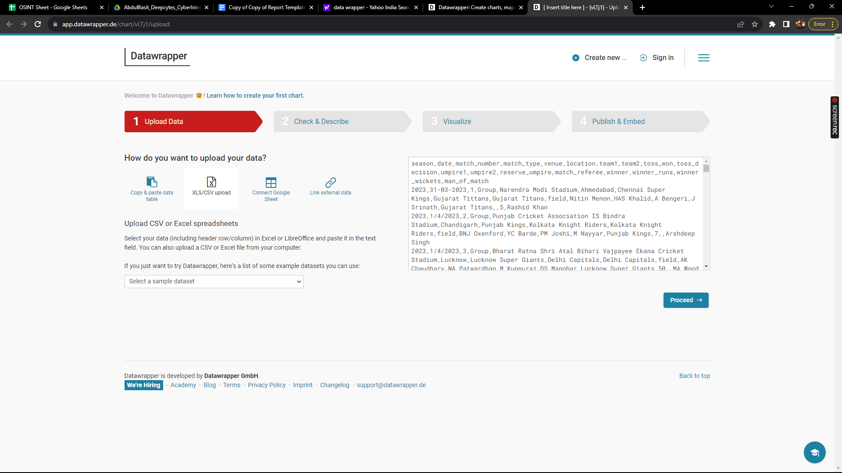

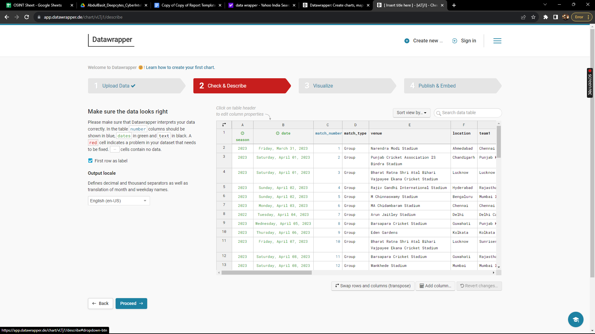

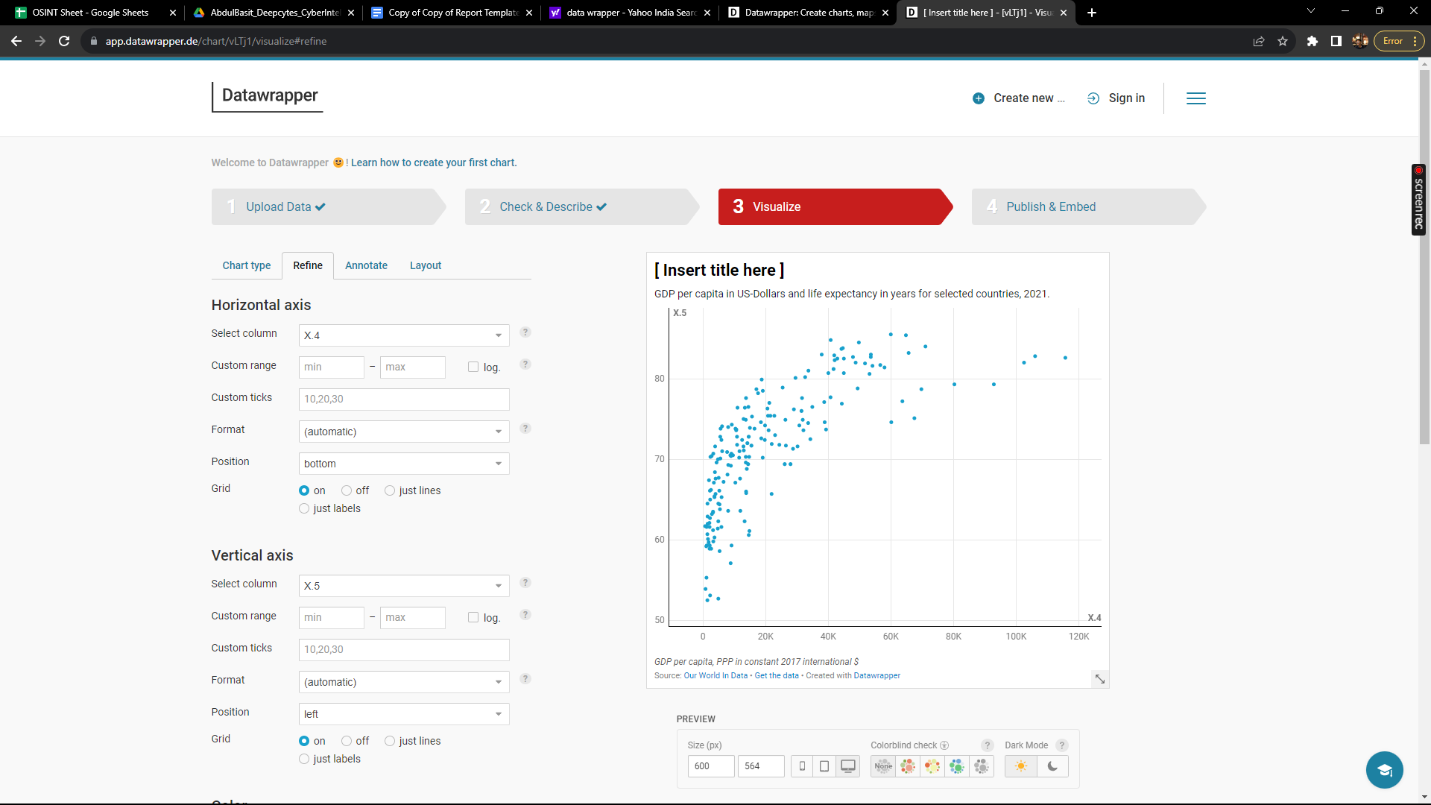

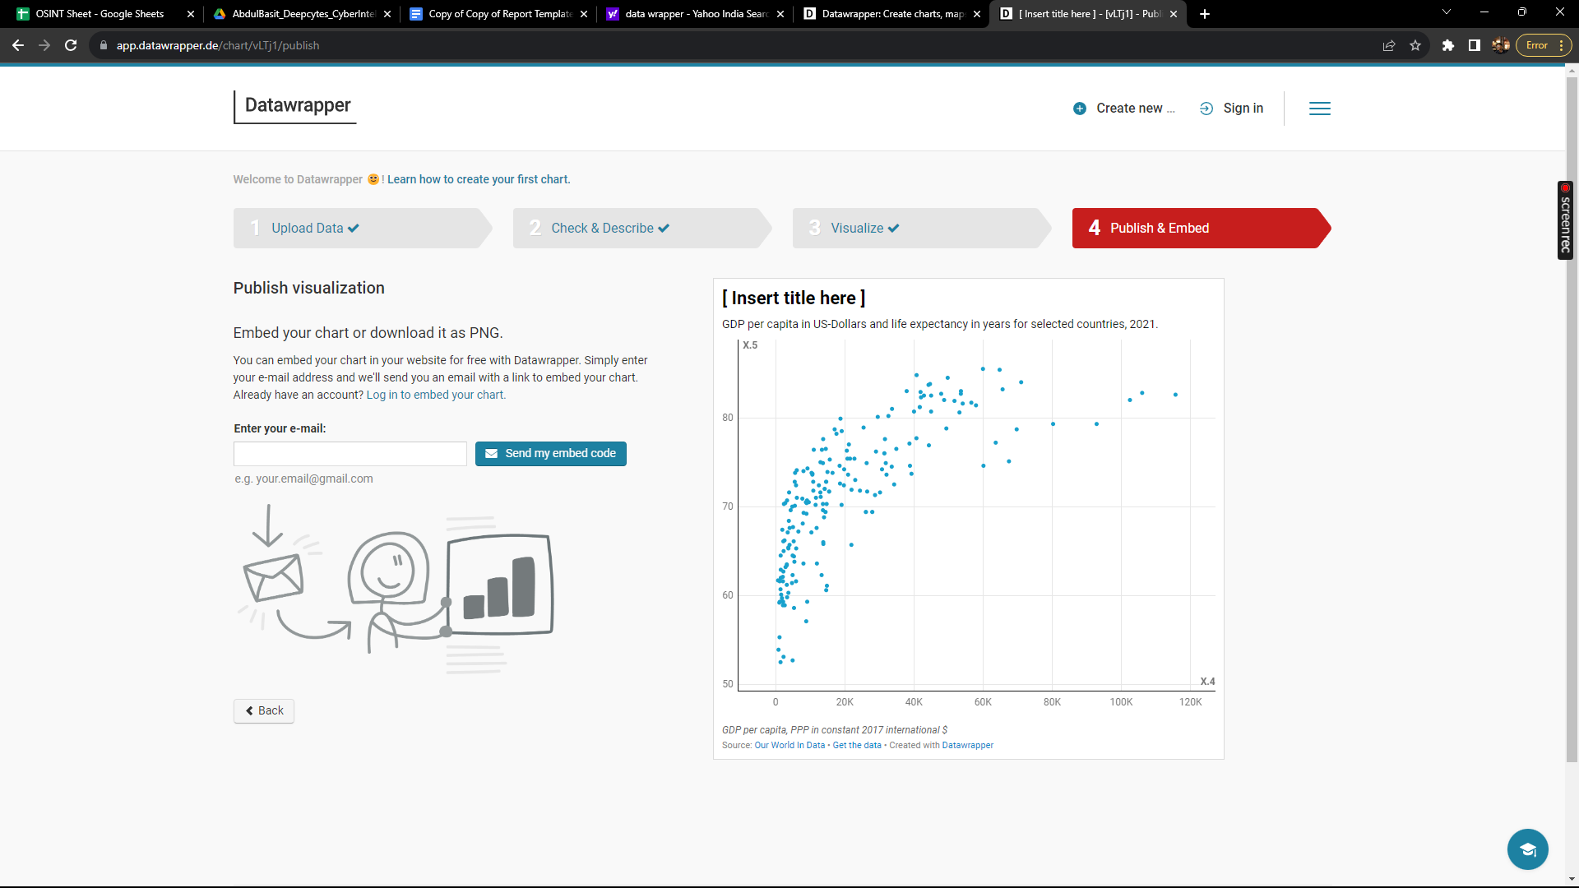

# Scope and Limitations

DataWrapper is a powerful tool for creating interactive charts and maps. However, it is important to be aware of the limitations of the tool.

DataWrapper is not a data analysis tool. DataWrapper cannot be used to perform complex data analysis tasks, such as statistical analysis or machine learning.

Additionally, DataWrapper is not a data visualization tool for all types of data. DataWrapper is best suited for creating charts and maps from simple datasets.

# Conclusion

DataWrapper is a valuable tool for businesses and individuals who want to create engaging data visualizations. The tool is easy to use and provides a variety of features. However, it is important to be aware of the limitations of the tool before using it.