**Flight Aware**

**Transport Trackers | 23.09.2023**

# Executive Summary

FlightAware is a web-based tool that provides real-time and historical flight tracking information. The tool uses a variety of data sources, including radar data, ADS-B data, and flight plan data, to track the movements of commercial and private aircraft around the world. FlightAware is a valuable tool for businesses and individuals who need to track the location of flights, monitor air traffic, or research flight data.

This tool report provides a comprehensive overview of the installation, execution, scope, and limitations of the FlightAware tool. The report also includes recommendations for how to use the tool effectively.

# Index

**Executive Summary 2**

**Index 2**

**1. Introduction 2**

**2. Tool Details 2**

**3. Installation 3**

**4. Execution 3**

**5. Scope and Limitations 3**

**6. Conclusion 3**

**7. References (if any) 4**

# Introduction

FlightAware is a web-based tool that provides real-time and historical flight tracking information. The tool uses a variety of data sources, including radar data, ADS-B data, and flight plan data, to track the movements of commercial and private aircraft around the world.

FlightAware provides a variety of features, including:

* Real-time flight tracking: FlightAware allows users to track the location of flights in real time. Users can view the positions of flights on a map, as well as information about the flight's number, type, origin, destination, and status.
* Historical flight tracking: FlightAware also allows users to view the historical flight tracking data for any flight. Users can see where a flight has been in the past, as well as its speed, altitude, and heading.
* Flight information: FlightAware provides detailed information about each flight, such as its number, type, origin, destination, status, aircraft type, and airline. Users can also view photos and videos of aircraft.
* Airport information: FlightAware provides information about airports around the world, such as their location, contact information, and arrival and departure times for flights.

# Tool Details

It is a web based application.   
Website:https://www.flightaware.com/

# Installation

**FlightAware is a web-based tool, so there is no need to install any software. To use the tool, simply visit the FlightAware website and create an account.**

# Execution

Once you have created an account, you can start using the FlightAware tool to track flights. To track a flight, simply enter the flight's number, aircraft type, or origin and destination into the search bar and click "Search." FlightAware will then display the flight's position on a map, as well as information about the flight's number, type, origin, destination, and status.

You can also use the FlightAware tool to track flights by area. To do this, simply click on the "Map" tab and zoom in on the area that you want to track. FlightAware will then display all of the flights in the area, as well as their positions and information.

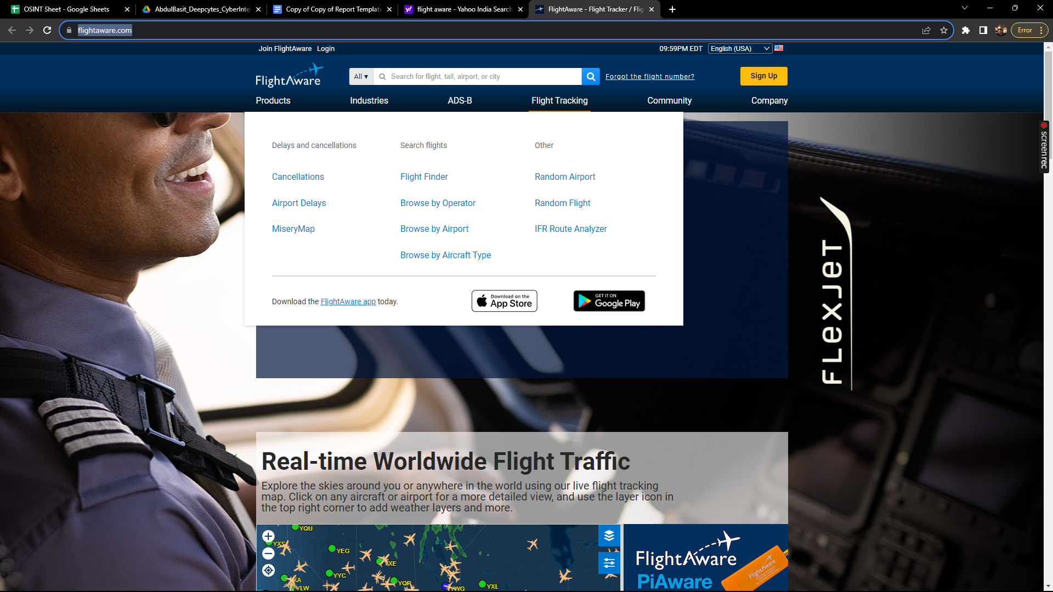

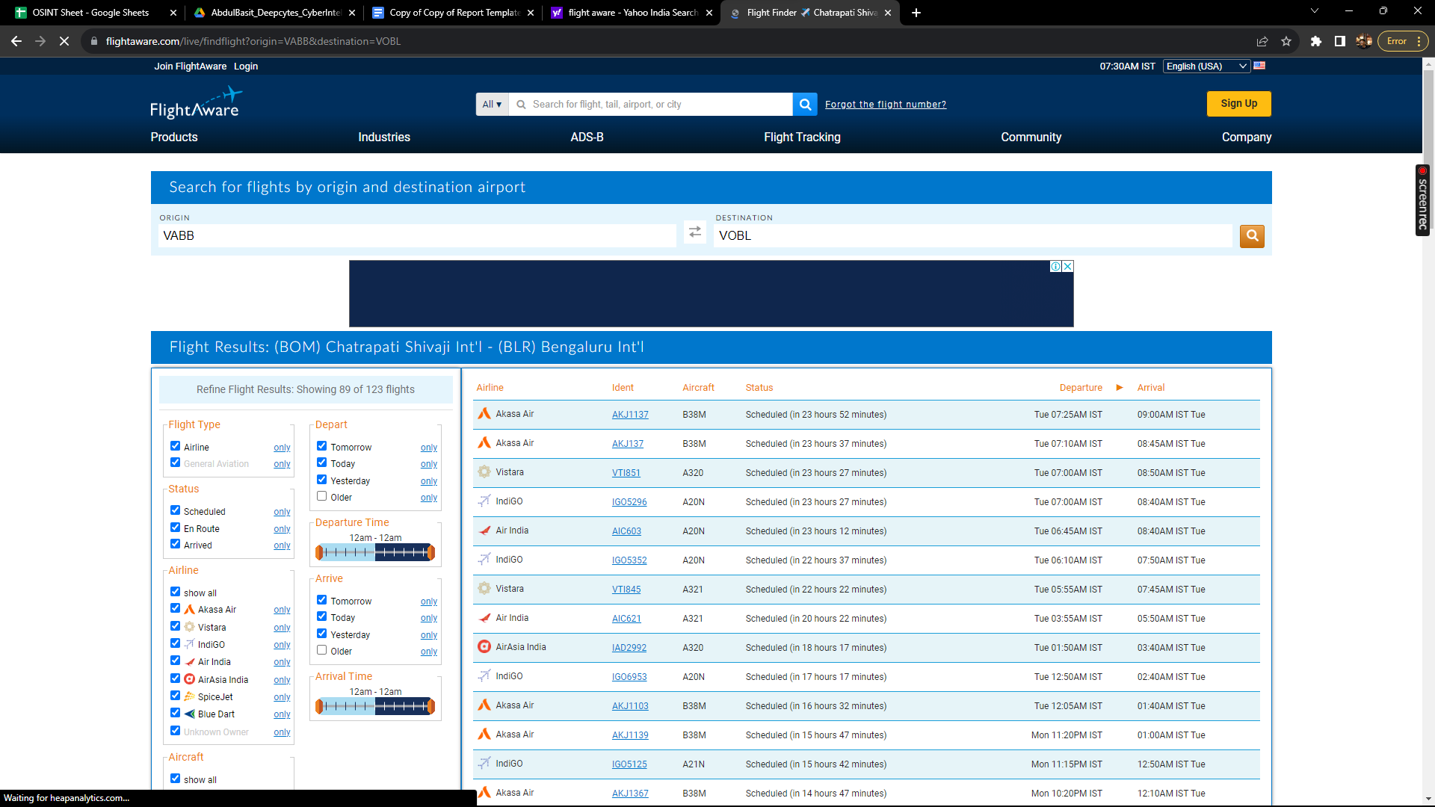

# Scope and Limitations

FlightAware is a powerful tool for tracking flights and monitoring air traffic. However, it is important to be aware of the limitations of the tool.

FlightAware can only track flights that are equipped with ADS-B transceivers or that are being tracked by radar. Not all aircraft are equipped with ADS-B transceivers, so FlightAware will not be able to track all aircraft.

Additionally, FlightAware cannot guarantee that the information that it displays is accurate or up-to-date. It is possible that the information that FlightAware displays may be incorrect or out of date.

# Conclusion

FlightAware is a valuable tool for businesses and individuals who need to track the location of flights, monitor air traffic, or research flight data. The tool is easy to use and provides a variety of useful features. However, it is important to be aware of the limitations of the tool before using it.