**Open Railway Map**

**Transport Trackers | 23.09.2023**

# Executive Summary

OpenRailwayMap is a free and open-source web-based map of the world's railway infrastructure. It is built on OpenStreetMap data, and includes information on railway tracks, stations, signals, electrification, and track gauge. OpenRailwayMap is a valuable tool for businesses, individuals, and railway enthusiasts alike.

# Index

**Executive Summary 2**

**Index 2**

**1. Introduction 2**

**2. Tool Details 2**

**3. Installation 3**

**4. Execution 3**

**5. Scope and Limitations 3**

**6. Conclusion 3**

**7. References (if any) 4**

# Introduction

OpenRailwayMap is a free and open-source web-based map of the world's railway infrastructure. It is built on OpenStreetMap data, and includes information on railway tracks, stations, signals, electrification, and track gauge. OpenRailwayMap is a valuable tool for businesses, individuals, and railway enthusiasts alike.

OpenRailwayMap can be used for a variety of purposes, including:

* Planning railway journeys
* Researching railway infrastructure
* Monitoring railway traffic
* Identifying potential railway development projects

# Tool Details

It is a web based tool.

Website: https://www.openrailwaymap.org/

# Installation

**OpenRailwayMap is a web-based tool, so there is no need to install any software. To use the tool, simply visit the OpenRailwayMap website.**

# Execution

**To use OpenRailwayMap, simply zoom in on the area of the map that you want to view. OpenRailwayMap will then display the railway infrastructure in the area. You can use the legend to learn more about the different symbols and colors that are used on the map.**

**You can also use the search bar to search for specific railway features, such as stations or lines. OpenRailwayMap will then zoom in on the feature that you searched for and display it on the map.**

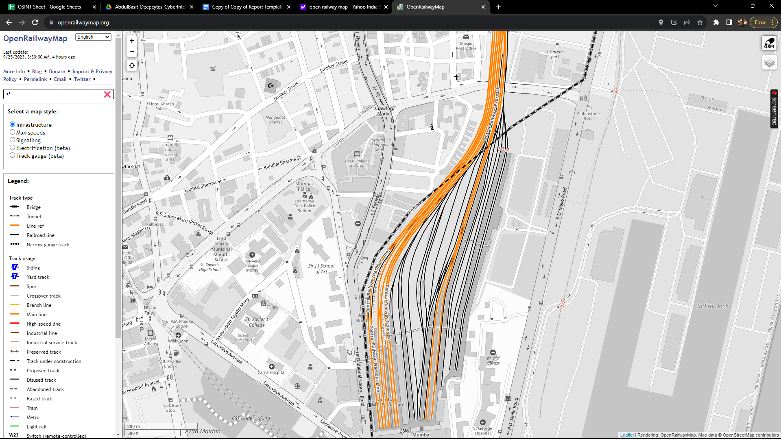

# Scope and Limitations

OpenRailwayMap is a powerful tool for viewing and analyzing railway infrastructure. However, it is important to be aware of the limitations of the tool.

OpenRailwayMap is only as accurate as the OpenStreetMap data that it is based on. If the OpenStreetMap data is inaccurate, then the OpenRailwayMap data will also be inaccurate.

Additionally, OpenRailwayMap does not provide all of the information that you may need about railway infrastructure. For example, OpenRailwayMap does not provide information on train schedules or fares.

# Conclusion

OpenRailwayMap is a valuable tool for businesses, individuals, and railway enthusiasts alike. The tool is easy to use and provides a variety of useful features. However, it is important to be aware of the limitations of the tool before using it.