**RAWGraphs**

**Data Visualisation | 23.09.2023**

# Executive Summary

RAWGraphs is a free and open-source web-based data visualization tool that can be used to create a variety of charts and graphs without any coding skills. RAWGraphs provides a user-friendly interface for selecting and customizing data visualizations, and its charts are exportable in a variety of formats, including SVG, PNG, and PDF.

This tool report provides a comprehensive overview of the installation, execution, scope, and limitations of the RAWGraphs tool. The report also includes recommendations for how to use the tool effectively.

# Index

**Executive Summary 2**

**Index 2**

**1. Introduction 2**

**2. Tool Details 2**

**3. Installation 3**

**4. Execution 3**

**5. Scope and Limitations 3**

**6. Conclusion 3**

**7. References (if any) 4**

# Introduction

RAWGraphs is a free and open-source web-based data visualization tool that can be used to create a variety of charts and graphs without any coding skills. RAWGraphs provides a user-friendly interface for selecting and customizing data visualizations, and its charts are exportable in a variety of formats, including SVG, PNG, and PDF.

RAWGraphs is a valuable tool for businesses and individuals who want to create clear and concise data visualizations to communicate their findings. RAWGraphs is also a popular tool for educators and students, as it provides a way to learn about data visualization without having to learn to code.

# Tool Details

It is a web based tool.

Website: https://www.rawgraphs.io/

# Installation

**RAWGraphs is a web-based tool, so there is no need to install any software. To use the tool, simply visit the RAWGraphs website and create an account.**

# Execution

Once you have created an account, you can start using the RAWGraphs tool to create data visualizations. To do this, follow these steps:

* Upload your data: RAWGraphs supports a variety of data formats, including CSV, TSV, JSON, and Excel.
* Select a chart type: RAWGraphs provides a variety of chart types to choose from, including bar charts, line charts, pie charts, and scatter plots.
* Customize your chart: Once you have selected a chart type, you can customize it to meet your needs. For example, you can change the colors, labels, and axes of your chart.
* Export your chart: Once you are satisfied with your chart, you can export it in a variety of formats, including SVG, PNG, and PDF.

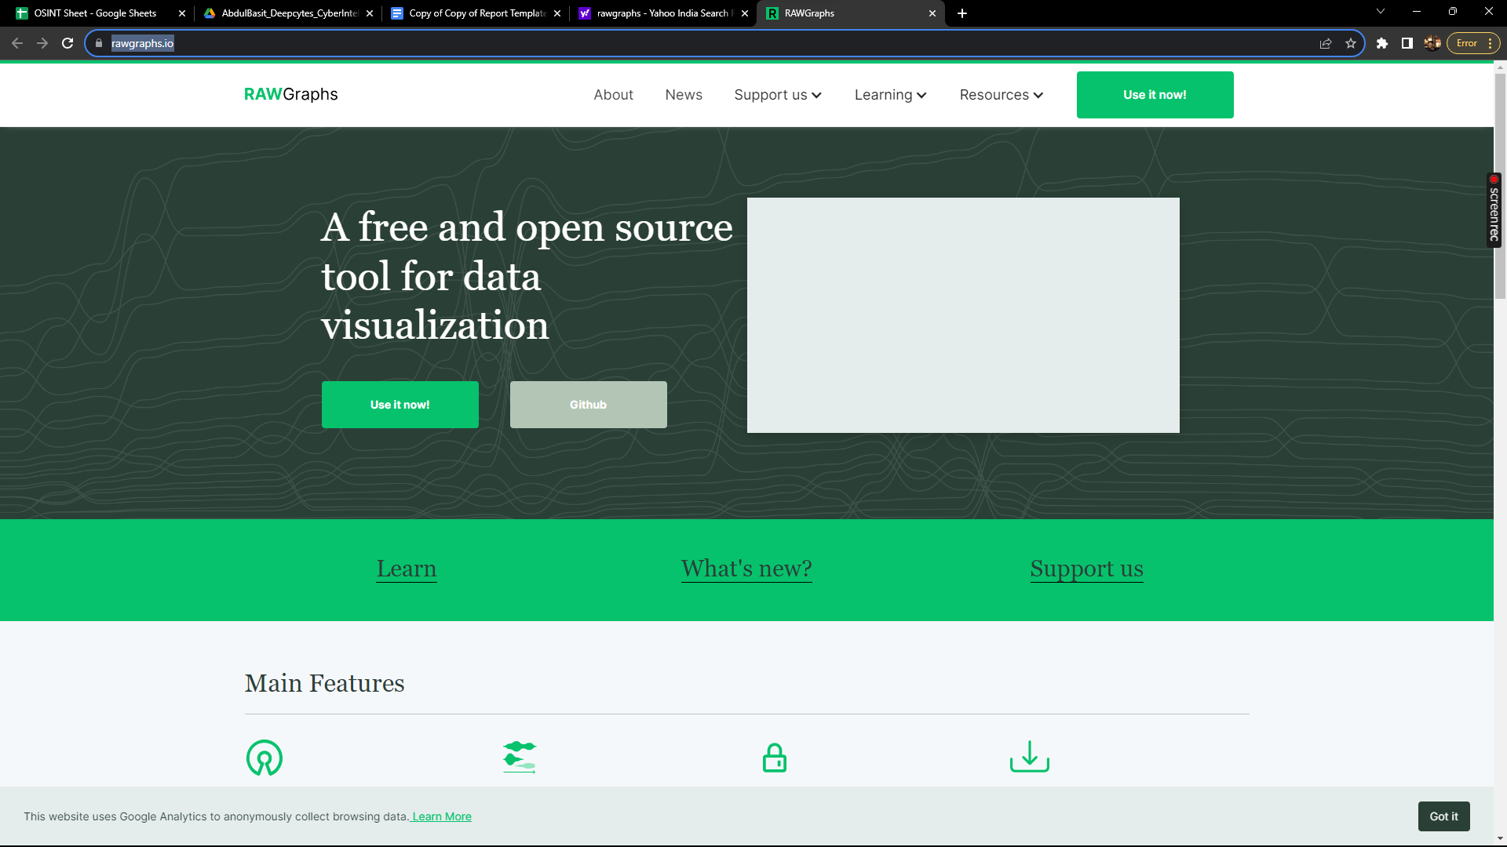

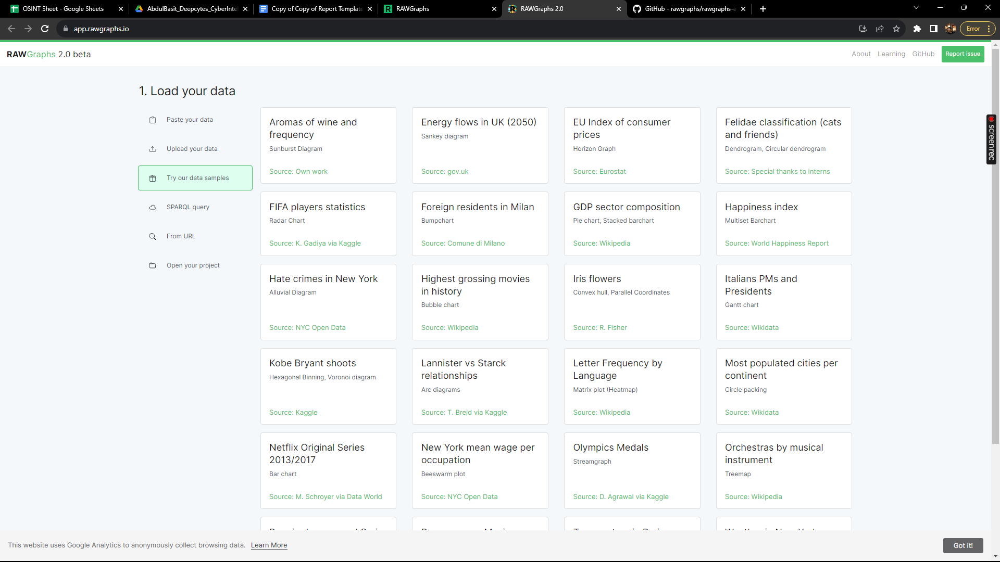

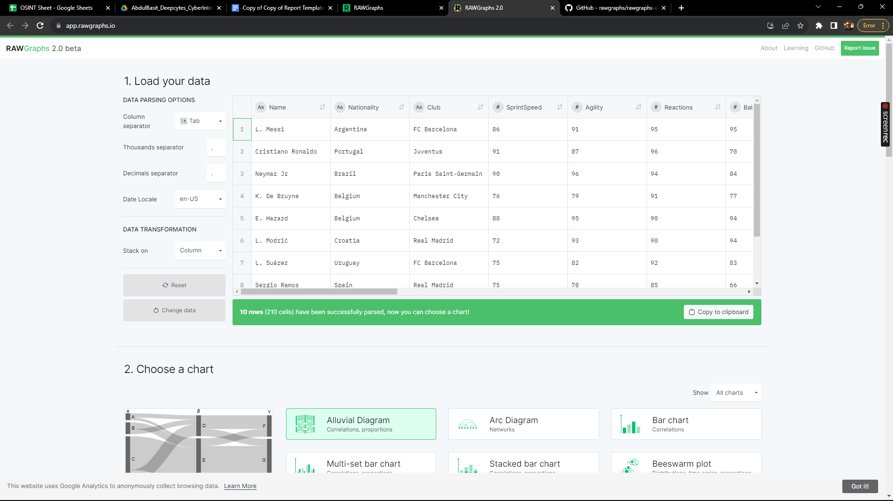

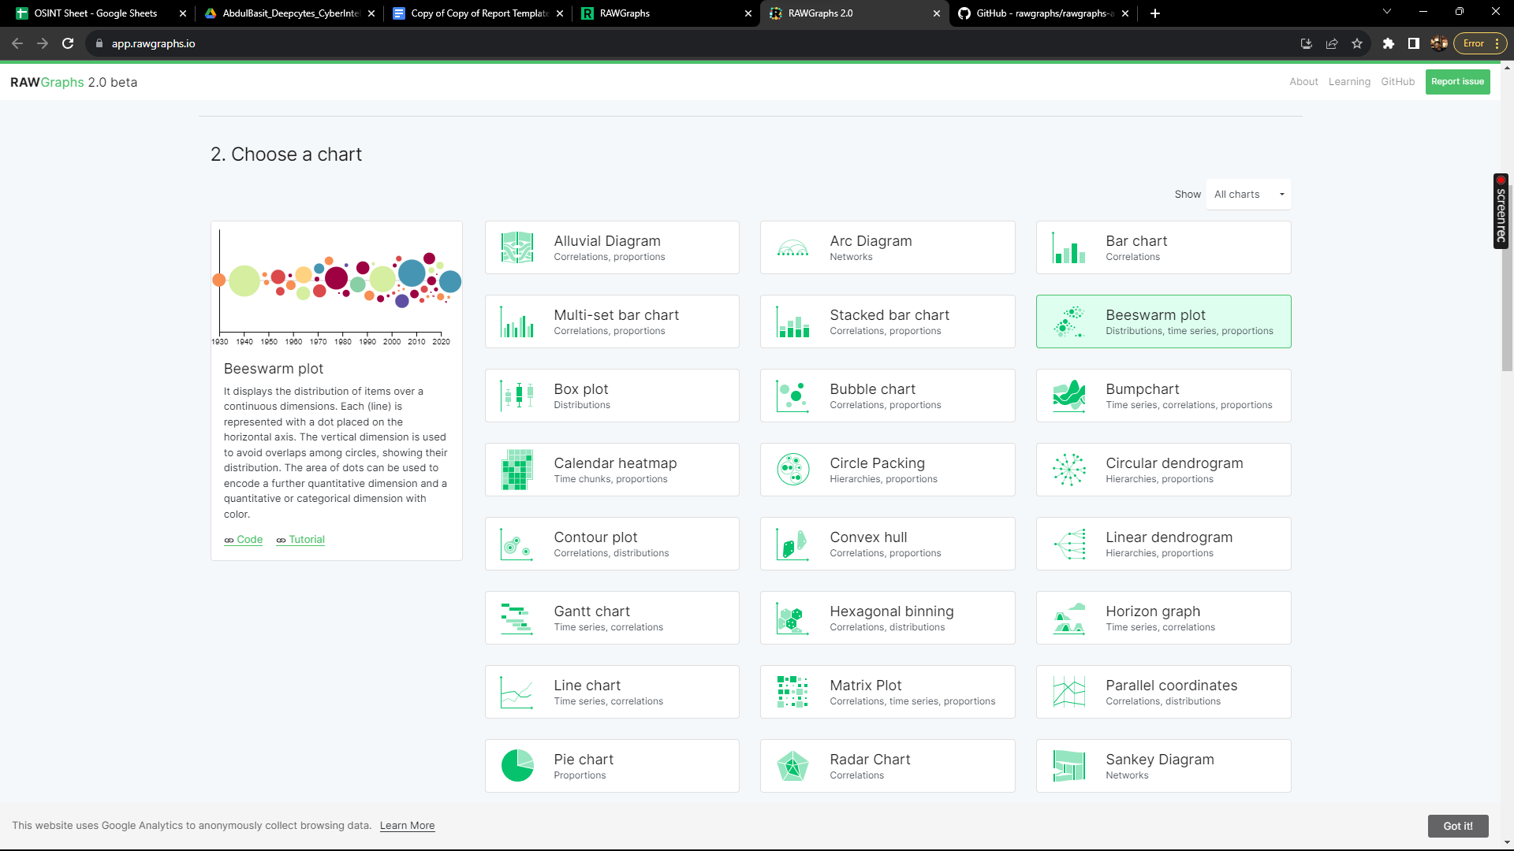

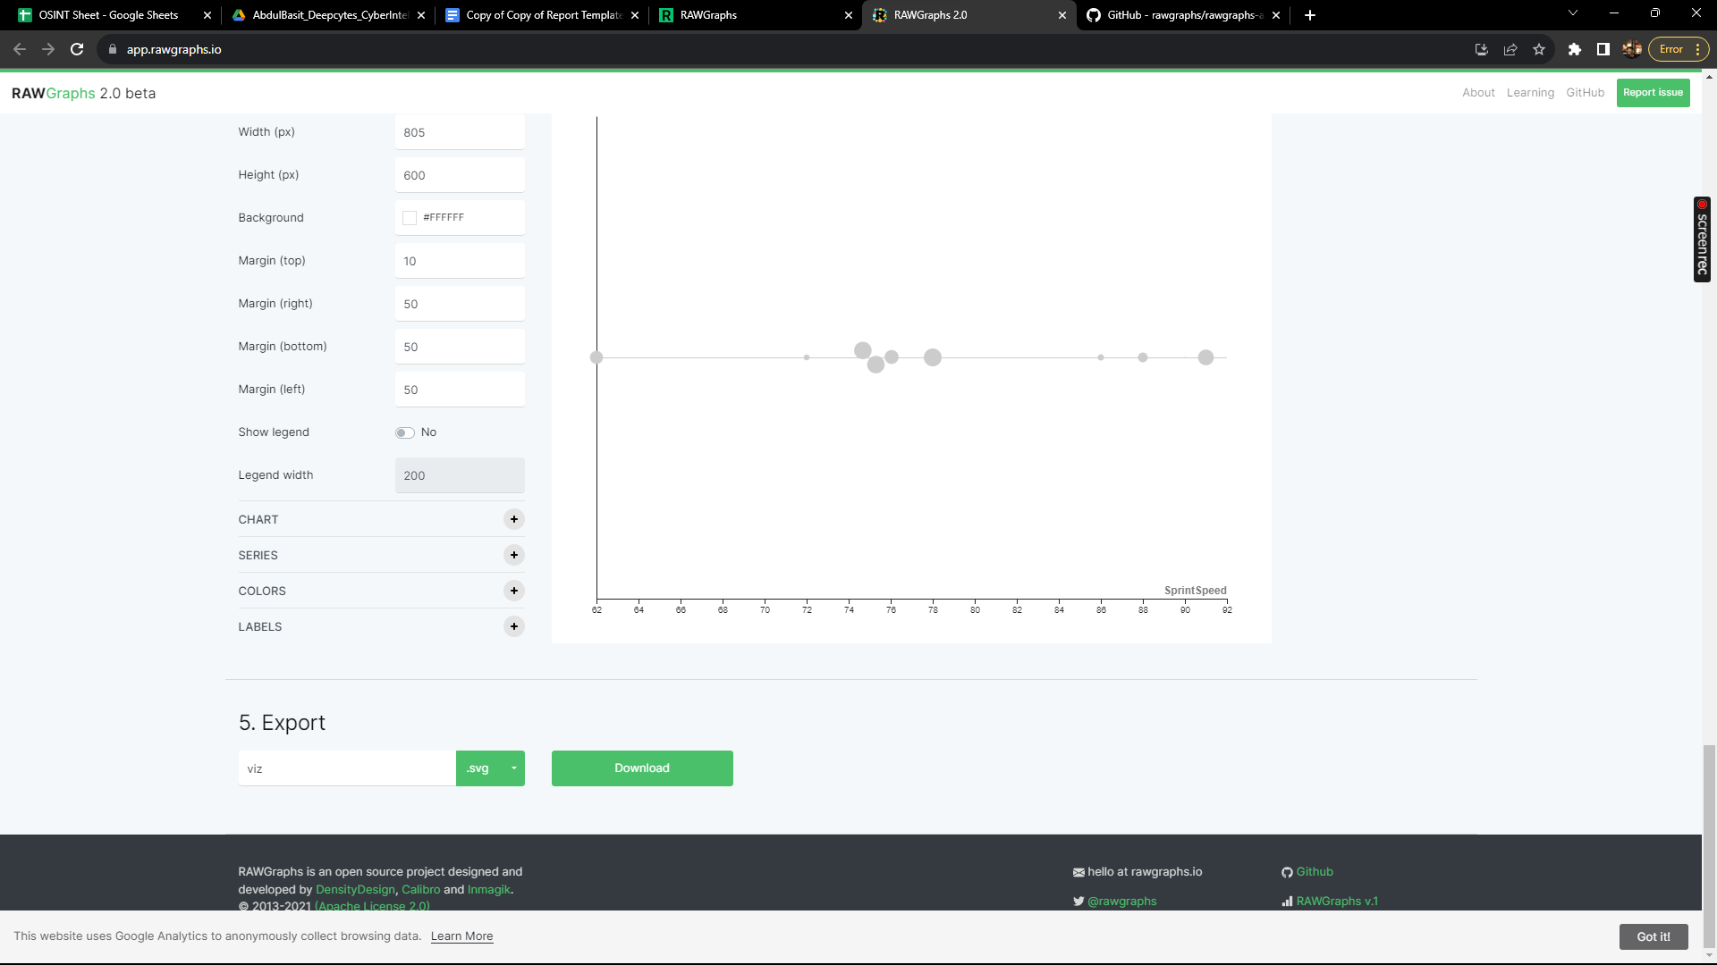

# Scope and Limitations

RAWGraphs is a powerful tool for creating data visualizations without any coding skills. However, it is important to be aware of the limitations of the tool.

RAWGraphs is not a replacement for more advanced data visualization tools, such as Tableau or R. RAWGraphs does not provide the same level of flexibility or control as these tools.

Additionally, RAWGraphs is not suitable for all types of data visualizations. For example, RAWGraphs cannot be used to create complex interactive data visualizations.

# Conclusion

RAWGraphs is a valuable tool for businesses and individuals who want to create clear and concise data visualizations without any coding skills. RAWGraphs is also a popular tool for educators and students.