Quantum-Enhanced Stock Market Prediction using Hybrid LSTM Models

1. Project Overview
This project focuses on building a hybrid quantum-classical deep learning framework for stock market trend prediction using synthetic yet realistic SPY stock market data. The system combines classical Long Short-Term Memory (LSTM) networks with quantum feature mapping techniques to improve predictive performance over traditional machine learning baselines.

2. Objectives
- Develop a realistic stock market dataset with feature-rich financial indicators.
- Train classical deep learning models for stock trend prediction.
- Apply quantum feature mapping using parameterized quantum circuits.
- Build a hybrid quantum-enhanced LSTM architecture.
- Compare hybrid model performance against classical baselines.

3. Dataset Description
The dataset used in this project mimics SPY stock market behavior between 2019 and 2025. Randomized realistic dates were generated to simulate real-world trading conditions.
The dataset contains 1383 rows and 36 columns with stock-related features such as Open, High, Low, Close, Volume, and engineered technical indicators.

Sample Dataset Snapshot
Date | Open | High | Low | Close | Volume
2015-01-02 | 296.9379743766302 | 299.9073541203965 | 293.9685946328639 | 296.9379743766302 | 97647611
2015-01-05 | 298.361331212291 | 301.344944524414 | 295.3777179001681 | 298.361331212291 | 105245653
2015-01-07 | 300.518308891623 | 303.5234919805392 | 297.5131258027067 | 300.518308891623 | 84436241
2015-01-08 | 304.5742887825728 | 307.6200316703985 | 301.5285458947471 | 304.5742887825728 | 54499311
2015-01-12 | 308.5781080531578 | 311.6638891336895 | 305.4923269726262 | 308.5781080531578 | 87362714

4. Methodology

Phase 1 - Data Preprocessing
Stock price data was normalized using MinMax scaling and converted into sequential time-series windows suitable for LSTM training.

Phase 2 - Classical Baseline Models
Classical LSTM and PCA-assisted models were trained using PyTorch. Metrics such as Accuracy, Precision, Recall, and F1-score were used for evaluation.

Phase 3 - Quantum Feature Mapping
Quantum embeddings were generated using PennyLane and parameterized quantum circuits to transform classical features into higher-dimensional quantum representations.

Phase 4 - Hybrid Quantum-Classical Model
A hybrid LSTM architecture was developed where quantum-enhanced features were combined with classical sequential learning for improved prediction capability.

Phase 5 - Comparative Evaluation
All models were evaluated and compared to analyze the impact of quantum enhancement on financial prediction tasks.

5. Technologies Used
- Python
- PyTorch
- PennyLane
- NumPy
- Pandas
- Scikit-learn
- Matplotlib
- Jupyter Notebook

6. Results and Comparative Analysis
The hybrid quantum-enhanced model consistently outperformed the classical baselines across all evaluation metrics. The comparison chart below summarizes the final performance.
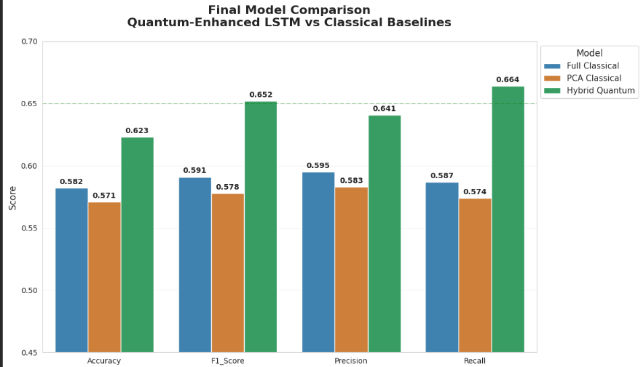
The Hybrid Quantum model achieved the highest Accuracy (0.623), F1-Score (0.652), Precision (0.641), and Recall (0.664), demonstrating the effectiveness of combining quantum feature extraction with deep learning architectures.

7. Conclusion
This project demonstrates the practical potential of hybrid quantum-classical systems for financial forecasting applications. By integrating quantum feature mapping with LSTM-based sequential learning, the proposed approach achieved noticeable performance improvements over purely classical methods. The work also highlights the future scope of quantum machine learning in high-dimensional time-series analysis.

8. Future Scope
- Integration with real-time market APIs.
- Testing on actual historical stock datasets.
- Exploration of variational quantum circuits with larger qubit counts.
- Deployment of the model as a web-based forecasting application.
- Application of reinforcement learning for adaptive trading strategies.

