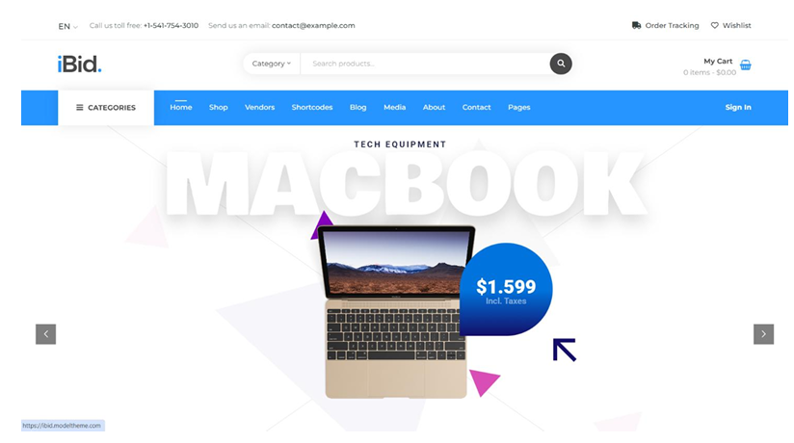

**Purpose**: The Home Screen aims to provide a seamless and engaging user experience, guiding users through the auction process with ease and efficiency.

|  |  |  |  |  |  |
| --- | --- | --- | --- | --- | --- |
| Sr. | Screen Element | Input Type | O/M | 1/N | Description |
| 1 | Title | Text |  | 1 | Shows the site title "iBid." |
| 2 | Category | Text | M | 1 | Shows a dropdown menu to select categories of products. |
| 3 | Search Item | Text | M | 1 | Allows users to search for items by entering item names. |
| 4 | My Cart | Text | M | 1 | Displays items that the user wants to purchase. |
| 5 | Navbar | Link | M | 1 | Displays links to various pages like Home, Shop, Vendors, Shortcodes, Blog, Media, About, Contact, and Pages. |
| 6 | Slider of Latest Ausction Item | Image | M | N | Shows a slider of the latest added auction items, currently displaying a MacBook with the price of $1,599 including taxes. |

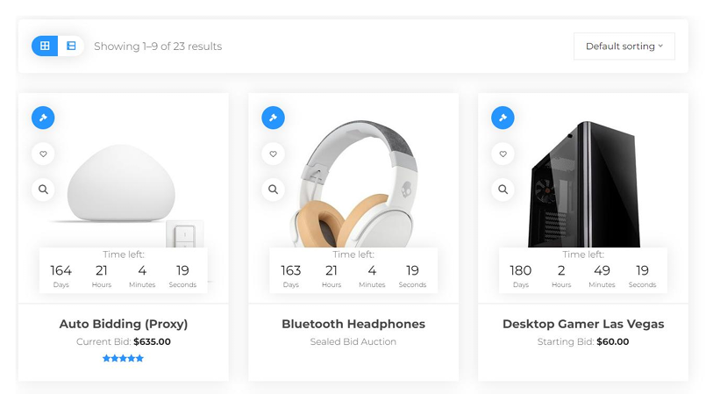

**Purpose**: To display auction items in a user-friendly way, allowing users to browse, sort, and view item details easily. The page provides essential information such as item images, auction time, current bid prices, and quick view options to aid in efficient browsing and decision-making.

|  |  |  |  |  |  |
| --- | --- | --- | --- | --- | --- |
| Sr. | Screen Element | Input Type | O/M | 1/N | Description |
| 1 | Grid -> List (List > Grid) | BUTTONS |  | 1 | Toggle between grid and list views for displaying items. |
| 2 | Default sorting | BUTTON | M | 1 | Sort the list based on various criteria such as alphabet, bid amount, and new/old items. |
| 3 | Item image | IMAGE | M | 1 | Displays an image of the auction item. |
| 4 | Auction time left | DATETIME | M | 1 | Shows the remaining time for the auction in a countdown format. |
| 5 | Item current/starting bid | TEXT | O | 1 | Displays the current bid price or the starting bid price in dollars. |
| 6 | Quick view | BUTTON | M | N | Provides a quick view of the item details. |

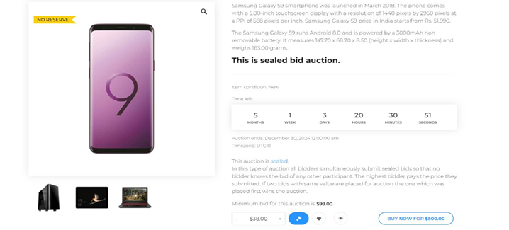

**Purpose**: To display detailed information about a specific auction item, allowing users to view item specifications, auction details, and place bids. This page provides comprehensive information such as item images, descriptions, auction type, time left, minimum bid, and bidding options to facilitate informed decision-making for potential bidders.

|  |  |  |  |  |  |
| --- | --- | --- | --- | --- | --- |
| Sr. | Screen Element | Input Type | O/M | 1/N | Description |
| 1 | Item Image | IMAGE |  | 1 | Displays the main image of the auction item. |
| 2 | Item Description | TEXT | M | 1 | Provides detailed information about the auction item, including specifications and condition. |
| 3 | Auction Type | TEXT | M | 1 | Indicates the type of auction (e.g., sealed bid auction). |
| 4 | Time Left | DATETIME | M | 1 | Shows the remaining time for the auction in a countdown format. |
| 5 | Auction End Date | DATETIME | M | 1 | Displays the date and time when the auction will end. |
| 6 | Bid Amount | TEXTBOX | M | 1 | Allows users to enter their bid amount. |
| 7 | Share | BUTTON | O | 1 | Option to share the auction item. |
| 8 | Buy Now | BUTTON | O | 1 | Allows users to buy the item immediately at a specified price. |

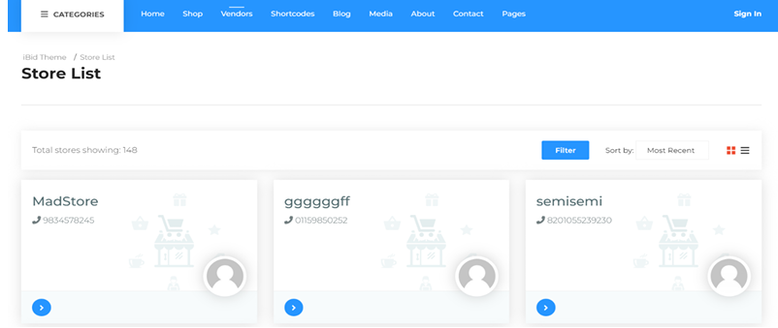

**Purpose**: The purpose of this screen is to display a list of stores available in the system. It allows users to view store details, filter the list, and sort the stores based on different criteria.

|  |  |  |  |  |  |
| --- | --- | --- | --- | --- | --- |
| Sr. | Screen Element | Input Type | O/M | 1/N | Description |
| 1 | Store Name | TEXT |  | 1 | Displays the name of the store. |
| 2 | Store Contact | TEXT | M | 1 | Shows the contact number of the store. |
| 3 | Store Image | IMAGE | O | 1 | Displays an image representing the store. |
| 4 | Filter Button | BUTTON | M | 1 | Allows users to filter the list of stores based on specific criteria. |
| 5 | Sort Dropdown | DROPDOWN | M | 1 | Provides options to sort the store list (e.g., Most Recent). |
| 6 | Navigation Arrows | BUTTON | O | 1 | Allows users to navigate through the store cards. |

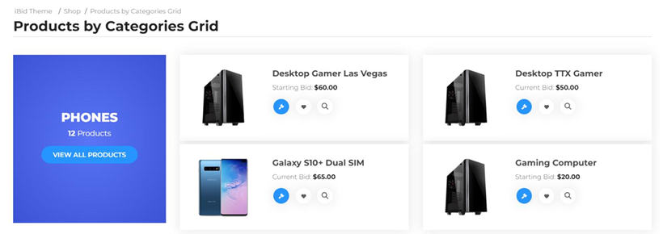

**Purpose**: This screen is Purpose to show Categories Wise Item.

|  |  |  |  |  |  |
| --- | --- | --- | --- | --- | --- |
| Sr. | Screen Element | Input Type | O/M | 1/N | Description |
| 1 | Categories Name | TEXT |  | 1 | Displays the name of the category (e.g., PHONES). |
| 2 | Category Product Count | TEXT | M | 1 | Shows the number of products in the category. |
| 3 | View All Products Button | BUTTON | M | 1 | Displays the main image of the product. |
| 4 | Product Title | TEXT | M | N | Shows the title of the product. |
| 5 | View Details Button | BUTTON | O | N | Allows users to view detailed information about the product. |