1. Explain the process of inserting image in an HTML document.
2. Explain the difference between <P> and <div> elements.
3. Create a HTML page which will divide a page in two horizontal fragments using frameset tag, each frame should have different background color and different headings.
4. Write an HTML-CSS code for showing following animation (Observe the animation mentioned)

|  |  |  |
| --- | --- | --- |
| Light Green  blue  Move down | | |
|  | Dark blue | Move diagonally |

1. Write an HTML5 code to embedded audio and video in web page.
2. Write an HTML Code to create the following table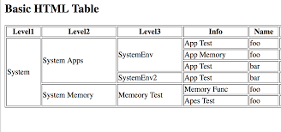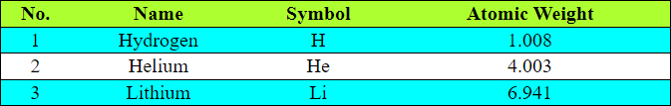
3. Write an HTML Code to create the following form

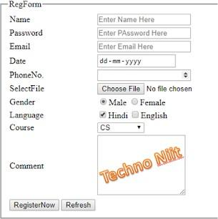

1. Write HTML code to drag and drop a specific image
2. What is validation. Create a form that has following fields, "Username", "Password" and "Confirm Password". Validate each field as follows:
   1. Username should of minimum 10 characters
   2. Password should contain 1 upper case letter, 1 lower case letter, 1 digit and 1 special character and the length of the password should be minimum 8.
   3. Confirm password should match password entered.
3. Write a Javascript program to find biggest of three numbers using Math object. (Use button and text box)
4. Write a Javascript code to change an image when mouse hover over the image and get the previous image when mouse moves out of the image.
5. Write a Java Script to find factorial of a number
6. Write a JavaScript function to get the month name from a particular date
7. Write a Javascript program to change HTML attribute value
8. Write a Javascript program to sort an array and display it in an ordered list format with the click of a button
9. Write a Java Script code to display digital clock on the screen.
10. Write a Java Script code to change advertisement stored in the form of image after 5 min atomically.
11. Write an HTML code to process placement registration form which accept the Students details like Name, Address, Email_id, Contact_no, DOB, Percentage, Branch (must be selected using radio button) and technology preferred (using checkbox). Write the javaScript code to validate the following:
12. Valid email_id (“@ “ and “.”)
13. All the fields must be filled before submission of the form.
14. Percentage validation is minimum first class (=>60%)
15. Write a XML document code to store the employee details like Name, Address, Gender and company name.
16. Write a PHP program to reverse a number
17. Display the following information using XML and XSLT

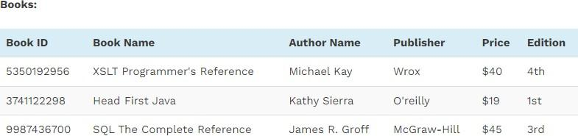

1. Write a PHP program to check if the entered string is palindrome
2. Create a DTD for catalogue of cars, where each car element has the child elements make, model, year , color, engine and doors. The engine element has the child elements no_of_cylinders and fuel_type