**Entity - Relationship Diagram**

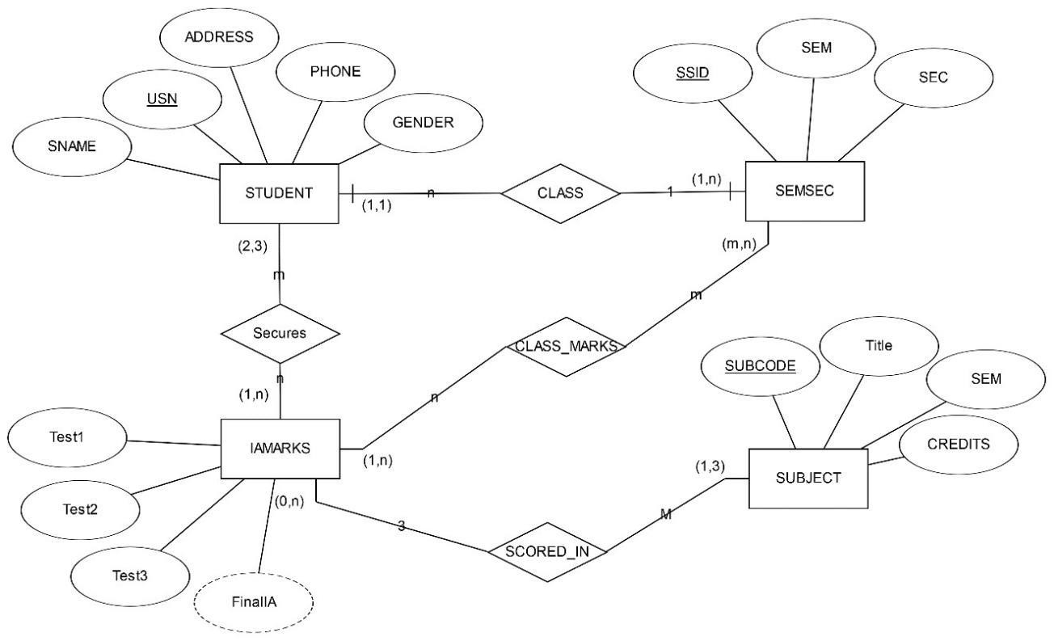

**Schema Diagram**

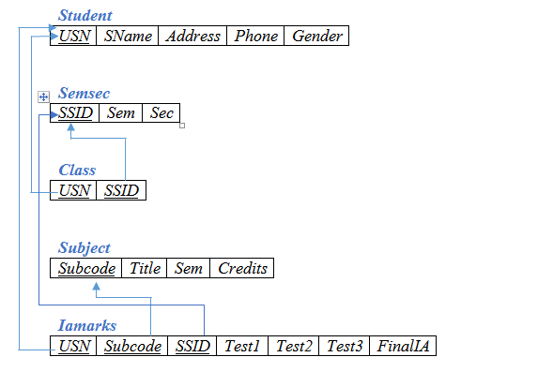

-- CREATION OF TABLES

-- STUDENT

CREATE TABLE STUDENT (

USN VARCHAR (10) PRIMARY KEY,

SNAME VARCHAR (25),

ADDRESS VARCHAR (25),

PHONE INTEGER,

GENDER CHAR (1));

-- SEMSEC

CREATE TABLE SEMSEC (

SSID VARCHAR (5) PRIMARY KEY,

SEM INTEGER,

SEC CHAR (1));

-- CLASS

CREATE TABLE CLASS (

USN VARCHAR (10),

SSID VARCHAR (5),

PRIMARY KEY (USN, SSID),

FOREIGN KEY (USN) REFERENCES STUDENT (USN),

FOREIGN KEY (SSID) REFERENCES SEMSEC (SSID));

-- SUBJECT

CREATE TABLE SUBJECT (

SUBCODE VARCHAR (8),

TITLE VARCHAR (20),

SEM INTEGER,

CREDITS INTEGER,

PRIMARY KEY (SUBCODE));

-- IAMARKS

CREATE TABLE IAMARKS (

USN VARCHAR (10),

SUBCODE VARCHAR (8),

SSID VARCHAR (5),

TEST1 INTEGER,

TEST2 INTEGER,

TEST3 INTEGER,

FINALIA INTEGER,

PRIMARY KEY (USN, SUBCODE, SSID),

FOREIGN KEY (USN) REFERENCES STUDENT (USN),

FOREIGN KEY (SUBCODE) REFERENCES SUBJECT (SUBCODE),

FOREIGN KEY (SSID) REFERENCES SEMSEC (SSID));

-- VALUES FOR TABLES

-- STUDENT

INSERT INTO STUDENT VALUES ('1RN13CS020','AKSHAY','BELAGAVI',887788112,'M');

INSERT INTO STUDENT VALUES ('1RN13CS062','SANDHYA','BENGALURU',772282991,'F');

INSERT INTO STUDENT VALUES ('1RN13CS091','TEESHA','BENGALURU',771231231,'F');

INSERT INTO STUDENT VALUES ('1RN13CS066','SUPRIYA','MANGALURU',887788112,'F');

INSERT INTO STUDENT VALUES ('1RN14CS010','ABHAY','BENGALURU',990021120,'M');

INSERT INTO STUDENT VALUES ('1RN14CS032','BHASKAR','BENGALURU',992321109,'M');

INSERT INTO STUDENT VALUES ('1RN14CS025','ASMI','BENGALURU', 789473737,'F');

INSERT INTO STUDENT VALUES ('1RN15CS011','AJAY','TUMKUR', 984509134,'M');

INSERT INTO STUDENT VALUES ('1RN15CS029','CHITRA','DAVANGERE',769677211,'F');

INSERT INTO STUDENT VALUES ('1RN15CS045','JEEVA','BELLARY', 994485012,'M');

INSERT INTO STUDENT VALUES ('1RN15CS091','SANTOSH','MANGALURU',881233220,'M');

INSERT INTO STUDENT VALUES ('1RN16CS045','ISMAIL','KALBURGI',990023221,'M');

INSERT INTO STUDENT VALUES ('1RN16CS088','SAMEERA','SHIMOGA',990554221,'F');

INSERT INTO STUDENT VALUES ('1RN16CS122','VINAYAKA','CHIKAMAGALUR',880088001,'M');

-- SEMSEC

INSERT INTO SEMSEC VALUES ('CSE8A', 8,'A');

INSERT INTO SEMSEC VALUES ('CSE8B', 8,'B');

INSERT INTO SEMSEC VALUES ('CSE8C', 8,'C');

INSERT INTO SEMSEC VALUES ('CSE7A', 7,'A');

INSERT INTO SEMSEC VALUES ('CSE7B', 7,'B');

INSERT INTO SEMSEC VALUES ('CSE7C', 7,'C');

INSERT INTO SEMSEC VALUES ('CSE6A', 6,'A');

INSERT INTO SEMSEC VALUES ('CSE6B', 6,'B');

INSERT INTO SEMSEC VALUES ('CSE6C', 6,'C');

INSERT INTO SEMSEC VALUES ('CSE5A', 5,'A');

INSERT INTO SEMSEC VALUES ('CSE5B', 5,'B');

INSERT INTO SEMSEC VALUES ('CSE5C', 5,'C');

INSERT INTO SEMSEC VALUES ('CSE4A', 4,'A');

INSERT INTO SEMSEC VALUES ('CSE4B', 4,'B');

INSERT INTO SEMSEC VALUES ('CSE4C', 4,'C');

INSERT INTO SEMSEC VALUES ('CSE3A', 3,'A');

INSERT INTO SEMSEC VALUES ('CSE3B', 3,'B');

INSERT INTO SEMSEC VALUES ('CSE3C', 3,'C');

INSERT INTO SEMSEC VALUES ('CSE2A', 2,'A');

INSERT INTO SEMSEC VALUES ('CSE2B', 2,'B');

INSERT INTO SEMSEC VALUES ('CSE2C', 2,'C');

INSERT INTO SEMSEC VALUES ('CSE1A', 1,'A');

INSERT INTO SEMSEC VALUES ('CSE1B', 1,'B');

INSERT INTO SEMSEC VALUES ('CSE1C', 1,'C');

-- CLASS

INSERT INTO CLASS VALUES ('1RN13CS020','CSE8A');

INSERT INTO CLASS VALUES ('1RN13CS062','CSE8A');

INSERT INTO CLASS VALUES ('1RN13CS066','CSE8B');

INSERT INTO CLASS VALUES ('1RN13CS091','CSE8C');

INSERT INTO CLASS VALUES ('1RN14CS010','CSE7A');

INSERT INTO CLASS VALUES ('1RN14CS025','CSE7A');

INSERT INTO CLASS VALUES ('1RN14CS032','CSE7A');

INSERT INTO CLASS VALUES ('1RN15CS011','CSE4A');

INSERT INTO CLASS VALUES ('1RN15CS029','CSE4A');

INSERT INTO CLASS VALUES ('1RN15CS045','CSE4B');

INSERT INTO CLASS VALUES ('1RN15CS091','CSE4C');

-- SUBJECT

INSERT INTO SUBJECT VALUES ('10CS81','ACA', 8, 4);

INSERT INTO SUBJECT VALUES ('10CS82','SSM', 8, 4);

INSERT INTO SUBJECT VALUES ('10CS83','NM', 8, 4);

INSERT INTO SUBJECT VALUES ('10CS84','CC', 8, 4);

INSERT INTO SUBJECT VALUES ('10CS85','PW', 8, 4);

INSERT INTO SUBJECT VALUES ('10CS71','OOAD', 7, 4);

INSERT INTO SUBJECT VALUES ('10CS72','ECS', 7, 4);

INSERT INTO SUBJECT VALUES ('10CS73','PTW', 7, 4);

INSERT INTO SUBJECT VALUES ('10CS74','DWDM', 7, 4);

INSERT INTO SUBJECT VALUES ('10CS75','JAVA', 7, 4);

INSERT INTO SUBJECT VALUES ('10CS76','SAN', 7, 4);

INSERT INTO SUBJECT VALUES ('15CS51', 'ME', 5, 4);

INSERT INTO SUBJECT VALUES ('15CS52','CN', 5, 4);

INSERT INTO SUBJECT VALUES ('15CS53','DBMS', 5, 4);

INSERT INTO SUBJECT VALUES ('15CS54','ATC', 5, 4);

INSERT INTO SUBJECT VALUES ('15CS55','JAVA', 5, 3);

INSERT INTO SUBJECT VALUES ('15CS56','AI', 5, 3);

INSERT INTO SUBJECT VALUES ('15CS41','M4', 4, 4);

INSERT INTO SUBJECT VALUES ('15CS42','SE', 4, 4);

INSERT INTO SUBJECT VALUES ('15CS43','DAA', 4, 4);

INSERT INTO SUBJECT VALUES ('15CS44','MPMC', 4, 4);

INSERT INTO SUBJECT VALUES ('15CS45','OOC', 4, 3);

INSERT INTO SUBJECT VALUES ('15CS46','DC', 4, 3);

INSERT INTO SUBJECT VALUES ('15CS31','M3', 3, 4);

INSERT INTO SUBJECT VALUES ('15CS32','ADE', 3, 4);

INSERT INTO SUBJECT VALUES ('15CS33','DSA', 3, 4);

INSERT INTO SUBJECT VALUES ('15CS34','CO', 3, 4);

INSERT INTO SUBJECT VALUES ('15CS35','USP', 3, 3);

INSERT INTO SUBJECT VALUES ('15CS36','DMS', 3, 3);

-- IAMARKS

INSERT INTO IAMARKS (USN, SUBCODE, SSID, TEST1, TEST2, TEST3) VALUES ('1RN13CS091','10CS81','CSE8C', 15, 16, 18);

INSERT INTO IAMARKS (USN, SUBCODE, SSID, TEST1, TEST2, TEST3) VALUES ('1RN13CS091','10CS82','CSE8C', 12, 19, 14);

INSERT INTO IAMARKS (USN, SUBCODE, SSID, TEST1, TEST2, TEST3) VALUES ('1RN13CS091','10CS83','CSE8C', 19, 15, 20);

INSERT INTO IAMARKS (USN, SUBCODE, SSID, TEST1, TEST2, TEST3) VALUES ('1RN13CS091','10CS84','CSE8C', 20, 16, 19);

INSERT INTO IAMARKS (USN, SUBCODE, SSID, TEST1, TEST2, TEST3) VALUES ('1RN13CS091','10CS85','CSE8C', 15, 15, 12);

-- DISPLAYING TABLES

-- STUDENT

SELECT * FROM STUDENT;

-- SEMSEC

SELECT * FROM SEMSEC;

-- CLASS

SELECT * FROM CLASS;

-- SUBJECT

SELECT * FROM SUBJECT;

-- IAMARKS

SELECT * FROM IAMARKS;

-- QUERIES

-- 1) List all the student details studying in fourth semester 'C' section.

SELECT S.*, SS.SEM, SS.SEC

FROM STUDENT S, SEMSEC SS, CLASS C

WHERE S.USN = C.USN AND

SS.SSID = C.SSID AND

SS.SEM = 4 AND

SS.SEC = 'C';

-- 2) Compute the total number of male and female students in each semester and in eachsection.

SELECT SS.SEM, SS.SEC, S.GENDER, COUNT(S.GENDER) AS COUNT

FROM STUDENT S, SEMSEC SS, CLASS C

WHERE S.USN = C.USN AND

SS.SSID = C.SSID

GROUP BY SS.SEM, SS.SEC, S.GENDER

ORDER BY SEM;

-- 3) Create a view of Test1 marks of student USN '1RN13CS091' in all subjects.

CREATE VIEW STU_TEST1_MARKS_VIEW

AS

SELECT TEST1, SUBCODE

FROM IAMARKS

WHERE USN = '1RN13CS091';

SELECT * FROM STU_TEST1_MARKS_VIEW;

-- 4) Calculate the FinalIA (average of best two test marks) and update the corresponding table for all students.

UPDATE IAMARKS

SET FINALIA=GREATEST(TEST1+TEST2,TEST2+TEST3,TEST1+TEST3)/2;

SELECT * FROM IAMARKS;

-- 5) Categorize students based on the following criterion:

-- If FinalIA = 17 to 20 then CAT = 'Outstanding'

-- If FinalIA = 12 to 16 then CAT = 'Average'

-- If FinalIA< 12 then CAT = 'Weak'

-- Give these details only for 8 th semester A, B, and C section students.

SELECT S.USN,S.SNAME,S.ADDRESS,S.PHONE,S.GENDER,

(CASE

WHEN IA.FINALIA BETWEEN 17 AND 20 THEN 'OUTSTANDING'

WHEN IA.FINALIA BETWEEN 12 AND 16 THEN 'AVERAGE'

ELSE 'WEAK'

END) AS CAT

FROM STUDENT S, SEMSEC SS, IAMARKS IA, SUBJECT SUB

WHERE S.USN = IA.USN AND

SS.SSID = IA.SSID AND

SUB.SUBCODE = IA.SUBCODE AND

SUB.SEM = 8;