Exercise

 Create an application to navigate through two named routes:

1. Create two routes.
2. Create text button or elevated button etc in each screen.
3. Navigate to the second route using Navigator.push() method.
4. Return to the first route using Navigator.pop() method.

The application should produce the following routes (screens):

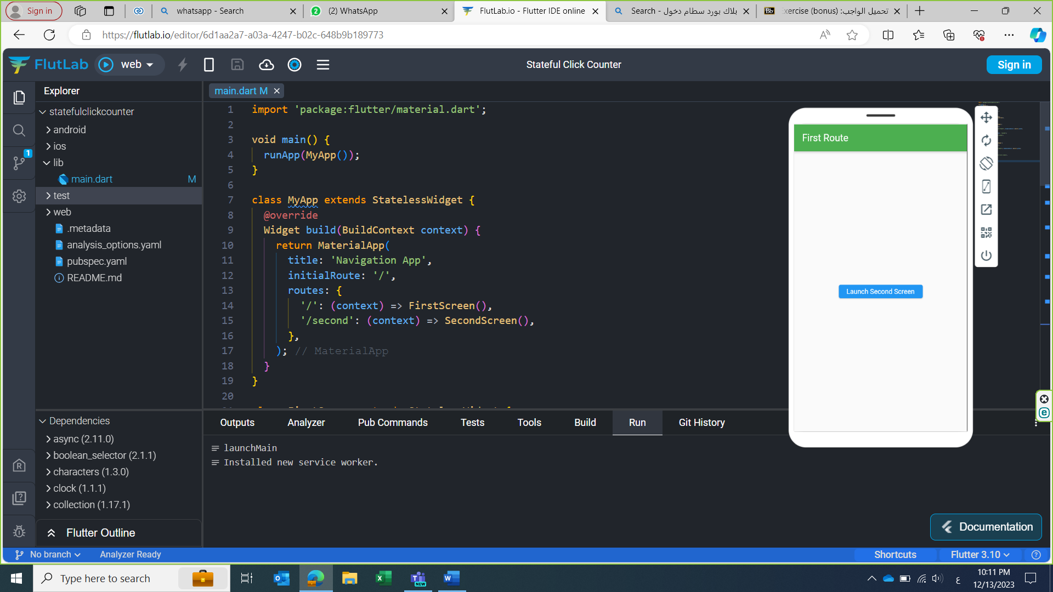

import 'package:flutter/material.dart';

void main() {

  runApp(MyApp());

}

class MyApp extends StatelessWidget {

  @override

  Widget build(BuildContext context) {

    return MaterialApp(

      title: 'Navigation App',

      initialRoute: '/',

      routes: {

        '/': (context) => FirstScreen(),

        '/second': (context) => SecondScreen(),

      },

    );

  }

}

class FirstScreen extends StatelessWidget {

  @override

  Widget build(BuildContext context) {

    return Scaffold(

      appBar: AppBar(title: Text('First Route'), backgroundColor: Colors.green),

      body: Center(

        child: ElevatedButton(

          onPressed: () {

            Navigator.pushNamed(context, '/second');

          },

          child: Text('Launch Second Screen'),

        ),

      ),

    );

  }

}

class SecondScreen extends StatelessWidget {

  @override

  Widget build(BuildContext context) {

    return Scaffold(

      appBar:

          AppBar(title: Text('Second Route'), backgroundColor: Colors.green),

      body: Center(

        child: ElevatedButton(

          onPressed: () {

            Navigator.pop(context);

          },

          child: Text('Go back to the first screen'),

        ),

      ),

    );

  }

}