**WRES3315 EMBEDDED SYSTEM PROGRAMMING**

**TUTORIAL 2**

1. What do ADC, DAC and SRAM stand for?

ADC = Analog-to-digital Converter

DAC = Digital-to-analog converter

SRAM = Static Random Access Memory

1. What do UART, CAN, I2C and SPI stand for, and what do these mbed features have in common?

UART – Universal Asynchronous Receiver/Transmitter

CAN – Controller Area Network - irregulated communication

I2C – Inter-Integrated Controller –

SPI – Serial Peripheral Interface -

Common things between all of these mbed features are ways of communication between compatible microcontrollers. All serial protocols.

1. How many digital inputs are available on the mbed?

26 pins

**Pin 5 to pin 30.**

1. Which mbed pins can be used for analog input and output?

Analog Input Pin 15 – 20

Analog Output Pin 18

1. How many microcontrollers are on the mbed PCB and what specifically are they?

**It comes with an API which allow programs to be devised quickly and reliably.**

**API = it’s like a blackbox solution. You want to do something, just call the API and give the corresponding value. Like programming, we only call function.**

It has two microcontrollers. One LPC1768 microcontroller and another interface microcontroller

1. What is unique about the mbed compiler software?
2. An mbed is part of a circuit which is to be powered from a 9 V battery. After programming the mbed is disconnected from the USB. One part of the circuit external to the mbed needs to be supplied from 9 V, and another part from 3.3 V. No other battery or power supply is to be used. Draw a diagram which shows how these power connections should be made.



1. An mbed is connected to a system, and needs to connect three analog inputs, one SPI connection, one analog output, and two PWM outputs. Draw a sketch showing how these connections can be made, and indicating mbed pin number.

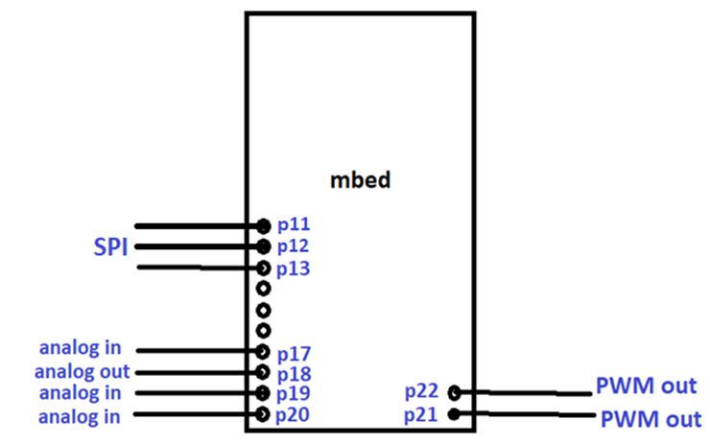

1. A friend enters the code shown below into the mbed compiler, but when compiling a number of errors are flagged. Find and correct the faults.

#include "mbed"

Digital Out myled(LED1); int man() {

white(1) {

myled = 1;

wait(0.2)

myled = 0;

watt(0.2);

}

Corrected code:

#include "mbed.h"

DigitalOut myled(LED1);

int main() {

while(1) {

myled = 1;

wait(0.2);

myled = 0;

wait(0.2);

}

}

1. By not connecting all the LPC1768 microcontroller pins to the mbed external pins, a number of microcontroller peripherals are “lost” for use. Identify what these are, for ADC, UART, CAN, I2C, SPI and DAC.

|  |  |  |  |
| --- | --- | --- | --- |
|  | **LPC1768** | **mbed** | **“lost”** |
| **ADC** | **8 channels** | **6** | **2** |
| **UART** | **4** | **3** | **1** |
| **CAN** | **2** | **1** | **1** |
| **I2C** | **3** | **2** | **1** |
| **SPI** | **3** | **2** | **1** |
| **DAC** | **1** | **1** | **0** |