Challange 1

1. Here is looks file of 00-access.log  
      
      
    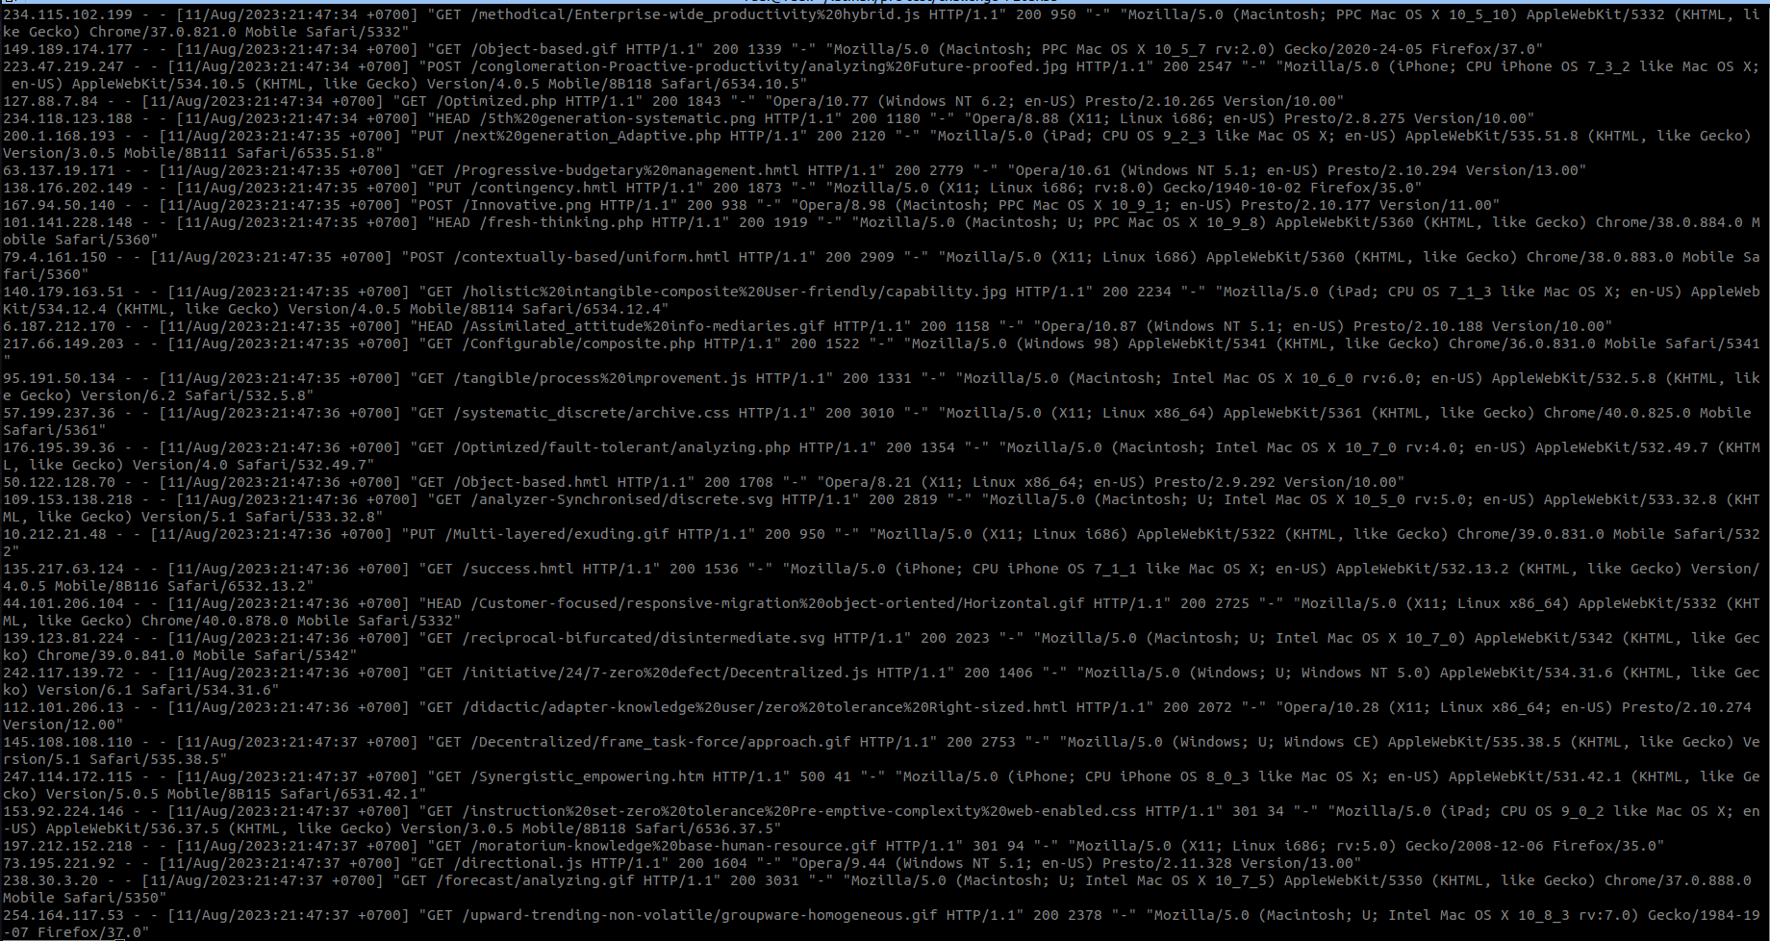
2. Here is looks of file 01-access.log  
      
    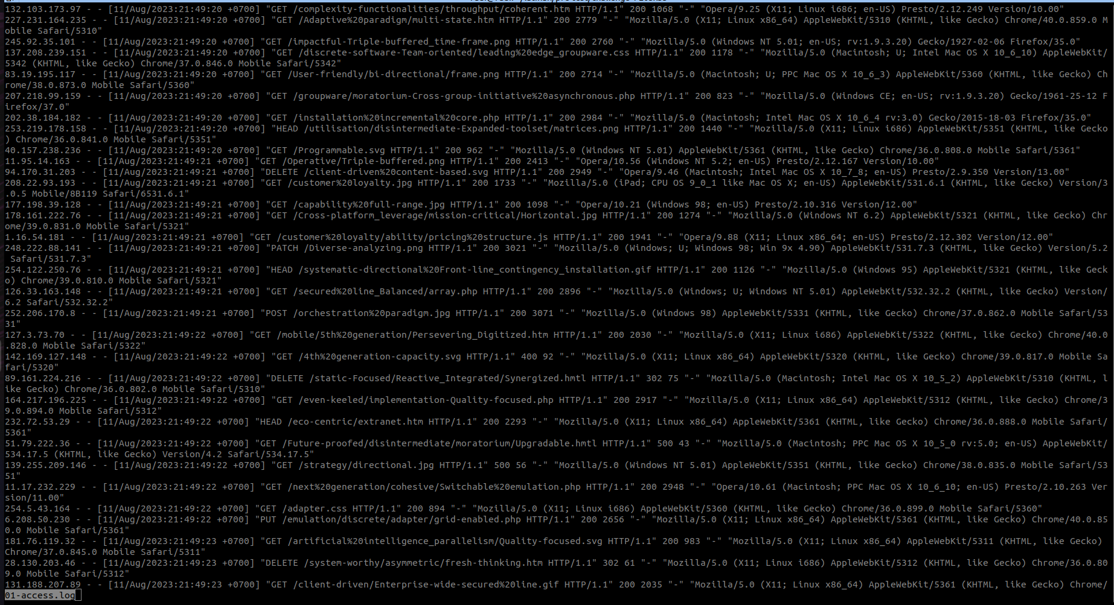  
     
     
     
     
     
     
     
   3. Here is looks of file 02-access.log

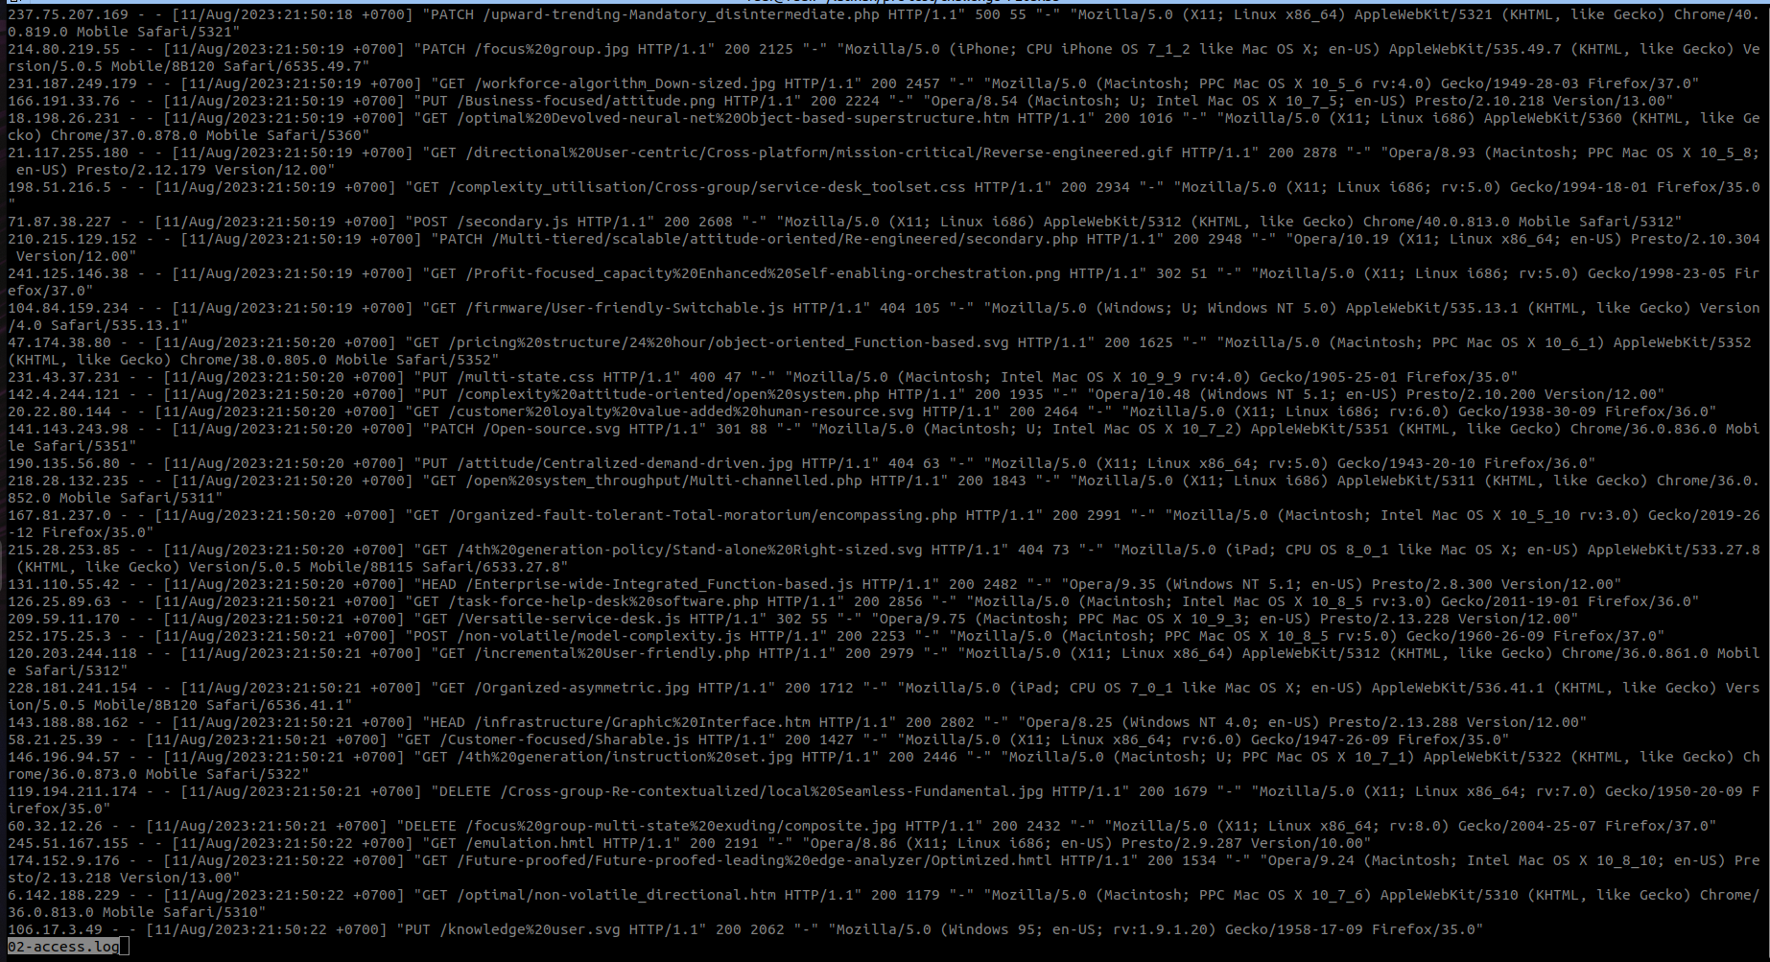  
  
  
  
4. Here is looks of the script   
  
 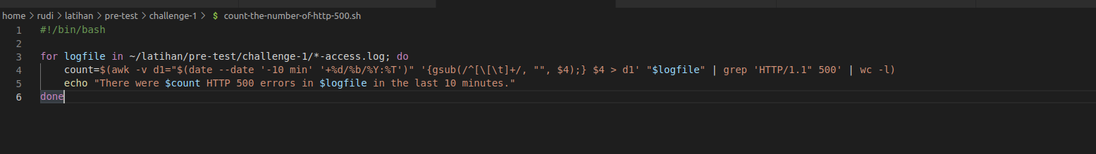  
  
5. Here is the result of the script

