Challenge 2

1. So here is the docker-compose file . so because nginx need to be the reverse porxy i creeate another container which is httpd that shows the index.html   
      
    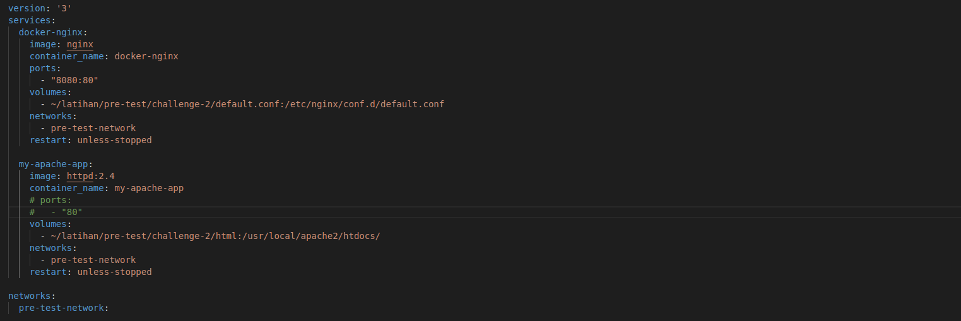
2. default.conf   
     
   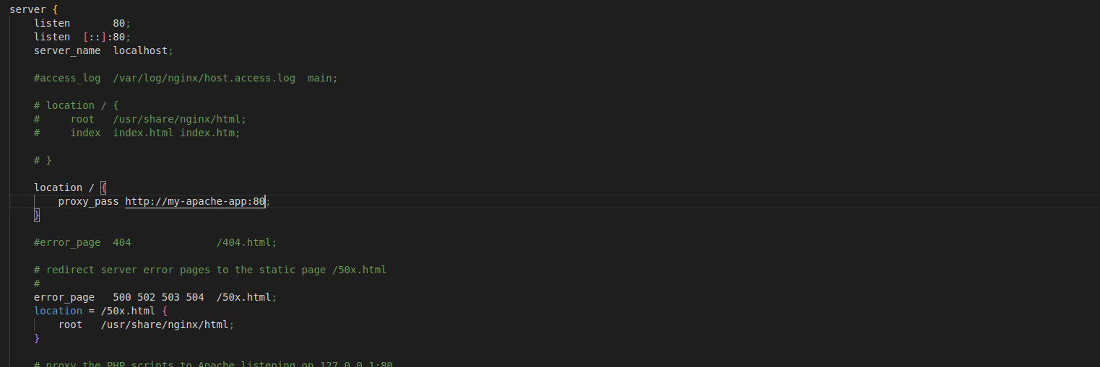  
     
   3. Result of the nginx proxy   
     
    