Responsive Layout and Mobile Checkout Optimization for BiteSize
Question 1: Using a Media Query Breakpoint to Transform the Layout
Bitesize can fix its cramped phone experience by treating the stacking as a design decision instead of an accident. Marcotte (2011) describes responsive design as the combination of fluid grids, flexible images, and CSS media queries. The media query detects the viewport and swaps one set of layout rules for another. For BiteSize, the first step is to pick a breakpoint where the three-column desktop grid starts to feel crowded, commonly near 768 pixels, and place the mobile rules inside that query.
The page first needs a viewport meta tag in the HTML head, set to device width with an initial scale of 1. Without it, phones render the page at a desktop width and shrink it, so the media query never works as intended. The desktop layout can use CSS Grid with three columns for the menu, product list, and cart summary. Inside a rule such as @media (width <= 768px), the grid is redefined as a single column, so the sections stack in a deliberate order (see Figure 1). The menu collapses into a compact bar, product cards span the full width, and the cart summary becomes a fixed bar at the bottom of the screen, so checkout is always one tap away.
Images and text blocks should use relative units, such as a max width of 100 percent for images and rem based spacing, so they flex smoothly between breakpoints (Marcotte, 2011). Buttons and links should be at least about 44 pixels tall so thumbs can hit them reliably. BiteSize can also write the phone layout as the default and add columns with a minimum width query as screens grow, which keeps the mobile code lean and stops desktop rules from leaking onto small screens. Testing in browser device mode and on real phones will show whether a second breakpoint, for example near 480 pixels, is needed for small handsets.
Figure 1
Desktop Three Column Layout Becoming a Single Column Phone Layout
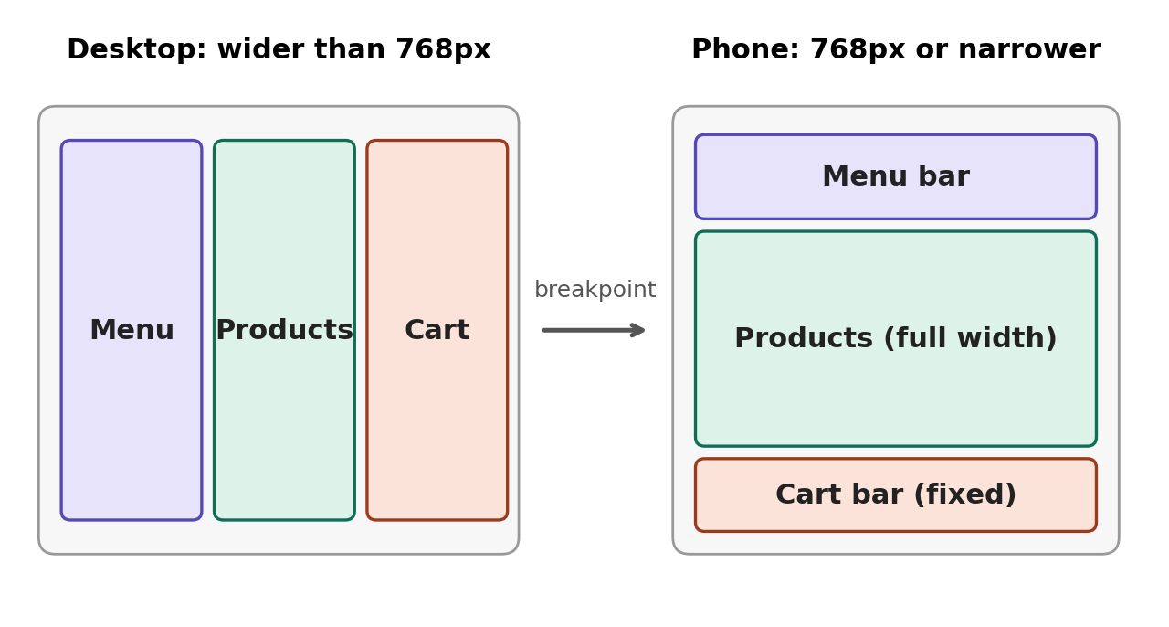
Note. Original diagram created by the author.
Question 2: HTML5 Input Types and Attributes for Fast Smartphone Entry
Wroblewski (2008) argues that good forms reduce the effort a person must spend, using clear labels, fields sized to the expected answer, and as few inputs as possible. On a phone, HTML5 lets BiteSize apply that idea directly, because the input type decides which on screen keyboard appears.
For contact details, type equals email brings up a keyboard with the at sign and period within reach, and type equals tel opens a numeric dial pad for phone numbers. For quantities, postal codes, and card numbers, type equals text paired with inputmode equals numeric gives a number pad without the spinner arrows of type equals number, which suits identifiers that are not true quantities (see Figure 2). Delivery notes can use a textarea, and the enterkeyhint attribute, set to next on middle fields and done on the final one, labels the keyboard return key sensibly.
Attributes matter just as much. The autocomplete attribute lets the phone fill name, email, tel, address, and card details from saved data, which removes most of the typing. The required attribute and a pattern attribute catch missing or malformed entries before submission, while a short placeholder gives a format example without replacing the visible label. Wroblewski (2008) favors labels placed above fields, which also keeps text readable at narrow widths. The autofocus attribute should be used only on the first field of each step, so the keyboard does not jump around unexpectedly.
Visual sizing finishes the job. Fields should be full width, at least 44 pixels tall, with a font size of 16 pixels or more, since smaller text can trigger automatic zoom on some mobile browsers. Splitting the multistep form into short screens with a visible progress indicator keeps each step light, and a clear final button such as Place order reduces hesitation. Together, these choices reduce keystrokes, errors, and abandoned carts, which directly targets the lost mobile sales BiteSize is seeing.
Figure 2
Checkout Fields Matched to Phone Keyboards
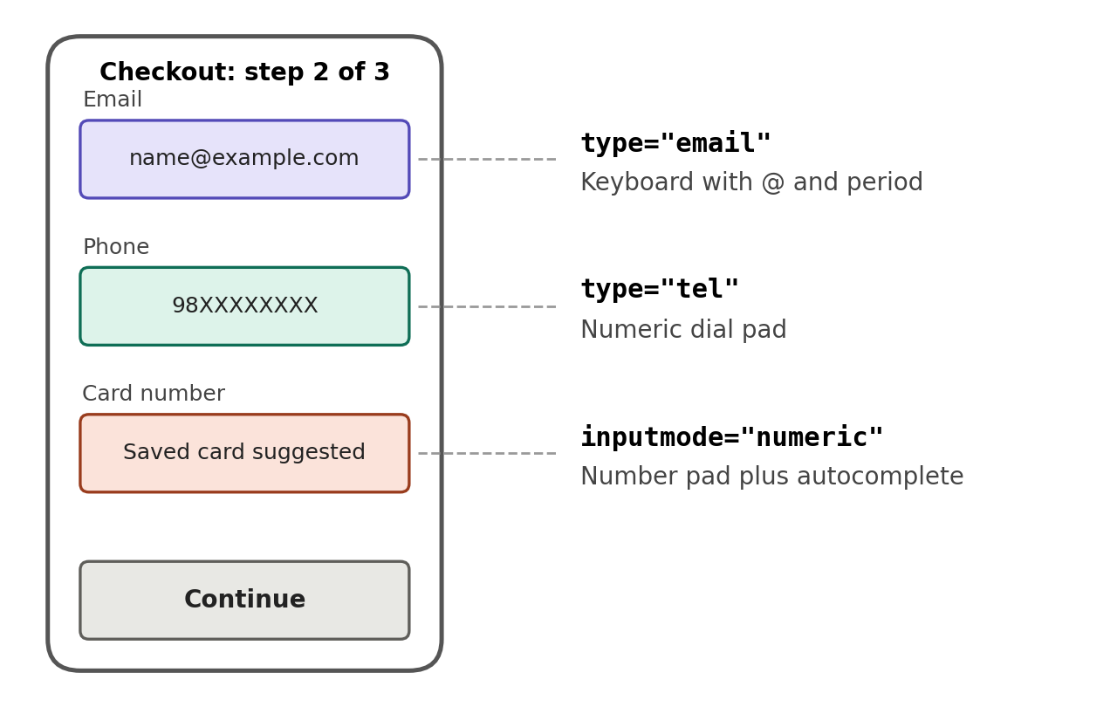
Note. Original diagram created by the author.

References
Marcotte, E. (2011). Responsive web design. A Book Apart.
Wroblewski, L. (2008). Web form design: Filling in the blanks. Rosenfeld Media.

