Building a personal portfolio with HTML5
Manchan Rana Magar
Model Institute of Technology, Kathmandu, Nepal
CSE 230: Web Design and Development
Professor Chaudhary
September 28, 2026

Building a Personal Portfolio with Semantic HTML5
A personal portfolio is often the first impression of a student’s work for an employer or an instructor, which is why the presentation is as important as the content itself. For this project, a single-page portfolio was designed and built with semantic HTML5 and no CSS to follow the default rendering of the browser. Duckett (2011) notes that HTML is used to build the structure and semantics of a page while CSS is used to stylize and present it on a web page. This project focused strictly on the former to demonstrate that a semantic and properly structured document will render consistently and be easy to navigate and read without additional styling. The code for this project is available in a public GitHub repository at https://github.com/manchan-rana/semantic-html-portfolio.
Implementation
The page follows the sectioning elements of the HTML Living Standard, including the header, nav, main, section, article, and footer (WHATWG, n.d.). As Figure 1 shows, the h1 title and an unordered list of anchor links are placed inside the header and nav, with the link pointing to the section of interest in the main. The about section comprises a brief biography and a profile image stored in a local image’s directory, whereas the skills section uses the descriptioon list because the skills are terms coupled with their description. Figure 2 shows that each project in the projects section is placed in its own article element as a self-contained item, where each article includes the heading, description, and active link to the repository. Several considerations have been taken regarding HTML accessibility. Firstly, the profile image has descriptive alt text, meeting the text alternative requirements of Success Criterion 1.1.1 of the Web Content Accessibility Guidelines 2.1 (Kirkpatrick et al., 2018). Secondly, the labels in the contact form are associated with corresponding fields via the for and id attributes, announcing their purpose to the user of assistive technologies, which meets Success Criterion 3.3.2 (Kirkpatrick et al., 2018). The email input has the type of email, and all fields are marked as required (no script needed). No style element, style attribute or stylesheets are used in the file.
Figure 1
Code for the Header, Navigation, and About Section
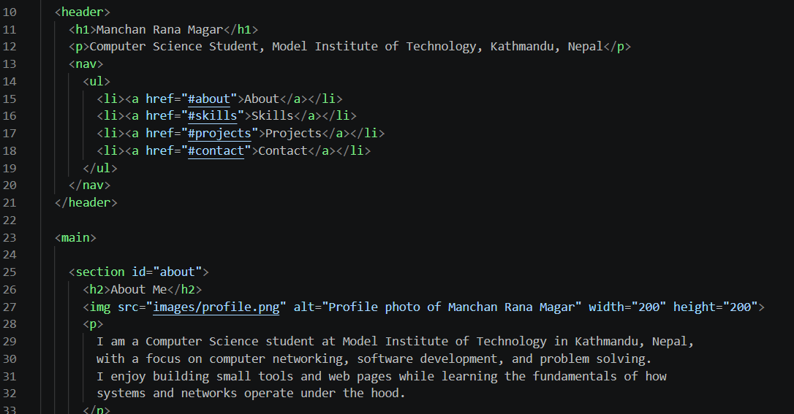
Note. Lines 10 to 33 of index.html.
Figure 2
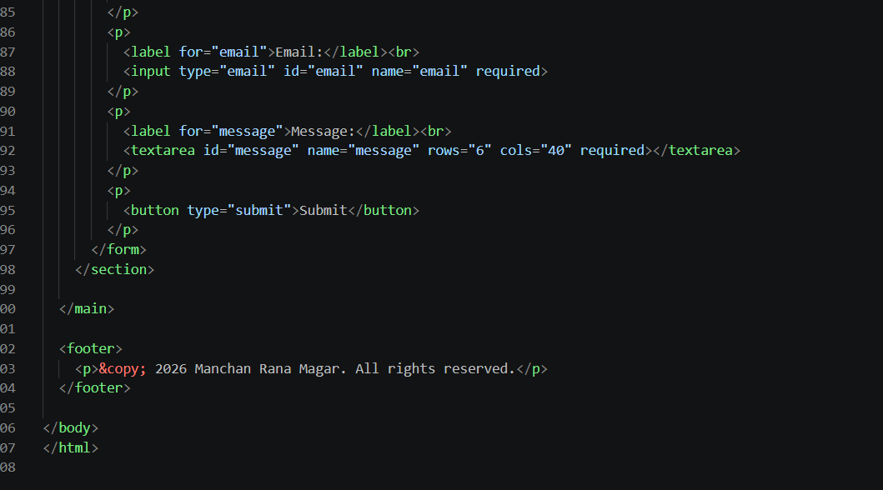
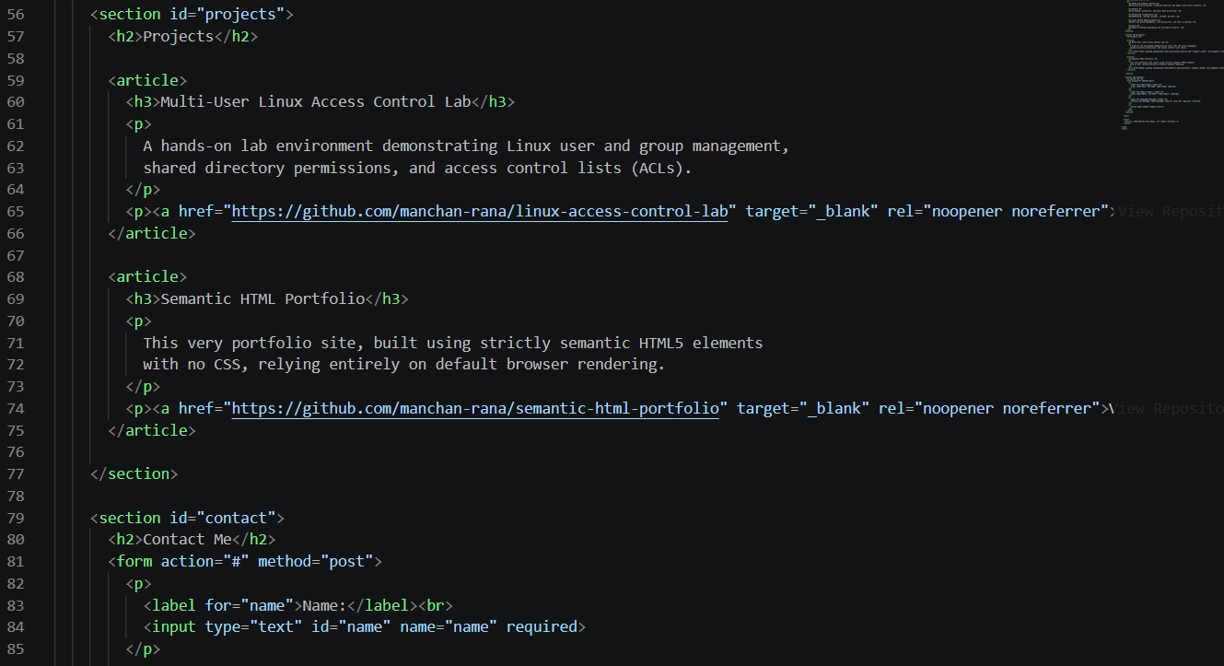
Source Code for the Project Articles and Contact Form

Note. Except of lines 56 to 104 of index.html. The email and message fields follow the same label and input pattern as the name field.
Results
Figure 3 below presents the page as rendered using browser default styles. As seen in the image, headings decrease in size, the navigation is presented as a bulleted list, skills are displayed as terms with indented descriptions, and the fields are stacked vertically. The file was validated with the W3C Nu Html Checker, and the results showed that there were no errors and warnings, as seen in Figure 4 below.
Figure 3
Rendered Portfolio Page
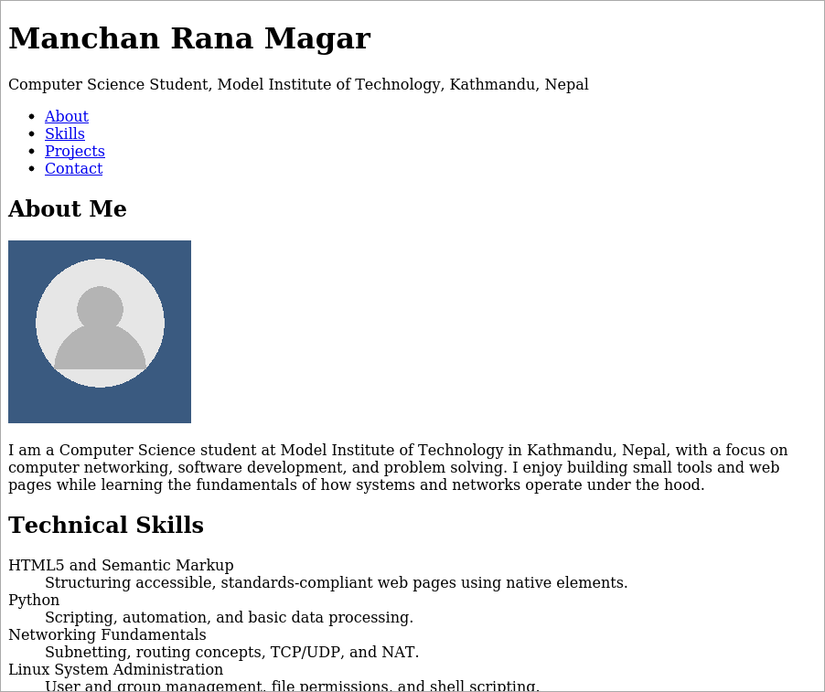 | 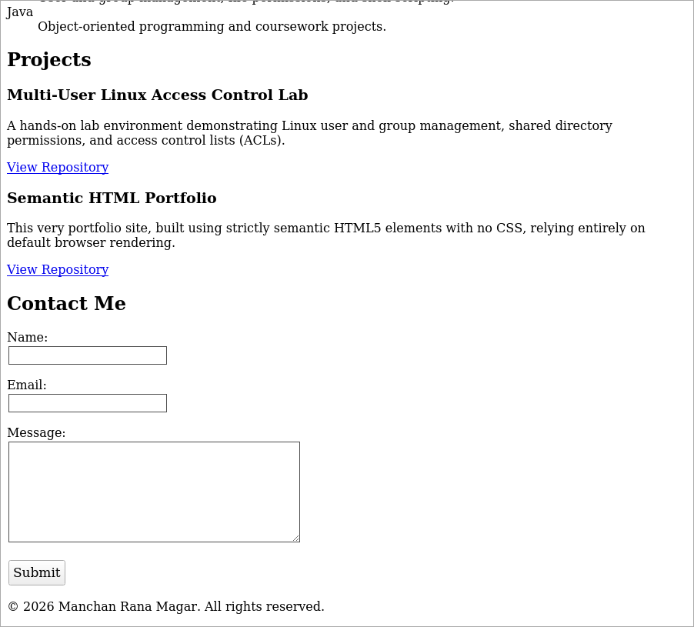
Note. The page is split into two halves for display. The left half shows the header through the skills section, and the right half shows the projects and contact sections.
Figure 4
W3C Nu Html Checker Result for index.html
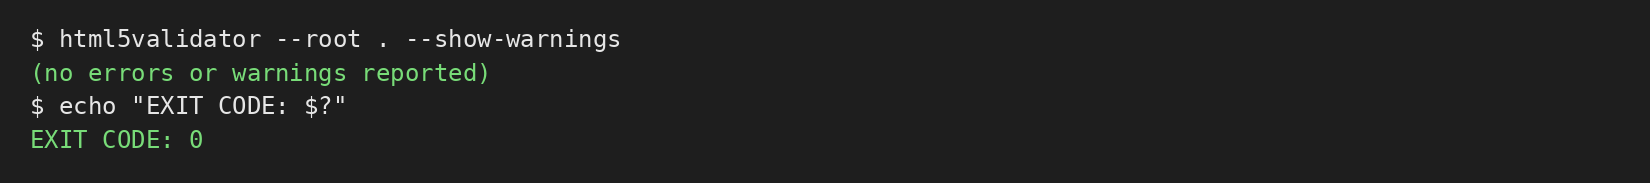
Note. The checker reported zero errors and zero warnings.
Conclusion
The project demonstrated that semantic HTML5 can be used to create a page that is organized, navigable by the links it contains, and valid, albeit bland by default. Since the structure is semantic, a stylesheet could be added later to enhance the presentation without altering the existing structure. The additions that would need to happen in the future include the creation of a stylesheet that would improve the page’s design and a server-side handler for the contact form, which currently has no destination.
References
Duckett, J. (2011). HTML and CSS: Design and build websites. John Wiley & Sons.
Kirkpatrick, A., O’Connor, J., Campbell, A., & Cooper, M. (Eds.). (2018). Web content accessibility guidelines (WCAG) 2.1. World Wide Web Consortium. https://www.w3.org/TR/WCAG21/
WHATWG. (n.d.). HTML living standard. Retrieved September 28, 2026, from https://html.spec.whatwg.org/

