WEB DEVELOPMENT PROJECT
Responsive Student
Portfolio
Project Report
Student | [Enter student name]
Student ID | [Enter student ID]
Institution | [Enter college or institution]
Course | [Enter course name or code]
Instructor | [Enter instructor name]
Submission date | 4 October 2026
Semantic HTML · External CSS · Responsive design

Introduction
This project applies semantic HTML and an external CSS stylesheet to create a professional portfolio for a BSc CSIT student. The site introduces a student profile, summarizes six areas of technical study, and presents two academic project examples: a hospital services website and a library database.
A portfolio needs to make its content easy to scan while preserving a meaningful page structure. HTML elements such as main, nav, section, article, header, and footer identify the role of content. The HTML Standard defines these elements by their semantics and intended use (WHATWG, 2026). Clear structure also supports consistent navigation and future updates.
The assignment also emphasizes separation of concerns. The page content lives in index.html, while its color, type, spacing, and layout rules live in style.css. This separation makes the presentation easier to maintain and lets one stylesheet control the full page. The site uses a custom palette, CSS Grid and Flexbox, mobile media queries, and a locally stored SVG illustration.

Project goals
- Use semantic HTML for navigation, page regions, project articles, headings, and lists.
- Keep visual styling in an external stylesheet and use a consistent color and type system.
- Adapt the layout for desktop, tablet, and mobile viewports with Grid, Flexbox, and media queries.
- Prepare the source files and documentation for a public GitHub repository and GitHub Pages.

Implementation Details

Semantic page structure
The page begins with document metadata and a stylesheet link, then uses a shared header and labelled navigation. A skip link lets keyboard users move directly to the main content. The main region contains named sections for the introduction, background, skills, projects, and contact details; each section has a heading that labels its purpose.
The two project summaries use article elements, and the skills are presented as a list. Descriptive alternative text is supplied for the external SVG illustration, while decorative icons are hidden from assistive technology. These choices keep structure and meaning in the markup rather than relying on visual position alone (WHATWG, 2026).
Figure 1
Semantic HTML source excerpt
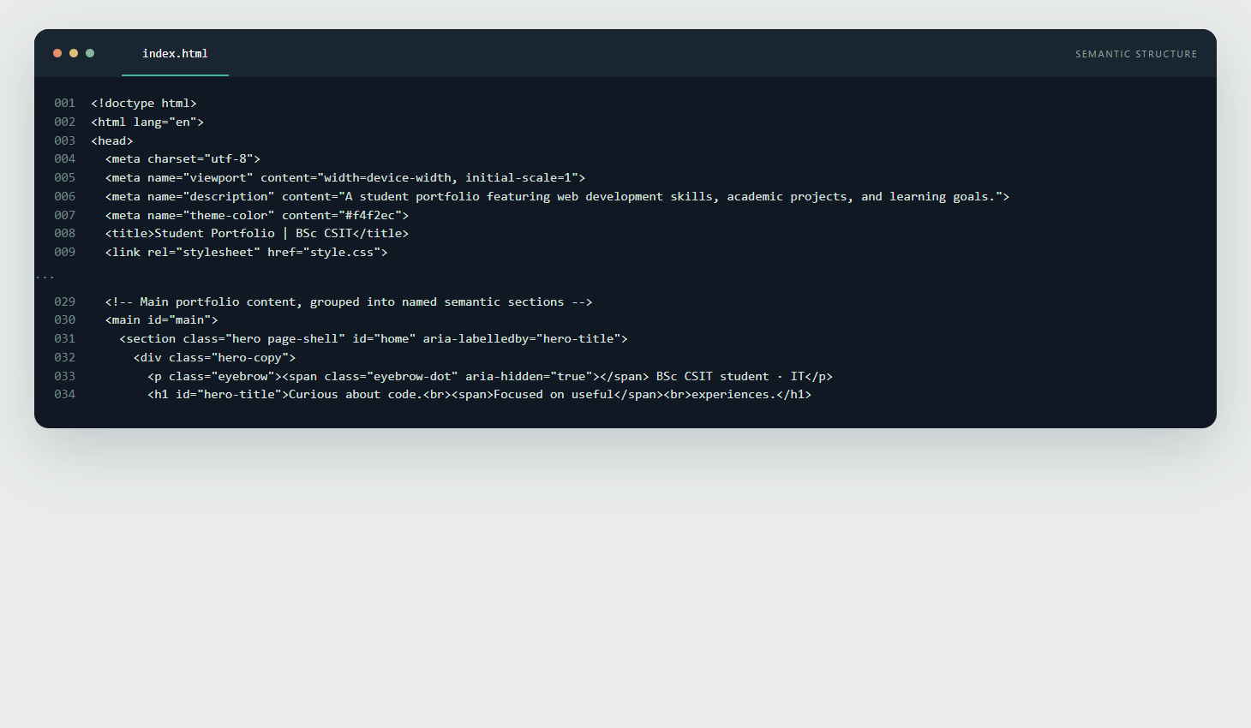
Note. Selected lines from index.html show the external style.css link, the main region, and the labelled hero section.
The project directory contains index.html, style.css, and assets/portfolio-illustration.svg. Relative paths are used for the stylesheet and image so the site can be published from a repository root without a build step.

Visual Design and Responsive Layout
The visual system pairs a warm neutral background with deep blue-green text, teal accents, and coral highlights. Georgia is used for display headings and system sans-serif fonts for supporting text. Reusable CSS custom properties keep these choices consistent. The hero and project areas use CSS Grid, while navigation, calls to action, skill tags, and footer content use Flexbox.
Responsive design combines flexible layouts with rules for narrower screens. MDN describes media queries as a way to apply styles when viewport or device conditions match (MDN contributors, n.d.). This stylesheet changes the hero and card grids at 850 pixels and 620 pixels; on a narrow screen, the hero stacks vertically, skill cards use two columns, project cards use one column, and navigation wraps below the wordmark.
Visible keyboard focus, a skip link, scalable text, reduced-motion handling, and non-color labels improve access and usability. The interface relies on local assets and does not require JavaScript or externally hosted fonts.
Figure 2
External CSS excerpt
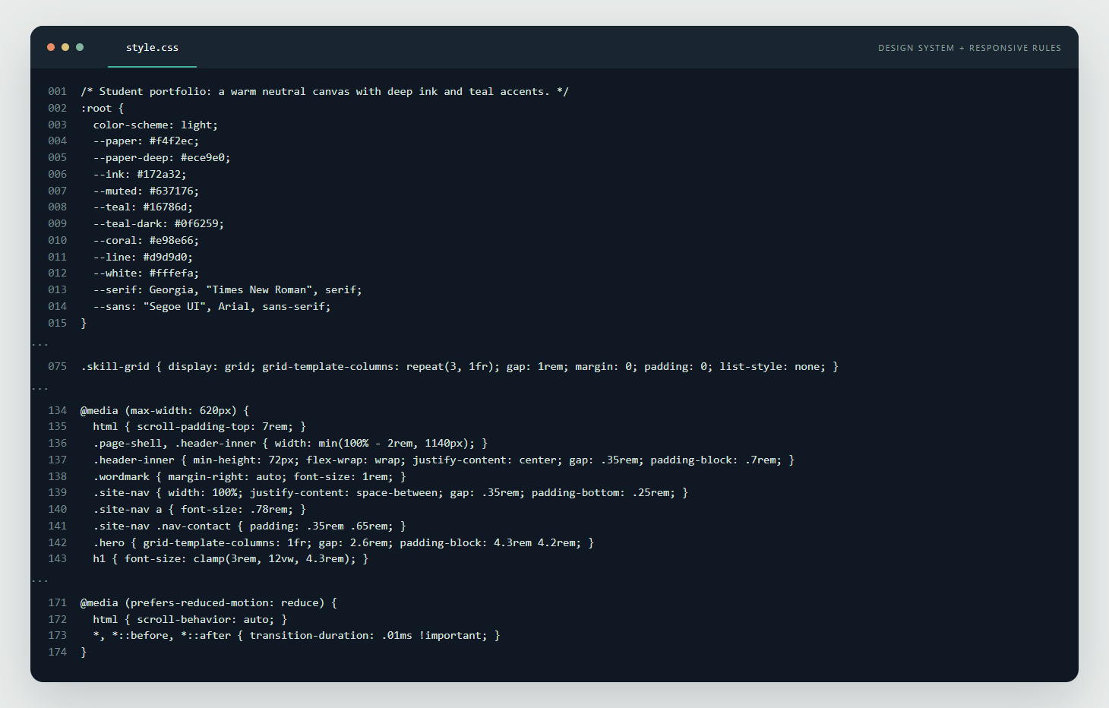
Note. Selected lines from style.css show the color tokens, a Grid declaration, the mobile breakpoint, and reduced-motion handling.

Results and Publication Status
The browser-rendered page brings the profile, learning areas, project summaries, and contact call to action into one responsive site. Desktop and mobile captures were reviewed at 1,440 × 800 pixels and 390 × 844 pixels. At both captured widths, the document width matched the viewport and no horizontal page overflow appeared.
Figure 3
Rendered portfolio at desktop and mobile sizes
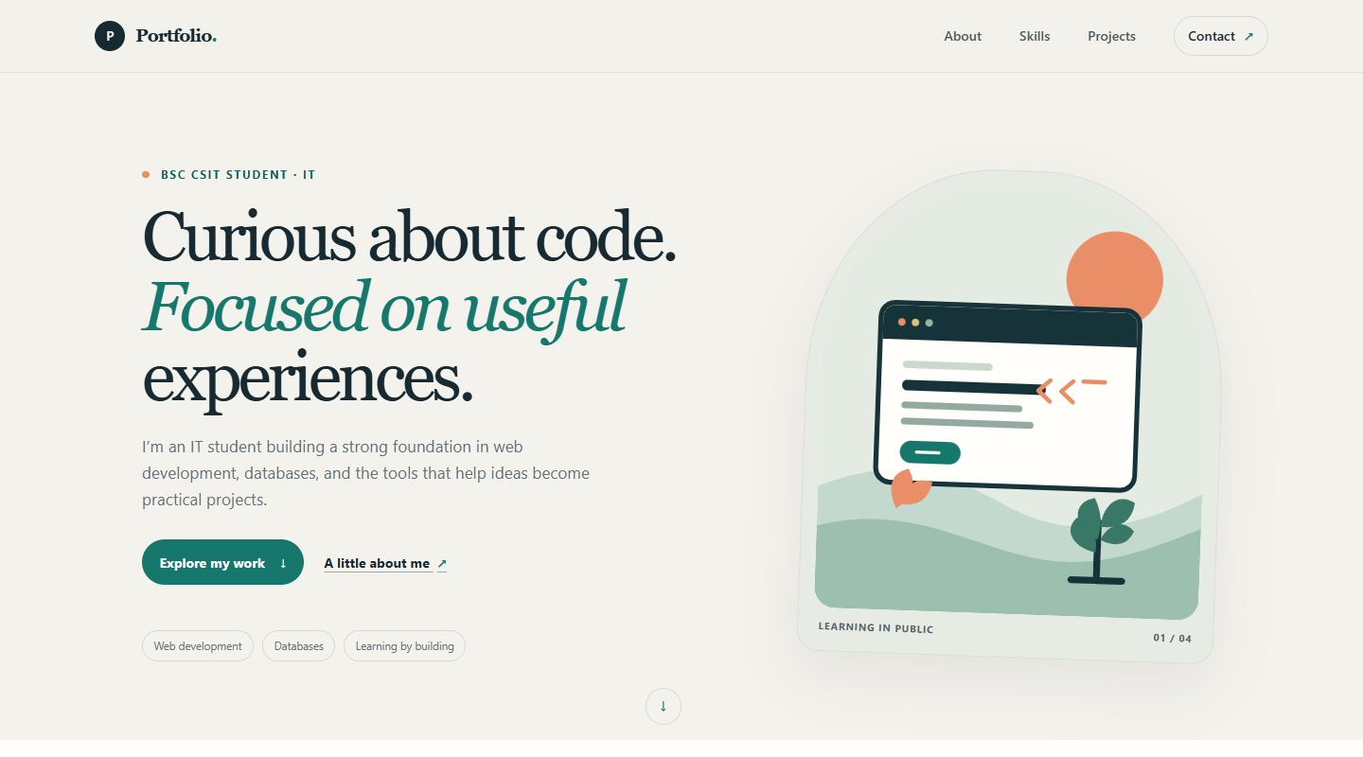 | 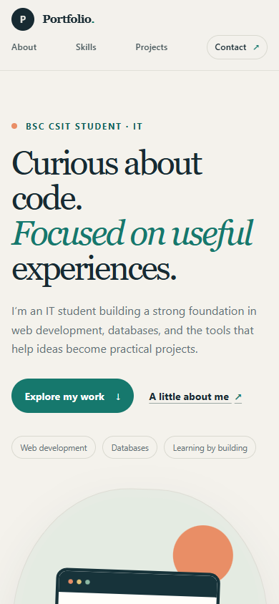
Note. Desktop: 1,440 × 800 px. Mobile: 390 × 844 px. Captures show the local portfolio before publication.

GitHub Pages handoff
GitHub Pages publishes static HTML, CSS, and JavaScript files from a GitHub repository (GitHub, n.d.). The codebase is prepared for deployment, but no repository has been connected and the site is not yet live. The included README documents the Git workflow: initialize the local repository, stage and commit the files, add the GitHub remote, and push the main branch. Then select the main branch and root folder under Settings → Pages and verify the generated site.
Public repository | [Add the confirmed GitHub repository URL]
Live site | [Add the confirmed GitHub Pages URL]

Conclusion
The portfolio meets the core implementation goals by combining semantic HTML, external CSS, a cohesive visual system, responsive Grid and Flexbox layouts, and mobile-specific styles. Its project summaries and skills reflect the supplied student background, while the locally stored illustration keeps the site self-contained.
Before submission, add the student and course details on the cover, replace the example contact address, confirm that project descriptions match the completed work, publish the files to a public GitHub repository, and insert the verified repository and live-site URLs above. The deployment step is still required before the assignment can claim a public GitHub Pages site.
References
GitHub. (n.d.). What is GitHub Pages?. GitHub Docs. Retrieved October 4, 2026, from https://docs.github.com/en/pages/getting-started-with-github-pages/what-is-github-pages
MDN contributors. (n.d.). Responsive design. MDN Web Docs. Retrieved October 4, 2026, from https://developer.mozilla.org/en-US/docs/Learn_web_development/Core/CSS_layout/Responsive_Design
WHATWG. (2026, September 8). HTML Standard. Retrieved October 4, 2026, from https://html.spec.whatwg.org/multipage/sections.html

