DRIVER GAMEPAD
6) Deploy Flap
Index

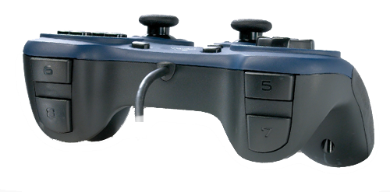
8)
SERVO RIGHT

5)
Deploy Minibot
7)
SERVO LEFT

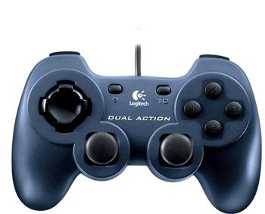
DRIVE CONTROLS

Left Motors Right Motors

