CHAOS OPERATOR GAMEPAD
6)
STOW
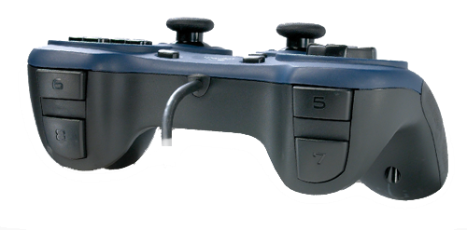
7)
-NORMAL PEGS
5)
-CENTER PEGS
8)
[MANUAL MODE]
(HOLD)
[MAN. SHOULDER
UP]

[MAN. SHOULDER DOWN]

1) Red
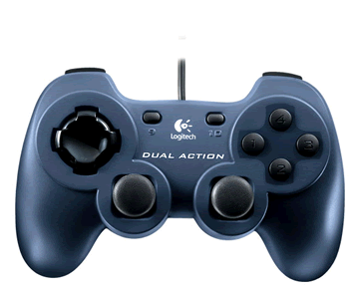
4)
CHANGE PEG HEIGHT
3)
Blue

RIGHT Y

CHAINSAW
UP - SCORE
DOWN – DRAW
[Triggers Score State]
LEFT Y
-[MAN. ELBOW]
D-PAD
PEG HEIGHTS

TOP PEGS

MIDDLE PEGS

BOTTOM PEGS
2)
White

10) SHUTTLE

