**Navigating COVID-19 Research Data: An Integrated Analysis of Epidemiology, Government Policies, and Public Sentiment**

Shouzhifan Zhu

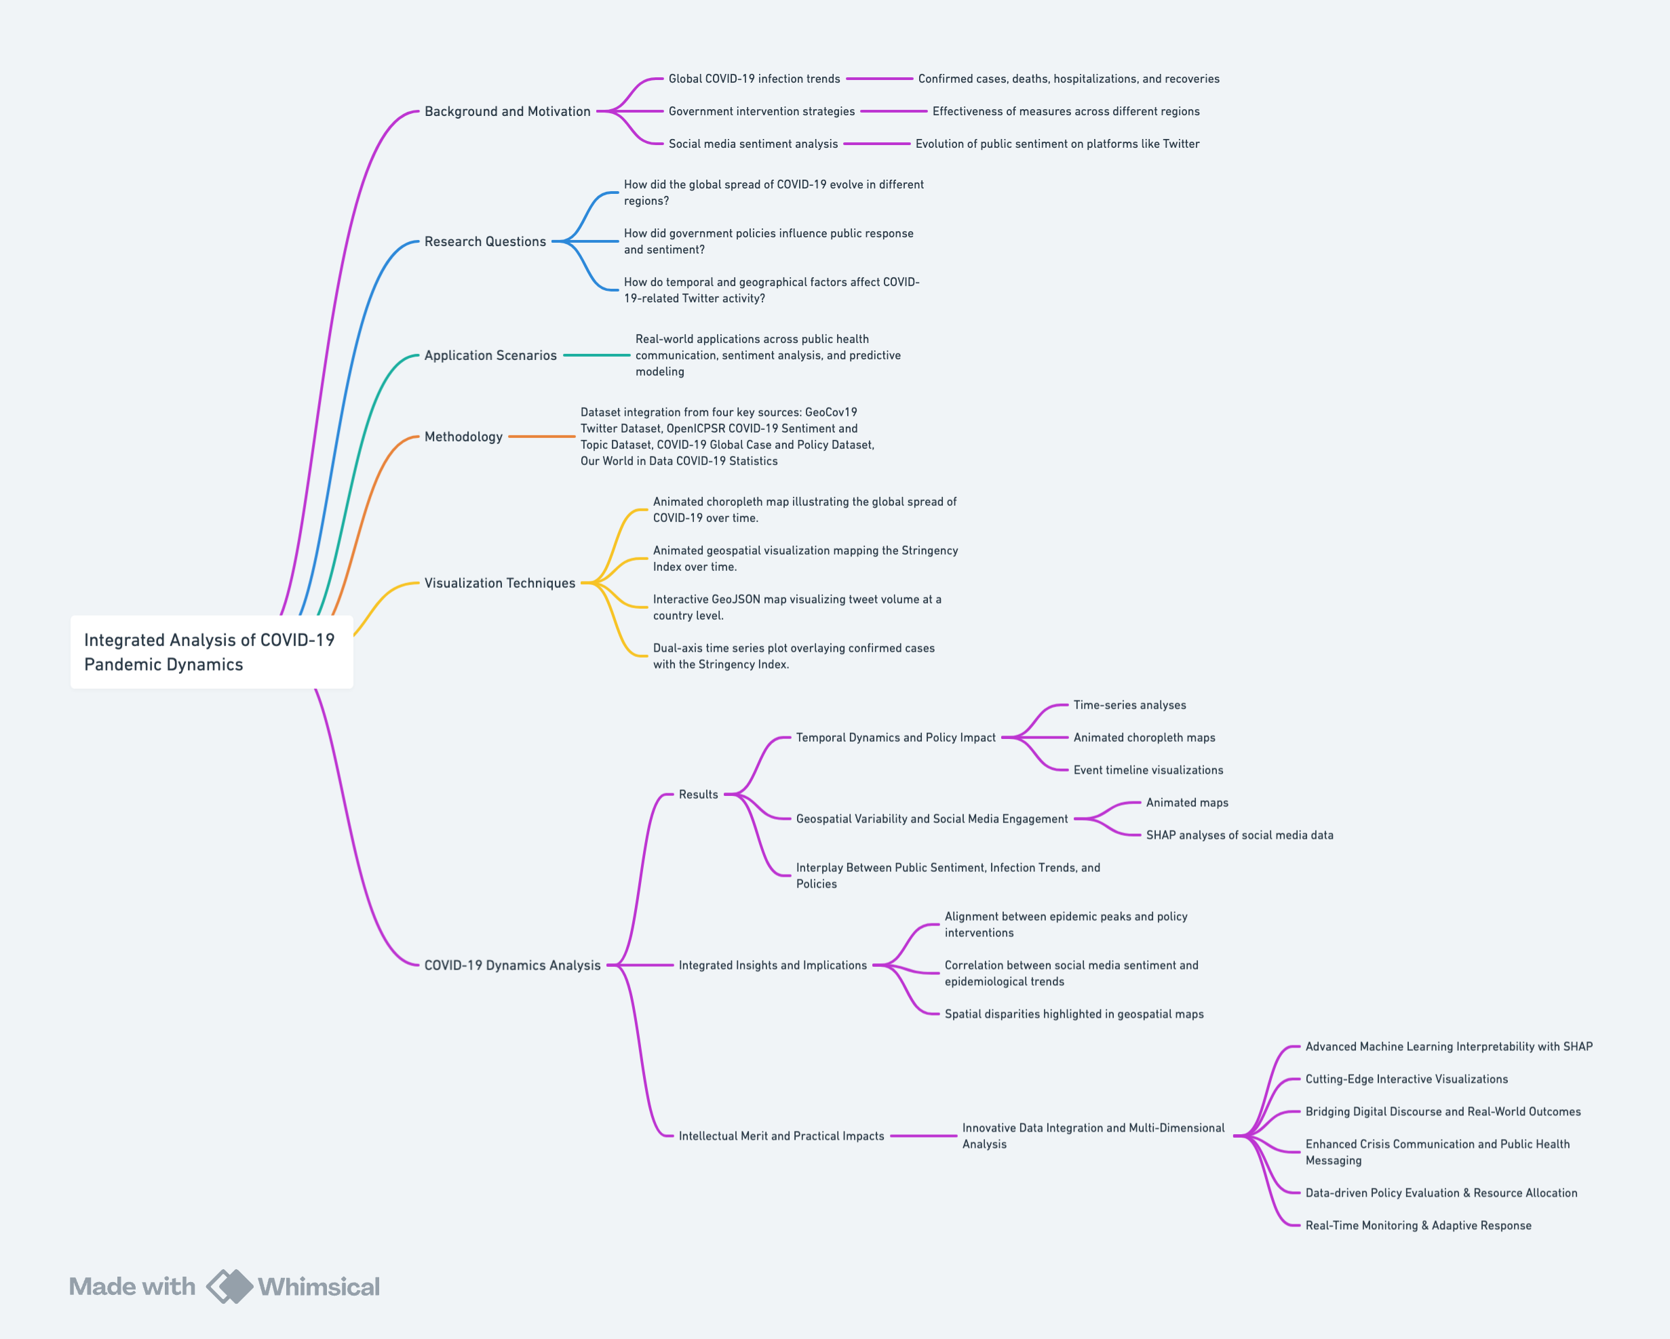

Research Methodology Flowchart (Created by Whimsical)

**Background and Motivation**

For the past few years, the COVID-19 pandemic has reshaped global health and profoundly altered societal structures and communication patterns worldwide (Clemente-Suárez et al., 2021). Understanding the progression of the pandemic, especially how the virus spread across different regions, the severity of outbreaks, and the timing of key events, is crucial for assessing its broader social, economic, and psychological impacts (Paremoer et al., 2021). This project begins by analyzing global COVID-19 infection trends, including confirmed cases, deaths, hospitalizations, and recoveries, to map the trajectory of the pandemic. By visualizing these trends across various periods and geographic regions, we aim to uncover correlations between epidemiological patterns and public sentiment.

Government intervention strategies have been central to global responses to the pandemic. Countries worldwide implemented various policies, from strict lockdowns, social distancing mandates, and travel bans to comprehensive economic relief efforts and vaccination campaigns to mitigate the virus’s impact. However, the effectiveness of these measures has varied significantly across different regions (Haug et al., 2020). By analyzing the evolution of government responses over time, this project investigates whether stricter policies correlate with changes in infection rates and how these interventions influence public behavior and sentiment (Hale et al., 2021).

At the same time, social media platforms, particularly Twitter, emerged as vital spaces for public discourse during the pandemic. As the crisis unfolded, sentiment on these platforms evolved dramatically: early discussions were dominated by fear and uncertainty, whereas prolonged lockdowns led to increased expressions of anger and frustration. Conversely, moments of relief and optimism, often linked to vaccine rollouts or policy relaxations, punctuated these trends. By comparing sentiment trends on social media with epidemiological data and government policies, we aim to assess whether spikes in fear or anger correlate with surges in infections or the implementation of strict interventions.

This project underscores the importance of integrating multiple data sources to develop a holistic understanding of the pandemic. By combining epidemiological records, government policy responses, and social media sentiment analysis, we not only track the progression of the virus but also reveal how public emotions and behaviors evolved in real time. Advanced machine learning techniques, particularly SHAP (Shapley Additive Explanations) analysis, are used to break down the contribution of various temporal, geographical, and policy-driven factors. This approach provides transparent and interpretable insights into which aspects of government interventions and social behavior most strongly influence infection dynamics and online engagement.

The integrated framework presented in this study bridges the gap between raw data and actionable insights. It informs public health strategies by demonstrating that effective crisis communication and adaptive policy-making require a deep understanding of both epidemiological trends and public sentiment. Ultimately, this work lays the foundation for more inclusive, data-driven decision-making in public health—providing tools that are not only academically robust but also practically valuable for policymakers, healthcare providers, and the general public in managing current and future global health crises.

**Research Questions**

This project explores the relationship between COVID-19 global trends, government policies, and public sentiment on social media through the following key questions:

* How did the global spread of COVID-19 evolve in different regions?
* How did government policies influence public response and sentiment?
* How do temporal and geographical factors affect COVID-19-related Twitter activity?

We examine trends in confirmed cases, hospitalizations, and deaths worldwide to understand the trajectory of the pandemic and its variations across different countries. By analyzing policy stringency levels, we investigate whether stricter measures (e.g., lockdowns, travel bans) led to heightened public frustration and how sentiment shifted as policies changed. Additionally, we assessed tweet volume fluctuations across different periods (e.g., weekdays vs. weekends) and locations to uncover patterns in public engagement with pandemic-related discussions.

**Application Scenarios**

The findings from this project on the temporal and geographical variability in COVID-19-related tweets, as analyzed through SHAP, namely Shapley Additive Explanations, have significant real-world applications across public health communication, sentiment analysis, and predictive modeling. By understanding the factors that influence tweet volumes, this project can help healthcare providers develop more effective communication strategies and tailor public health interventions to specific regions and periods. For example, if SHAP analysis shows that tweet volumes peak on weekends, health organizations could schedule important announcements or updates during these high-engagement periods to ensure maximum reach. Additionally, by identifying geographical trends, policymakers can allocate resources and focus their efforts on regions with higher levels of social media engagement, ensuring that interventions are both timely and relevant.

This project can also be used to inform crisis management strategies by offering real-time insights into public sentiment. By examining the SHAP values that highlight key features like the day of the week, month, or geographical location, health officials can gauge how different regions are reacting to the pandemic and adjust their messaging accordingly. For instance, if SHAP analysis reveals heightened frustration or fear in certain regions, public health authorities can adjust their strategies to address these concerns, providing targeted messaging or increasing support where it is most needed. This could help mitigate public unrest and improve trust in public health measures, particularly during critical phases of the pandemic.

Furthermore, this project’s insights into tweet volume patterns can assist in predictive modeling and geospatial research. By using the temporal and geographical features highlighted in the SHAP analysis, researchers can predict future trends in tweet activity, which could correlate with real-world events such as outbreaks or changes in government policies. This predictive capability can support decision-makers in preparing for potential surges in public engagement and ensuring that resources are distributed efficiently. For example, countries with consistently high tweet volumes may require more urgent attention and allocation of resources, while regions with lower engagement might need targeted efforts to increase awareness or participation in health initiatives.

Ultimately, this project can bridge the gap between social media analytics and real-world applications, enabling a more data-driven approach to public health interventions. By understanding the factors that influence social media discussions around COVID-19, health organizations can improve their ability to communicate effectively with the public, address emerging concerns, and adapt their strategies as the pandemic evolves. This approach can also be applied to other global health crises, offering a valuable framework for real-time monitoring and response.

**Methodology**

**Dataset**

Our study integrates four key datasets to provide a comprehensive analysis of the COVID-19 pandemic, examining the relationship between global infection trends, government policies, and public sentiment on social media. By combining large-scale Twitter data with real-world epidemiological and policy response records, this research seeks to understand how public discourse evolved alongside the pandemic’s progression and how governmental actions influenced both the spread of the virus and public reactions.

**GeoCov19 Twitter Dataset**

The GeoCov19 dataset comprises a large collection of COVID-19-related tweets obtained using over 800 predefined keywords and hashtags. The dataset includes both geotagged tweets and tweets with location metadata, allowing for spatial and temporal analyses of COVID-19-related social media discussions.

This dataset serves as the foundation for our analysis of public sentiment and engagement on social media. By examining tweet volumes and geographic distributions, we can assess how public discussions about COVID-19 evolved over time and whether trends in social media activity correlated with real-world pandemic developments.

**OpenICPSR COVID-19 Sentiment and Topic Dataset**

This dataset provides a deeper understanding of COVID-19-related tweets by classifying them into different latent topics, sentiment categories, and emotional intensities. It utilizes natural language processing and machine learning techniques to extract key attributes such as positive, negative, and neutral sentiment, as well as emotional markers like anger, fear, sadness, and joy.

By incorporating this dataset, we move beyond simple tweet volume analysis and delve into the actual content and sentiment of COVID-19-related discussions. This allows us to explore how public sentiment evolved in response to major pandemic events, such as lockdowns, vaccine rollouts, and policy shifts.

**COVID-19 Global Case and Policy Dataset**

This dataset compiles country-level data on confirmed COVID-19 cases, deaths, recoveries, hospitalizations, and vaccinations. It also integrates policy response records, including government-imposed lockdowns, travel restrictions, contact tracing measures, and economic support policies.

The inclusion of this dataset allows us to directly compare government policy interventions with COVID-19 case trends. By aligning these data points with social media sentiment analysis, we investigate whether specific policy measures influenced public discourse and behavioral patterns during different stages of the pandemic.

**Our World in Data COVID-19 Statistics**

This dataset provides comprehensive statistics on the global COVID-19 pandemic, including detailed records of confirmed cases, deaths, testing rates, hospitalizations, and vaccinations. It aggregates data from official government sources, health agencies, and research institutions.

Our World in Data serves as a key reference for validating and cross-checking trends observed in other datasets. By integrating this dataset with our sentiment and policy analysis, we can track the progression of COVID-19 across different regions and assess the broader impact of governmental actions on public health outcomes.

**Dataset Integration and Analytical Framework**

By integrating data from these four diverse sources, our study provides a multi-faceted perspective on the COVID-19 pandemic. Each dataset contributes a unique layer of analysis:

* The GeoCov19 dataset captures the temporal and geographical dynamics of COVID-19-related discussions on Twitter.
* The OpenICPSR dataset enables sentiment and topic modeling to interpret public reactions to pandemic events and policies.
* The COVID-19 Data Hub links case numbers and government interventions, helping to assess the effectiveness of public health policies.
* Our World in Data provides high-quality epidemiological statistics, anchoring our findings in well-documented real-world data.

This integrated approach allows us to investigate how government policies and pandemic developments influenced social media engagement. For example, we explore whether stricter lockdown measures corresponded with increased tweet volumes expressing frustration or fear or whether public sentiment shifted positively following vaccine rollouts. Additionally, by comparing global case trends with online discussions, we assess whether social media activity serves as a leading indicator for public health concerns.

**Visualization Techniques**

This study employs advanced visualization techniques to analyze and present the relationships among COVID-19-related tweets, global infection trends, and government policies. Given the complexity and diversity of the datasets used in this research, integrating multiple sources was crucial in uncovering meaningful patterns. By combining data on COVID-19 case numbers, government response measures, and social media activity, these visualizations provide a comprehensive perspective on the pandemic’s impact on public discourse. The visualization design follows key principles from data visualization theory, particularly those outlined by Munzner (2014), to ensure clarity, accuracy, and accessibility.

A critical aspect of this study is the use of data abstraction techniques to highlight key trends while maintaining interpretability. Time-series plots are utilized to track infection rates alongside tweet volumes, revealing correlations between pandemic severity and spikes in public discussions. These visualizations leverage the effectiveness of position as a visual encoding channel for quantitative data, which is fundamental for facilitating accurate temporal comparisons (Munzner, 2014). Geographic heatmaps further illustrate the spatial distribution of tweet activity, providing insight into regional variations in public engagement. By encoding data spatially, these maps exploit the human visual system’s ability to detect patterns across geographic regions, adhering to best practices for the arrangement of spatial data (Munzner, 2014).

To examine the relationship between government interventions and public sentiment, policy indices such as lockdown strictness, travel restrictions, and vaccination efforts are mapped against social media activity. These comparative visualizations enable a multi-faceted exploration of how different policy measures influenced tweet volumes and sentiment shifts. By integrating these diverse datasets, this study applies the principle of multiple views in visualization design, allowing users to analyze policy impacts from different perspectives (Munzner, 2014). This approach ensures that complex, multidimensional relationships are more accessible and interpretable.

One of the most significant visualization techniques employed in this study is the application of SHAP (Shapley Additive Explanations) to quantify the influence of temporal, geographical, and policy-related features on tweet volume. SHAP summary plots allow for the ranking of influential variables based on their contribution to the predictive model, making them valuable for understanding how different factors shape online discourse. Temporal SHAP analysis reveals that certain time-based features—such as weekends and specific months—strongly influence tweet activity, with higher engagement observed during weekends. This pattern aligns with established trends in social media usage, where public discussions tend to peak during non-working days. Similarly, geospatial SHAP analysis identifies significant disparities in tweet volume across countries, with the USA, China, and various European nations exhibiting the highest levels of online engagement. These SHAP-based visualizations not only highlight the most influential predictors but also provide an interpretable representation of the interaction between real-world events and public discourse.

The effectiveness of these visualizations is further enhanced through deliberate design choices in color schemes, mark selection, and encoding channels. SHAP summary plots utilize position along the x-axis to quantify the impact of each feature, while color gradients help differentiate between high and low feature values, improving perceptual clarity. Following Munzner’s recommendations on the use of color in visualization, these design choices ensure that color encoding is both meaningful and accessible (Munzner, 2014). Interactive geo-visualizations provide an additional layer of insight, enabling users to explore country-level tweet trends and sentiment shifts dynamically. These interactive elements facilitate deeper engagement with the data, reinforcing the principle that visualizations should support exploratory analysis rather than merely presenting static information.

By integrating multiple datasets and employing SHAP analysis, this study effectively visualizes the complex temporal, spatial, and policy-related dynamics of COVID-19-related discussions on Twitter. The combination of time-series analysis, geospatial mapping, and machine learning interpretability techniques presents a holistic view of how public discourse evolved throughout the pandemic. These visualizations serve as powerful tools for researchers and policymakers, offering actionable insights into the relationship between government interventions, public sentiment, and pandemic progression. By adhering to established principles of visualization design (Munzner, 2014), this study ensures that its findings remain not only scientifically rigorous but also accessible and interpretable to a broad audience.

### **Advanced Tools**

**Interactive Visualization Tools**

In this study, we employ a range of interactive visualization tools to analyze and present the relationships between COVID-19 global infections, governmental policies, and public sentiment. These visualizations integrate geospatial and temporal data, allowing users to dynamically explore trends and patterns over time. By incorporating interactive elements, our approach enhances the interpretability of complex datasets and provides deeper insights into the pandemic’s progression and its societal impact.

A key visualization in our study is an animated choropleth map (Figure 1) that illustrates the global spread of COVID-19 infections over time. This interactive map, powered by *Plotly*, enables users to track the daily new confirmed cases per million people across countries. A time slider allows for dynamic exploration of infection trends, revealing how different waves of the pandemic unfolded across regions. The color intensity represents the logarithm of new cases, ensuring better visual differentiation between countries with vastly different case counts. By observing how case numbers fluctuated globally, this visualization provides crucial context for understanding policy responses and public sentiment shifts.

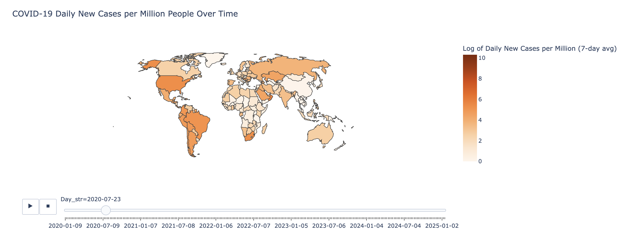

Figure 1: Global Spread of COVID-19 Over Time

To complement the infection trends, we introduce an animated geospatial visualization (Figure 2) that maps the Stringency Index over time. This index quantifies the strictness of government responses, including lockdowns, travel restrictions, and school closures. The interactive map enables users to see how different countries adjusted their policies throughout the pandemic. By integrating this with scatter plots representing confirmed cases, the visualization highlights how governmental actions correlated with infection rates. This approach facilitates an in-depth analysis of whether stringent measures effectively curbed case numbers or whether public compliance varied by region.

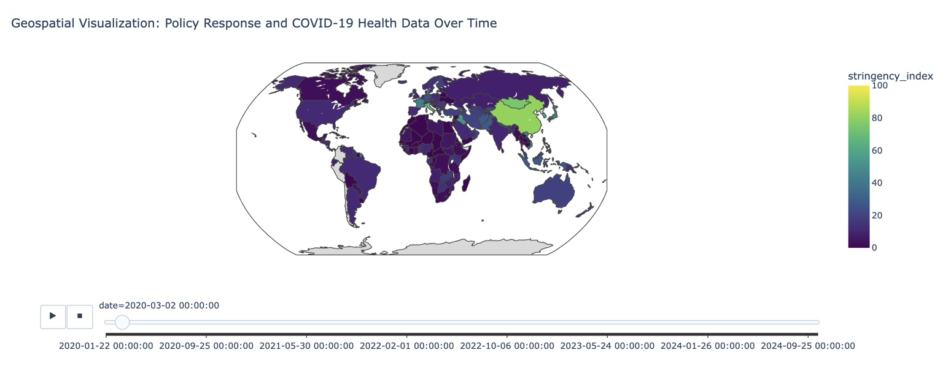

Figure 2: Government Policy Responses and Their Evolution

Understanding the social media discourse surrounding COVID-19 is vital in assessing public sentiment and information dissemination. To this end, we visualize the global distribution of COVID-19-related tweets through an interactive GeoJSON map (Figure 3).

This visualization captures tweet volumes at a country level, with darker shades indicating higher activity. Users can explore which regions had the highest engagement in pandemic-related discussions, revealing patterns in public awareness, misinformation spread, and regional concerns. This map serves as a crucial bridge between real-world pandemic trends and digital discourse.

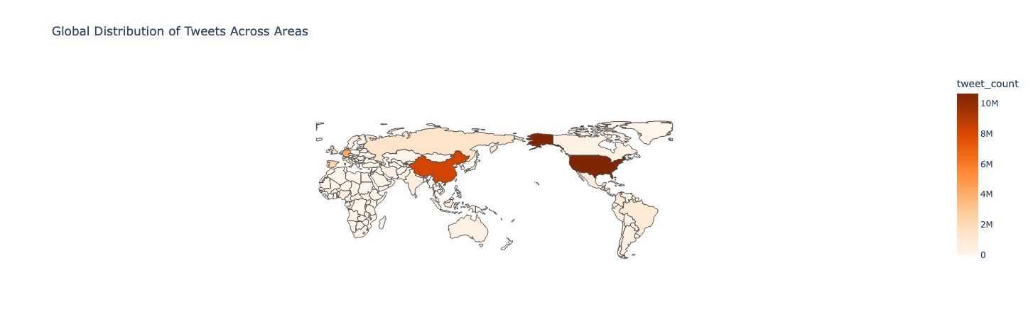

Figure 3: Tweet Volume and Global Social Media Engagement

To explore the interplay between infection rates and governmental actions, we employ a dual-axis time series plot (Figure 4) that overlays confirmed COVID-19 cases with the Stringency Index.

This visualization enables users to see whether stricter policies led to declines in infection rates or whether policy relaxations corresponded to case surges. By allowing detailed examination of different periods, this tool helps contextualize major policy shifts and their effects. Notably, this visualization can indicate potential delays in policy effectiveness, revealing whether government measures were proactive or reactive in response to rising cases.

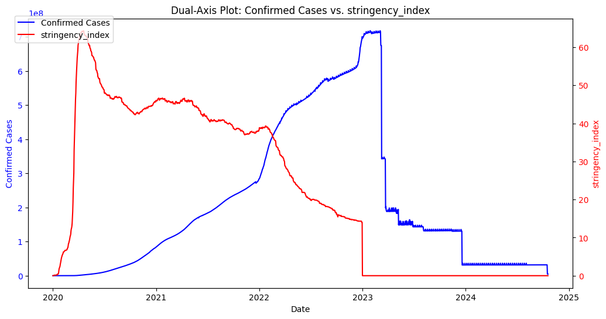

Figure 4: Relationship Between Confirmed Cases and Government Stringency

To further dissect the long-term progression of the pandemic, we present an interactive time series visualization (Figure 5) showcasing COVID-19 trends in the top 10 most affected countries.

Users can switch between logarithmic and linear scales to better analyze exponential growth phases and plateaus in case numbers. The interactive range selector allows for flexible time exploration, while sampled scatter points enhance readability. This visualization is particularly useful for comparing how different nations managed outbreaks over time, reflecting the effectiveness of their policies and public health interventions.

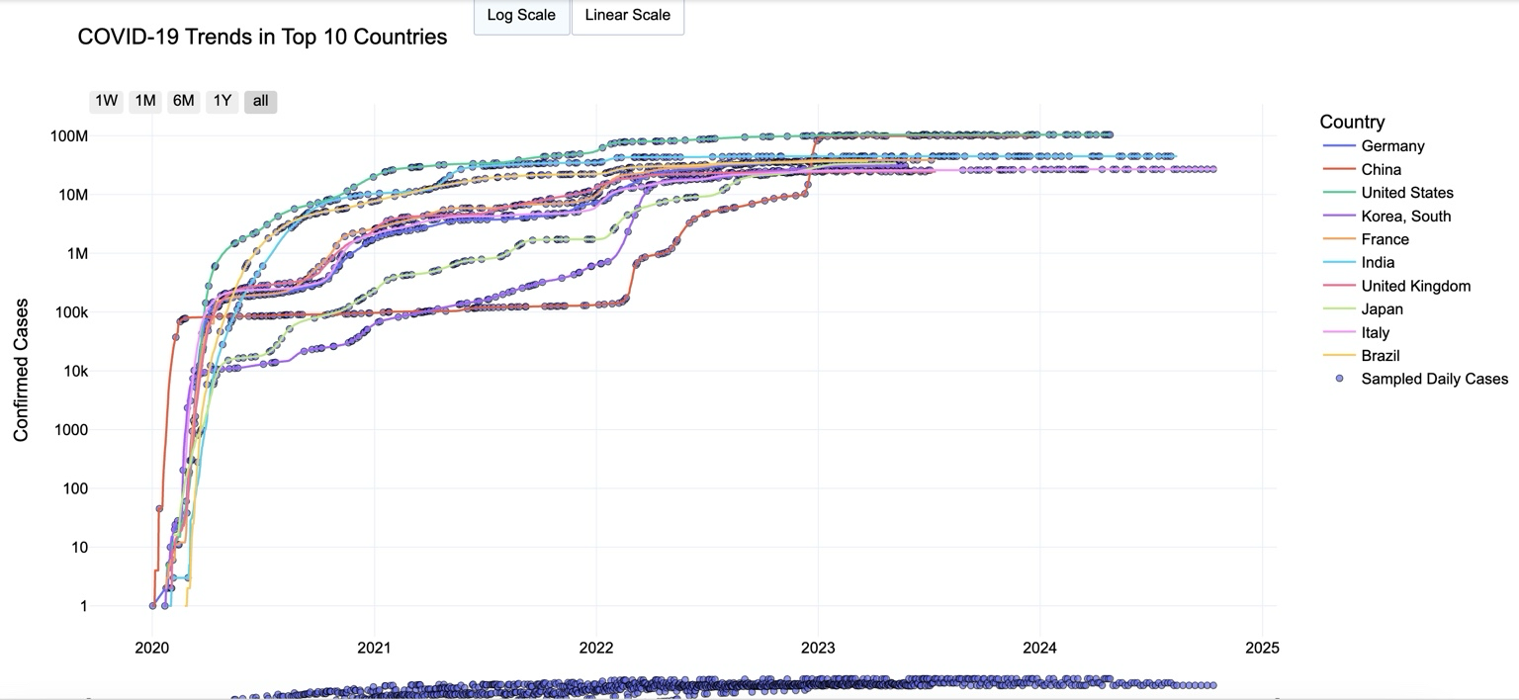

Figure 5: COVID-19 Trends in the Most Affected Countries

These interactive visualization tools collectively provide a multi-faceted analysis of the pandemic, integrating geospatial, temporal, and social media data. By allowing users to explore infection trends, policy shifts, and public sentiment, our approach ensures that complex datasets remain accessible and interpretable.

**Machine Learning**

To enhance the interpretability of COVID-19 trends and their relationship with social media activity, we employed machine learning models, including Logistic Regression and XGBoost. These models allowed us to quantify the influence of various temporal, geographical, and policy-driven factors on tweet volumes and infection rates. By integrating SHAP analysis, we were able to interpret the contribution of each feature, revealing the key drivers behind observed trends.

Temporal features played a crucial role in shaping both online discourse and the actual spread of COVID-19. Using a linear regression model, we examined the impact of features such as weekends, ordinal dates, and months on tweet volumes and daily infection counts. The SHAP summary plot for temporal features, shown in Figure 6, illustrates that weekends had a particularly strong influence, with higher tweet activity observed during these periods. A similar pattern emerged when analyzing daily COVID-19 cases, as seen in Figure 7, where time-based attributes such as ordinal date and month significantly affected reported infections. These results suggest that both public discourse and real-world pandemic trends exhibited periodic fluctuations, likely driven by changes in public attention, media coverage, and governmental reporting schedules.

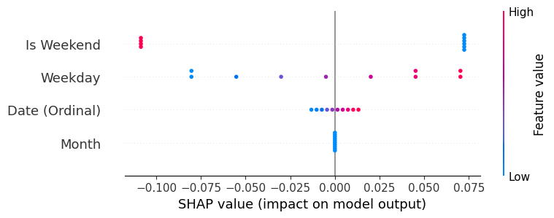

Figure 6: SHAP Summary Plot for Temporal Features (Tweet Volume)

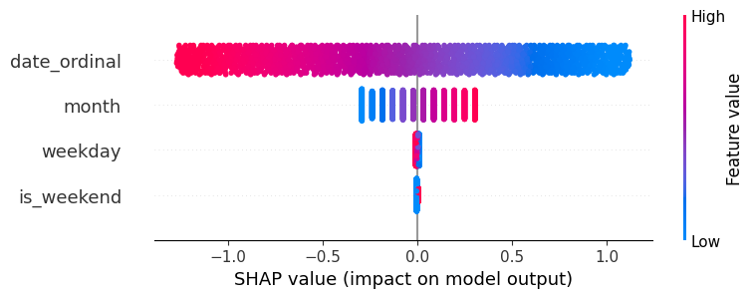

Figure 7: SHAP Summary Plot for Temporal Features (COVID-19 Cases)

Beyond temporal dynamics, the geographical distribution of tweets and COVID-19 cases revealed stark disparities in engagement and infection trends. We trained an XGBoost model to assess how tweet volumes varied across countries and found that certain regions, such as the United States and China, dominated online discussions. The SHAP summary plot for geographical features, displayed in Figure 8, highlights how countries with large social media user bases contributed disproportionately to global tweet activity. This pattern was further mirrored in COVID-19 case distributions, where certain regions exhibited a more substantial impact on the overall trajectory of infections. As illustrated in Figure 9, the SHAP analysis for geographical factors shows that a few key countries accounted for a significant portion of global case numbers, underscoring the role of location in shaping both public perception and actual pandemic outcomes.

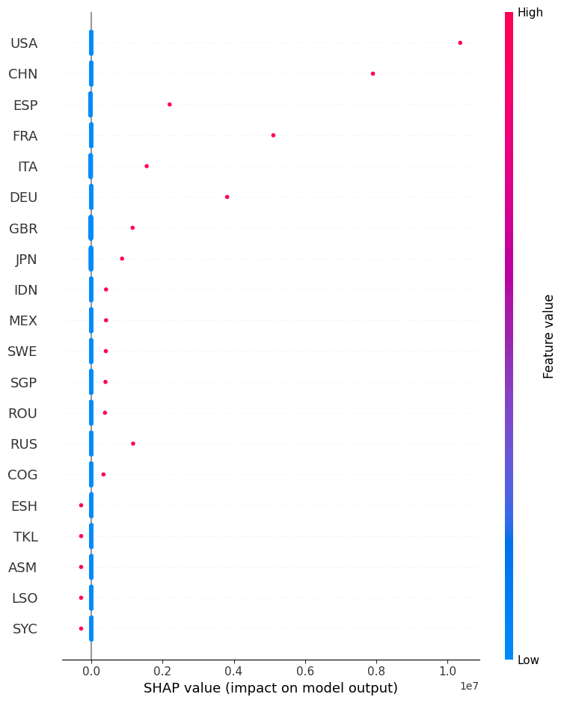

Figure 8: SHAP Summary Plot for Geographical Features (Tweet Volume)

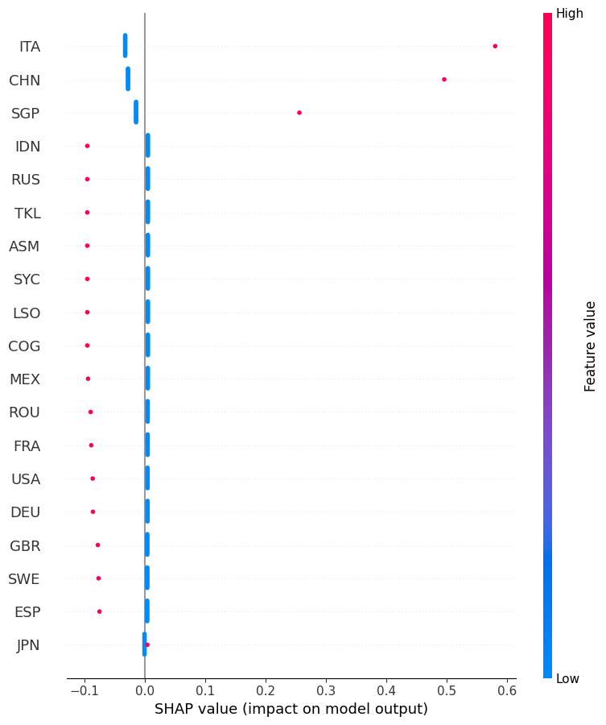

Figure 9: SHAP Summary Plot for Geographical Features (COVID-19 Cases)

In addition to temporal and geographical influences, government policies played a fundamental role in shaping the course of the pandemic. To assess the effectiveness of different interventions, we incorporated policy indices, including the Stringency Index, Containment Health Index, and Economic Support Index, into our predictive models. The SHAP summary plot for government policy measures, presented in Figure 10, reveals that stringent lockdowns, movement restrictions, and mandatory mask policies had a notable impact on reducing infection rates. These findings provide crucial insights into the effectiveness of various policy decisions, demonstrating how different countries responded to the crisis and how these interventions influenced the overall trajectory of the pandemic.

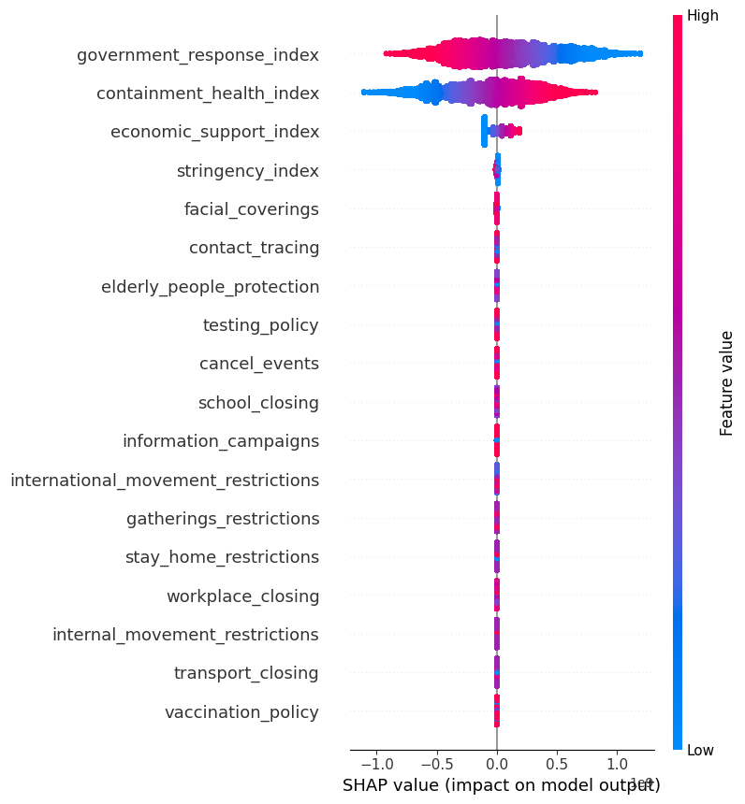

Figure 10: SHAP Summary Plot for Government Policy Measures

By leveraging machine learning models with SHAP interpretability, we were able to move beyond simple trend analysis and develop a deeper understanding of the mechanisms underlying COVID-19 discourse and spread. The results highlight the interconnectedness of social media discussions, real-world infections, and governmental actions, offering a comprehensive perspective on how public sentiment, epidemiological data, and policy responses evolved in tandem. This integrated approach underscores the importance of data-driven decision-making in managing future global health crises, where real-time monitoring of public reaction and pandemic trends can inform more effective and responsive strategies.

### **Results**

Our comprehensive analysis reveals that the dynamics of the COVID-19 pandemic are shaped by a complex interplay between epidemiological trends, government interventions, and public sentiment expressed on social media. By integrating diverse datasets and employing advanced machine learning interpretability techniques, such as SHAP analysis, our visualizations provide deep insights into how these dimensions interact over time and across regions.

**Temporal Dynamics and Policy Impact**

Time-series analyses indicate that the progression of COVID-19 infections exhibits distinct temporal patterns that are closely intertwined with government interventions. Our animated choropleth maps, which cover the entire temporal span of the dataset, reveal that peaks in daily new cases per million—visualized on a log scale for clarity—often coincide with periods of heightened policy stringency. For instance, when countries implemented strict lockdown measures or travel bans, the maps show pronounced spikes in infection rates, suggesting that the initial impact of these interventions may have been countered by delays in behavioral adaptation or resource mobilization. Moreover, event timeline visualizations highlight that critical policy milestones—such as the declaration of the pandemic by WHO, the onset of nationwide lockdowns, and the introduction of travel restrictions—correspond with abrupt changes in the epidemic curve, underscoring the significant role that timely policy actions play in modulating outbreak dynamics.

**Geospatial Variability and Social Media Engagement**

Geospatial visualizations provide a compelling global perspective on how the pandemic unfolded differently across regions. Our animated maps illustrate persistent regional disparities: countries with dense populations and high social media penetration, such as the United States, Brazil, and India, consistently record high infection rates and vigorous online discussions. Conversely, smaller or less-connected regions tend to exhibit lower levels of both infection and digital engagement. This spatial heterogeneity is further corroborated by our SHAP analyses of social media data, which reveal that geographical factors strongly influence tweet volumes. Highly connected nations not only contribute disproportionately to the overall volume of COVID-19-related tweets but also experience dynamic shifts in sentiment that mirror local epidemiological trends. In essence, our findings suggest that the intensity of public discourse on social media reflects both the severity of the outbreak and the scale of government interventions in each region.

**Interplay Between Public Sentiment, Infection Trends, and Policies**

A key contribution of this study is the demonstration of the synergistic relationship between public sentiment and policy effectiveness. SHAP analyses of tweet volume models indicate that temporal features—such as weekends—exert a strong influence on online engagement, with higher tweet volumes observed during periods when the public is more active. This temporal variation in sentiment often aligns with critical phases of the epidemic, as captured by our infection trend analyses. Furthermore, government policy measures, quantified through indices like the stringency index and government response index, emerge as significant predictors not only of infection rates but also of public sentiment. Regions with stricter policies tend to exhibit heightened social media activity, suggesting that while rigorous interventions can be effective in curbing viral transmission, they may also provoke public anxiety and dissent. Conversely, periods of policy relaxation are sometimes associated with a decline in both infection rates and online engagement, hinting at the possibility that easing restrictions might foster a sense of relief and reduced public scrutiny.

**Integrated Insights and Implications**

The integration of multiple data sources and advanced visualization techniques allows us to draw several key conclusions. First, the alignment between epidemic peaks and policy interventions implies that public health measures, while necessary, require careful timing and communication to maximize their effectiveness. Second, the strong correlation between social media sentiment and epidemiological trends suggests that digital platforms can serve as real-time sensors for gauging public reaction and anticipating shifts in outbreak dynamics. Finally, the spatial disparities highlighted in our geospatial maps underscore the need for tailored policy responses that consider regional differences in population density, social media usage, and healthcare capacity.

In summary, our study advances the understanding of COVID-19 dynamics by bridging the gap between epidemiological data, policy analysis, and public sentiment. The integrated approach—combining temporal, spatial, and machine learning interpretability analyses—provides actionable insights for public health authorities. These findings not only inform future crisis communication strategies but also lay the groundwork for more adaptive and responsive policymaking in the face of global health emergencies.

**Intellectual Merit and Practical Impacts**

This study advances our understanding of the COVID-19 pandemic by integrating multiple data sources—including epidemiological records, government policy responses, and social media sentiment—to create a comprehensive, multi-dimensional analysis of crisis dynamics. Our work is distinguished by the following key contributions:

**Innovative Data Integration and Multi-Dimensional Analysis**

Unlike studies that rely on a single data source, our research synthesizes diverse datasets to examine the interplay between infection trends, policy interventions, and public sentiment. By combining traditional epidemiological metrics (e.g., confirmed cases, hospitalizations) with government response indices and large-scale Twitter data, we establish a framework that captures both the objective progression of the pandemic and the subjective public reaction to it.

**Advanced Machine Learning Interpretability with SHAP**

A unique aspect of our work is the application of SHAP (Shapley Additive Explanations) analysis. By quantifying the contributions of temporal, geographical, and policy-related features in our predictive models, SHAP analysis provides transparent, interpretable insights that illuminate how specific factors—such as weekend effects or stringent lockdown measures—drive changes in infection rates and social media engagement. This level of interpretability not only enhances model reliability but also deepens our theoretical understanding of the factors influencing pandemic dynamics.

**Cutting-Edge Interactive Visualizations**

Our project leverages interactive visualization tools—including animated choropleth maps, dual-axis time-series plots, and event timeline diagrams—to make complex, multi-faceted data accessible and interpretable. The animated maps enable users to explore the evolution of infection rates and policy stringency over time, while dual-axis plots reveal correlations between government actions and epidemiological outcomes. These visualizations provide a dynamic and intuitive means of understanding the spatial and temporal heterogeneity inherent in the COVID-19 crisis.

**Bridging Digital Discourse and Real-World Outcomes**

By juxtaposing social media sentiment analysis with real-world infection and policy data, our study demonstrates that online public discourse is not merely reactive but can serve as a predictive indicator of outbreak dynamics and policy effectiveness. The strong correspondence between peaks in tweet volumes, shifts in sentiment, and key epidemiological and policy milestones underscores the potential of social media as a real-time sensor for public response during health emergencies.

**Enhanced Crisis Communication and Public Health Messaging**

Our findings reveal critical temporal windows—such as weekends and key policy implementation dates—during which public engagement surges. This insight can inform the timing of public health announcements, ensuring that messages reach the widest audience during periods of peak social media activity. Furthermore, by understanding regional differences in both infection trends and digital engagement, policymakers can tailor messages to address local concerns and cultural contexts.

**Data-Driven Policy Evaluation and Resource Allocation**

The integration of geospatial data with policy indices provides a nuanced picture of how government interventions correlate with infection control. By identifying regions where strict policies coincide with favorable epidemiological trends—or conversely, where policy measures appear less effective—decision-makers can adjust strategies and allocate resources more efficiently. This evidence-based approach enables proactive adjustments in policy implementation, potentially mitigating the impact of future outbreaks.

**Real-Time Monitoring and Adaptive Response**

Our interactive visualization tools, such as animated choropleth maps and event timeline graphs, offer decision-makers the ability to monitor pandemic dynamics in real time. This capability is invaluable for crisis management, as it allows for rapid detection of emerging hotspots, shifts in public sentiment, and the effectiveness of recent interventions. The resulting insights facilitate adaptive responses that can improve public compliance and overall crisis resilience.

**Interdisciplinary Applications and Democratization of Data**

Beyond public health, the methodologies developed in this study have broad applicability across fields such as political science, marketing, and urban planning. By democratizing access to complex data through interactive visualizations and interpretable machine learning models, our work empowers a wide range of stakeholders—from academics to frontline public health officials—to engage with data-driven decision-making processes.

In summary, this project not only deepens our theoretical understanding of the intertwined dynamics of pandemics, policies, and public sentiment but also delivers actionable insights for managing current and future global health crises. By bridging the gap between digital discourse and real-world outcomes, our study lays the foundation for more inclusive, adaptive, and effective public health strategies.

**Supplementary Materials**

GitHub repository: <https://github.com/ManchesterBlue/Info301_Final>.

Grammarly Report:

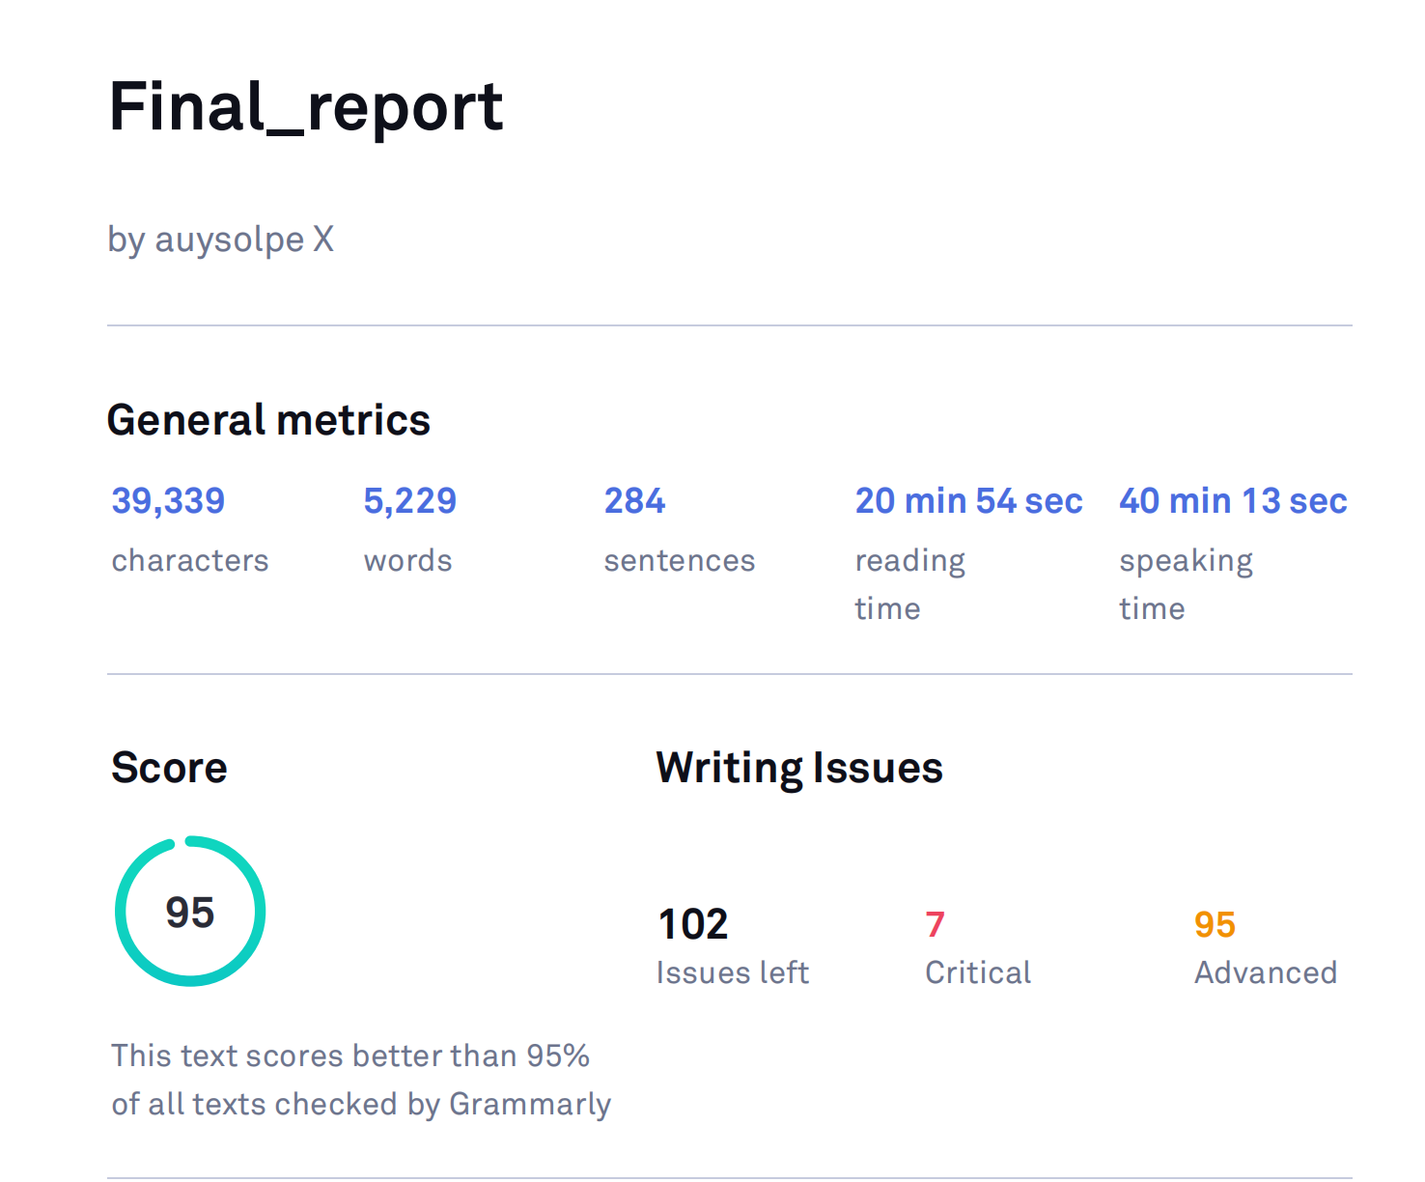

**References**

Abd-Alrazaq, A., Alhuwail, D., Househ, M., Hamdi, M., & Shah, Z. (2020). Top concerns of tweeters during the COVID-19 pandemic: Infoveillance study. *JMIR Public Health and Surveillance, 6*(2), e19016. [https://pmc.ncbi.nlm.nih.gov/articles/PMC7247466](https://pmc.ncbi.nlm.nih.gov/articles/PMC7247466" \t "_new).

Brooks, S. K., Webster, R. K., Smith, L. E., Woodland, L., Wessely, S., Greenberg, N., & Rubin, G. J. (2020). The psychological impact of quarantine and how to reduce it: Rapid review of the evidence. *The Lancet, 395*(10227), 912–920. https://doi.org/10.1016/S0140-6736(20)30460-8

Clemente-Suárez, V. J., Navarro-Jiménez, E., Jimenez, M., Hormeño-Holgado, A., Martinez-Gonzalez, M. B., Benitez-Agudelo, J. C., Perez-Palencia, N., Laborde-Cárdenas, C. C., & Tornero-Aguilera, J. F. (2021). Impact of COVID-19 pandemic in public mental health: An extensive narrative review. *Sustainability, 13*(6), 3221. https://doi.org/10.3390/su13063221

Dar, A. B., Lone, A. H., Zahoor, S., Khan, A. A., & Naaz, R. (2023). Social media sentiment analysis during the COVID-19 pandemic: A systematic review. *Frontiers in Public Health, 11*, 10133460. [https://pmc.ncbi.nlm.nih.gov/articles/PMC10133460](https://pmc.ncbi.nlm.nih.gov/articles/PMC10133460" \t "_new).

Hale, T., Angrist, N., Goldszmidt, R., Kira, B., Petherick, A., Phillips, T., Webster, S., Cameron-Blake, E., Hallas, L., Majumdar, S., & Tatlow, H. (2021). A global panel database of pandemic policies (Oxford COVID-19 Government Response Tracker). *Nature Human Behaviour, 5*(4), 529–538. https://doi.org/10.1038/s41562-021-01079-8

Haug, N., Geyrhofer, L., Londei, A., Dervic, E., Desvars-Larrive, A., Loreto, V., Pinior, B., Thurner, S., & Klimek, P. (2020). Ranking the effectiveness of worldwide COVID-19 government interventions. *Nature Human Behaviour, 4*(12), 1303–1312. https://doi.org/10.1038/s41562-020-01009-0

Johns Hopkins University Center for Systems Science and Engineering (JHU CSSE). (2020). *COVID-19 dashboard*. Retrieved from [https://coronavirus.jhu.edu/](https://coronavirus.jhu.edu/" \t "_new)

Lundberg, S. M., & Lee, S.-I. (2017). A unified approach to interpreting model predictions. In *Advances in Neural Information Processing Systems* (Vol. 30).

Munzner, T. (2014). *Visualization analysis and design*. A K Peters/CRC Press.

Natural Earth. (2020). *Admin 0 - Countries (1:110m scale)*. Retrieved from [https://www.naturalearthdata.com/downloads/110m-cultural-vectors/110m-admin-0-countries/](https://www.naturalearthdata.com/downloads/110m-cultural-vectors/110m-admin-0-countries/" \t "_new)

Paremoer, L., Nandi, S., Serag, H., & Baum, F. (2021). COVID-19 pandemic and the social determinants of health. *BMJ, 372*, n129. https://doi.org/10.1136/bmj.n129

Qatar Computing Research Institute (QCRI). (2020). *GeoCoV19: A dataset of hundreds of millions of multilingual COVID-19 tweets with location information*. Retrieved from [https://crisisnlp.qcri.org/covid19](https://crisisnlp.qcri.org/covid19" \t "_new)

Sridhar, A., Balasubramanian, P., Khatun, F., & Subramani, R. (2023). Artificial intelligence in COVID-19 Twitter data analysis: Trends and challenges. *BMC Medical Informatics and Decision Making, 23*, 10487588. [https://pmc.ncbi.nlm.nih.gov/articles/PMC10487588](https://pmc.ncbi.nlm.nih.gov/articles/PMC10487588" \t "_new).