**Measures and track elements**

The track is made of two different blocks

* Lane: Area delimited by three black lines, two signalling the edges and a central one.
* Straight segment: Segment with no curvature
* Curved segment: Piece of track with a 90 degree turn
* Intersection: Area without a line to be followed. It contains +/- 90deg turn to either side or a forward path.

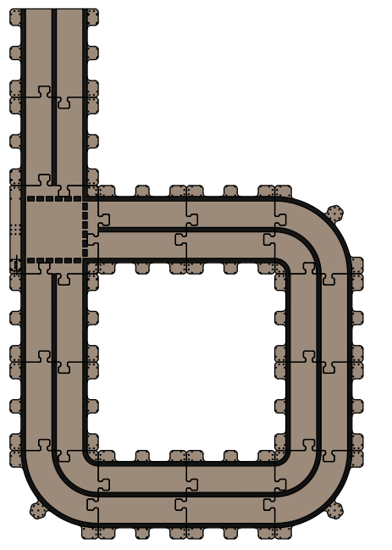

Sample track

Traffic Signs based on the standard UK traffic sign models:

* Go ahead, Turn Left, Turn Right: Expected behaviour is to pick a new direction in the current intersection.
* Stop: It represents the end of the track and the robot should stop moving
* Give way: It represents a temporal stop and the robot should stop briefly and then continue the movement.
* Men at Work: The robot should reduce its pace.

The physical specifications of the traffic signs are the following:

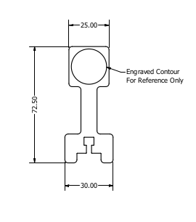

**Traffic Lights Connection guide**

Traffic light pinout

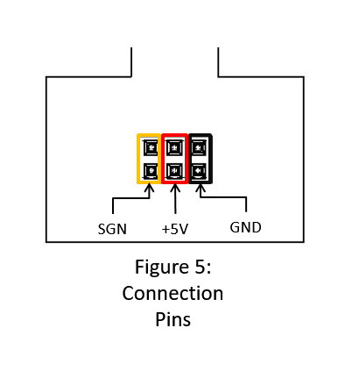

5V and GND can be obtained from any power source in the board. The signal SGN is send through IO5 (see Pinout traffic light)

**Challenge description**

You are going to have to present you solution to a committee of judges experts in the field, then your agent will have to navigate through an unknown combination of the items presented here. In case of conflict, there are two hierarchies to apply:

1. Traffic lights > Traffic signs
2. Proximity of the traffic sign

**Rules**

* Each team will be equipped with one robot and a complete description of the elements in the final challenge. The hardware needs to be returned by the end of the competition.
* There are no restrictions in terms of the pieces of software usable in the challenge.
* Only software written during the hackathon can be used by participants, any suspicious of breaking this rule will lead to a disqualification of the team.
* During the project assessment, an unknown environment will be presented containing the elements given to the participants during the first day and their application is expected to navigate it autonomously.
* Coding time ends the 9th of March at midday and if you want to apply for prizes you’ll need to submit your code online. During the afternoon of the 9th of March and the Morning of the 10th participants will present their projects in front of a board of judges.
* When assisting the results of the challenge we are going to consider performance, tools used and clarity of the presentation.
* The organisation reserves the rights to modify this rules if necessary.