Measures and track elements

The track is made of two diferent blocks

- Lane: Area delimited by three black lines, two signaling the edges and a central one.
- Straight segment: Segment with no curvature
- Curved segment: Piece of track with a 90 degree turn
- Interection: Area without a line to be followed. It containts +/- 90deg turn to either side and a forwar path.
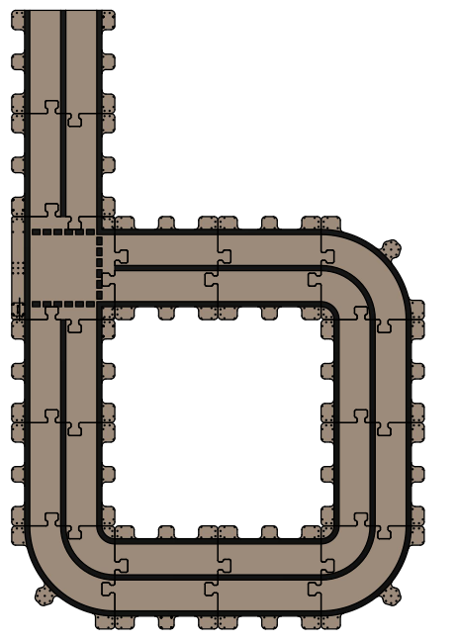

Sample track

Traffic Signs based on the standard UK traffic sign models :

- Go ahead, Turn Left, Turn Right: Expected behaviour is to pick a new direction in the current intersection.
- Stop: It represents the end of the track and the robot should stop moving
- Give way: It represents a temporal stop, the robot should stop briefly and then continue the movement.
- Men at Work: The robot is traversing a dangerous environment and should reduce its pace.

The physical specifications of the traffic signs are the following:
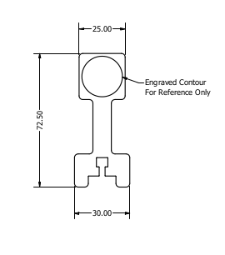

Traffic Lights Connection guide

Challenge description

You are going to have to present you solution to a comitee of judges experts in the field, then your agent will have to succesfully navigate though an unknown combination of the items presented here. In case of conflit there are two herarchies to apply :

- Traffic lights > Traffic signs
- Proximity of the traffic sign

Rules

- Each team will be equiped with one robot and a complete description of the elements in the final challenge. The hardware needs to be returned by the end of the competition.
- There are no restrictions in terms of the pieces of software usable in the challenge.
- Only software written during the hackathon can be used by participants, any suspicious of breaking this rule will lead to a disqualification of the team.
- During the project assesment an unknown environment will be presented containing the elements given to the participants during the first day and their aplication will be expected to navigate it autonomously.
- The organisation reserves the rights to modify this rules if necessary.

