# Manchester Robotics / Tecnológico de Monterrey

# TE3001B: Fundamentación de Robótica

## Introduction

This course, developed by Manchester Robotics ltd. (MCR2), introduces the basic concepts and general knowledge of the ROS environment to the user.

This course is divided into five sessions, carefully designed for the user to learn about the different aspects of ROS2, from topics and messages to control, simulation using ROS2.

This course will be based on challenges to make the student aware of ROS basics and ROS communication with hardware.

## General Information

* MCR2 Person in Charge: Mario Martinez
* Tecnológico de Monterrey Person in Charge: Dr. Luis Alberto Munoz
* Duration 5 Weeks
* Weekly Briefings : Tuesday 9AM (TBD)
* Classes: 5 Weeks
* Starting: February 10.
* Requirements:
  + Computer with access to Zoom (online classes).
  + Computer with Ubuntu 22.04 and ROS2 Humble or MCR2 Virtual Machine or WSL.
  + Knowledge of Windows.
  + Basic knowledge of Ubuntu (recommended).
  + Basic understanding of robotics (recommended).
  + Access to a Hackerboard/ESP32 microcontroller and a MCR2 DC motor.
  + In case a regular ESP32 is being used, L298n Motor Driver and a DC motor brushed with encoder

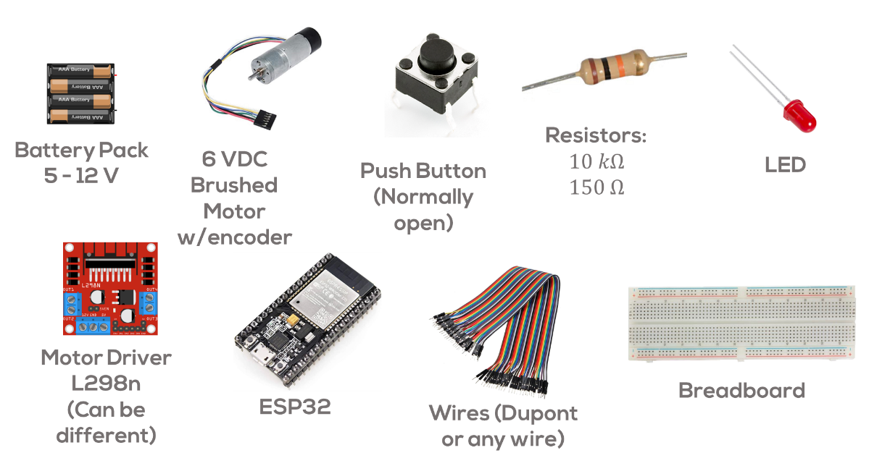

* Student Demographic: TBD
* Number of Professors: TBD
* Grading: Minimum Requirements by MCR2, Professor Determined.
* Deliverables: Each professor determines
* Final Challenge Deliverable: Short presentation in a final Video (Best of each campus) + Q&A
* Rubric: Minimum Requirements (Each professor determines the marking scheme).
* ZOOM Link Classes: TBD
* ZOOM Link Briefings: TBD
* Student GitHub Link: TBD

## Week 1: Introduction

* Who are we? Introduction to MCR2.
* Introduction to Robotics
* Introduction to ROS
* Overview of the ROS Environment
  + Topics, Messages, ROS.
* Launch Files
* Mini challenge: Generate a node that sends a signal to another node to process it.

## Week 2: ROS Practicalities and Control

### ROS Practicalities

* ROS Namespaces
* ROS Parameters
* ROS Parameter Callbacks
* ROS Services

## Week 3: ROS-Hardware Communication

### ROS Motor Speed Regulation

* Micro ROS Basics
* QoS
* Executors
* Mini Challenge: Motor Speed regulation using ROS.

## Week 4: ROS Data Acquisition

### Encoder Data Acquisition

* Encoder Basic Theory
* Closed Loop Control Theory
* Real-time (Optional)
* WiFi (Optional)
* Mini Challenge: Acquire data from the encoders using Arduino.

## Week 5: Challenge

* Presentation of the Challenge: PID Controller using ROS and compare with simulation.
* Final presentation.