**Expirment 4**

**Openweather**.**html**

<!DOCTYPE html>

<html lang="en">

<head>

<meta charset="UTF-8">

<meta name="viewport" content="width=device-width, initial-scale=1.0">

<title>OPENWEATHERMAP.ORG</title>

</head><body>

<header>

<h1>Open weather</h1>

</header>

<a href="https://openweathermap.org/city/1252948">openweathermap.org</a>

<br><br><br>

<footer>

© 2012 — 2023 OpenWeather ® All rights reserved

</footer>

</body></html>

**Output :**

Output 1: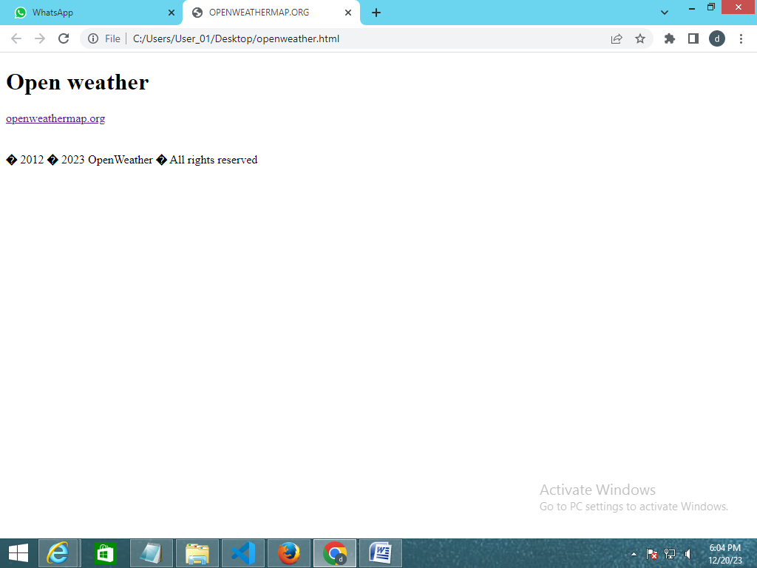

output 2: