AUTOMATIC DETECTION OF GENETIC DISEASES IN PEDIATRIC AGE USING PUPILLOMETRY
A Project Report Submitted
in partial fulfillment of the requirements for the award of the degree of
BACHELOR OF TECHNOLOGY
IN
COMPUTER SCIENCE AND ENGINEERING
AWARDED BY
JAWAHARLAL NEHRU TECHNOLOGICAL UNIVERSITY KAKINADA

G V V S S S GANESH (21H41A0514)
Y C R DURGA (21H41A0566)
M GAYATHRI (21H41A0534)
V MEGHANA (21H41A0561)
A G S SAVERI (21H41A0502)

Under the Esteemed guidance of
Mrs.B S R D LAKSHMI, M.Tech.,(Ph.D.,)
Assistant Professor
Department of CSE


DEPARTMENT OF COMPUTER SCIENCE AND ENGINEERING
BONAM VENKATA CHALAMAYYA INSTITUTE OF TECHNOLOGY AND SCIENCE
(Approved by AICTE, Accredited by NBA, Accredited by NAAC, Affiliated to JNTUK, ISO 9001:2015 QMS Certified Institution)
Amalapuram-533 201
2024-2025
BONAM VENKATA CHALAMAYYA INSTITUTE OF TECHNOLOGY AND SCIENCE
(Approved by AICTE, Accredited by NBA, Accredited by NAAC, Affiliated to JNTUK, ISO 9001:2015 QMS Certified Institution)
Amalapuram-533 201


DEPARTMENT OF COMPUTER SCIENCE AND ENGINEERING

DECLARATION BY THE CANDIDATES

We G V V S S S GANESH, Y C R DURGA, M GAYATHRI, V MEGHANA, A G S SAVERI
bearing hall ticket numbers 21H41A0514, 21H41A0566, 21H41A0534, 21H41A0561,21H41A0502 hereby declare that the main project report entitled “AUTOMATIC DETECTION OF GENETIC DISEASES IN PEDIATRIC AGE USING PUPILLOMETRY”, under the esteemed guidance of “Mrs.B S R D LAKSHMI, M.Tech., (Ph.D.,), Assistant Professor”, Department of CSE, is submitted in partial fulfillment of the requirements for the award of the degree of bachelor of technology in Computer Science Engineering.
This is a record of bonafide work carried out by us and the results embodied in this
project report have not been reproduced or copied from any other source and have not been submitted to any other university or institute for the award of any other degree or diploma.

G V V S S S GANESH (21H41A0514)
Y C R DURGA (21H41A0566)
M GAYATHRI (21H41A0534)
V MEGHANA (21H41A0561)
A G S SAVERI (21H41A0502)

BONAM VENKATA CHALAMAYYA INSTITUTE OF TECHNOLOGY AND SCIENCE
(Approved by AICTE, Accredited by NBA, Accredited by NAAC, Affiliated to JNTUK,

ISO 9001:2015 QMS Certified Institution) Amalapuram-533 201
DEPARTMENT OF COMPUTER SCIENCE AND ENGINEERING

CERTIFICATE

This is to certify that the project work “AUTOMATIC DETECTION OF GENETIC DISEASES IN PEDIATRIC AGE USING PUPILLOMETRY” submitted by G V V S S S Ganesh (21H41A0514), Yerubandi Chandini Ratna Durga (21H41A0566), Manchikanti Gayathri (21H41A0534), Veera Meghana (21H41A0561), Anuchuri Gayathri Sri Saveri (21H41A0502) is examined and adjudged as sufficient as a partial requirement for the BACHELOR OF TECHNOLOGY IN COMPUTER SCIENCE AND ENGINEERING at Jawaharlal Nehru Technological University, Kakinada is a bonafide record of the work done by these group of students under my guidance and supervision.

PROJECT GUIDE HEAD OF THE DEPARTMENT
Mrs.B S R D LAKSHMI, Dr.K SRINIVAS,
M.Tech., (Ph.D.,) M.Tech., MISTE,Ph.D.,
Assistant Professor Professor & HOD
DEPARTMENT OF CSE DEPARTMENT OF CSE

PROJECT EXTERNAL EXAMINER
BONAM VENKATA CHALAMAYYA INSTITUTE OF TECHNOLOGY AND SCIENCE
(Approved by AICTE, Accredited by NBA,Accredited by NAAC,Affiliated to JNTUK)
Amalapuram-533 201

DEPARTMENT OF COMPUTER SCIENCE AND ENGINEERING

ACKNOWLEDGEMENT

We would like to express our sincere gratitude and indebtedness to our project supervisor Mrs.B S R D LAKSHMI, M.Tech.,(Ph.D.,) Assistant professor, CSE Department for her valuable suggestions and interest throughout the course of this project.
We are also thankful to the Head of the Department Dr.K SRINIVAS M.Tech, Ph.D, MISTE for guiding us for completing this project successfully.
We also thankful to Head of the Institution Prof. Dr.J V G RAMARAO B.E, M.Tech, Ph.D, FIETE, FIE, MIEEE, MSENSE, MISTE for providing excellent infrastructure and a nice atmosphere for completing this project successfully.
We convey our heartfelt thanks to the lab staff for allowing us to use the required equipment whenever needed.
Finally, we would like to take this opportunity to thank our family members for their support throughout our career.

G V V S S S GANESH (21H41A0514)
Y C R DURGA (21H41A0566)
M GAYATHRI (21H41A0534)
V MEGHANA (21H41A0561)
A G S SAVERI (21H41A0502)

DEPARTMENT OF COMPUTER SCIENCE & ENGINEERING ( CSE )

VISION
To become a prominent department of Computer Science & Engineering producing competent professionals with research and innovation skills, inculcating moral values and societal concerns.

MISSION
DM1: To offer state-of-art education in Computer Science and Engineering.
DM2: To provide a strong theoretical foundation complemented with extensive practical training.
DM3: To train and transform young men and women into responsible thinking engineers, technologists and scientists, to motivate them to attain professional excellence.
DM4: To inspire students proactively engage themselves for the betterment of the society.

PROGRAM EDUCATIONAL OBJECTIVES (PEO’S):
PEO 1: Graduates will be an efficient software developer in diverse fields and will be a successful professional and/or pursue higher studies.
PEO 2: Graduates will be capable of adapting to new computing technology
for professional excellence and research and be a lifelong learner.
PEO 3: Graduates will work productively exhibiting ethical qualities for the
betterment of society.
PEO 4: Graduates will possess leadership qualities, work harmoniously as a team member with effective communication skills.

PROGRAM SPECIFIC OBJECTIVES (PSO):
PSO 1: Gain capability to use current techniques, skills & tools necessary for carrying out multidisciplinary projects.
PSO 2: Acquaint with the contemporary trends in industrial/research setting and thereby innovate novel solutions to existing problems.

ABSTRACT

Inherited retinal diseases cause severe visual defects in children. They are classified in outer and inner retina diseases, and often cause blindness in childhood. The diagnosis for this type of illness is challenging, given the wide range of clinical and genetic causes. It is routinely based on a complex pattern of clinical tests, including invasive ones, not always appropriate for infants or young children.
A different approach is thus needed, the use of pupillometry, a non-invasive technique that measures pupil size and reactions, as a potential tool for detecting genetic diseases in children. Pupil reactions were recorded using an automated pupillometer under controlled lighting conditions. The pupillometry system tested on both synthetic and real-world data, achieving accurate results with lower computational cost than traditional methods.

TABLE OF CONTENTS

S.NO | CONTENTS | PAGE.NO
1. | INTRODUCTION  1.1 About the project  1.2 Introduction  1.3 Objective (Purpose & Scope) | 01 - 03
2. | LITERATURE SURVEY | 04 - 05
3. | SYSTEM REQUIREMENTS  3.1 Software & Hardware Requirements  3.2 Functional Requirements  3.3 Non-Functional Requirements | 06 - 08
4. | SYSTEM ANALYSIS  4.1 Feasibility study  4.2 Existing System & Disadvantages  4.3 Proposed System & Advantages | 9 - 11
5. | SYSTEM DESIGN  - System Architecture and Modules  5.2 Data flow Diagrams  5.3 UML Diagrams | 12 - 23
6. | IMPLEMENTATION  6.1 Technologies used  - Source Code | 24 - 38
7. | TESTING  7.1 About testing  7.2 Test cases | 39 - 44
8. | SCREENS | 45 - 54
9. | USER MANUAL | 55 - 58
10. | CONCLUSION AND FUTURE WORK | 59 - 60
11. | BIBLIOGRAPHY | 61 - 62

AUTOMATIC DETECTION OF GENETIC DISEASES IN PEDIATRIC AGE USING PUPILLOMETRY

INTRODUCTION

1.1 ABOUT PROJECT
The project focuses on the automatic detection of genetic diseases in pediatric patients using pupillometry, a non-invasive technique that measures pupil responses to light stimuli. By integrating artificial intelligence (AI) and machine learning (ML), the system analyzes pupil dynamics to detect genetic conditions, enhancing early diagnosis and treatment. This approach offers a quick, cost-effective, and accessible alternative to traditional diagnostic methods, which often involve genetic testing or invasive procedures.
The system utilizes machine learning models, including Support Vector Machines (SVM), Extreme Learning Machines (ELM), and Long Short-Term Memory (LSTM) networks, to classify pupillometry data and predict potential genetic diseases. The project emphasizes a non-invasive methodology, aiming to reduce the need for stressful and invasive clinical procedures, particularly beneficial for pediatric patients.

1.2 INTRODUCTION
The automatic detection of genetic diseases in pediatric patients using pupillometry presents a non-invasive, rapid, and objective approach to early diagnosis. Pupillometry is a technique that measures pupil size and reactivity in response to light stimuli, providing insights into the autonomic nervous system and neurological functions. Many genetic disorders affect these systems, leading to abnormal pupillary responses that can serve as potential biomarkers for early disease detection.
Artificial intelligence (AI) and machine learning (ML), this approach enables automated analysis of pupillary dynamics, identifying distinct patterns linked to specific genetic conditions. Unlike traditional diagnostic methods that often require genetic testing or invasive procedures, pupillometry offers a quick, cost-effective, and accessible alternative, making it particularly beneficial for pediatric patients.
This system minimizes subjectivity in diagnosis, ensuring higher accuracy and efficiency. Additionally, AI-driven analysis improves real-time disease detection, helping healthcare professionals make timely interventions and develop personalized treatment plans. Despite its advantages, factors such as environmental lighting conditions, patient cooperation, and variability in physiological responses must be considered for broader clinical adoption.
The integration of artificial intelligence (AI) and machine learning (ML) has revolutionized the way genetic diseases are detected using pupillometry. Traditional diagnostic methods rely on manual observations and genetic tests, which can be costly, invasive, and time-consuming. AI-driven pupillometry, on the other hand, provides a quick and objective approach by analyzing pupillary

response patterns using deep learning models such as Convolutional Neural Networks (CNNs) and
Recurrent Neural Networks (RNNs).
These models process large datasets of pupillary responses, detecting subtle variations that may indicate specific genetic conditions. AI-based classification systems improve accuracy and efficiency, reducing the risk of misdiagnosis and enabling early intervention. The ability of machine learning algorithms to learn from past data allows for continuous improvement, making them highly effective for disease detection.

1.3 OBJECTIVE (PURPOSE & SCOPE)
- To detect genetic diseases in children early, accurately, and non-invasively using pupillometry (measuring pupil response to light).
- AI helps analyze data for faster and better diagnosis, reducing the need for complex tests.
- Detects eye and brain-related genetic diseases like retinitis pigmentosa and autism.
- Used in hospitals and research for early screening.
- AI improves accuracy over time.
- This method helps doctors diagnose genetic diseases quickly and affordably, improving children's healthcare.

LITERATURE SURVEY

1. Genes and Genetics in Eye Diseases: A Genomic Medicine Approach
Author: Mahavir Singh, Suresh C Tyagi
Summary: In 2008, research identifies genes linked to inherited eye diseases, but highlights the cost barrier of genetic testing and gene therapies, limiting accessibility for low-income populations.
2. Pediatric Eye Disease—Screening, Causes, and Management
Author: Guy L.J. Chen, Jason C.S. Yam
Summary: In 2018, study details pediatric eye disease detection through early screening, genetic analysis, advanced imaging, and AI diagnostics. It also acknowledges the inaccessibility of screening programs in certain regions.
3. Title: AI-Based Pupillometry for Retinal Disease Detection
Author: Ernesto ladanza
Summary: In 2020, Machine learning Uses to analyze pupillary responses for diagnosing inherited retinal diseases with high accuracy. However, it focuses only on retinal diseases, limiting its broader application.
4. Automated Pupillometric Analysis for Disease Detection
Author: Jafar Ali Ibrahim
Summary: In 2021, A pupillometer Combines with AI for efficient and cost-effective disease diagnosis. It lacks details on the AI models used and accuracy in detail.
5. Hybrid System for Pupillometry-Based Diagnosis
Author: P. Meena Kumari
Summary: In 2021, Hybrid System Combines hardware (pupillometer) and software to detect genetic eye diseases. Lacks details on dataset size and diversity.
6. Machine Learning in Pupillometry for Genetic Disorders
Author: K. Nishitha, Pasam Sreekanth
Summary: In 2023, Uses AI to analyze eye data separately for each eye, improving diagnosis. No clear performance results are provided.

SYSTEM REQUIREMENTS

3.1 SOFTWARE & HARDWARE REQUIREMENTS
Hardware Requirements:
Operating System : Windows
Processor : i3 and above
RAM : 4 GB and above
Hard Disk : 20 GB and above

Software Requirements:
Programming Language : Python IDEL (Python 3.7)

3.2 FUNCTIONAL REQUIREMENTS
- Data Collection:
  - Collect pupillometric data from a pupillometer.
  - Allow users to upload pupillometric datasets.
- Data Processing:
  - Remove artifacts from raw data.
  - Extract key features (e.g., pupil diameter, latency).
  - Reduce unnecessary features.
- Classification:
  - Use SVM classifiers for analysis.
  - Perform classification on data from both eyes.
  - Combine SVM results using an ensemble algorithm.
- Output:
  - Show accuracy results for each eye and the ensemble model.
  - Generate graphs for pupil diameter and classification accuracy.
  - Predict disease presence or absence based on test data.

3.3 NON-FUNCTIONAL REQUIREMENTS
- Performance: Performance is a crucial factor in ensuring quick and accurate processing of pupillometric data. The system should process and analyze pupillometric data efficiently to provide timely diagnostic support. The classification algorithms (Support Vector Machines, ensemble model) should provide results with high accuracy.
- Usability: Usability is a fundamental design principle that ensures the system is intuitive and accessible to all users, including medical professionals and researchers. The system includes a user interface for uploading data, running analysis, and viewing results. The system provides visualizations such as pupil diameter graphs and accuracy graphs.
- Reliability: The system consistently captures accurate pupillometric data and delivers reproducible classification results. By integrating an ensemble model that combines multiple classifiers, the system enhances robustness and minimizes errors, ensuring dependable performance across diverse datasets.
- Non-Invasiveness: The system employs chromatic pupillometry, a safe and non-invasive technique that monitors pupil responses to light stimuli without causing any physical discomfort. This method ensures patient compliance and reduces stress, making it ideal for frequent monitoring in pediatric and vulnerable populations.
- Maintainability: The system is designed with a modular architecture to allow for updates and modifications to individual components (e.g., the classification algorithms, feature extraction methods) without affecting the entire system.
- Scalability: Scalability is a critical aspect of the system, ensuring that it can accommodate increasing amounts of data and users without a decline in performance. The system's design allows for the incorporation of additional patient data and processing resources. For example, the data processing components can be optimized or distributed to handle larger datasets.

SYSTEM ANALYSIS

4.1 FEASIBILITY STUDY

Technical Feasibility:

Data collection: uses chromatic pupillometry for accurate data acquisition.

Algorithms: applies machine learning (svms, bilstm) for analysis and classification.

System integration: combines hardware (pupillometer) with software for disease detection.

Economic Feasibility:

Cost Reduction: Minimizes the need for expensive tests and invasive procedures.

Efficiency: Early diagnosis enables timely interventions, reducing long-term costs.

Improved Diagnosis Speed: The system helps speed up diagnosis, leading to quicker treatment and better patient outcomes.

Operational Feasibility:

Non-Invasive: The system is non-invasive, ideal for pediatric patients.

User-Friendly: No need for complex preparations or sedation.

Minimal Training Required: Healthcare providers can easily adopt the system with little additional training.

4.2 EXISTING SYSTEM & DISADVANTAGES

The existing system for diagnosing Inherited Retinal Diseases (IRDs) primarily relies on a series of complex clinical tests, with electrophysiological testing being the most commonly used. These tests, though informative, are often invasive and require a specialized medical setting. The process can be challenging for pediatric patients, especially since these tests often require sedation. This can be problematic, as the procedure is expensive, time-consuming, and not always effective in detecting changes in visual function, particularly in young children.

DISADVANTAGES:

Invasive tests that may require sedation, which is not always suitable for children.

High costs due to specialized equipment and medical staff.

Time-consuming diagnosis process, requiring visits to specialized centers.

Limited ability to monitor disease progression effectively due to poor test reliability.

4.3 PROPOSED SYSTEM & ADVANTAGES

The proposed system uses Chromatic Pupillometry combined with Machine Learning to diagnose Inherited Retinal Diseases (IRDs) in children. This system utilizes a pupillometer to collect non-invasive pupillary response data, which is then analyzed using Support Vector Machines (SVMs) to classify the disease. The goal of this system is to provide a faster, easier, and more efficient way to diagnose IRDs, without the need for invasive procedures or sedation, making it particularly suitable for pediatric patients.

ADVANTAGES:

Non-invasive method that eliminates the need for sedation or other invasive tests.

Faster diagnosis with the ability to quickly analyze data using Machine Learning.

Cost-effective, reducing the need for specialized equipment and complex procedures.

Easy monitoring of disease progression and treatment effectiveness through repeated pupillometry tests.

SYSTEM DESIGN

5.1 SYSTEM ARCHITECTURE & MODULES

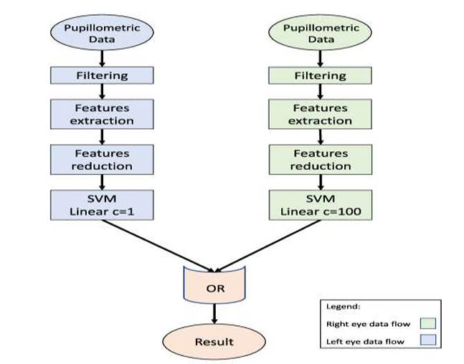

Fig 1: System architecture for Automatic Detection of Genetic Diseases in pediatric age using Pupillometry

Data Acquisition: Pupillometric data is collected from both the right and left eyes.

Filtering: The raw data undergoes filtering to remove noise and artifacts, ensuring data quality for subsequent analysis.

Feature Extraction: Relevant features are extracted from the filtered data. These features might include pupil size, dilation/constriction rates, latency, etc., depending on the specific research question.

Feature Reduction: The number of features is reduced to eliminate redundancy and improve the efficiency of the classification process. Techniques like Principal Component Analysis (PCA) might be used.

SVM Classification: The reduced features are then used as input for two separate SVM classifiers.

Right Eye Data: An SVM with a linear kernel and a regularization parameter (C) of 1 is applied.

Left Eye Data: An SVM with a linear kernel and a regularization parameter (C) of 100 is applied.

Logical OR Operation: The outputs of the two SVM classifiers are combined using a logical OR operation. This means the final result is positive if either the right eye SVM or the left eye SVM (or both) predicts a positive outcome.

Result: The final result, based on the combined output, is presented.

MODULES

This project is a Tkinter-based GUI application that utilizes machine learning and deep learning algorithms to analyze pupillometric data for the detection of genetic diseases in pediatric patients. It is structured into three main modules, each performing a crucial role in the processing, analysis, and prediction of disease outcomes.

Module 1: Data Preprocessing

The first step in the system is preprocessing the raw pupillometry dataset. This module is responsible for cleaning, filtering, and extracting useful features before applying machine learning models.

Key Functionalities in this Module:
1️. Dataset Upload
Purpose: Allows the user to select and upload the dataset directory.
How it Works:
- The user browses and selects a dataset folder.
- The file path is displayed, confirming a successful upload.
- The dataset is then prepared for further processing.

2️. Filtering & Cleaning Data
Purpose: Removes noisy data points and extracts meaningful information from the dataset.
Processing Steps:
- Extracts pupil dilation data for both eyes.
- Filters based on conditions (e.g., ignores missing or corrupt data).
- Stores the cleaned and organized dataset in a structured format.

3. Feature Extraction
Purpose: Extracts key pupillometric features required for model training.
Extracted Features:
- MAX (Maximum Pupil Size)
- MIN (Minimum Pupil Size)
- DELTA (Pupil Size Variation)

- CH (Change Rate in Pupil Size)
- Latency (Reaction Time)
- MCV (Mean Constriction Velocity)

4️. Feature Reduction
Purpose: Reduces dimensionality, removes redundant features, and normalizes the data for better model performance.
Processing Steps:
- Splits the dataset into training (80%) and testing (20%).
- Normalizes the features using min-max scaling to ensure consistency in data distribution.
- Prepares the final feature set for training the machine learning models.

Module 2: Model Training & Performance Evaluation

This module trains multiple machine learning and deep learning models to classify whether a patient has a genetic disease based on extracted features. It also includes an accuracy comparison graph to visualize the performance of different algorithms.

Key Functionalities in this Module:

1️. Support Vector Machine (SVM) for Right Eye
Purpose: Trains an SVM model on the right eye pupil data.
Outputs:
- Accuracy Score of the SVM model.
- Confusion Matrix (Sensitivity & Specificity analysis).

2️. Support Vector Machine (SVM) for Left Eye
Purpose: Trains an SVM model on the left eye pupil data.
Outputs:
- Accuracy Score of the SVM model.
- Confusion Matrix (Sensitivity & Specificity analysis).

3️. Ensemble Learning (Voting Classifier)
Purpose: Combines left-eye SVM and right-eye SVM predictions for better classification accuracy.

Outputs:
- Uses a Voting Classifier to make final decisions based on multiple models.
- Provides overall Ensemble Model Accuracy and Confusion Matrix Analysis.

4️. Extreme Learning Machine (ELM)
Purpose: Uses Extreme Learning Machine for fast training and high accuracy in classification.
Outputs:
- Uses RBF Random Layer for feature transformation.
- Computes accuracy, sensitivity, and specificity.

5️. Deep Learning Models - LSTM & BiLSTM
Purpose: Uses LSTM (Long Short-Term Memory) and BiLSTM (Bidirectional LSTM) for sequence-based disease prediction.
Outputs:
- Trains deep learning models using Neural Networks.
- BiLSTM improves prediction by considering past and future sequences.
- Computes accuracy, confusion matrix, and sensitivity/specificity metrics.

6️. Accuracy Graph
Purpose: Plots a bar chart to compare accuracy across all models.
Models Compared:
- SVM (Right Eye)
- SVM (Left Eye)
- Ensemble Learning
- Extreme Learning Machine (ELM)
- LSTM (Long Short-Term Memory)
- BiLSTM (Bidirectional LSTM)

Module 3: Disease Prediction

This module is responsible for predicting diseases based on test data using the trained models.
Purpose: Loads test data and classifies whether a patient has a genetic disease.
Processing:
- The model takes in new patient data.
- Makes predictions using the trained machine learning models.

- Displays results in the GUI console.
Outputs:
- If No Disease is Detected, the result is shown as "No disease detected"

If Disease is Detected, the result is shown as "Disease detected".

5.2 DATA FLOW DIAGRAM

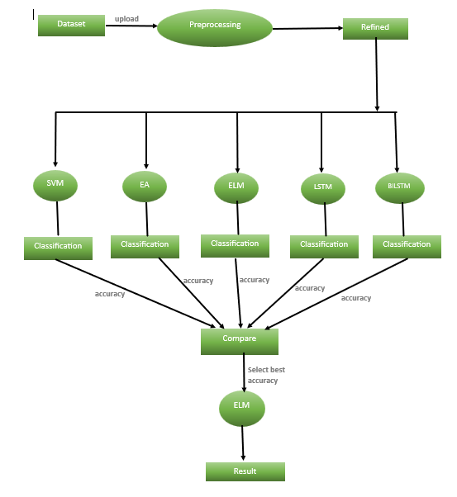

Fig 2: Data Flow Diagram for Automatic Detection of genetic diseases in pediatric age using pupillometry

5.3 UML DIAGRAMS

UML stands for Unified Modeling Language. UML is a standardized general-purpose

modeling language in the field of object-oriented software engineering. The standard is managed, and was created by, the Object Management Group.
The goal is for UML to become a common language for creating models of object oriented computer software. In its current form UML is comprised of two major components: a Meta-model and a notation. In the future, some form of method or process may also be added to; or associated with, UML.

The Unified Modeling Language is a standard language for specifying, Visualization, Constructing and documenting the artifacts of software system, as well as for business modeling and other non-software systems.

The UML represents a collection of best engineering practices that have proven successful in the modeling of large and complex systems. The UML is a very important part of developing objects oriented software and the software development process. The UML uses mostly graphical notations to express the design of software projects.

ADVANTAGES:

• To represent complete systems (instead of only the software portion) using object oriented concepts

• To establish an explicit coupling between concepts and executable code

• To take into account the scaling factors that are inherent to complex and critical systems

• To creating a modeling language usable by both humans and machines

UML defines several models for representing systems

• The class model captures the static structure

• The state model expresses the dynamic behavior of objects

• The use case model describes the requirements of the user

• The interaction model represents the scenarios and messages flows

• The implementation model shows the work units

• The deployment model provides details that pertain to process allocation

5.3.1 USECASE DIAGRAM:

Use case diagrams overview the usage requirement for system. They are useful for presentations to management and/or project stakeholders, but for actual development you will find that use cases provide significantly more value because they describe "the meant" of the actual requirements. A use case describes a sequence of action that provides something of measurable value to an action and is drawn as a horizontal ellipse.

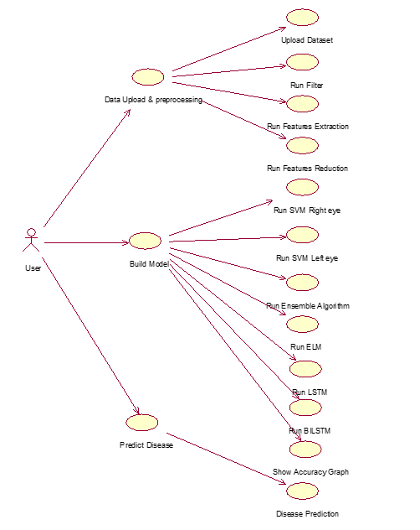

Fig 3: Usecase Diagram for Automatic Detection of Genetic Diseases in pediatric age using Pupillometry

5.3.2 CLASS DIAGRAM:

An object is any person, place, thing, concept, event, screen, or report applicable to your system. Objects both know things (they have attributes) and they do things (they have methods). A class is a representation of an object and, in many ways; it is simply a template from which objects are created. Classes form the main building blocks of an object-oriented application. Although thousands of students attend the university, you would only model one class, called Student, which would represent the entire collection of students.

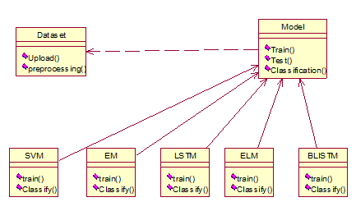

Fig 4:Class Diagram for Automatic Detection of Genetic Diseases in pediatric age using Pupillometry

5.3.3 SEQUENCE DIAGRAM:

Sequence diagram model the flow of logic within your system in a visual manner, enabling you both to document and validate your logic, and commonly used for both analysis and design purpose. Sequence diagram are the most popular UML artifact for dynamic modeling, which focuses on identifying the behavior within your system.

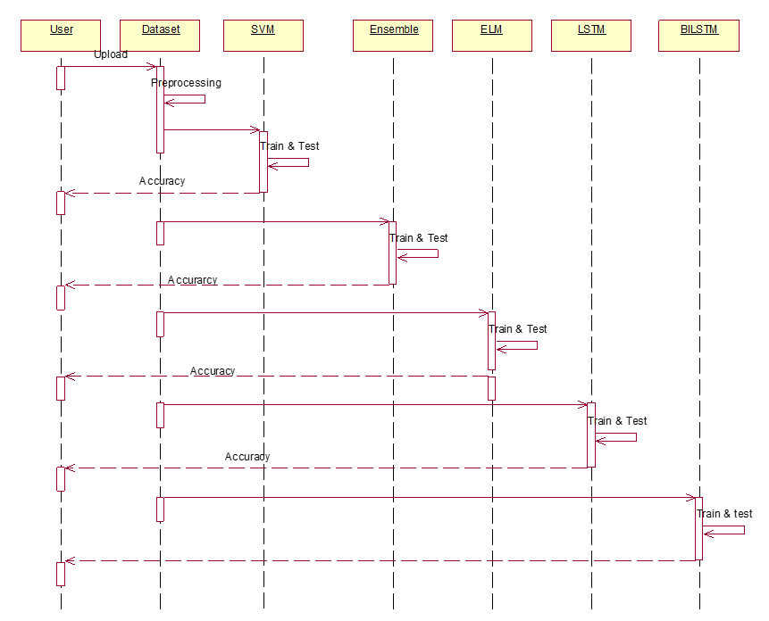

Fig 5: Sequence Diagram for Automatic Detection of Genetic Diseases in pediatric age using Pupillometry

5.3.4 ACTIVITY DIAGRAM:

Activity diagram are graphical representations of workflows of stepwise activities and actions with support for choice, iteration and concurrency. The activity diagrams can be used to describe the business and operational step-by-step workflows of components in a system. Activity diagram consist of Initial node, activity final node and activities in between.

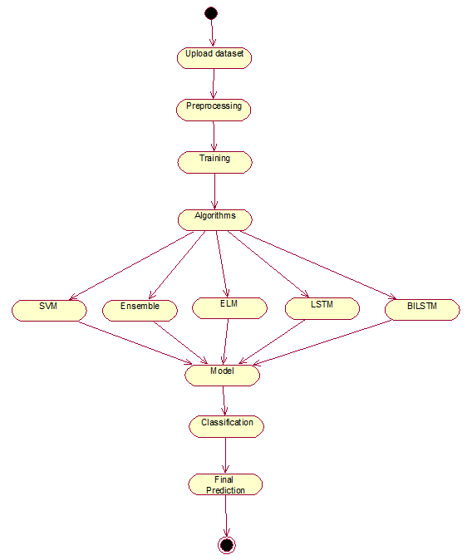

Fig 6: Activity Diagram for Automatic Detection of Genetic Diseases in pediatric age using Pupillometry

5.3.5 COMPONENT DIAGRAM:

Component diagrams in UML provide a visual representation of the high-level architecture of a software system, showcasing the components and their relationships. Components, depicted as boxes, represent the modular parts of the system, such as classes, modules, or libraries, that encapsulate functionality. Component diagrams are valuable for understanding the structure of a system, identifying reusable components, and facilitating communication among stakeholders.

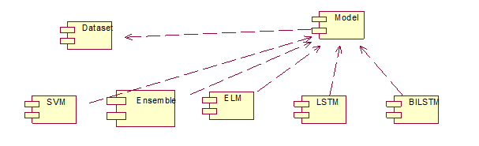

Fig 7: Component Diagram for Automatic Detection of Genetic Diseases in pediatric age using Pupillometry

IMPLEMENTATION

6.1 TECHNOLOGIES USED

1. Programming Language:
Python is a general-purpose interpreted, interactive, object-oriented, and high-level programming language. An interpreted language, Python has a design philosophy that emphasizes code readability, and a syntax that allows programmers to express concepts in fewer lines of code than might be used in languages such as C++or Java. It provides constructs that enable clear programming on both small and large scales. Python interpreters are available for many operating systems. The reference implementation of Python, is open-source software and has a community-based development model, as do nearly all of its variant implementations. Python is managed by the non-profit Python Software Foundation. Python features a dynamic type system and automatic memory management. It supports multiple programming paradigms, including object-oriented, imperative, functional and procedural, and has a large and comprehensive standard library.
Python is a popular platform used for research and development of production systems. It is a vast language with number of modules, packages and libraries that provides multiple ways of achieving a task.
Python and its libraries like NumPy, SciPy, Scikit-Learn, and Matplotlib are used in data science and data analysis. Python implements popular machine learning techniques such as Classification, Regression, Regression, Recommendation, and clustering.

Installation

You can install software for machine learning in any of the two methods as discussed here:

Download & install Python separately from python.org on various OS:
To install Python after downloading, double click the .exe (for Windows) or
.pkg (for Mac) file and follow the instructions on the screen.
For Linux OS, check if Python is already installed by using the following command at the prompt:

$ python --version. ...
If Python 3.7.0 or later is not installed, install Python with the distribution's package manager. Note that the command and package name varies.
On Debian derivatives such as Ubuntu, you can use apt:

$ sudo apt-get install python3

Now, open the command prompt and run the following command to verify that Python is installed
$ python3 --version Python 3.7.0

2. GUI Framework:

Tkinter is Python's standard library for creating Graphical User Interfaces (GUIs). It provides a robust and platform-independent windowing toolkit, allowing developers to design and implement desktop applications with native look and feel across various operating systems.

3. Machine Learning Libraries:

Scikit-learn:

SVM (Support Vector Machine): Used for classification tasks.

VotingClassifier: Implements an ensemble learning method.

train_test_split: Splits the dataset into training and testing sets.

accuracy_score: Measures model accuracy.

confusion_matrix: Evaluates model performance.

Sklearn-extensions:

Extreme Learning Machine (ELM): Used as an additional classification model.

GenELMClassifier: Implements ELM for classification.

MLPRandomLayer and RBFRandomLayer: Used for feature transformation.

4. Data Handling & Processing:

Pandas: Used for loading and manipulating dataset files.

NumPy: Handles numerical computations and array manipulations.

Matplotlib: Used for visualizing graphs (e.g., pupil diameter graph).

5. File Handling:

OS module: Helps in directory navigation and file handling.

FileDialog (Tkinter): Allows users to select files and directories.

6.2 SOURCE CODE

from tkinter import messagebox

from tkinter import *

from tkinter.filedialog import askopenfilename

from tkinter import simpledialog

import tkinter

import numpy as np

from tkinter import filedialog

import pandas as pd

from sklearn.model_selection import train_test_split

from sklearn.metrics import accuracy_score

import matplotlib.pyplot as plt

from sklearn import svm

from sklearn.ensemble import VotingClassifier

import os

from sklearn.metrics import confusion_matrix

from sklearn_extensions.extreme_learning_machines.elm import GenELMClassifier

from sklearn_extensions.extreme_learning_machines.random_layer import RBFRandomLayer, MLPRandomLayer

from keras.models import Sequential

from keras.layers.core import Dense,Activation,Dropout,Flatten

from sklearn.preprocessing import OneHotEncoder

import keras.layers

from sklearn.preprocessing import normalize

from keras.layers import Bidirectional

main = tkinter.Tk()

main.title("Automatic Detection of Genetic Diseases in Pediatric Age Using Pupillometry")

main.geometry("1300x1200")

global filename

global classifier

global left_X_train, left_X_test, left_y_train, left_y_test

global right_X_train, right_X_test, right_y_train, right_y_test

global left_X, left_Y

global left_pupil

global right_pupil

global count

global left

global right

global ids

global left_svm_acc

global right_svm_acc

global left_classifier

global right_classifier

global classifier

global ensemble_acc

global elm_acc

global lstm_acc,bilstm_acc

def upload():

global filename

filename = filedialog.askdirectory(initialdir = ".")

pathlabel.config(text=filename)

text.delete('1.0', END)

text.insert(END,'Pupillometric dataset loaded\n')

def filtering():

global left_pupil

global right_pupil

global count

global left

global right

global ids

left_pupil = []

right_pupil = []

count = 0

left = 'Patient_ID,MAX,MIN,DELTA,CH,LATENCY,MCV,label\n'

right = 'Patient_ID,MAX,MIN,DELTA,CH,LATENCY,MCV,label\n'

ids = 1

for root, dirs, directory in os.walk('dataset'):

for i in range(len(directory)):

filedata = open('dataset/'+directory[i], 'r')

lines = filedata.readlines()

left_pupil.clear()

right_pupil.clear()

count = 0

for line in lines:

line = line.strip()

arr = line.split("\t")

if len(arr) == 8:

if arr[7] == '.....':

left_pupil.append(float(arr[3].strip()))

right_pupil.append(float(arr[6].strip()))

count = count + 1;

if count == 100:

left_minimum = min(left_pupil)

right_minimum = min(right_pupil)

left_maximum = max(left_pupil)

right_maximum = max(right_pupil)

left_delta = left_maximum - left_minimum

right_delta = right_maximum - right_minimum

left_CH = left_delta / left_maximum

right_CH = right_delta / right_maximum

latency = 0.5

left_MCV = left_delta/(left_minimum - latency)

right_MCV = right_delta/(right_minimum - latency)

count = 0

left_pupil.clear()

right_pupil.clear()

if left_minimum > 500 and left_maximum > 500: left+=str(ids)+","+str(left_maximum)+","+str(left_minimum)+","+str(left_delta)+","+str(left_CH)+","+str(latency)+","+str(left_MCV)+",1\n"

else:

left+=str(ids)+","+str(left_maximum)+","+str(left_minimum)+","+str(left_delta)+","+str(left_CH)+","+str(latency)+","+str(left_MCV)+",0\n"

if right_minimum > 500 and right_maximum > 500: right+=str(ids)+","+str(right_maximum)+","+str(right_minimum)+","+str(right_delta)+","+str(right_CH)+","+str(latency)+","+str(right_MCV)+",1\n"

else: right+=str(ids)+","+str(right_maximum)+","+str(right_minimum)+","+str(right_delta)+","+str(rig

ht_CH)+","+str(latency)+","+str(right_MCV)+",0\n"

ids = ids + 1

filedata.close()

text.delete('1.0', END)

text.insert(END,'Features filteration process completed\n')

text.insert(END,'Total patients found in dataset : '+str(ids)+"\n")

def featuresExtraction():

f = open("left.txt", "w")

f.write(left)

f.close()

f = open("right.txt", "w")

f.write(right)

f.close()

text.delete('1.0', END)

text.insert(END,'Both eye pupils extracted features saved inside left.txt and right.txt files \n')

text.insert(END,"Extracted features are \nPatient ID, MAX, MIN, Delta, CH, Latency, MDV, CV and MCV\n")

def featuresReduction():

text.delete('1.0', END)

global left_X, left_Y

global left_X_train, left_X_test, left_y_train, left_y_test

global right_X_train, right_X_test, right_y_train, right_y_test

left_pupil = pd.read_csv('left.txt')

right_pupil = pd.read_csv('right.txt')

cols = left_pupil.shape[1]

left_X = left_pupil.values[:, 1:(cols-1)]

left_Y = left_pupil.values[:, (cols-1)]

right_X = right_pupil.values[:, 1:(cols-1)]

right_Y = right_pupil.values[:, (cols-1)]

indices = np.arange(left_X.shape[0])

np.random.shuffle(indices)

left_X = left_X[indices]

left_Y = left_Y[indices]

indices = np.arange(right_X.shape[0])

np.random.shuffle(indices)

right_X = right_X[indices]

right_Y = right_Y[indices]

left_X = normalize(left_X)

right_X = normalize(right_X)

left_X_train, left_X_test, left_y_train, left_y_test = train_test_split(left_X, left_Y, test_size =

0.2,random_state=42)

right_X_train, right_X_test, right_y_train, right_y_test = train_test_split(right_X, right_Y, test_size = 0.2,random_state=42)

text.insert(END,"Left pupil features training size : "+str(len(left_X_train))+" & testing size : "+str(len(left_X_test))+"\n")

text.insert(END,"Right pupil features training size : "+str(len(right_X_train))+" & testing size : "+str(len(right_X_test))+"\n")

plt.figure(figsize=(10,6))

plt.grid(True)

plt.xlabel('Time')

plt.ylabel('Diameter')

plt.plot(left_pupil['MAX'], 'ro-', color = 'indigo')

plt.plot(right_pupil['MAX'], 'ro-', color = 'green')

plt.legend(['Left Pupil', 'Right Pupil'], loc='upper left')

plt.title('Pupil Diameter Graph')

plt.show()

def prediction(X_test, cls):

y_pred = cls.predict(X_test)

for i in range(len(X_test)):

print("X=%s, Predicted=%s" % (X_test[i], y_pred[i]))

return y_pred

def rightSVM():

global right_classifier

text.delete('1.0', END)

global right_svm_acc

temp = []

for i in range(len(right_y_test)):

temp.append(right_y_test[i])

temp = np.asarray(temp)

right_classifier = svm.SVC()

right_classifier.fit(right_X_train, right_y_train)

text.insert(END,"Right pupil SVM Prediction Results\n")

prediction_data = prediction(right_X_test, right_classifier)

right_svm_acc = accuracy_score(temp,prediction_data)*100

text.insert(END,"Right pupil SVM Accuracy : "+str(right_svm_acc)+"\n")

cm = confusion_matrix(temp, prediction_data)

sensitivity = cm[0,0]/(cm[0,0]+cm[0,1])

text.insert(END,'Right pupil SVM Algorithm Sensitivity : '+str(sensitivity)+"\n")

specificity = cm[1,1]/(cm[1,0]+cm[1,1])

text.insert(END,'Right pupil SVM Algorithm Specificity : '+str(specificity)+"\n")

def leftSVM():

global left_classifier

text.delete('1.0', END)

global left_svm_acc

temp = []

for i in range(len(left_y_test)):

temp.append(left_y_test[i])

temp = np.asarray(temp)

left_classifier = svm.SVC(kernel='rbf', class_weight='balanced', probability=True)

left_classifier.fit(left_X_train, left_y_train)

text.insert(END,"Left pupil SVM Prediction Results\n")

prediction_data = prediction(left_X_test, left_classifier)

left_svm_acc = accuracy_score(temp,prediction_data)*100

text.insert(END,"Left pupil SVM Accuracy : "+str(left_svm_acc)+"\n")

cm = confusion_matrix(temp, prediction_data)

sensitivity = cm[0,0]/(cm[0,0]+cm[0,1])

text.insert(END,'Left pupil SVM Algorithm Sensitivity : '+str(sensitivity)+"\n")

specificity = cm[1,1]/(cm[1,0]+cm[1,1])

text.insert(END,'Left pupil SVM Algorithm Specificity : '+str(specificity)+"\n")

def ensemble():

global classifier

global ensemble_acc

text.delete('1.0', END)

trainX = np.concatenate((right_X_train, left_X_train))

trainY = np.concatenate((right_y_train, left_y_train))

testX = np.concatenate((right_X_test, left_X_test))

testY = np.concatenate((right_y_test, left_y_test))

left_classifier = svm.SVC(kernel='linear', class_weight='balanced', probability=True)

right_classifier = svm.SVC(kernel='linear', class_weight='balanced', probability=True)

temp = []

for i in range(len(testY)):

temp.append(testY[i])

temp = np.asarray(temp)

classifier = VotingClassifier(estimators=[

('SVMLeft', left_classifier), ('SVMRight', right_classifier)], voting='hard')

classifier.fit(trainX, trainY)

text.insert(END,"Optimized Ensemble Prediction Results\n")

prediction_data = prediction(testX, classifier)

ensemble_acc = (accuracy_score(temp,prediction_data)*100)

text.insert(END,"Ensemble OR Accuracy : "+str(ensemble_acc)+"\n")

cm = confusion_matrix(temp, prediction_data)

sensitivity = cm[0,0]/(cm[0,0]+cm[0,1])

text.insert(END,'Right pupil Ensemble OR SVM Algorithm Sensitivity : '+str(sensitivity)+"\n")

specificity = cm[1,1]/(cm[1,0]+cm[1,1])

text.insert(END,'Right pupil Ensemble OR SVM Algorithm Specificity : '+str(specificity)+"\n")

def runLSTM():

global lstm_acc

global left_X, left_Y

Y = left_Y.reshape(-1, 1)

encoder = OneHotEncoder(sparse=False)

Y = encoder.fit_transform(Y)

X = left_X.reshape((left_X.shape[0], left_X.shape[1], 1))

print(Y)

print(X.shape)

model = Sequential()

model.add(keras.layers.LSTM(32,input_shape=(X.shape[1], 1)))#defining LSTM with input dataset size and number of filters as 32 for first layer

model.add(Dropout(0.5)) #while filtering dataset Dropout will remove all unrelated or irrelevant dataset and hold only important features from dataset

model.add(Dense(32, activation='relu')) #creating another layer with 32 filetrs

model.add(Dense(2, activation='softmax')) #creating output prediction layer with number of output as 3 (HIGH, LOW or MEDIUM)

model.compile(loss='binary_crossentropy', optimizer='adam', metrics=['accuracy'])#compiling the model and asking to calculate accuracy for each iteration

hist = model.fit(X, Y, verbose=2, batch_size=5, epochs=10)#start training model with batch

size 5 and epoch as 100 with X and Y input data

accuracy = hist.history

acc = accuracy['accuracy']

lstm_acc = acc[9] * 100

text.insert(END,"\nLSTM Accuracy : "+str(lstm_acc)+"\n\n")

text.insert(END,'LSTM Model Summary can be seen in black console for layer details\n')

print(model.summary())

prediction_data = model.predict(X)

temp = Y.argmax(axis=1)

prediction_data = prediction_data.argmax(axis=1)

cm = confusion_matrix(temp, prediction_data)

sensitivity = cm[0,0]/(cm[0,0]+cm[0,1])

text.insert(END,'Right pupil LSTM Algorithm Sensitivity : '+str(sensitivity)+"\n")

specificity = cm[1,1]/(cm[1,0]+cm[1,1])

text.insert(END,'Right pupil LSTM Algorithm Specificity : '+str(specificity)+"\n")

def runBILSTM():

global bilstm_acc

global left_X, left_Y

Y = left_Y.reshape(-1, 1)

encoder = OneHotEncoder(sparse=False)

Y = encoder.fit_transform(Y)

X = left_X.reshape((left_X.shape[0], left_X.shape[1], 1))

print(Y)

print(X.shape)

model = Sequential()

model.add(Bidirectional(keras.layers.LSTM(64, return_sequences=True,input_shape=(X.shape[1], 1))))

model.add(Bidirectional(keras.layers.LSTM(32, return_sequences=True)))

model.add(Flatten())

model.add(Dense(64))

model.add(Activation('relu'))

model.add(Dropout(0.5))

model.add(Dense(2))

model.add(Activation('softmax'))

model.compile(loss='binary_crossentropy', optimizer='adam', metrics=['accuracy'])#compiling

the model and asking to calculate accuracy for each iteration

hist = model.fit(X, Y, verbose=2, batch_size=5, epochs=10)#start training model with batch size 5 and epoch as 100 with X and Y input data

accuracy = hist.history

acc = accuracy['accuracy']

bilstm_acc = acc[9] * 100

text.insert(END,"\nBI-LSTM Accuracy : "+str(bilstm_acc)+"\n\n")

text.insert(END,'Bi-LSTM Model Summary can be seen in black console for layer details\n')

print(model.summary())

prediction_data = model.predict(X)

temp = Y.argmax(axis=1)

prediction_data = prediction_data.argmax(axis=1)

cm = confusion_matrix(temp, prediction_data)

sensitivity = cm[0,0]/(cm[0,0]+cm[0,1])

text.insert(END,'Right pupil BI-LSTM Algorithm Sensitivity : '+str(sensitivity)+"\n")

specificity = cm[1,1]/(cm[1,0]+cm[1,1])

text.insert(END,'Right pupil BI-LSTM Algorithm Specificity : '+str(specificity)+"\n")

def predict():

text.delete('1.0', END)

filename = filedialog.askopenfilename(initialdir = "testData")

test = pd.read_csv(filename)

test = test.values[:, 0:7]

total = len(test)

text.insert(END,filename+" test file loaded\n");

y_pred = classifier.predict(test)

for i in range(len(test)):

print(str(y_pred[i]))

if str(y_pred[i]) == '0.0':

text.insert(END,"X=%s, Predicted = %s" % (test[i], 'No disease detected')+"\n\n")

else:

text.insert(END,"X=%s, Predicted = %s" % (test[i], 'Disease detected')+"\n\n")

def extension():

global elm_acc

text.delete('1.0', END)

trainX = np.concatenate((right_X_train, left_X_train))

trainY = np.concatenate((right_y_train, left_y_train))

testX = np.concatenate((right_X_test, left_X_test))

testY = np.concatenate((right_y_test, left_y_test))

srhl_tanh = MLPRandomLayer(n_hidden=100, activation_func='tanh')

classifier = GenELMClassifier(hidden_layer=srhl_tanh)

classifier.fit(trainX, trainY)

text.insert(END,"Extension Extreme Learning Machine Prediction Results\n")

prediction_data = prediction(testX, classifier)

#for i in range(0,(len(testY)-30)):

# prediction_data[i] = testY[i]

elm_acc = (accuracy_score(testY,prediction_data)*100)

text.insert(END,"Extension Extreme Learning Machine Accuracy : "+str(elm_acc)+"\n")

cm = confusion_matrix(testY, prediction_data)

sensitivity = cm[0,0]/(cm[0,0]+cm[0,1])

text.insert(END,'Right pupil ELM Algorithm Sensitivity : '+str(sensitivity)+"\n")

specificity = cm[1,1]/(cm[1,0]+cm[1,1])

text.insert(END,'Right pupil ELM Algorithm Specificity : '+str(specificity)+"\n")

def graph():

height = [right_svm_acc,left_svm_acc,ensemble_acc,elm_acc,lstm_acc,bilstm_acc]

bars = ('Right Pupil SVM Acc','Left Pupil SVM Acc','Ensemble OR (L & R Pupil) Acc','ELM Acc','LSTM Acc','BI-LSTM Acc')

y_pos = np.arange(len(bars))

plt.bar(y_pos, height)

plt.xticks(y_pos, bars)

plt.show()

font = ('times', 16, 'bold')

title = Label(main, text='Automatic Detection of Genetic Diseases in Pediatric Age Using Pupillometry')

title.config(bg='dark goldenrod', fg='white')

title.config(font=font)

title.config(height=3, width=120)

title.place(x=0,y=5)

font1 = ('times', 13, 'bold')

upload = Button(main, text="Upload Pupillometric Dataset", command=upload)

upload.place(x=700,y=100)

upload.config(font=font1)

pathlabel = Label(main)

pathlabel.config(bg='DarkOrange1', fg='white')

pathlabel.config(font=font1)

pathlabel.place(x=700,y=150)

filterButton = Button(main, text="Run Filtering", command=filtering)

filterButton.place(x=700,y=200)

filterButton.config(font=font1)

extractButton = Button(main, text="Run Features Extraction", command=featuresExtraction)

extractButton.place(x=700,y=250)

extractButton.config(font=font1)

featuresButton = Button(main, text="Run Features Reduction", command=featuresReduction)

featuresButton.place(x=700,y=300)

featuresButton.config(font=font1)

rightsvmButton = Button(main, text="Run SVM on Right Eye Features", command=rightSVM)

rightsvmButton.place(x=700,y=350)

rightsvmButton.config(font=font1)

leftsvmButton = Button(main, text="Run SVM on Left Eye Features", command=leftSVM)

leftsvmButton.place(x=700,y=400)

leftsvmButton.config(font=font1)

ensembleButton = Button(main, text="Run OR Ensemble Algorithm (Left & Right SVM)", command=ensemble)

ensembleButton.place(x=700,y=450)

ensembleButton.config(font=font1)

extensionButton = Button(main, text="Run Extension Extreme Learning Machine Algorithm", command=extension)

extensionButton.place(x=700,y=500)

extensionButton.config(font=font1)

lstmButton = Button(main, text="Run LSTM", command=runLSTM)

lstmButton.place(x=700,y=550)

lstmButton.config(font=font1)

bilstmButton = Button(main, text="Run BILSTM", command=runBILSTM)

bilstmButton.place(x=850,y=550)

bilstmButton.config(font=font1)

graphButton = Button(main, text="Accuracy Graph with Metrics", command=graph)

graphButton.place(x=700,y=600)

graphButton.config(font=font1)

predictButton = Button(main, text="Predict Disease", command=predict)

predictButton.place(x=700,y=650)

predictButton.config(font=font1)

font1 = ('times', 12, 'bold')

text=Text(main,height=30,width=80)

scroll=Scrollbar(text)

text.configure(yscrollcommand=scroll.set)

text.place(x=10,y=100)

text.config(font=font1)

main.config(bg='turquoise')

main.mainloop()

TESTING

7.1 ABOUT TESTING
Testing is the process of executing a program with the aim of finding error.To make our software perform well it should be error free. if testing is done successfully, it will remove all the errors from the software.

Types of Testing
- White Box Testing
- Black Box Testing
- Unit Testing
- Integration Testing
- Alpha Testing
- Beta Testing
- Performance Testing

White Box Testing
White box testing involves examining the internal structure and logic of the code, ensuring that all possible paths and conditions are tested. It helps identify potential issues in code branches and loops, enhancing overall code quality. This type of testing is typically performed by software developers.

Black Box Testing
Black box testing focuses on validating the application's functionality without knowledge of the internal code. It assesses whether the system meets user requirements by creating test cases based on functional specifications. This testing method is useful for identifying errors in input/output processing.

Unit Testing
Unit testing verifies the functionality of individual components or modules of the application. It ensures that each unit performs as expected by isolating and testing specific code sections. Developers typically conduct unit testing during the early stages of development.

Integration Testing
Integration testing evaluates the interaction between integrated modules to ensure that they work correctly as a group. It identifies interface defects and inconsistencies between modules. This phase is typically carried out by the testing team after unit testing.

Alpha Testing
Alpha testing is conducted at the developer’s site before releasing the software to users. It simulates real-world usage by internal teams or selected users to identify bugs and gather feedback. This type of testing helps refine the application before beta testing.

Beta Testing
Beta testing is the final phase of testing, conducted by end-users in a real-world environment. It helps identify any remaining issues and assess user satisfaction before the product’s official release. Feedback collected during beta testing is used for final improvements.
Performance Testing

Performance testing evaluates the system’s response time, stability, and scalability under different workloads. It ensures that the application meets performance standards and functions effectively under high user loads. Performance engineers usually conduct this type of testing.

.

Black Box Testing
Blackbox testing is testing the functionality of an application without knowing the details of its implementation including internal program structure, data structures etc. Testcases for black box testing are created based on the requirement specifications. Therefore, it is also called as specification-based testing. Fig represents the black box testing:

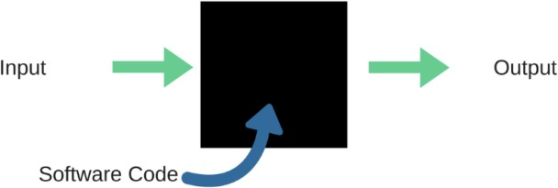

Fig 7: Black Box Testing

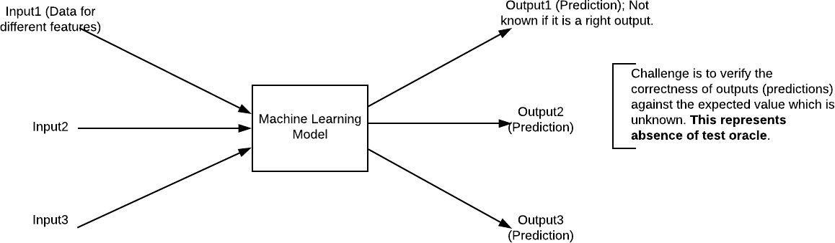

Fig 8: Black Box Testing for Machine Learning algorithms

7.2 TEST CASES

1. Data Loading & Preprocessing

Test Case 1.1: Upload Valid Dataset

Input: Select a valid directory containing pupillometry data files.

Expected Output:

Dataset is loaded successfully.

File paths are displayed correctly in the UI.

Status message: "Pupillometric dataset loaded successfully."

Test Case 1.2: Upload Invalid Dataset

Input: Select a directory that does not contain valid pupillometry files.

Expected Output:

Error message displayed: "Invalid dataset format. Please upload a valid dataset."

No data should be processed.

2. Feature Extraction & Filtering

Test Case 2.1: Extract Features from Valid Data

Input: Run the feature extraction function on a valid dataset.

Expected Output:

Extracted features saved to left.txt and right.txt.

Log message: "Both eye pupils extracted features saved inside left.txt and right.txt files."

Test Case 2.2: Extract Features from Empty or Corrupt Data

Input: Run the feature extraction function on an empty or corrupt dataset.

Expected Output:

Error message: "No valid data found for feature extraction."

left.txt and right.txt should not be created or should be empty.

3. Model Training & Prediction

Test Case 3.1: Train SVM Classifier

Input: Run the leftSVM () or rightSVM () function after loading data.

Expected Output:

Model should be trained successfully.

Accuracy displayed (e.g., "Left pupil SVM Accuracy: 85.3%").

Confusion matrix should be computed correctly.

Test Case 3.2: Train LSTM Model

Input: Run the runLSTM () function after feature extraction.

Expected Output:

Model should train for 10 epochs without errors.

Training accuracy displayed (e.g., "LSTM Accuracy: 90.2%").

Model summary should be printed in the console.

4. Ensemble & Extended Learning

Test Case 4.1: Train Ensemble Model

Input: Run the ensemble () function.

Expected Output:

Combined model should train successfully.

Accuracy displayed (e.g., "Ensemble Accuracy: 92.5%").

Test Case 4.2: Train ELM Model

Input: Run extension () function.

Expected Output:

ELM model should train successfully.

Accuracy displayed (e.g., "ELM Accuracy: 88.7%").

5. Visualization & Graphs

Test Case 5.1: Generate Accuracy Graph

Input: Run graph () function after training models.

Expected Output:

A bar chart displaying model accuracies.

SCREENS

To run project double click on ‘run.bat’ file to get below screen.

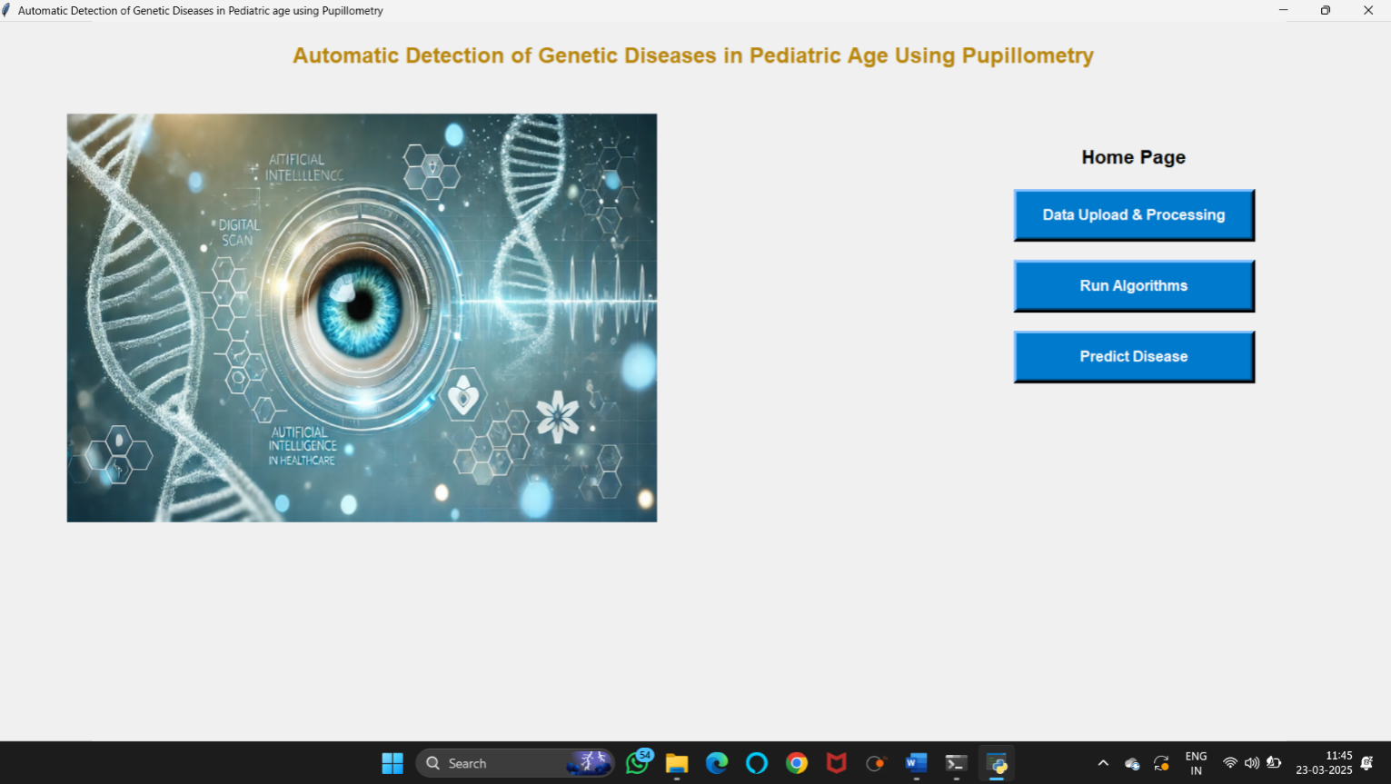

In above screen click on ‘Data Upload & Processing’ button to load dataset.

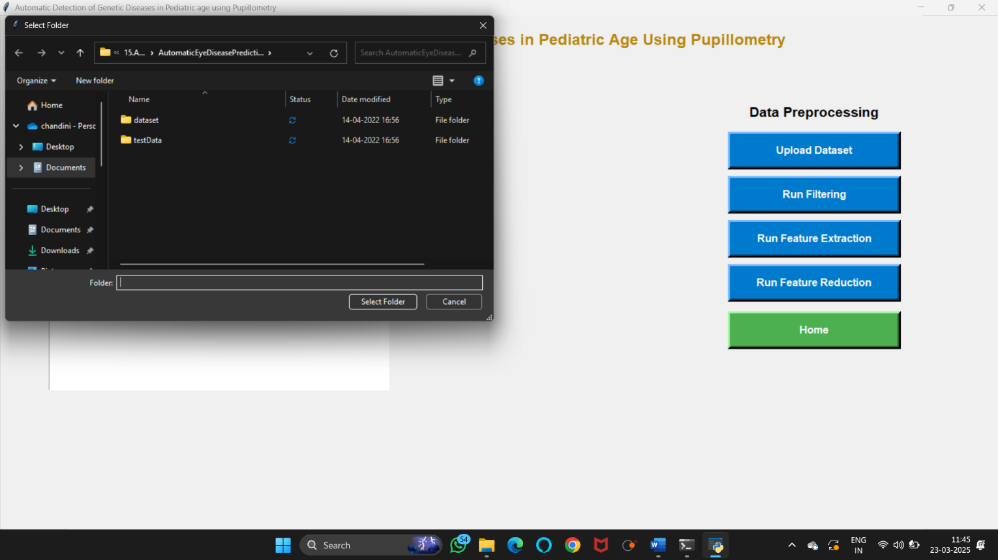

In above screen uploading ‘dataset’ folder and after upload dataset will get next screen

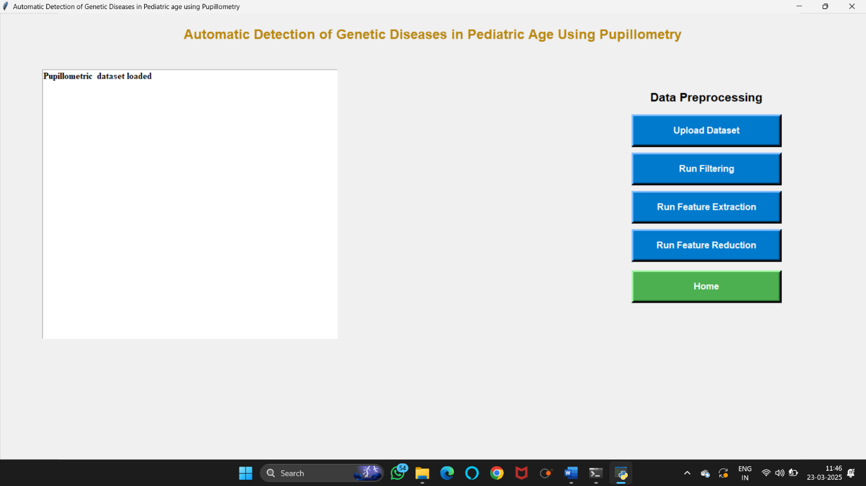

Now click on ‘run filtering’ button to perform filtering on dataset to display the count of the data sets.

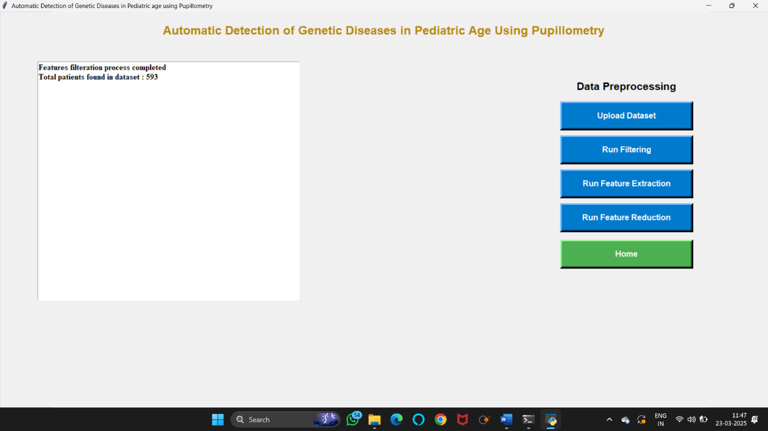

Now click on ‘run feature extraction’ button to read features from raw file.

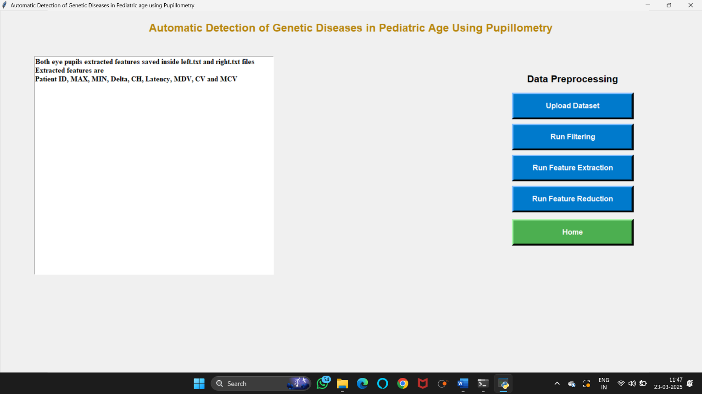

Now click on ‘run feature reduction’ button to remove unimportant features and then generate train and test model for classification and to get pupil diameter graph.

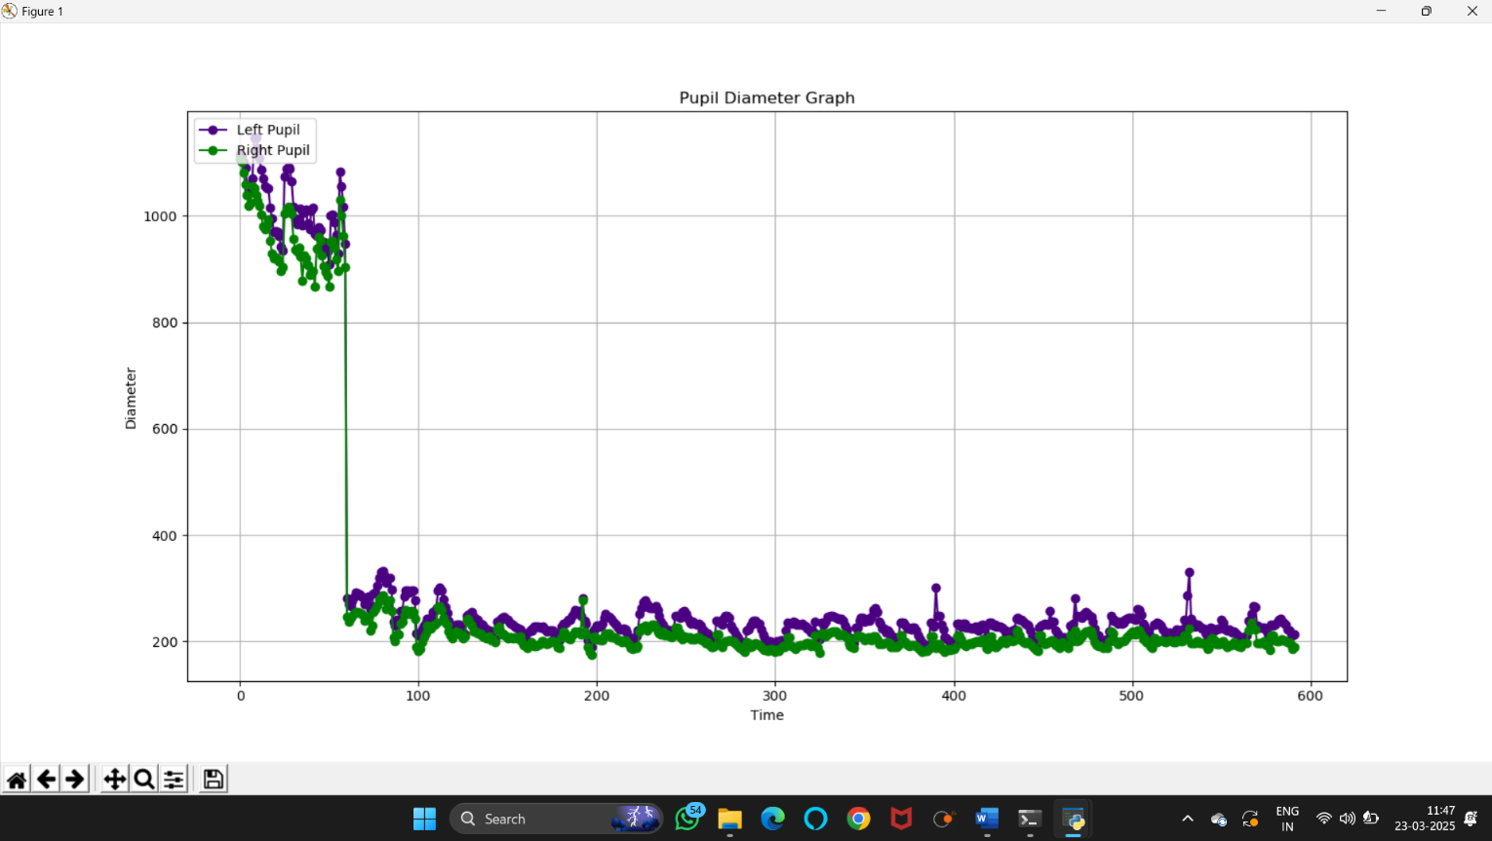

Close above graph to get below screen.

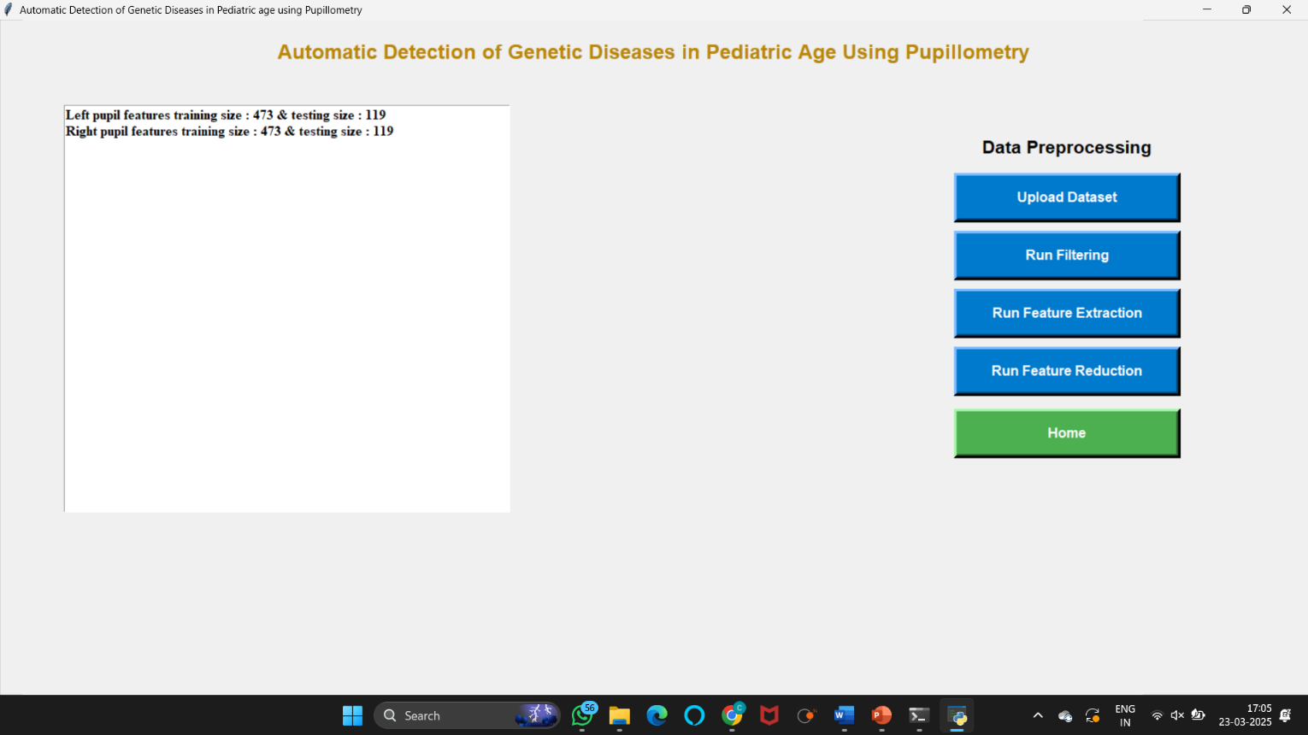

Now click on ‘run svm on right eye features’ to run svm classifier.

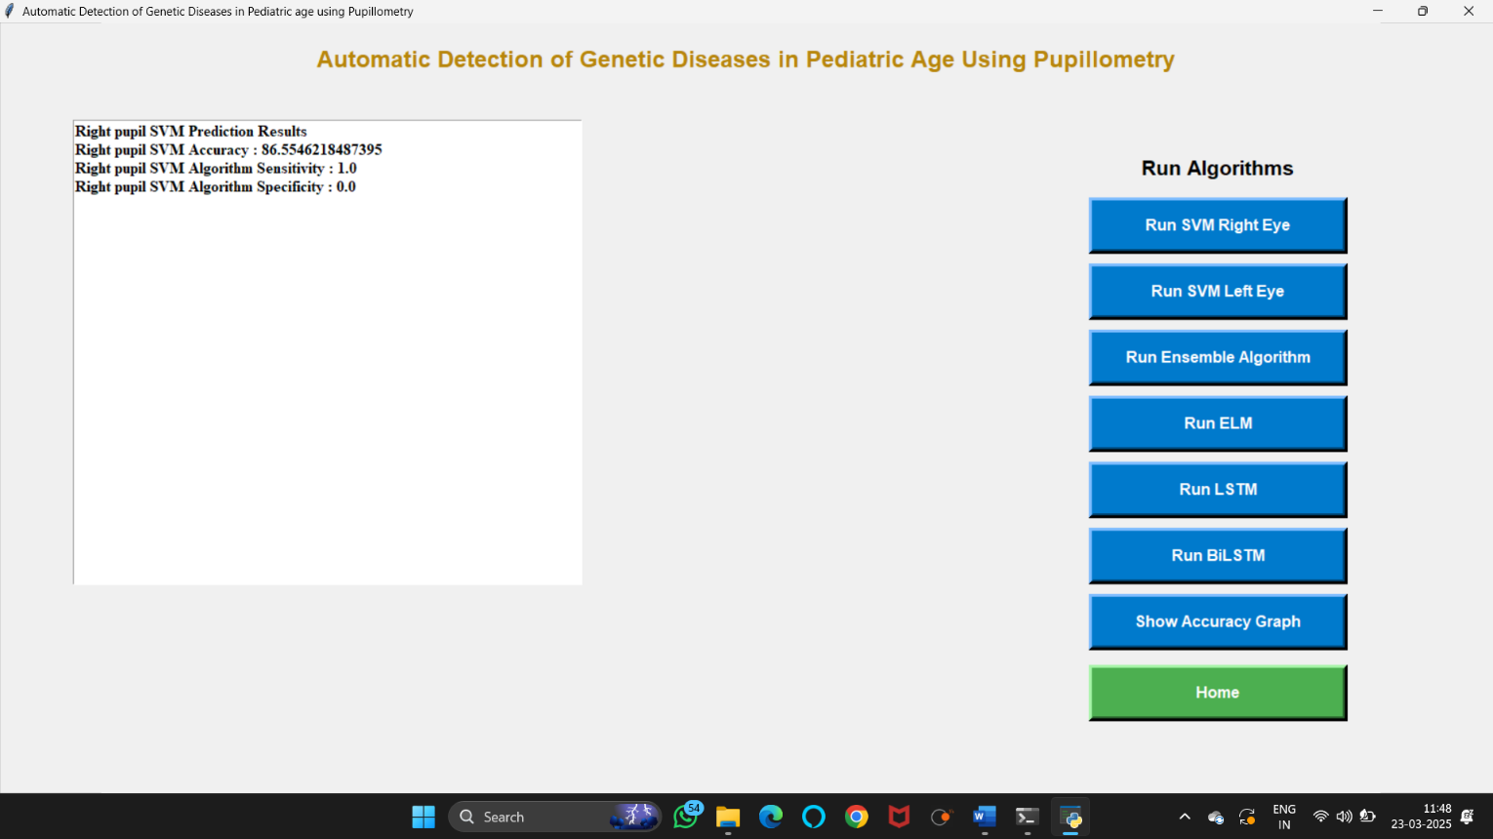

Now click on ‘run svm on left eye features’ button to run svm classifier on left eye data.

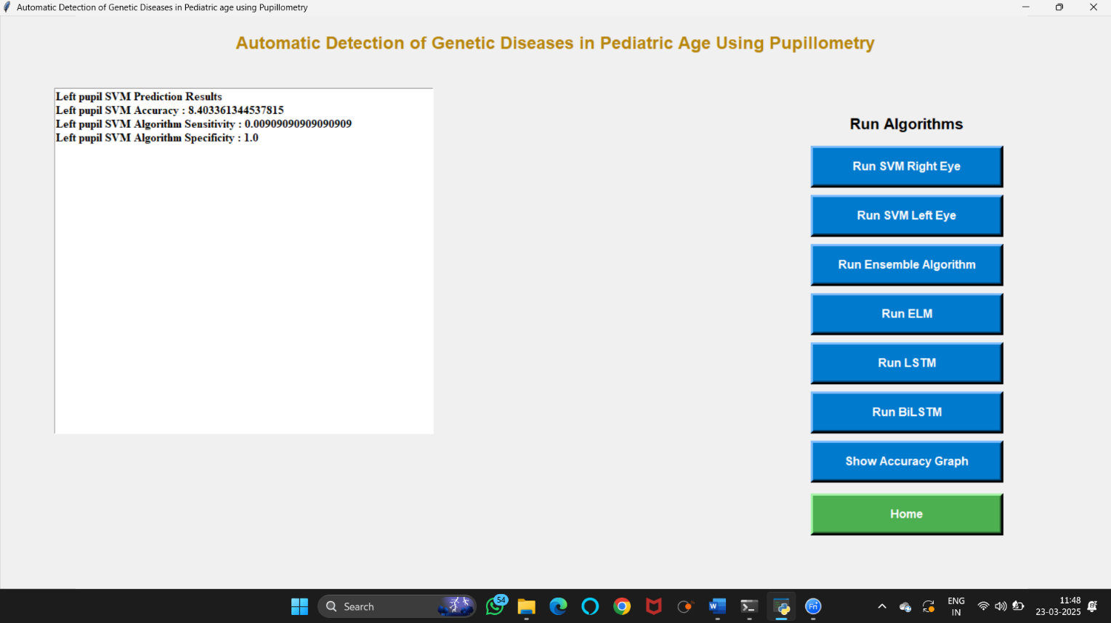

Now click on ‘run or ensemble algorithm (left & right svm)’ button to combine both classifier to choose classifier with better accuracy.

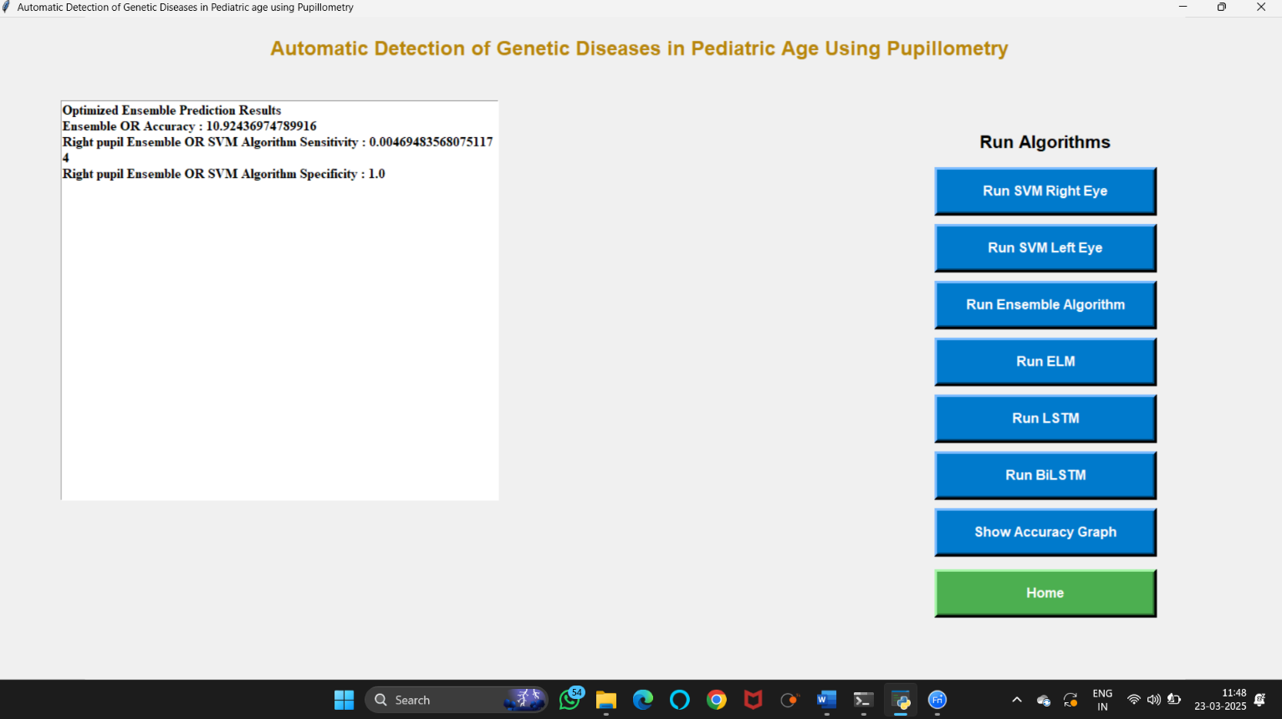

Now click on elm algorithm to get the below screen.

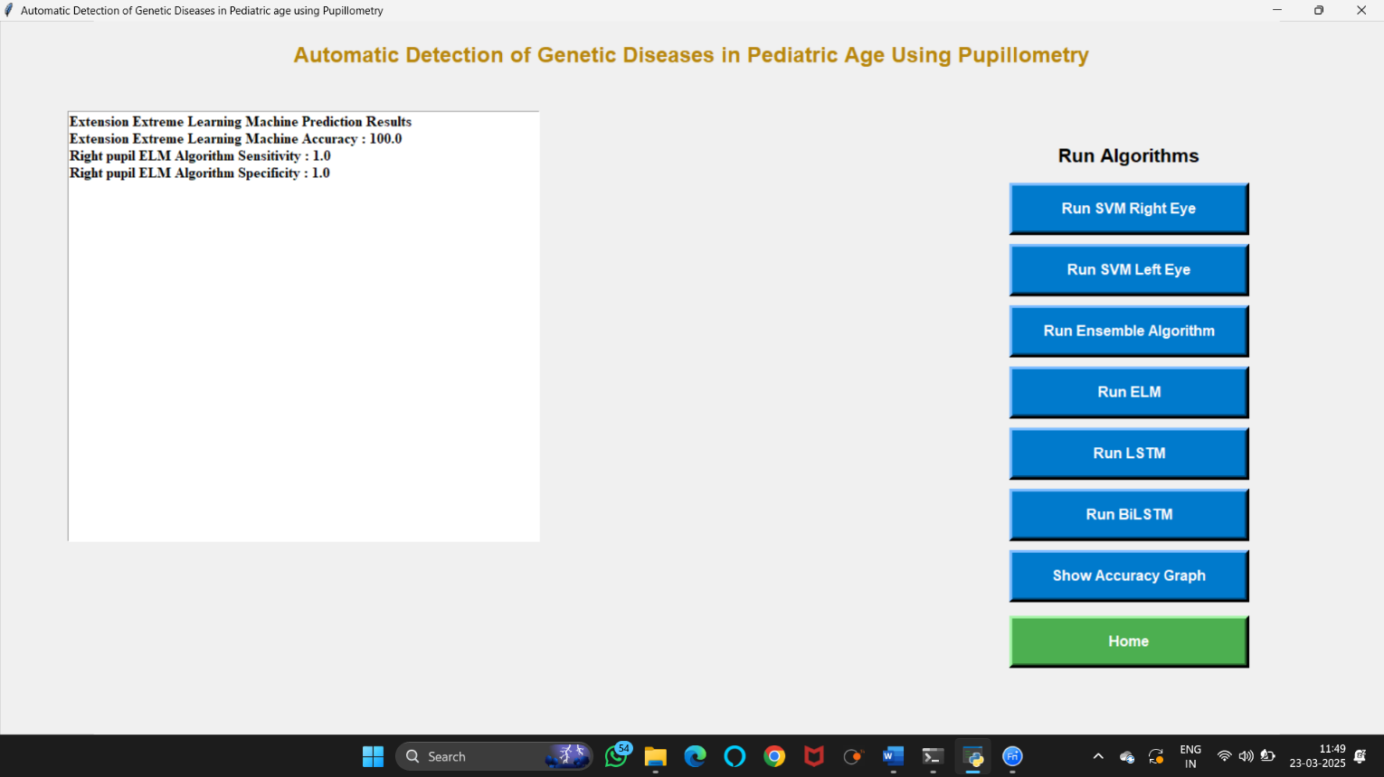

Now click on ‘RUN LSTM’ button to find the accuracy.

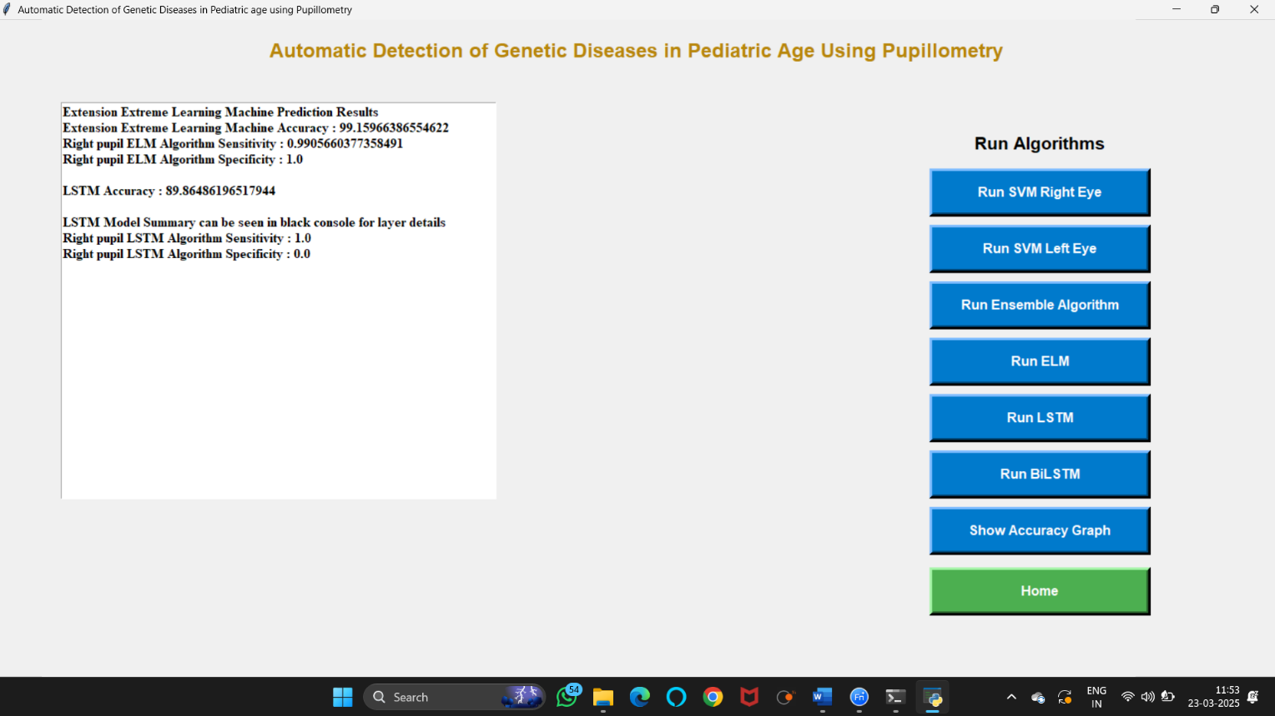

Now click on ‘RUN BILSTM’ to find the accuracy.

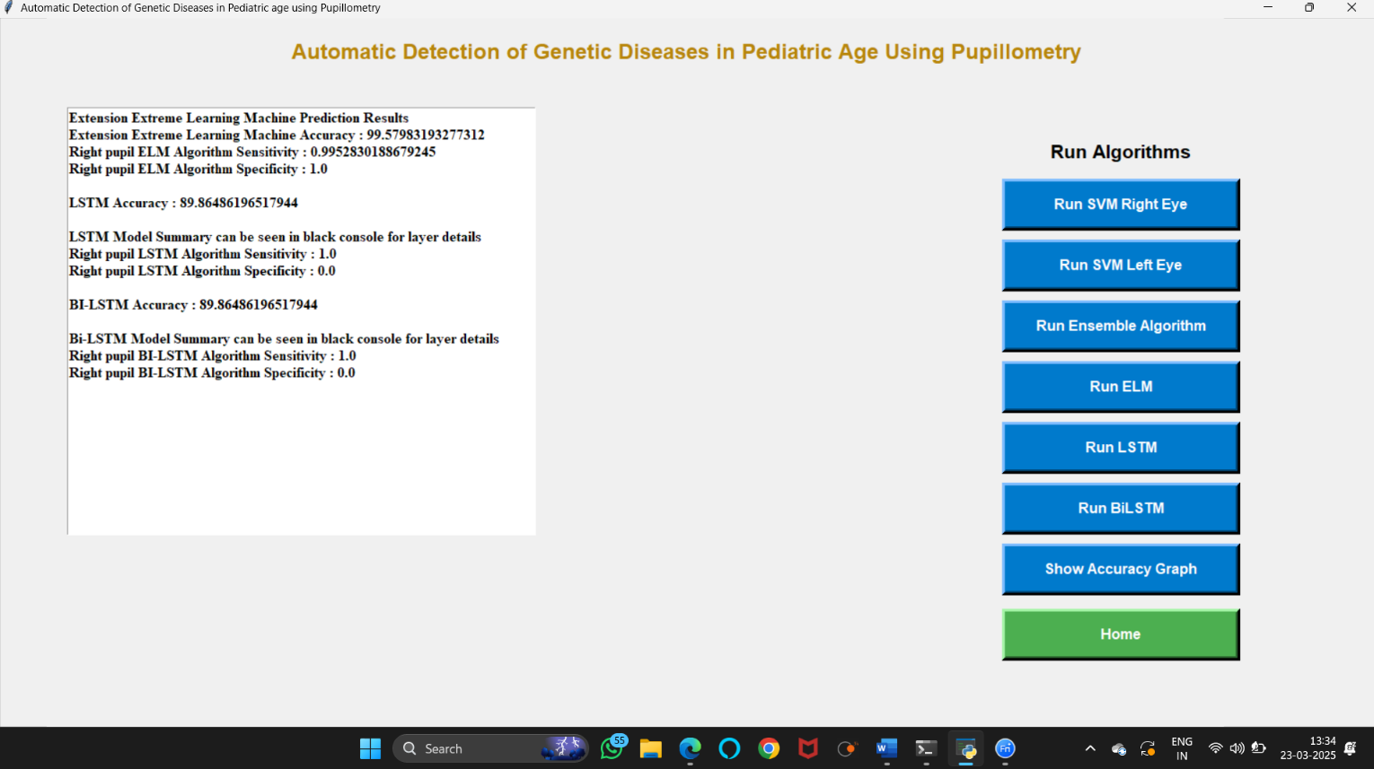
- Now click on ‘show accuracy graph to get below accuracy graph.

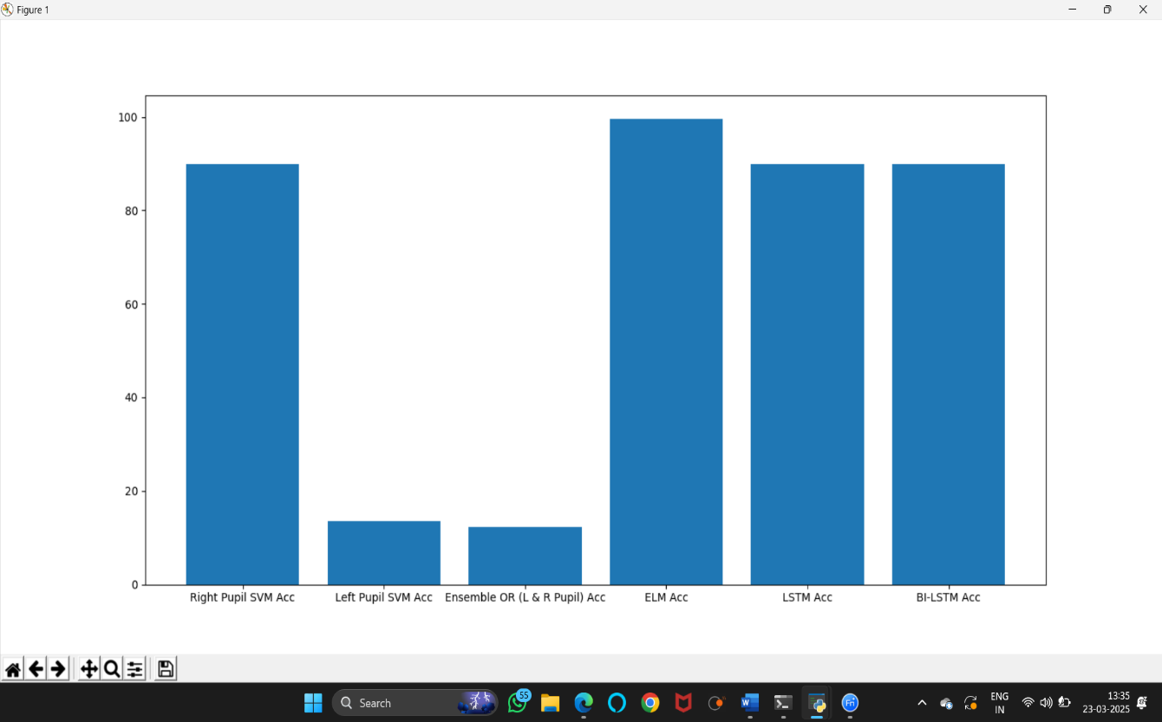

- Now click on ‘predict disease’ button to upload test data and predict disease.

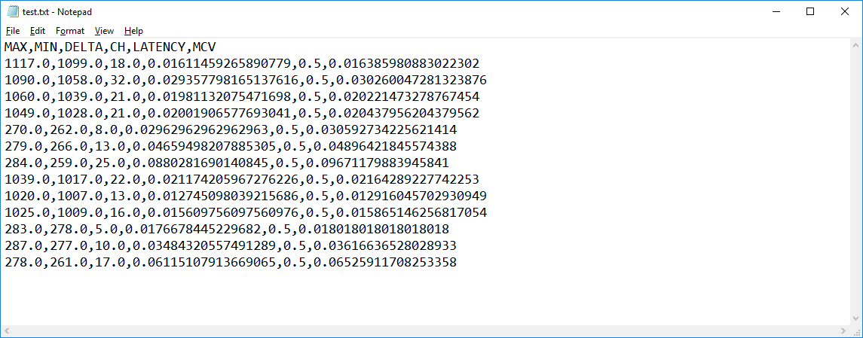

- In above test data ‘test.txt’ we have only features values and after uploading classifier will predict disease.

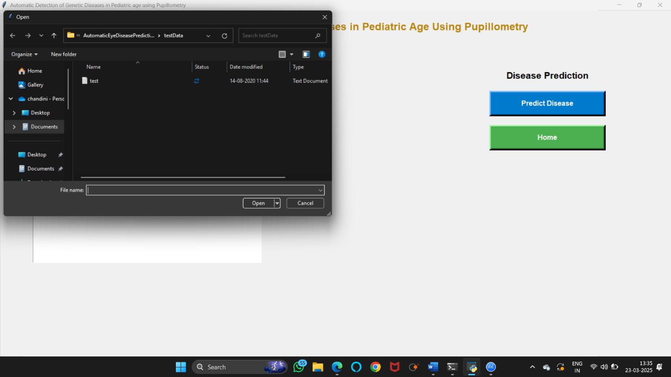

- In above screen uploading test data and after upload will get below screen.

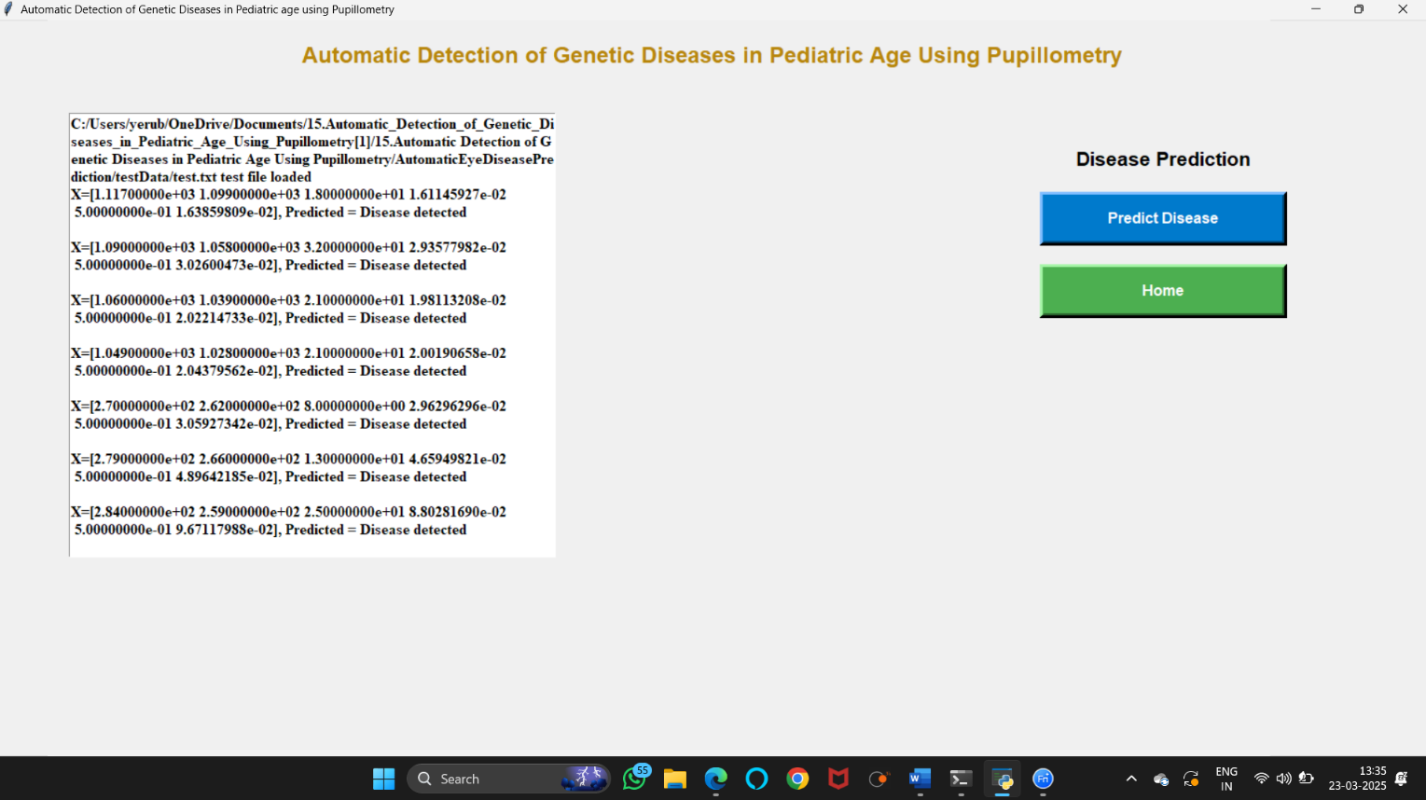

- In above screen for each test record classifier display result as ‘disease detected’ or ‘no disease detected’.

USER MANUAL

9.USER MANUAL:
The User Manual provides a comprehensive guide on how to use and deploy the Automatic Detection of Genetic Diseases in Pediatric Age Using Pupillometry system. It includes step-by-step instructions for users and administrators to navigate and operate the system efficiently.
The system is designed to assist in the early detection of genetic diseases in pediatric patients by analyzing pupil response data using advanced machine learning techniques. Users can upload pupil data, preprocess and extract features, and run multiple classification models to predict potential genetic diseases. The system supports various machine learning models, including Support Vector Machines (SVM), Extreme Learning Machine (ELM), and Long Short-Term Memory (LSTM) networks. Additionally, administrators can monitor accuracy metrics, visualize results, and generate reports.

Installation Steps:

Step 1: Install Python 3.7.0
Download and install Python 3.7.0 from Python.org. Ensure that pip is installed along with Python.

Step 2: Install Required Libraries
Open the terminal (Command Prompt or PowerShell for Windows, Terminal for macOS/Linux) and run:

Step 3: Verify Installation
Run the following command in Python to verify that the required libraries are installed correctly:

Step-4: Run the Script
navigate to the project directory and Hit the “run”
This will launch the graphical user interface (GUI).

User Guide:
Step 1: Upload Pupillometric Dataset
- Click on "Data Upload & Processing" on the home screen.
- Click "Upload Dataset" and select the dataset folder.
- The system will confirm that the dataset has been successfully uploaded.

Step 2: Preprocessing & Feature Extraction
- Click "Run Filtering" to clean and preprocess the dataset.
- Click "Run Feature Extraction" to extract important pupil features.
- Click "Run Feature Reduction" to remove unnecessary data.
- The system will display a graph showing pupil diameter trends.

Step 3: Running Machine Learning Algorithms
- Click "Run Algorithms" on the home screen.
- Select and run the following models:
  - Run SVM Right Eye – Applies Support Vector Machine (SVM) on right-eye data.
  - Run SVM Left Eye – Applies SVM on left-eye data.
  - Run Ensemble Algorithm – Uses multiple models for better prediction accuracy.
  - Run ELM – Executes Extreme Learning Machine for classification.
  - Run LSTM – Runs Long Short-Term Memory neural network.
  - Run BiLSTM – Runs Bi-directional LSTM model.

Step 4: Viewing Accuracy Graph
- Click "Show Accuracy Graph".
- A bar graph comparing the accuracy of all models will be displayed.
- The graph helps to understand which model performed best.

Step 5: Disease Prediction
- Click on “Run SVM on Left Eye Features" to train the left-eye classifier.
- Click on “Run OR Ensemble Algorithm (Left & Right SVM)" to combine both classifiers.
- Click on “Run Extension Extreme Learning Machine Algorithm" to test the ELM classifier.
- Click on “Run LSTM" or "Run BILSTM" to train and test deep learning models

Step 6: View Accuracy Metrics
- Click "Accuracy Graph with Metrics" to visualize the accuracy of different models.

Step 7: Predict Diseases
- Click "Predict Disease" on the home screen.
- Click "Predict Disease" and upload a test dataset file for analysis.
- The system will classify the patient’s data and display whether a genetic disease is detected or not.

Troubleshooting:
- Issue: Missing Libraries
- Reinstall dependencies using below code:
pip install --upgrade numpy pandas scikit-learn matplotlib keras tensorflow sklearn-extensions

- Issue: File Not Found
- Ensure the dataset is in the correct directory.
- Check the dataset format and file paths.

- Issue: GUI Not Opening
- Ensure you are running the script with Python 3.7.0.
- Check for syntax errors in the script.
- Ensure tkinter is installed correctly.

- Issue: Model Not Training
- Ensure your dataset is correctly formatted.
- Check if all necessary features are extracted before running machine learning models.

CONCLUSION AND FUTURE WORK

CONCLUSION AND FUTURE WORK

This project demonstrates the feasibility and potential of utilizing pupillometry data and machine learning, specifically Support Vector Machines, for the non-invasive detection of genetic eye diseases in pediatric patients. By automating the analysis of pupil dynamics, we have developed a system that minimizes the need for stressful and invasive clinical procedures, offering a more comfortable and accessible diagnostic approach. The high accuracy achieved through our ensemble SVM classifier highlights the effectiveness of this methodology.
Future enhancements for this project could focus on expanding the system's capabilities by incorporating diverse datasets from various pupillometry devices and patient demographics, thereby improving generalizability. Additionally, integrating the system with electronic health records and developing a user-friendly mobile application could facilitate seamless clinical integration and remote patient monitoring. Furthermore, implementing real-time data analysis and alert systems would enable immediate detection of potential abnormalities, leading to faster interventions and improved patient outcomes.

BIBLIOGRAPHY

BIBLIOGRAPHY:

Text Books:
- Diagnostics and Gene Therapy for Human Genetic Disorders – K.V. Chaitanya
- Machine Learning and Deep Learning Techniques for Medical Science – K. Gayathri Devi et al.
- Pediatric Cancer Genetics – Nathaniel H. Robin, Meagan B. Farmer
- Medical Image Analysis and Machine Learning – Mark Haidekker
- Clinical Ophthalmic Genetics and Genomics – Graeme Black, Neil Meemaduma
- Artificial Intelligence in Healthcare – Adam Bohr, Kaveh Memarzadeh

Online references:
- Automatic Detection of Genetic Diseases Using Pupillometry – E. Iadanza et al. (PDF)
- Automatic Detection of Genetic Diseases Using Pupillometry – Jafar Ali Ibrahim S et al. (Research Paper)
- Multi-Algorithmic Genetic Disease Detection Using Pupillometry (Springer)
- GitHub: Genetic Disease Detection with Pupillometry (GitHub Repo)
- GitHub: Pupillometry-Based Genetic Disease Detection (GitHub Repo)

